Partnership Courtyard, The Ramparts,
Dundalk, Ireland

Version 6.4.4.0
January 27, 2017
www.measuresoft.com
+353 42 933 2399

This document is the copyright of Measuresoft and may not be modified, copied or distributed in any form whatsoever without the prior permission of Measuresoft.

WITS Input User Manual

Table of Contents

1. Configuration 3
1.1. Communications 3
Enable Wits Receiver Interface 3
Scan Rate 4
Report time out if no Records Received after 4
1.2. Connection 4
Serial connection 4
TCP Connection 4
2. Channel Configuration 5
Enable Channel 6
Tag 6
Description: 6
Units 6
Scaling 6
Event Checking 7
Significant Change 7
Low and High Alarm Checking 7

Configuration

The first time the system is configured it is necessary to enable and configure all devices you require. To configure a particular device select the Devices option from the main menu followed by the WITS Input device. This will launch an application to configure the device. The following dialog will be displayed.

This dialog displays the status, errors, and the achieved scan time of the device. In order to communicate with the device the communication settings will need to be configured, they are described in detail below.

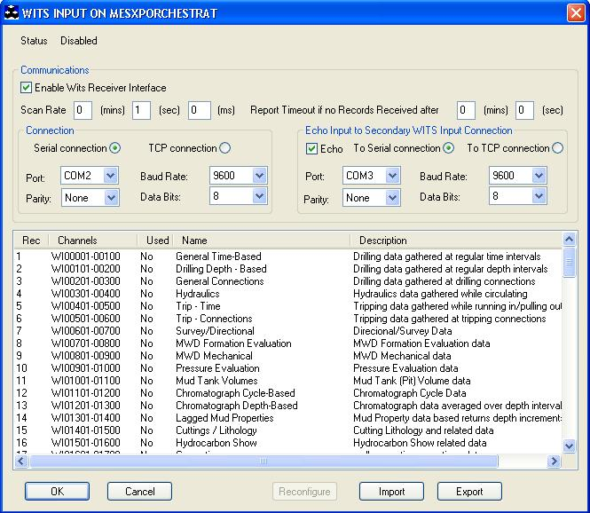

Communications

Enable Wits Receiver Interface
For the wits receiver interface to be operative and therefore configurable the Enable Wits Receiver Interface check box must be checked.

Scan Rate
To set the rate at which the device will scan, edit the text boxes associated with the Scan Rate field to the desired rate.

Report time out if no Records Received after
This allows the maximum time the scanner will wait for a received record which is set in minutes and seconds.

Connection

Serial connection

Comm Port
For serial connections, this allows you to select the port to which your WITs Input device will be connected. To choose a port, click on the down arrow to the right of the port field. The drop down list will contain a list of all available ports on your system. Choose the one you want.

Parity
There are 5 types of parity available
None
Odd
Even
Space
Mark
Parity is selected in the same way as the port – Click on the down arrow and select from the provided list.

Baud Rate
This allows you to select your desired baud rate. The baud rate is selected in the same way as the port and parity – click on the down arrow and choose from the provided list.

Data Bits
Select the appropriate amount of data bits to be used. The data bits amount is selected in the same way as the port and parity – click on the down arrow and choose from the provided list.

TCP Connection

Port
For TCP/IP connections, this allows you to select the TCP/IP port number. This is defaulted to 7.

Echo Input to Secondary WITS Input Connection

Echo

This allows you to echo the input to a secondary connection, either Serial Connection or TCP Connection, with the same options as the primary connection.

Channel Configuration

To perform channel configuration double click on the required record within the Wits Input dialog to display its corresponding list of channels.

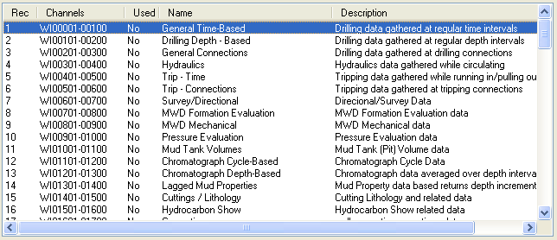

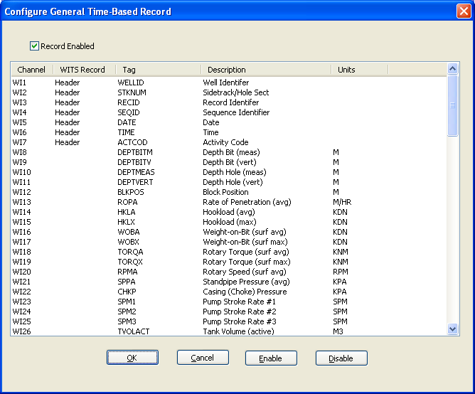

To configure a channel double click on the required channel to edit its configuration properties.

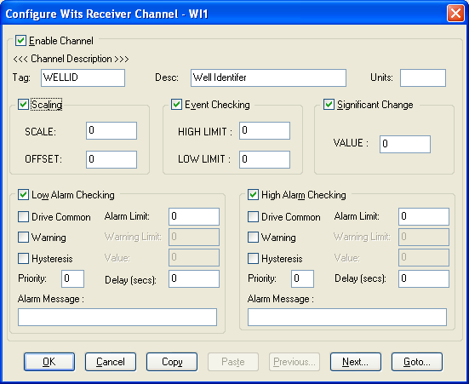

Enable Channel
For a channel to be operative and therefore configurable the Enable Channel check box must be checked.

Tag
A 15 characters alphanumeric field that can contain channel information or wiring schedule references.

Description:
A 32 channel alphanumeric field in which a description of the channel can be detailed.

Units
An 8 character field available to describe the units of the measurement.

Scaling
To enable the utility check the Scaling Check box. The Scale and Offset values can be entered directly into the text boxes. The formula applied is:
y = mx + c where: m is SCALE
x is the measured value.
c is the OFFSET

Event Checking
Event checking is used, if required to trigger a logger to record information on an event. Check the Event Checking check box if this facility is needed.

High Limit
A value entered in this text box will define the level that if exceeded, by the channel result will cause an event trigger.

Low Limit
A value entered in this text box will define the level that if the channel result falls below will cause an event trigger.

Significant Change
To enable check the Significant Change check box.

This facility allows filtering of data on channels on which significant change is of interest. Such changes can cause an event, which can be logged.

The figure entered in the Value text box is the rate of change in engineering units, which, if the measured channel exceeds per scan, either increasing or decreasing will cause the significant change event trigger.

Low and High Alarm Checking
Alarm checking is available on all channels throughout the ScadaPro system. Low Alarm and High Alarm levels can be configured independent of each other. All the values entered are in engineering units. If a channel reading exceeds the High Alarm limit then an alarm will be triggered as it will if the channel goes below the Low Alarm limit.
When monitoring channels, if the high or low alarm is triggered, then the fact will be annotated alongside the other channel information in the Monitor Window.

Enable Alarm Checking
Check either the Low Alarm Checking or High Alarm Checking or both check boxes to enable the facility.

Alarm Limit:
The value at which the channel will flag an alarm.

Warning and Limit:
If required, a warning can be displayed when a channel reaches a limit close to the alarm limit. For low alarm checking, the alarm limit must be less than the warning limit. For high alarm checking, the warning limit must be less than the alarm limit.

Delay:
Specify the number of seconds the channel must be in the alarm zone before an alarm will be flagged within the system.

Hysteresis
Hysteresis can prevent 'noisy' channels from reporting multiple alarms when the average reading is close to the alarm or warning threshold. The Hysteresis value is relative to the alarm or warning limit.
For example, if a channel’s high alarm is set to 80 degrees C, Hysteresis is enabled and a Hysteresis value of 5 degrees C is specified the system will respond as follows:
When the channel reading goes above the high alarm limit of 80 it will trigger the alarm. The alarm will not be reset until the channel reading falls below 75, the high limit - Hysteresis value.
Check the box if this feature is needed. Enter the value of the dead band in the text box.

Priority
Enter or edit the number in the text box to allocate the priority of this alarm.

Drive Common Alarm:
A common alarm is a single digital output, which will switch on when any channel with the Drive Common Alarm enabled goes into an alarm state.
Check this box if a link to the Common Alarm is required.

Alarm Message:
An Alarm Message can be defined to be displayed on the Status line of the ScadaPro Main Window when a channel goes into an alarm state.
Enter the message, up to 32 characters.

Encoding Channel Values

Alphanumeric record items can be received by mapping the expected input to an analog value.

Survey type Record 7 Item 12 – Channel 612 is recommended to have the following values.

MWD (1) (Measurement While Drilling)
Mag-SS (2) (Magnetic Single Shot)
Mag-MS (3) (Magnetic Multi Shot)
Gyr-Free (4) (Gyro-Free)
Gyr-Rate (5) (Gyro-Rate Integrating )
Inertial (6) (Inertial Navigation System)

Using the above mapping the alphanumeric value e.g. the item value received as MWD can be converted to a value of 1 by setting up a value.txt file in the
<Install Directory>\CURRENT_CONFIG\WITSO_<n> directory.

[Channel612]
1=MWD
2=Mag-SS
3=Mas-MS
4=Gyr-Free
5=Gyr-Rate
6=Inertial
0=*

The last entry indicates that an unmatched received value sets the input value to 0.

