March 12, 2021
Version: 6.6.0.0

Fergal Cassidy
Measuresoft Development LTD
Partnership Courtyard, The Ramparts, Dundalk, A91 KV67, Co. Louth, Ireland

This document is the copyright of Measuresoft and may not be modified, copied or distributed in any form whatsoever without the prior permission of Measuresoft.

Imp OPC Server USer Manual

Configuration of Solartron IMP Modules

1 Installation Procedure 3
1.1 Setup Installation 3
1.2 Manual OPC DLL Registration 5
1.2.1 Open command prompt in administrator mode. 5
1.2.2 Register Dlls 5
2 Introduction to Configuration 7
2.1 Launching the Device Configuration Utility 9
2.2 Channel Device Specific Configuration 11
2.2.1 To Configure an IMP Module 11
2.2.2 Steps to Configure 35951A / 35951B / 35951C / 35951D / 35951E /First 18 3595 1H/1J Channels 15
2.2.3 Steps to Configure a 35952A or Last 2 channels of 3595 1J/1H 17
2.2.4 Channel Device Specific Configuration Fields 19
2.2.5 Enable Alarm Checking 21
2.2.6 Drive Common Alarm 21
2.2.7 Drive CH 19 and Drive CH20 21
2.2.8 Alarm Limit 21
2.2.9 Warning and Limit (Analogue channel only) 21
2.2.10 Hysteresis 21
2.2.11 Priority 22
2.2.12 Alarm Delay 22
2.2.13 Alarm Message 22
2.2.14 Buttons on the Configuration Dialogs 29
2.3 Interrogating IMP Modules 31
2.3.1 To Interrogate IMP Modules 31
2.3.2 Read 32
2.3.3 Calibrate 32
2.3.4 Steps to Calibrate an IMP Module 32
2.4 Advanced Configuration 34
2.4.1 Steps for Carrying Out Advanced Configuration 34
2.4.2 Advanced Device Specific Configuration Fields 35
2.4.3 To Add a Calibration Polynomial 37
2.4.4 To Edit a Calibration Polynomial 38
2.4.5 To Delete a Calibration Polynomial 38
2.5 Error Codes 39

Installation Procedure

Setup Installation

Run Setup.MSI from the following dialog will appear, click Next:

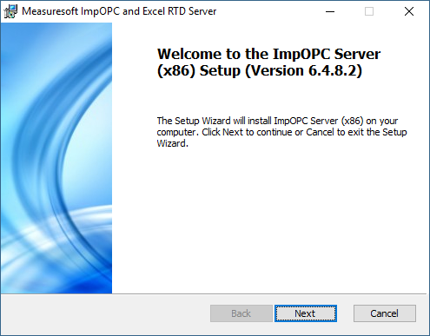

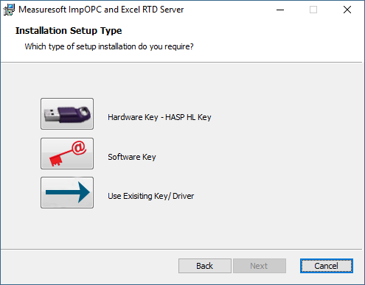
Select Hardware Key – Hasp HL Key, a new setup will open to install the hardware key dialog. When this setup is finished the Imp OPC setup will continue.

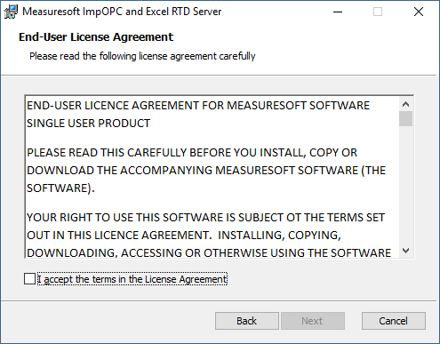
Accept the terms of the Licence Agreement and Click Next to continue.

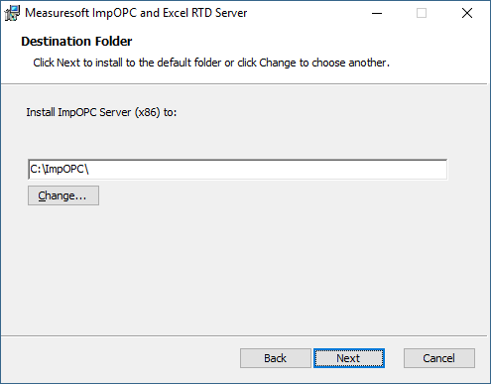
Click Next to accept the default destination folder.
Click Install on the “Ready to install ImpOPC Server (X86)” dialog, and the install will begin.
Click Finish when install completed.

Manual OPC DLL Registration

Open command prompt in administrator mode.

In the run dialog type CMD, Command Prompt will appear right click and select “Run as Administrator”
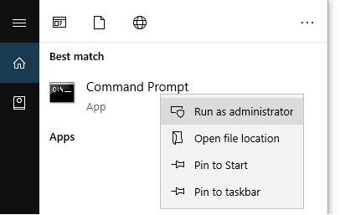
Command prompt will now open.

Register Dlls

Change directory to the ImpOPC BIN directory that has been installed in the previous step by entering the command CD c:\ImpOPC\Bin as per the image below:

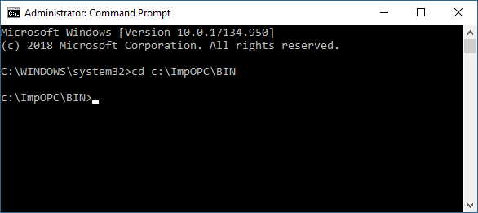

Enter the following command:
regsvr32 opccomn_ps.dll
A dialog will appear to say that it has succeeded.

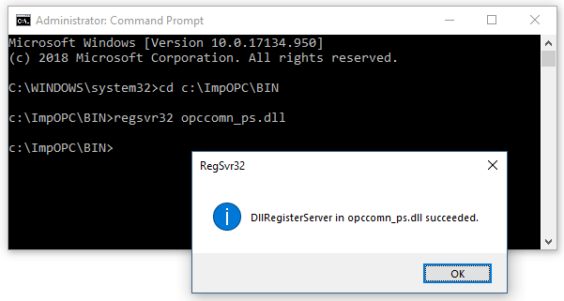
Enter the following command:
regsvr32 OPCProxy.dll
A dialog will appear to say that it has succeeded.
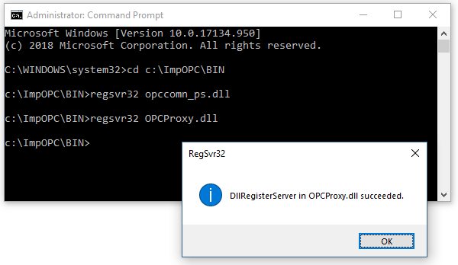
Enter the following commands, there will be no dialogs after these.
OPCEnum.exe /RegServer
MS_OPCsvr.exe /RegServer

Imp OPC is now installed.

Introduction to Configuration

To configure IMP channels, you must firstly choose an IMP module to configure and then configure the channels within that selected module. The configuration of IMP channels varies depending on the:
- Type of IMP module selected
- The Mode a particular channel is in
Below is a list of IMP modules, their type, the number of channels within that module and what the module supports

Module Name | Module Type | No of Channels | Supports
35951A | Analog Input | 20 | Thermocouples, Voltage, Current
35951B | Analog Input | 10 | Strain Gauges, PRT’s, Voltage, Resistance
35951C | Analog Input | 20 | Thermocouples, Voltage, Current
35951D | Analog Output | 4 | Voltage, Current
35951E | Analog Input | 20 | Thermocouples,  Voltage, Current
35951H/1J | Universal Imp  Analog Input and 2 Digital I/O | 20 | Thermocouples, Voltage, Current  PRT’s, Resistance  Status, Events, Frequency, etc.
35952A | Digital Input, Digital Output, Counter Output | 20 | Status, Events, Frequency, etc.

The steps needed to configure a particular channel within a particular module will be examined. Different dialogs are displayed depending on the IMP module type. Different fields are displayed on each dialog depending on the Mode of the channel.

The following is explained:
Steps to Configure a 35951A/35951B/35951C/35951D/35951E IMP Channel
Steps to Configure a 35952A IMP Channel
List of fields on particular configuration dialogs
Explanation of those fields

Launching the Device Configuration Utility

To Start the Device Configuration Utility :

- Choose the Solartron IMPS option from the Devices menu. The following application window will appear.
Click on the Module Configuration Tab to get a list of the modules on the network.

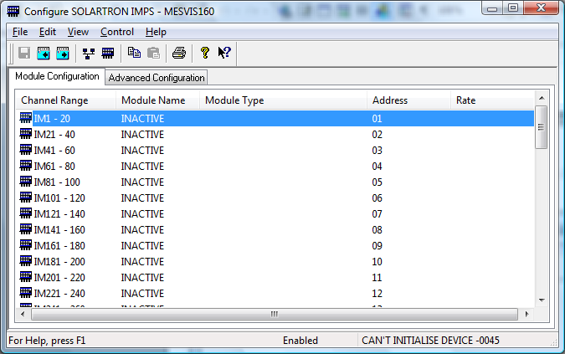

- You can now configure the IMPs using the various options
Fields on the Module Configuration Tab

A list of Channels, Module names, Module types, Addresses and Scan Rates are visible on the window.

Channel Range
There can only be a maximum of 1000 channels on any IMP network

Module Name
This refers to the name of the IMP module. There are 7 IMP module types :

- 35951A
- 35951B
- 35951C
- 35951D
- 35951H/1J
- 35951E
- 35952A

Module Type
IMP Modules will be one of the following:

- Analog Input
- Analog Output
- Digitals

Address
This is the physical address of the IMP on the IMP network. Addresses range from 1 to 50. There can only be a maximum of 50 IMP modules on any IMP network.

Rate
This refers to the scan rate (acquisition rate). This can be SLOW or FAST.

Channel Device Specific Configuration

Before configuring a channel, you must firstly configure a module

To Configure an IMP Module

- Click on a Channel Range in the Module Configuration Tab of the main Solartron IMPs configuration window.

- The following dialog will appear :

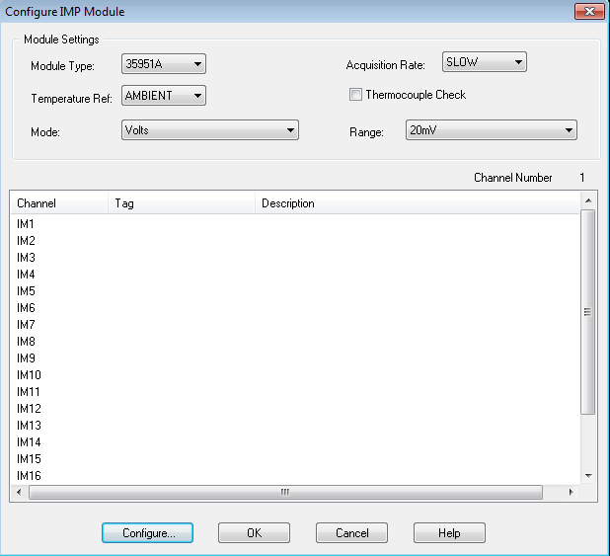

Fields on the Configure IMP Module Dialog

Module Type
This field allows you to specify the type of IMP module you wish to configure. Options here are :
- INACTIVE
- 35951A
- 35951B
- 35951C
- 35951D
- 35951E
- 35951H/1J
- 35952A

Acquisition Rate
This specifies the rate at which scanning occurs. You can choose SLOW or FAST.

Temperature Reference and Thermocouple Checking
These fields can only be set when you are configuring particular types of IMP module

Module Type | Temp. Ref & Thermo. Checking Available
35951A
35951B
35951C
35951D
35951E
35951H/1J
35952A

List Of Channels
A list of all the channels that can be configured is displayed here. The number of channels displayed depends on the type of module you are configuring (See diagram in the introduction for the number of channels in each module type.
Foe each channel, the following information is displayed:

- System Channel
- Tag
- Description

Mode
Sets the mode for all Imp channels automatically at module level and overrides any manually configured mode. If you manually change one of the imp channels after setting the mode from this menu, the Mode drop down box will appear blank to represent that not all the channels are the same.

Range
Sets the range for all Imp channels automatically at module level and overrides any manually configured range. If you manually change one of the Imp channels after setting the range from this menu, the range drop down box will appear blank to represent that not all the channels are the same.

System Channel
Displays the mapping of an IMP channel to a system channel

Tag
A tag is a twelve character alphanumeric field that can contain channel information. This field will contain Skipped (i.e. Channel not configured) or a valid tag

Description
Your description of the channel.
The currently highlighted channel is also shown in the Channel Number field.
We can now examine how to configure individual channels on each of the IMP modules

Steps to Configure 35951A / 35951B / 35951C / 35951D / 35951E /First 18 3595 1H/1J Channels

- Choose the module type on the configure IMP module dialog
- If available, Temperature Reference can be set to Ambient or External. Thermocouple Checking can also be enabled
- For each module the number of available channels will be visible in the channel listings.
- Select a channel to configure by: Double Clicking the desired channel with the mouse OR Click on the desired channel and click the Configure Channel button at the bottom of the Configure IMP Module dialog.

The following dialog will then appear for 35951A, 35951B, 35951C, 35951E, and the first 18 channels of the 3595 1H/1J:

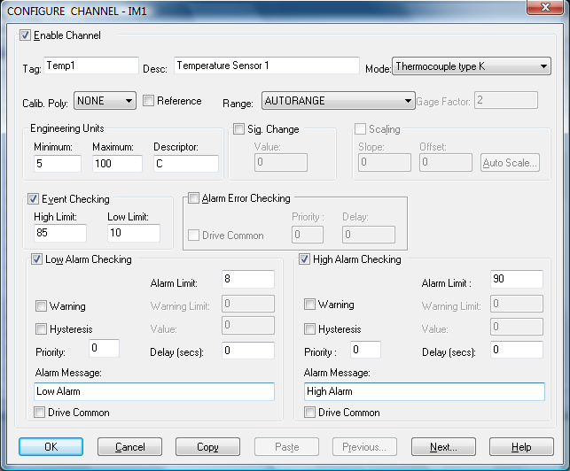

- The following dialog will then appear for 35951D:

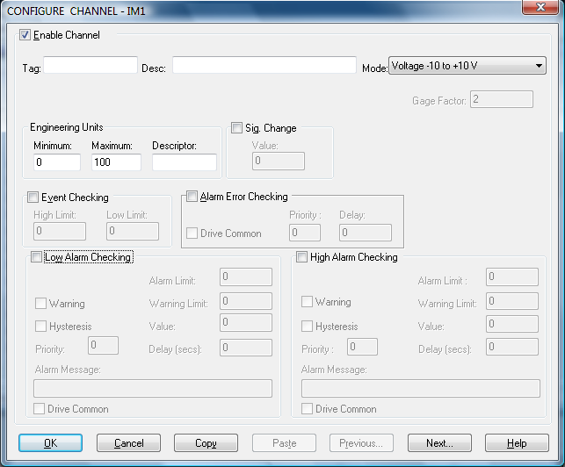
See section entitled “Channel Device Specific Configuration Fields” for an explanation of each field.
- Choose either OK or CANCEL button to return to the “Configure IMP Module” Dialog.
- If desired the changes to the configuration can be saved, or discarded by exiting the configuration utility without saving. Only changes to configuration which have been saved will be used by the system.
- In order for the changes to take effect, the system must reload the configurations and restart the device scanner. For channel specific changes this requires calling only the reconfigure command from the Control menu either in main menu or the Configuration utility. For Advanced configuration changes described in this section, the system must be disabled and re-enabled for the changes to take effect.
- The configuration of the 35951A / 35951B / 35951C / 35951D / 35951D IMP channel is now complete.
Note :
See section entitled “Buttons on the Configuration Dialogs”

Steps to Configure a 35952A or Last 2 channels of 3595 1J/1H

- Choose the 35952A module type on the configure IMP module dialog
- Temperature Reference and Thermocouple Checking cannot be used
- 20 channels will be visible in the channel listings.
- Select a channel to configure by: Double Clicking the desired channel with the mouse OR Click on the desired channel and click the Configure Channel button at the bottom of the Configure Module dialog.
- A dialog appears. Different fields are displayed depending on the selected Mode.
Note: that when using a 3595 4B or 4C SNet interface, events captured from 2A Imp modules are stored in: <productdir>\LOGGED_IMP_EVENTS\YYMMDD\rtmeHH00.log files.
- This dialog represents Digital Input, Digital Output and OFF modes
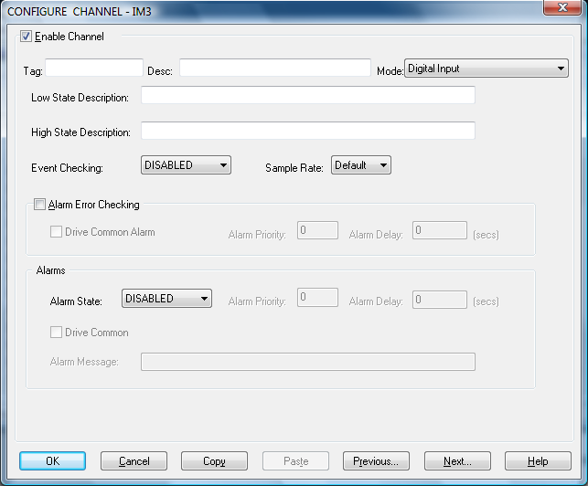
This dialog represents all other modes on the 31952A:

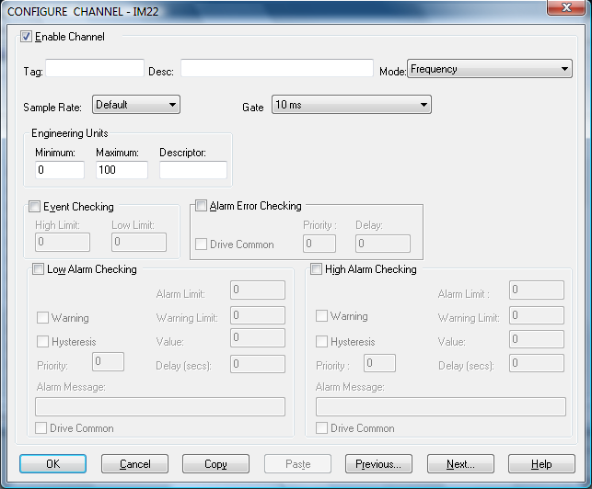
See section entitled “Channel Device Specific Configuration Fields” for an explanation of each field
- Choose either OK or CANCEL button to return to the Configure IMP Module dialog.
- If desired the changes to the configuration can be saved, or discarded by exiting the configuration utility without saving. Only changes to configuration which have been saved will be used by the system.
- In order for the changes to take effect, the system must reload the configurations and restart the device scanner. For channel specific changes this requires calling only the reconfigure command from the Control menu either in main menu or the Configuration utility. For Advanced configuration changes described in this section, the system must be disabled and re-enabled for the changes to take effect.
- The configuration of the 35952D IMP channel is now complete.

See section entitled “Buttons on the Configuration Dialogs”

When finished configuring channels you will be at the IMP Device Configuration dialog.

Channel Device Specific Configuration Fields

This section contains an alphabetic list of all the possible fields that can be displayed on various configuration screens.

Alarms

Alarm State
Alarm checking is available on all channels throughout the system. To configure alarm checking on a channel, click on the drop down box and select : OFF, LOW STATE, HIGH STATE as appropriate.

If the channel output state changes to an alarm state an alarm will be triggered on the channel. When monitoring channels, if the alarm is triggered, the fact will be annotated alongside the other channel information in the monitor window.

Alarm Priority
Use this to set the priority of the alarm triggered by the channel.

Common Alarm
Channels can be configured to trigger a common alarm. A common alarm is a single digital output which will switch on when any channel with the Drive Common Alarm enabled goes into an alarm state.

Alarm Message
An alarm message can be defined to be displayed on the status line of the applications main window when a channel goes into an alarm state

Calib Poly
This refers to the calibration polynomial. These are set in the Advanced section of the configuration. The drop down list will contain a list of any added/created calibration polynomial

Description
The description field is a 16-character alphanumeric field in which a description of the channel can be detailed

Enable Channel
The Enable Channel check box must be checked to enable, and allow this channel to be configured and ultimately included with all other configured channels in the overall system

Event Checking
Event checking is used to trigger a logger to record information on a number of channels during an event. Check the Event Checking check box if this facility is required

High Limit
A value in engineering units entered in this text box will define the level that if exceeded will cause an event trigger

Low Limit
A value entered in this text box will define the level that if the channel result falls below will cause an event trigger

High State Description
A 32-character field in which to enter a description of the high sate of the channel

Low Alarm Checking & High Alarm Checking
Alarm Checking is available on all channels throughout the system.
Low alarm and High alarm levels can be configured independent of each other. All the values entered are in engineering units. If a channel reading exceeds the high alarm limit then an alarm will be triggered as it will if the channel goes below the low alarm limit
When monitoring channels, if the high or low alarm is triggered, then the fact will be annotated alongside the other channel information in the Monitor window.

Enable Alarm Checking
Check either the Low Alarm Checking or High Alarm Checking or both check boxes to enable the facility.

Drive Common Alarm
A common alarm is a single digital output which will switch on when any channel with the Drive Common Alarm enabled goes into an alarm state. Check this box if a link to the Common Alarm is required.

Drive CH 19 and Drive CH20
Channel 19 and Channel 20 on 3595 1J/1H can be configured as an alarm digital output which will switch on/off when any channel with this field enabled goes into an alarm state.

Alarm Limit
Specifies the value which will trigger this alarm. for Low Alarm Checking it will be any value <= the Alarm Limit and for High Alarm Checking it will be any value >= the Alarm Limit.

Warning and Limit (Analogue channel only)
If required, a warning can be displayed when a channel reaches a limit close to the alarm limit. For low alarm checking, the limit must be less than the alarm limit. For high alarm checking, the warning limit must be less than the alarm limit.

Hysteresis
Hysteresis can prevent 'noisy' channels from reporting multiple alarms when the average reading is close to the alarm threshold. Check the box if this feature if needed. Enter the value of the dead band in the corresponding value field.

Priority
Enter or edit the number in the text box to allocate the priority of this alarm. Alarm priority ranges are from 0 to 255.

Alarm Delay
Enter the time, in seconds, between the channel value entering the alarm state and the system flagging an alarm.

Alarm Message
An Alarm Message can be defined to be displayed on the Status line of the Main Window when a channel goes into an alarm state. Enter the message, up to 32 characters, that is to appear in the event of an alarm.

Low State Description
A 32-character field in which to enter a description of the low state of the channel

Measure Loop Resistance
If the channel mode on the first 18 channels of a 3595 1J/1H is set to thermocouple, it is possible to measure the loop resistance of the thermocouple. The loop resistance measurement is stored in the specified channel. It is recommended to use the User Analog channels e.g. for IM1 specify P1.

Mode
Choosing a Mode option from this drop-down list will instruct the IMP module how the channel is to be measured and the readings interpreted. Conversion to engineering units occur automatically. The options available in the drop down list vary depending on the IMP module.

Mode is related to Range (The appropriate range for the measurement)

Table: 31951A and 31951C Modes and Associated Ranges

Mode | Range
OFF | None Available
Volts | AutoRange  20mV  200mV  2V  10V
Thermocouple Type E, J, K, R, S, T, B, N | AutoRange  20mV  200mV  2V  10V
Current | AutoRange  MicroAmps  Mamps  20mAmps  mAmps

Table : 31951B Modes and Associated Ranges

Mode | Range
OFF | NONE AVAILABLE
Volts | AutoRange  20mV  200mV  2V
Resistance, 4-term, 0.8mA drive | AutoRange  25 Ohms  250 Ohms  2K 5 Ohms
Resistance, 3-term, 08mA drive | AutoRange  25 Ohms  250 Ohms  2K 5 Ohms
RTD/PRT, 100Ohm, 4 Term  RTD/PRT, 100Ohm, 3 Term  1/2 bridge, 4mA dual current  1/2 bridge, 0.8mA dual current  1/4 bridge, 4 mA dual current  1/4 bridge, 0.8mA dual current  Full bridge, 8mA drive  Full bridge, 1.6 mA drive  3-wire, 4 mA drive  3-wire, 0.8 mA drive | AutoRange  20mV  200mV  2V

Table : 31951D Modes

OFF
Voltage -10V to +10V
Current 4 to 20 mA

Note: There are no Ranges with this type of module

Table: 31952A Modes and Associated Ranges

Mode | Range
OFF | NONE
Digital Input | NONE
Event Count Totalise  Event Count Increment  Event Capture | Edge :  -ve going edge  +ve going edge  +ve going edge or -ve going edge
Digital Output | NONE
Frequency | Gate Time :  10 ms  100ms  1 secs  10 secs
Period | Period :  1 period  10 periods  100 periods  1000 periods
One-Shot | Pulse :  -ve going start  +ve going start  -ve going stop  +ve going stop

Ref

When the reference check box is checked, the channel has been defined as a Reference channel. Values of a reference channel are displayed as the measured value - zero value. When the system is enabled, the zero value can be initialised using one of the following methods:
From the IMP Device Configuration window choose Initialise from the Control menu
From the application window choose initialise from the Control menu
Press keys : CTRL + I together

Sample Rate

This is the rate at which sampling occurs within the device. The options are :
(a) 1Khz
(b) 10Khz
(c) 100Khz
(d) 20 hz
(e) Default

Scaling

To enable the utility, check the Scaling check box. The slope and offset values can be entered directly into the text boxes.
The formula applied is:
y = mx + c
Where:
m = Slope
x = Measured Value
c = offset

AutoScale
Click on the autoscale button if you want to scale and offset values calculated automatically. The following dialog is displayed :

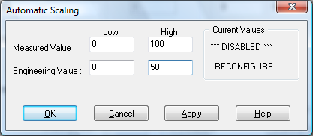

Enter the values in the text boxes - the Low measured value, the High measured value and the Output range of the Transducer

Scaling will not be applied to the channel even if the system is enabled. Scaling will be applied when the system is re-enabled or the IMP device is reconfigured.

Sig.Change (Signal Change)

To enable the significant change feature, click he Sig. Change check box. This facility allows filtering of data on channels on which significant changes are of interest. Such changes cause an event which can be logged.

The figure entered in the value text box, in engineering units, is the rate of change that the measured channels exceed per scan. Either increasing or decreasing will cause the significant event trigger.

The scan rate is determined in the Advanced IMP device window. If a logger is configured in Event mode, or Period-Event, each time the significant change trigger occurs information on the channels defined in the logger will be recorded. A significant change event only lasts one scan, unless the next reading also changes greater than the significant change value.

When monitoring channels, if the significant change is triggered, then the fact will be annotated alongside the other channel information in the monitor window.

Tag
The Tag is a 15-character alphanumeric field that can contain channel information.

Timeout
The timeout field is available when the Mode is Period or One-Shot. The options are :
(a) 200ms
(b) 2sec
(c) 20sec
(c) 50sec

Units
An 8-character field available to describe the units of the measurement

Buttons on the Configuration Dialogs

Eight buttons are at the bottom of the Configure Analog Input Channel Window. They are explained below :

OK Button
When a channel has been successfully configured click on the OK button to accept and move back to the previous window.

Cancel Button
Clicking on the Cancel button will nullify any changes made. The configuration of that channel will remain unaltered. The previous window will be displayed.

Copy Button
If the configuration of the current channel is to be repeated, clicking on this button will copy the configuration to the Windows Clipboard.

Paste Button
When a configuration has been copied to the Clipboard it can be pasted into any other channel on this IMP Module by this button.

Previous & Next Buttons
Clicking on Previous or Next buttons will accept the current channels configuration and move on to either the next or the previous channels Configuration Window.

Goto Button
Selecting the Goto button will accept the current channels configuration and move on to the channel entered in the resulting Goto Channel No. dialog box.

Help Button
If any Help is required concerning any element of this window, clicking on this button will select the Help utility.

Interrogating IMP Modules

To Interrogate IMP Modules

1. Click the Network Modules Icon on the toolbar of the main application window. A dialog will appear.

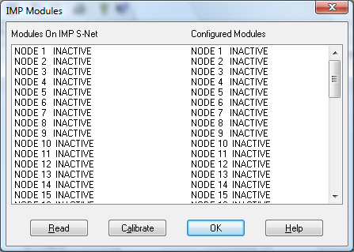
You are presented with two lists :

List on the left-hand side are IMP’s actually on the S-Net
List on the right-hand side are configured modules

It is possible to have modules present on the S-Net which have not been configured as well as having modules configured which are not present on the S-Net.

Two options are available here :

Read
The read option is only available if the IMP device is disabled. Clicking on the Read button will save some work in configuring the Imp module. It brings configuration information about inactive modules from the IMP into the system.

Calibrate
This option allows you to calibrate an IMP module on the S-Net

Steps to Calibrate an IMP Module

Click the Calibrate button on the IMP Modules dialog (after clicking the Modules button ion the IMP Device Configuration dialog)

The following dialog will appear :

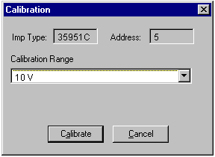Imp Type
This is the type of IMP module you are configuring (i.e. 31951A, B, C, D, E, 2A)

Address
This is the address of the IMP module on the S-Net

Calibration Range
Ranges are only available for 35951A, B and C
For 35951A and 31951C:

- 20mV
- 200mV
- 2V
- 10V

For 35951B:

20mV
200mV
2V
Resistance
4mA strain gage
0.8mA strain gage
4mA strain gage

Advanced Configuration

Steps for Carrying Out Advanced Configuration

- Click the Advanced Configuration tab on the main Imp Configuration Application window. The following view will appear :

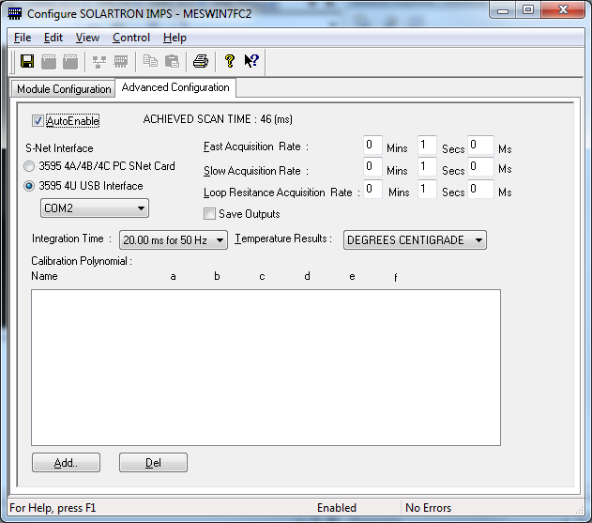

2. Fill in the fields as appropriate.
3. Select the appropriate communications method
i.e. 3595 8A RS232 Interface or 3595 4A/4B/4C PC to SNet Card.
Selecting the 3595 4U USB Interface allows selection of the COM Port provided by the USB interface.
4. Choose either the OK or CANCEL button to return to the IMP Device
Configuration dialog.

5. If desired the changes to the configuration can be saved, or discarded by exiting the configuration utility without saving. Only changes to configuration which have been saved will be used by the system.

6. In order for the changes to take effect, the system must reload the configurations and restart the device scanner. For channel specific changes this requires calling only the reconfigure command from the Control menu either in the Main Menu or the Configuration utility. For Advanced configuration changes described in this section, the system must be disabled and re-enabled for the changes to take effect.

7. Advanced configuration is now complete.

Advanced Device Specific Configuration Fields

The advanced configuration dialog contains the following fields :

Enable Device
This allows you to start or enable your device/scanner

Fast Acquisition Rate
This is the rate data is scanned from fast modules.

Slow Acquisition Rate
This is the rate data is scanned from slow modules. Note slow data is interleaved with fast data so that there an acquisition speed is regular e.g. 2 fast modules at 1 second 2 slow modules at 2 seconds means 1 slow module is interrogated every second.

Loop Resistance Acquisition Rate
This is the rate loop resistance measurements are made from 3595 1H/1J modules. Note loop resistance data is interleaved with fast data so that there an acquisition speed is regular e.g. 2 fast modules at 1 second 2 thermocouples with loop resistance at 2 seconds means 1 loop resistance is interrogated every second.

Integration Time
Options for the integration time are :
(a) 20.00ms for 50 Hz (or 400 Hz)
(b) 16.67ms for 50 Hz
(c) 5.00 for 400Hz
(d) 4.17ms
(e) 1.25ms
(f) 1.04 ms

Temperature Results
From the drop down list, choose the temperature conversion required :
(a) Degrees Centigrade
(b) Degrees Fahrenheit

Calibration Polynomials
Underneath this heading is a window reserved for listing all set Calibration Polynomials.
For IMP’s the polynomials are of the form:

ax⁵ + bx⁴+ cx³ + dx² + ex¹ + f
Calibration polynomials are set here. Once setup, these polynomials will appear in the drop down list in the channel configuration dialogs (in the Calib. Poly. Field) of the following modules: 31951A, B and C.

Calibration Polynomials are listed with their name together with their associated parameters (a - f)

To Add a Calibration Polynomial

- Click the Add button on the Advanced Configuration Tab of the main application window. The following dialog will appear :

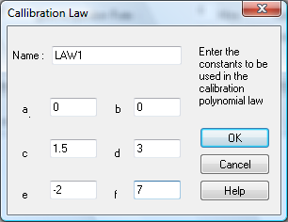

- Enter a name for the polynomial together with the 7 parameters - a to f
- Click the OK button to acknowledge or CANCEL to ignore
- If OK is selected, the added polynomial will be appended to the list of existing polynomials or if none exist will appear as the first.
- Choose either the OK or CANCEL button to return to the Advanced Configuration Tab of the main application window.
- If desired the changes to the configuration can be saved, or discarded by exiting the configuration utility without saving. Only changes to configuration which have been saved will be used by the system.
- In order for the changes to take effect, the system must reload the configurations and restart the device scanner. For channel specific changes this requires calling only the reconfigure command from the Control menu either in main menu or the Configuration utility. For Advanced configuration changes described in this section, the system must be disabled and re-enabled for the changes to take effect.
- Once all the above is complete, Advanced configuration is finished.

To Edit a Calibration Polynomial

- Double Click on the desired polynomial in the Advanced Configuration Tab.
- The Conversion Law dialog above will appear.
- Modify the values as needed.
- Choose OK to acknowledge or CANCEL to ignore.

To Delete a Calibration Polynomial

- Select the desired polynomial from the list on the Advanced Configuration Tab of the main application window using the mouse.
- Press the Del button on the Advanced Configuration Tab of the main application window.
3. The polynomial will be removed from the system.

Error Codes

Imp Errors

Error Code | Meaning
43 | Timeout on Imps
44 | Error on response from Imps
45 | S-Net not connected
50 | Imp not present on S-Net
51 | Error on Imp stream
52 | Too busy to configure S-Net
53 | Too many S-Net read requests
54 | S-Net command too long
55 | S-Net voltage below minimum
56 | Cancel read failure
60 | Input overflow
62 | Command string too long
70 | Invalid number
71 | Invalid hexadecimal
72 | Unknown internal command
73 | Parameter error
74 | Invalid use of I_RL
80 | Unable to return to local
81 | Not in local
99 | Error/Status lost

For all other errors see WIN32 reference manual.

