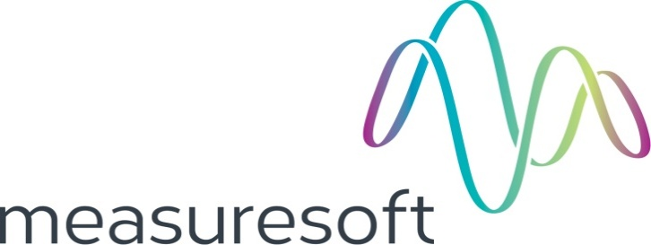
Partnership Courtyard, The Ramparts,
Dundalk, Ireland

Version 6.5.0.0
January 27, 2017
www.measuresoft.com
+353 42 933 2399

This document is the copyright of Measuresoft and may not be modified, copied or distributed in any form whatsoever without the prior permission of Measuresoft.

Gas Chromatograph User Manual

Table of Contents

1. Installing Chromatograph 3
2. Introduction 3
3. Gases 4
3.1. Configure Gas 5
4. Channels 6
4.1. Channel Configuration 7
Enable Channel 8
Tag 8
Description 8
Engineering Units 8
5. Settings 9
5.1. Auto Enable Gas Chromatograph Processor 9
5.2. Logger 9
5.3. Complete sample 13
5.4. Source Input Channel 13
5.5. Trigger Channel 14
5.6. Reference/Lagged Depth Channel 14
5.7. Filter Sample Input 14
Filter Width (Samples) 14
Filtered Output Channel 14
5.8. Peak Text 14
5.9. Trend 15
5.10. Print Trends to Default Printer on Completion 15
6. Trend 16
7. Calibration 17
7.1. Real-time calibration 17
7.2. Post Real-time calibration 19

Installing Chromatograph
Chromatograph can be installed as part of a client or server installation.

To install Chromatograph we recommend that you first close down all applications. Run the Chromatograph setup executable file.

This will launch the Chromatograph setup application

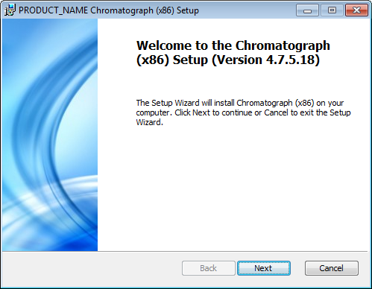

Click on the Next button to continue.

The setup program will search for the product directory on the system and will display an error message if it’s not found. If the product directory is found the setup program will display the path that Chromatograph is to be installed to:

<drive>:\\<Product Directory>

Follow the onscreen instructions to complete the installation.

Introduction

To select the processor from the ScadaPro main menu go to the processor tab and then select GAS CHROMATOGRAPH.

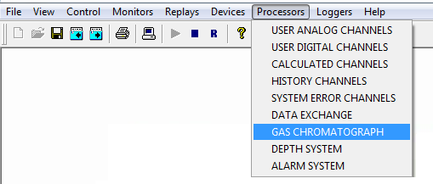

The configuration is divided into 4 sections, Gases, Channels, Settings, and Trends.

Gases

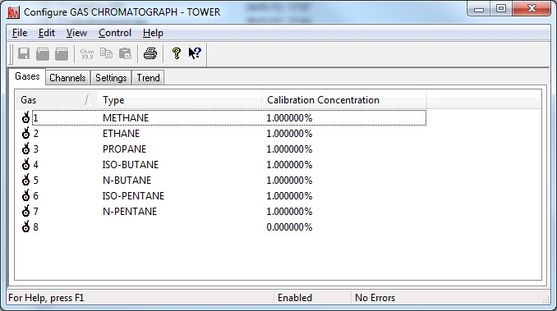

Configure Gas

The following can be configured for each gas type.

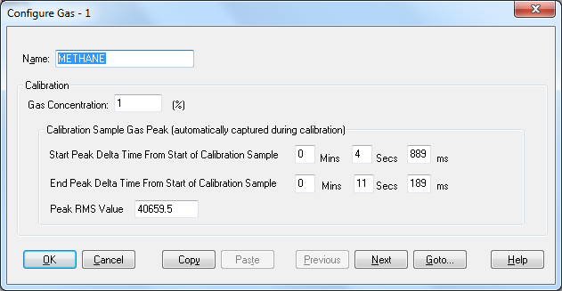

The calibration values are displayed with the values from the last calibration. The user also has the option of entering the concentration, start and end peak delta time and RMS without performing a calibration for each gas type. 1% Gas Concentration is equal to 10,000ppm

Channels

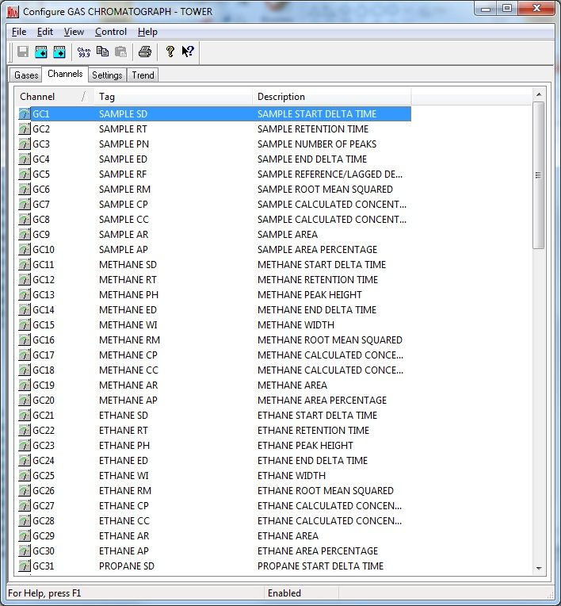

The gas channels are structured as follows:

Channels 1-10 refer to the Sample
Channels 11-30 refer to Gas Type #1
Channels 21-40 refer to Gas Type #2
Channels 31-50 refer to Gas Type #3
Channels 41-60 refer to Gas Type #4
Channels 51-70 refer to Gas Type #5
Channels 61-80 refer to Gas Type #6
Channels 71-90 refer to Gas Type #7
Channels 81-90 refer to Gas Type #8

Within each group of 10 channels the following channels are used

- SD,Start Delta Time,secs
- RT,Retention Time,secs
- PH,Peak Height,(units from signal channel) or Number for Peaks of the sample
- ED,End Delta Time,secs
- WI,Width,secs or Sample reference/lagged depth
- RM,Root Mean Squared (units from signal channel)
- CP,Calculated Concentration,%
- CC,Calculated Concentration,ppm
- AR,Area,ppm
- AP,Area%,%

Channel Configuration

The operator has the option to change the tags as with any other Scada channel e.g.

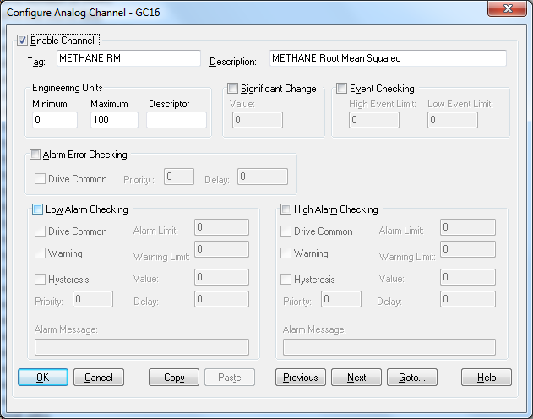

Enable Channel
The Enable Channel check box must be checked to enable and allow a channel to be configured and ultimately included with all other configured channels in the overall system.

Tag
The Tag field is a 12 character alphanumeric field that can contain channel information or wiring schedule references.

Description
The Description field is a 32 character alphanumeric field in which a description of the channel can be detailed.

Engineering Units
Specifies engineering details for this channel.

Settings

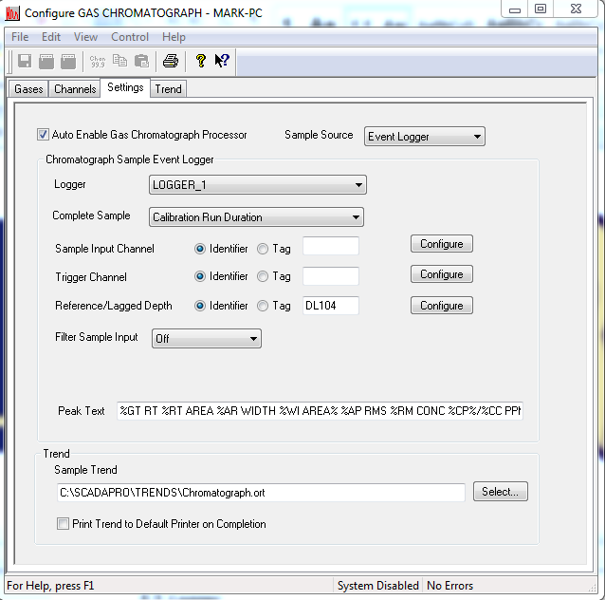

Sample Source

Sample source can either be Event Logger or Results File. The following section details hot to setup an Event Logger Sample Source. Section 8 details what needs to be done to setup a results File Sample Source, as the Peaksimple software that generates the Results files needs to be configured.

Auto Enable Gas Chromatograph Processor
Defines whether the process is launched when the system is enabled.

Logger

Select the logger which is used to log the Gas Chromatograph analog channel and associated text for the purposes of analysing the sample. The logger is cycled on event at the start and end of each sample so that there is a unique log file for each sample. As each gas concentration is calculated the Gas Chromatograph processor logs text to the log file indicating the gas concentration value calculated from each peak and the tag and description of each corresponding gas concentration channel.

The logger must be configured to be an event logger, logging the source channel every 100 milliseconds, with cycle on event and text logging enabled. Logger configuration is shown below.

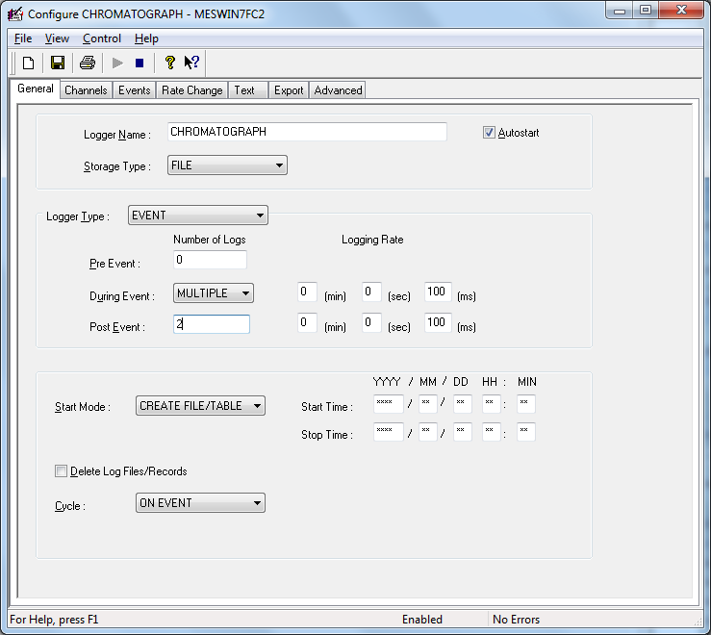

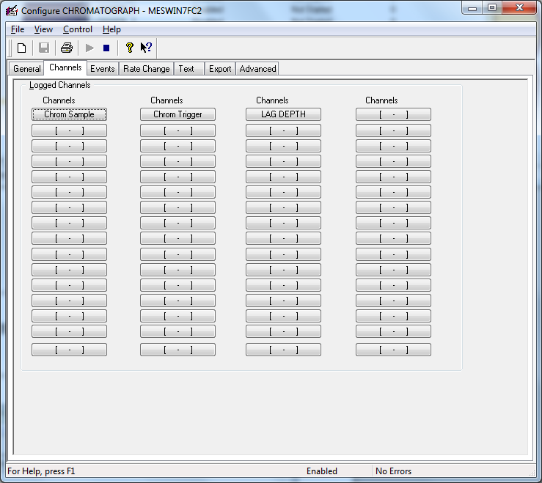

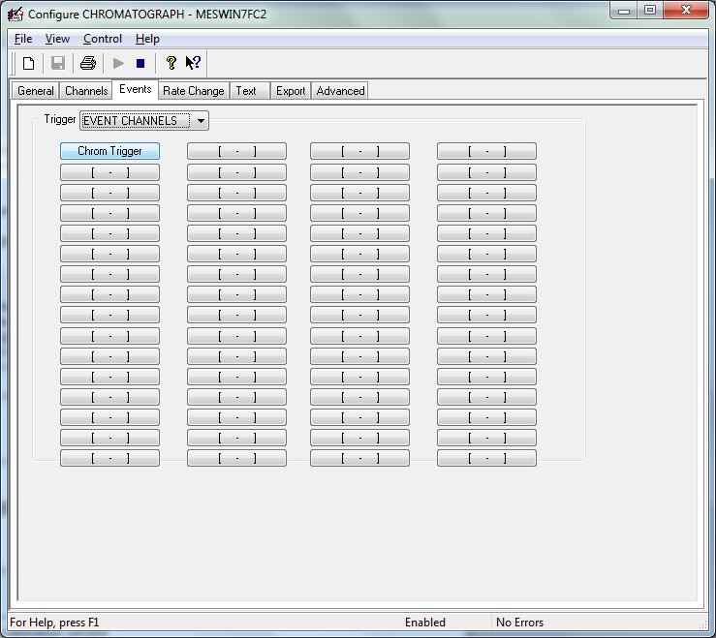

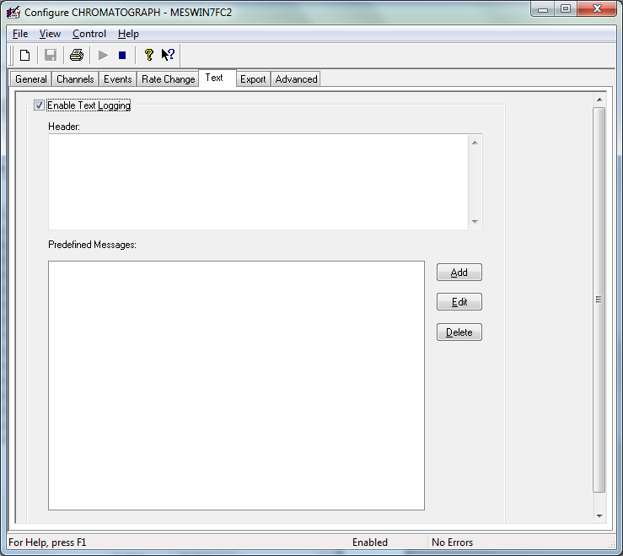

Complete sample

This is used to determine when a sample is complete. The option can be set to:

Trigger Channel goes out of event
Trigger channel goes out of event sets the logger to log only while trigger channels are in event.

Calibration Run Duration
Calibration Run Duration sets the logger to log for the maximum sample period when the trigger channels goes out of event.

Source Input Channel
This is the high speed analog input channel (10Hz) which is connected to the output of the Chromatograph and logged by the Chromatograph logger. Once this channel is chosen the Chromatograph logger sets this as the first channel that is logged.

The chromatograph outputs a signal peak for each gas type for a sample run. Light gases travel fastest through the chromatograph and thus a series of peaks is output for each gas type and the relative time window of each peak determines the gas type. The gas concentrations are calculated as follows

RMS of peak area in current sample
-------------------------------------------------- X Calibration Concentration in %
RMS of peak area in calibration sample

At then end of a sample all gas concentration channels are available for logging as lagged channels.

Trigger Channel

Once this channel is chosen the Chromatograph logger sets this as the Event channel. This is the channel that triggers the event to start event logging.

Reference/Lagged Depth Channel

This refers to a channel used to reference the gas sample. This is typically a lagged depth in a drilling application but it could be sample number for example. The reference channel is written to Gas Chromatograph Channel 5 and appended to the Start Sample text log on the trend.

Filter Sample Input

OFF
No filter sample algorithm selected.

Moving Average

This sets the Moving Average algorithm. In a Moving Average algorithm, each data sample is set to the average of the samples around it, including itself.

Olympic

This selects the Olympic smoothing algorithm. This algorithm is identical to the Moving Average algorithm except that the highest and lowest values in the set of samples are discarded before the average is taken.

Filter Width (Samples)

The filter width controls the number of samples on each side of the data point that are averaged to calculate the new value for each data point. For example, if filter width is set to 2, then two data points prior and two data points after are averaged with the data point being calculated for a total of 5 data points averaged for each data sample in the Chromatograph.

Filtered Output Channel
Select and configure the channel to hold the filtered data.

Peak Text
This is the logged text added to the Peak of each sample at Position 100%. Defaults to:

“%GT RT %RT AREA %AR WIDTH %WI AREA %AP RMS %RM CONC %CP%/%CC PPM.

The 2 letter mnemonics preceded by % refer to the values of the tags associated with each gas.

Trend
This is the trend used to display the source channel and corresponding gas concentrations.

Print Trends to Default Printer on Completion
This is used to print the trend to the default printer at end of each sample.

Trend

The trend section is used to display the trends.

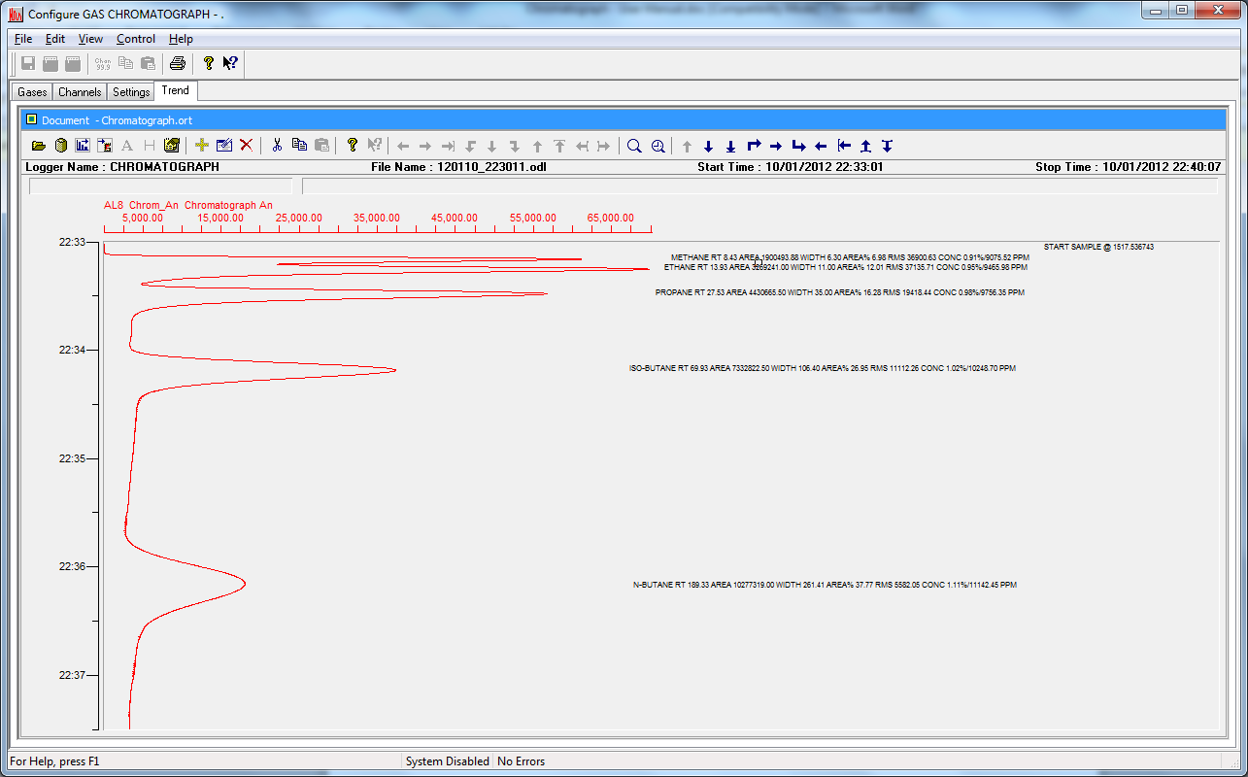

The trends tab allows you to open a trend (utility that allows logged data to be displayed in graphical form).

- Describe the “what” of system functions, not the “how”
- Ensure software requirements are complete (traceability)
- Define the support service

Calibration

In calibration mode a sample of the known concentration of each gas is run through the chromatograph. The software stores the RMS and the start and stop time of each peak.

Calibration is started by selecting Control/Start Calibration. When the calibration is started, the status at the bottom of the screen changes to “Calibrating”. The calibration process starts at the next occurrence of the signal channel going high. When the calibration process is complete the status at the bottom of the screen reverts back to “Enabled”.

Calibration is stopped by selecting Control/End Calibration. When the calibration is stopped, the status at the bottom of the screen changed to “Enabled”.

Real-time calibration

The following connections are assumed.

The INT START output from the Chromatograph needs to be wired into an Alpha Digital Status AL6 with the module set to FAST scanning at 20ms. The INTEG signal needs to be wired into an AL8 Analog Input voltage signal on the same module.

To calibrate in real-time on a Raygas detector perform the following steps.

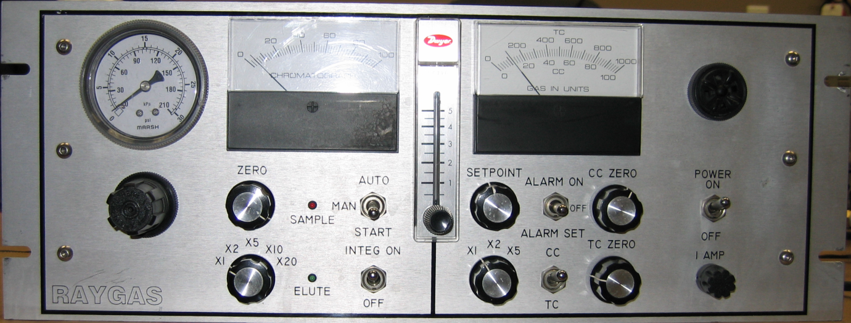

- Make sure the system is Enabled and the Chromatograph logger is enabled
- Make sure integration is ON on the detector
- Make sure the AUTO/MAN switch is set MANual on the detector
- Make sure Elute light is flashing (in idle mode) on the detector
- Select Control/Start Calibration from the calibration menu

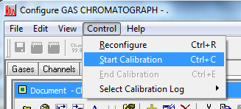

- The status at the bottom of the screen displays Calibrating
- Make sure the calibration gas is flowing
- Depress the AUTO/MAN switch to START
- The RED SAMPLE light will illuminate for a period
- The GREEN ELUTE light will display continuously for the duration of the chromatoram
- The calibration gas flow can then be stopped if required
- When the GREEN ELUTE light switches off or returns to flashing idle, select Control/Stop Calibration from the calibration menu.
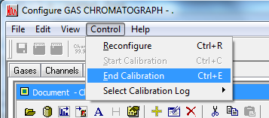

- The number of peak detected is displayed and the status at the bottom of the screen reverts to Enabled.

Post Real-time calibration

To calibrate using logged data select Control/Select Calibration Log
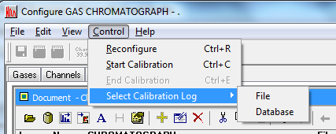

Select the logged data and the number of peaks detected is displayed.

Sample Capture from External Results File

The results file format for each peak needs to include the following columns:

- Component
- Retention
- Area
- Height
- External
- Units

Form the PeakSimple Menu select View/Results/Format
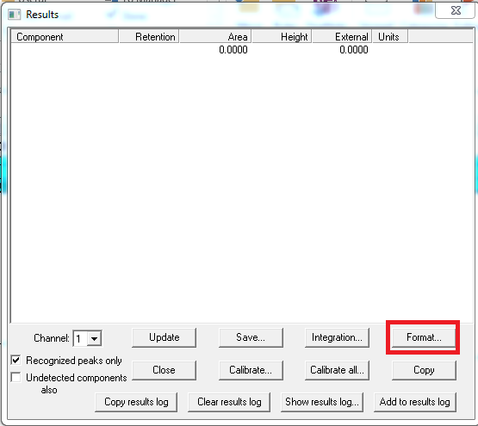

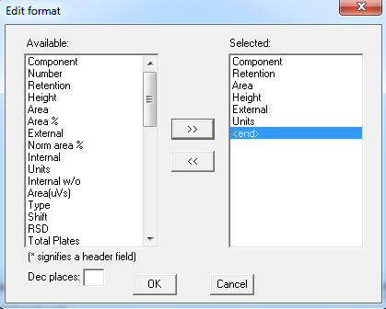

The components MUST be named the same as the gas definition in the Gas Chromatograph.

From the PeakSimple menu select Edit/Channels/Channel1/Components and check “Add to results Log”

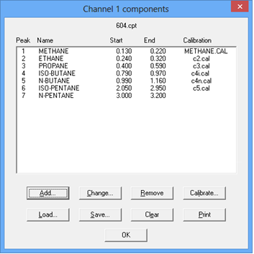

Ensure a .LOG file is created.

From the PeakSimple menu select Edit/Channels/Channel 1/Post-Run and check Add to results log
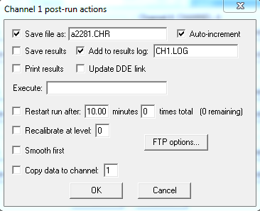
Set the location of the results file in the gas chromatograph screen

