Partnership Courtyard, The Ramparts,
Dundalk, Ireland

Version 6.6.0.0
March 12, 2021
www.measuresoft.com
+353 42 933 2399

This document is the copyright of Measuresoft and may not be modified, copied or distributed in any form whatsoever without the prior permission of Measuresoft.

Drill Pro User Manual

1. Installation and Setup 4
2. Lag-Depth Processor Channels Configuration 8
2.1 Channel configuration Selection Dialog. 9
2.2 Channel configuration dialog. 10
2.3 Enable Channel 10
2.4 Tag 10
2.5 Description 10
2.6 Engineering Units 11
2.7 Significant Change 11
2.8 Event Checking 11
2.8.1 High Limit 11
2.8.2 Low Limit 11
2.9 Alarm Error Checking 11
2.10 Source 11
2.11 Override Channel 11
2.12 Alarm Checking 12
2.12.1 Enable Alarm Checking 12
2.12.2 Drive Common Alarm 12
2.12.3 Alarm Limit 12
2.12.4 Warning and Limit 12
2.12.5 Hysteresis 12
2.12.6 Priority 12
2.12.7 Alarm Delay 13
2.12.8 Alarm Message 13
3. Depth System configuration. 13
3.1 Depth System Dialog. 13
3.2 Encoder placement. 14
3.2.1 Crown 14
3.2.2 Draw-works Dialog. 14
3.2.3 Other Dialog. 15
3.3 Status 15
3.4 Drilling mode 15
3.5 Enable Compensator and Riser. 16
4. Well Geometry 16
4.1 Hole and String Geometry Dialog. 16
4.2 Well Bore hole Data 16
4.3 Drill String Data 16
4.4 String Weight 17
4.5 Block and Kelly Weight 17
4.6 Buoyancy Factor 17
4.7 Reference Weight on Bit 17
4.8 Depth 17
5. Mud and Hydraulics 17
5.1 Configure Hydraulics Dialog. 18
5.2 General Fluid properties 18
5.3 Hydraulic Model 18
5.4 Flow In Sensor 18
5.5 RPM Sensor 18
5.6 Hydraulic Equations used. 19
6. Mud Pumps 19
6.1 Configure Mud Pumps Dialog. 19
6.2 Include Pump 19
6.3 Pump Characteristics 20
7. Pit Volume 20
7.1 Pit Probe Assignments Dialog. 20
7.2 Active Pits 20
7.3 Pit Volume Change 20
8. Tripping Information 21
8.1 Trip Monitor Dialog. 21
8.2 Trip Set-up. 21
8.3 Joint and stand lengths 21
8.4 Calculated and Observed Displacement 22
8.5 Swab and Surge pressures 22
9. Lag Depth 22
9.1 Lag System configuration Dialog. 22
9.2 Lag Depth 22
9.3 % Washout 22
9.4 Log Interval 22
9.5 # Avgs 22
9.6 Lag Differentials 23
9.7 Initialise Lag System 23
9.8 User counters 23
10. Well Direction 23
10.1 TVD and Directional Dialog. 23
10.2 TVD. 24
10.3 TVD Calculations Used 24
11. Constants 24
11.1 Pore pressure & Fracture Gradients Dialog. 24
11.2 Constants 25
11.3 Mud motor slope factor 25
11.4 Calculated Exponents. 25
11.5 Pore Pressure Formulae. 25
11.6 Normal Pore Pressure 26
11.7 D and D_{c} Exponent. 26
11.8 Fracture Gradient Formulae. 27
12. Advanced Device Configuration 27
12.1 Advanced configuration dialog. 27
12.2 AutoEnable Device 28
12.3 Save Outputs 28
12.3.1 By Tag 28
12.4 Wrap Over Box 28
12.5 Use Alpha 9xx 28
12.6 Reload DrillPro Channels 28
13. Channel Listing 28

Installation and Setup

Launch DrillPro Setup.exe.

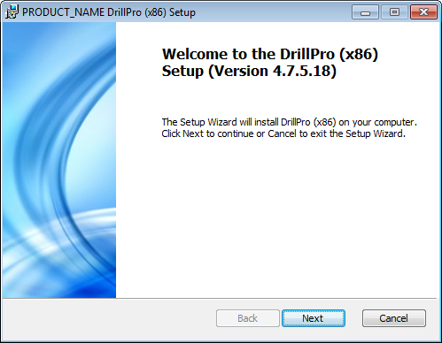

Note: If you are performing this installation under Windows XP or Server 2003 ensure Windows Installer is at version 4.5.

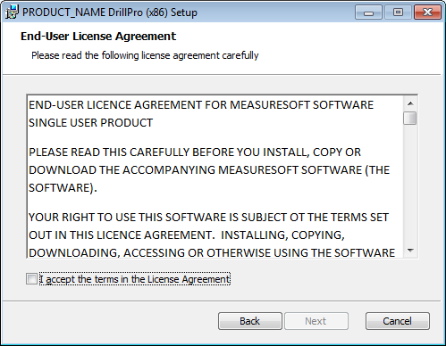

Accept the Product License agreement in order to continue installation.

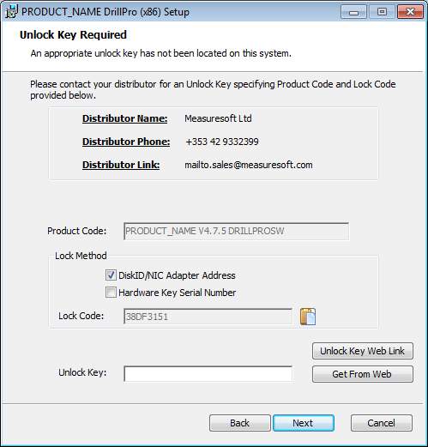

On the Product unlock key window insert the relevant software key or if a hardware key is being used and has been programmed for DrillPro this window will not appear.

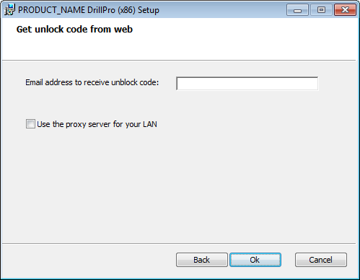

Clicking on “Get from Web” will send you an unlock key when you click OK if the lock code has been registered to the database.

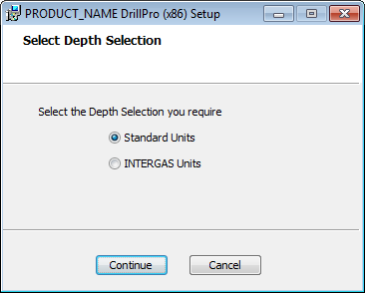

Select required system base units of measure when prompted.
The appropriate software should now be installed on your system.

The intent of the screens and user interface information that follows is to provide the operator with a convenient method to configure the package to different drilling rig and drilling conditions. It also provides a mean to quickly and efficiently maintain and supervise the performance of package and connect peripheral devices. For other rig and off-site personnel needing to view or collect data, refer to the graphical screen, channel monitor and Internet features available in ScadaPro. All channel information provided with DrillPro is available throughout the ScadaPro and it's optional components.

NB. The following I/O points and related DrillPro (DL) channels must be configured for the system to correctly function:-

- Valid depth channels - dependent on configuration.
- Mud weight-in sensor or override (DL13).
- Flow-in sensor (DL11) or mud pump signal(s), (DL24-29).
- Valid hook-load value, select override if necessary (DL7) to advance depth.
- Valid RPM value, select override if necessary (DL77) for ROP to be calculated.

If, while the system is enabled, any channel setup parameter is modified, the changes must be saved and the processor reconfigured.

Lag-Depth Processor Channels Configuration

The first time the system is setup it is necessary to enable and configure all physical I/O devices you require. To configure a particular device select the I/O Devices option from the main menu followed by the appropriate device name.
This will launch an application to configure the device and all the individual sensor channels. Follow the instructions for that device and refer to the device user manual for more information. It will be necessary to configure all physical I/O device channels since they will be linked to DrillPro channels providing source information. Note that the calibration of sensor channels, to the required units, is effected in the I/O device as opposed to the Lag / Depth processor
To configure the DrillPro option, select the Processors option from the main menu and pick Depth System from the drop down menu. From the list provided select a channel and double-click. Alternatively you can select a channel and then click on the Configure Channel button.
This will launch a channel configuration dialog that enables you to configure individual channels.

Channel configuration Selection Dialog.
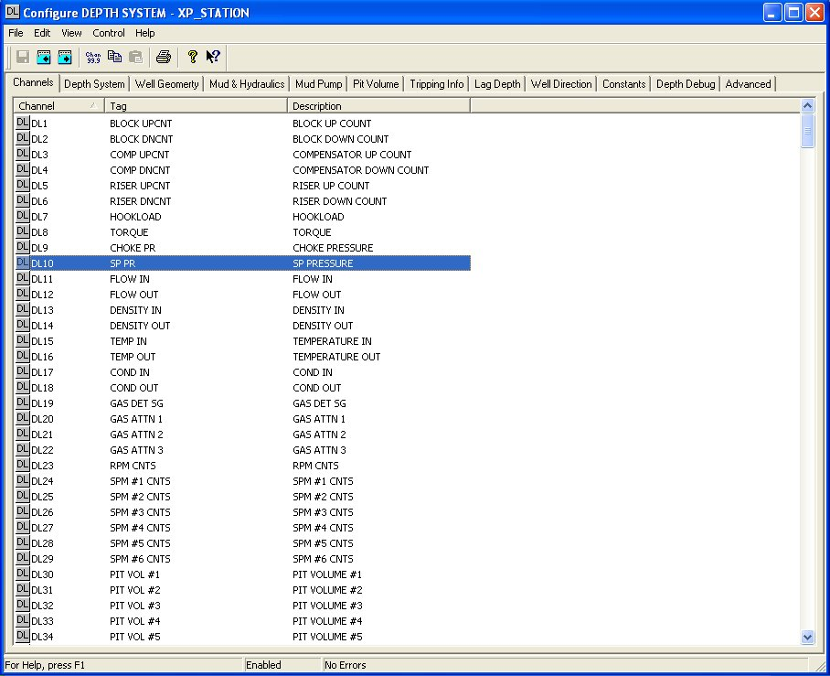

Channel configuration dialog.
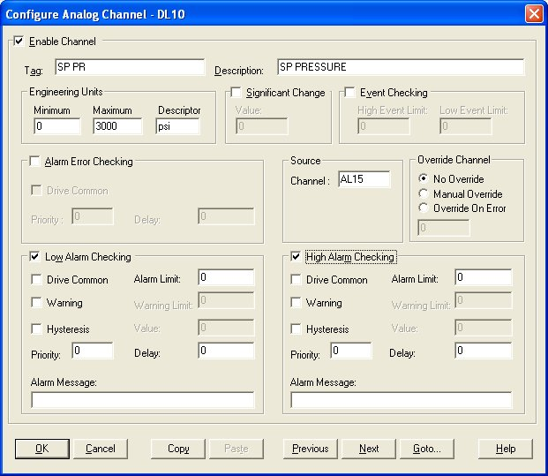

Enable Channel
The Enable Channel check box must be checked to enable, and allow this channel to be configured and ultimately included with all other configured channels in the overall system.

Tag
The Tag field is a 12 character alphanumeric field that can contain channel information or wiring schedule references.

Description
The Description field is a 32 character alphanumeric field in which a description of the channel can be detailed. Note that while the description and data can be changed the fundamental default function of these channels should not be modified as many are linked to internal functions and inter-channel calculations.

Engineering Units
Minimum and maximum values relate to the typical range expected for the variable. Used by other features, such as trends, to give a default range setting only. Units are a four-character field available to describe the units of the channel i.e. Bbls or Units.

Significant Change
The significant change status of a channel can be monitored from one scan to the next.

Event Checking
Event checking is used, if required, to trigger a logger to record information on a number of channels during an event. Check the Event Checking check box if this channel is to trigger an event. Events are detected on inputs using data acquired at 1Khz. Events are detected on outputs using the configured device scan rate.

High Limit
A value, in engineering units, entered in this text box will define the level that, if exceeded, will cause an event trigger.

Low Limit
A value entered in this text box will define the level that if the channel result falls below will cause an event trigger.

Alarm Error Checking
A common alarm is a single digital output that will switch on when any channel with the Drive Common Alarm enabled goes into an alarm state. Check this box if a link to the Common Alarm is required.
Enter a priority (0 = highest and 256= lowest) or edit the number in the text box to allocate the priority of this channel alarm. If a delay is required enter the time, in seconds, between the channel value entering the Alarm State and the alarm being activated.

Source
Enter the I/O device channel supplying source data for this channel description. If using an I/O device that supports a single up/down counter enter that channel in the "up count" channel and disable down count value. See "Advanced" settings for more information

Override Channel
Normal operation is with no override where I/O device data is fed directly to the channel. Manual override will force the channel to assume the value entered in the value box. Override on error will force the channel to assume the value entered in the value box automatically if that I/O point is in error. Note that "error" is defined as a specific state and no inference should be made in terms of what might be considered a reasonable or an unreasonable value.

Alarm Checking
Alarm checking is available on all channels throughout the system. Low Alarm and High Alarm levels can be configured independent of each other. If the channel output exceeds the High Alarm limit then an alarm will be triggered as it will if the output goes below the Low Alarm limit. Alarms and warnings are detected at the configured scan rate.

When monitoring channels, if the high or low alarm is triggered, then the fact will be annotated alongside the other channel information in the Channel Monitor. To configure the Alarm Checking section of the device, complete the options as follows for either or both the High Alarm and Low Alarm checking.

Enable Alarm Checking
Check either the Low Alarm Checking or High Alarm Checking or both check-boxes to enable the facility.

Drive Common Alarm
A common alarm is a single digital output that will switch on when any channel with the Drive Common Alarm enabled goes into an alarm state. Check this box if a link to the Common Alarm is required.

Alarm Limit
Specifies the value that will trigger this alarm. For Low Alarm Checking it will be any value <= the Alarm Limit and for High Alarm Checking it will be any value >= the Alarm Limit.

Warning and Limit
If required, a warning can be displayed when a channel reaches a limit close to the alarm limit. For low alarm checking, the limit must be less than the alarm limit. For high alarm checking, the warning limit must be less than the alarm limit

Hysteresis
Hysteresis can prevent 'noisy' channels from reporting multiple alarms when the average reading is close to the alarm threshold. Check the box if this feature if needed. Enter the value of the dead band in the corresponding value field.

Priority
Enter or edit the number in the text box to allocate the priority of this alarm. Alarm priority ranges are from 0 to 255.

Alarm Delay
Enter the time, in seconds, between the channel value entering the alarm state and the system flagging an alarm.

Alarm Message
An Alarm Message can be defined that will be displayed on the Status line of the Main Window when a channel goes into an alarm state. Enter the message, up to 32 characters, that is to appear in the event of an alarm.

Depth System configuration.

Depth System Dialog.
This screen enables the operator to have an overview of all variables connected to the depth tracking process. As will be described, it also provides mechanisms to modify and control the depth-related functions. Note: the screen displays the software status as to whether it's enabled or not.

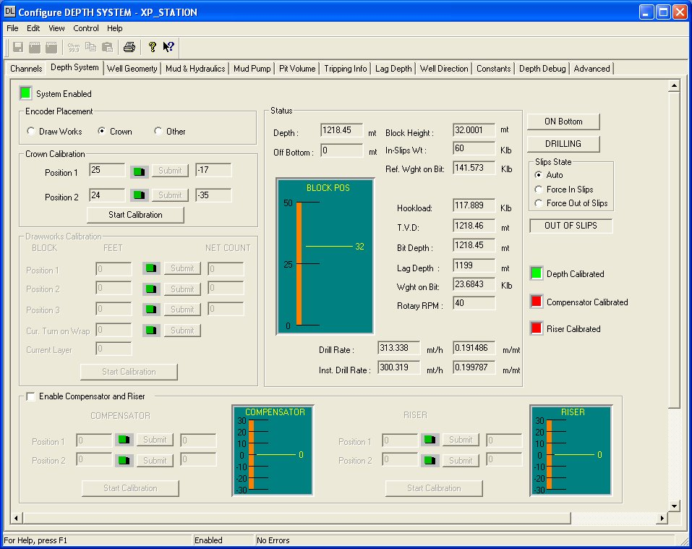

Encoder placement.
Selecting the encoder placement will effect how that section of the screen will appear.

Crown
Pressing Start Calibration will present the user with the option to manually, or automatically, perform the calibration function. If manual is chosen, the user will enter a block position 1 and number of encoder counts, typically 0 and press submit. Next, enter a distance traveled and the number of encoder counts that distance would relate to for position 2 and submit. Note that channels DL1 and 2 must be connected to valid I/O points for this to function.

Draw-works Dialog.
If draw-works is selected the follow screen modification is effected:
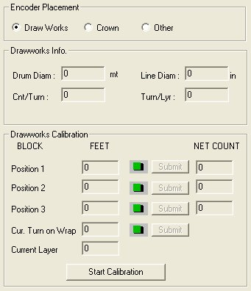

Enter the inner drum diameter, encoder counts per revolution of the drum, drilling line diameter and the number of turns of drill line per layer as spooled on the draw-works drum.
To calibrate, click "Start Calibration". Enter the current block position in position 1 and click submit. Move the block a know distance and enter the new block position in Position 2, the net count value will be displayed for reference only. Repeat this procedure for position 3. Note that the calibration is actually performed with respect to positions 1 and 2; position three is included to provide the user with an alert should the line change wraps that could cause an error in calibration. Finally enter the number of turns for the current wrap on the draw-works spool. The current drill line layer, as spooled on the draw-works is calculated and displayed for reference purposes.
Note that channels DL1 and 2 must be connected to valid I/O points for this to function.

Other Dialog.
Select this option if you have a "Geolograph" or similar such device that provides a digital pulse or on/off signal to indicate a new depth increment.
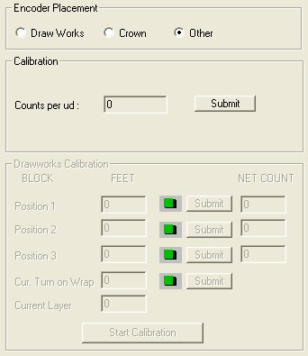

Enter the depth increment or count(s) per unit of distance that the input represents and click "submit". Note that channel DL65 must be connected to a valid I/O point for this to function.

Status
This area of the screen is generally providing operator information. However, the user can modify the current depth and block height.

Drilling mode
The "On Bottom" button is context sensitive. When displaying "On Bottom" clicking will pop-up a dialog asking the user to enter distance "Off Bottom"; when displaying "Off Bottom", clicking will set the system "On Bottom".
Similarly, the button marked "Drilling" can be clicked to set and display the rig status modes of Drilling, Trip In and Trip out.
Slips status is normally automatic since it is sensed by a combination of sensor devices and software, however the operator can manually over-ride these functions by selecting the required condition.

Enable Compensator and Riser.
For floating vessels, heave compensation can be achieved by enabling this function. Sensors must be configured and linked to channels DL3 through 6 and calibrated as outlined in section 3.1.1. above.

Well Geometry

Hole and String Geometry Dialog.
Once all string and hole parameters are correctly entered the system will automatically maintain all real-time updates.
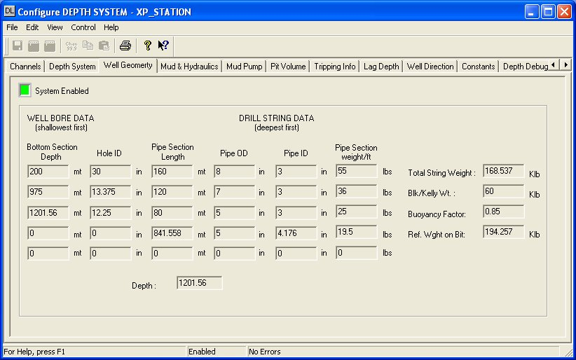

Well Bore hole Data
Enter all bottom section depths and hole diameters to match the current well conditions. Note that the depth entries are bottom section depth so the length of a section is implied by the difference between an entry and the one above. Double click on a field to modify it's contents.

Drill String Data
These sections are entered deepest first and, unlike hole data, should be deepest first with each entry being a length of section. It is organized this way so that the last entries in the depth and pipe columns are the ones that the system dynamically updates as drilling proceeds. Again, double click on a field to modify its contents.

String Weight
This value is computed from the user entered drill string data and the system dynamically updates it as drilling proceeds.

Block and Kelly Weight
This value is a user entered value, double click on a field to modify its contents.

Buoyancy Factor
This value is a user entered value, double click on a field to modify its contents.

Reference Weight on Bit
This value is computed from the previous three entries and is used, in conjunction with bit depth, to determine the on/off bottom status. It is also the reference used to derive the weight on bit value.

Depth
This field is replicated from the Depth System tab and is included here as an operator convenience to effect current depth updates without having to switch screens.

Mud and Hydraulics

Configure Hydraulics Dialog.
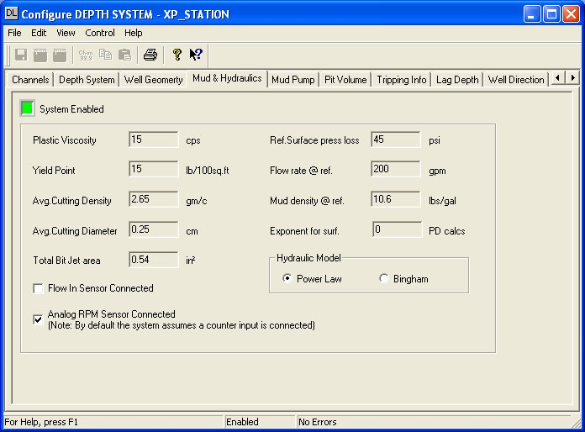

General Fluid properties
Enter all the typical data for basic mud and cuttings properties and update them as conditions or new data is made available. Surface pressure losses related to lines running from the pumps to standpipe and gooseneck etc. and are normally available from the tool-pusher or rig office.

Hydraulic Model
If the power law option is selected then enter the desired exponent for power law calculations. An entry of 0 will instruct the system to internally calculate and use that value (DL115) based on the formulae n=1.4427 Ln((YP+2PV)/(YP+PV)).

Flow In Sensor
If a flow in sensor is installed check this box, otherwise the flow in will be calculated based on the active pump rate.

RPM Sensor
By default, the system assumes a encode type sensor input so will expect a counter value from which it will calculate the rotary RPM as a function of previous counts to current counts. If, however, an analog sensor is used then check this box. Note that if the input type is defined as a frequency then this is equivalent to an analog signal.

Hydraulic Equations used.
Jet Area = 0.00076699 * (J₁²+ J₂²+ J₃²) where J_{N} is each jet diameter in inches.

Bit Pressure Drop (PD_{B}) = (gpm²*Mud Weight ppg)/(10858*jet area² {ins²})

Jet Velocity (J/V) = ^{(0.32083 * gpm)} / (_{jet area ins}²)

Impact Force = Mud density In ppg * flow rate gpm * Jet Velocity ft/sec./_{1932.0}

Bit Hydraulic Horsepower (HHP) = (^{PD}_{B} ^{* gpm}) / _{1714.0}

Mud Pumps

Configure Mud Pumps Dialog.
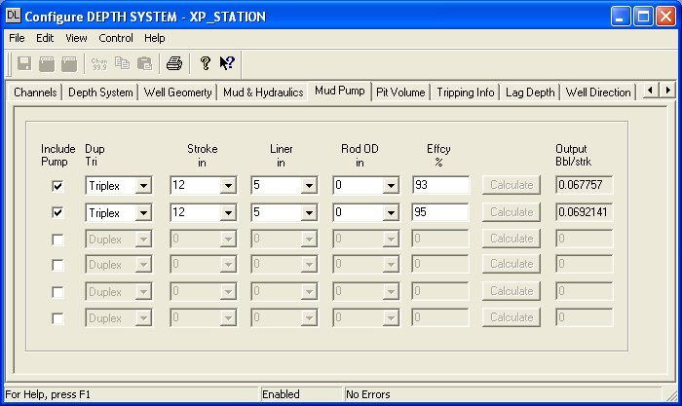

Include Pump
Checking this box means that the pump rate will be included as being active on the hole.

Pump Characteristics
Using the drop-down selection boxes chose the pump type and liner/rod sizes as appropriate. Note that any time a change is made click the calculate button to update the output per stroke value.

Pit Volume

Pit Probe Assignments Dialog.
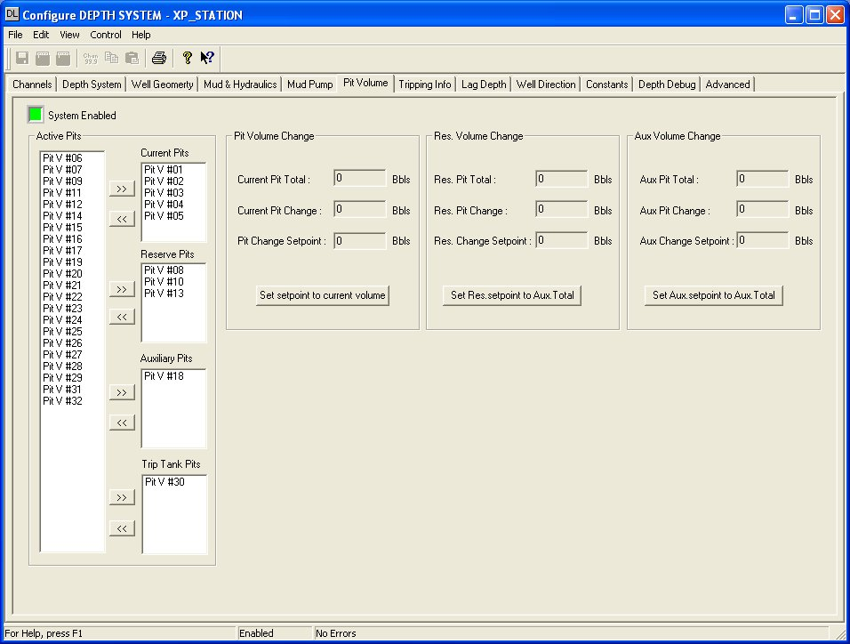

Active Pits
Click on each pit channel that you wish to include in to one of the four available categories i.e. current, active, reserve or trip tank. After each pit has been highlighted, click on the appropriate >> symbol and those channels will be moved to that category. If you need to remove one or more channels and send them back to the unassigned column select them, in the same manner, and click the << button.

Pit Volume Change
Once channel are assigned to the different categories the system will perform summing functions for each group. At any time the user may click the "set-point" buttons which will zero the "Current Pit Change" value or the pit change set-point may be manually entered. Three "totalizers" are provided so that independent tanks systems can be monitored as well as transfers for one tack system to another.

Tripping Information

Trip Monitor Dialog.
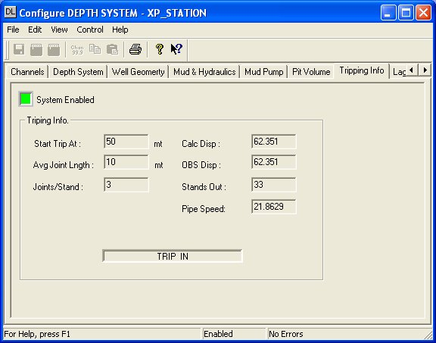

Trip Set-up.
The "start trip at" entry will cause the displayed mode to change from "Drilling" to "Trip Out"by monitoring the difference between current depth and bit position. When this distance is greater than the start trip at entry, it is assumed the current operation in tripping.

Joint and stand lengths
By making the software aware of the average joint length and the number of joints per stand, the stands in or out of the hole can be maintained while tripping.

Calculated and Observed Displacement
Using a combination of the well/pipe geometry and monitoring the trip tank, these values are calculated and displayed automatically when the system is in Trip mode.
Pipe running speed is displayed for user convenience.

Swab and Surge pressures
Whenever pipe is moving these values are calculated using equations as follows:

Lag Depth

Lag System configuration Dialog.
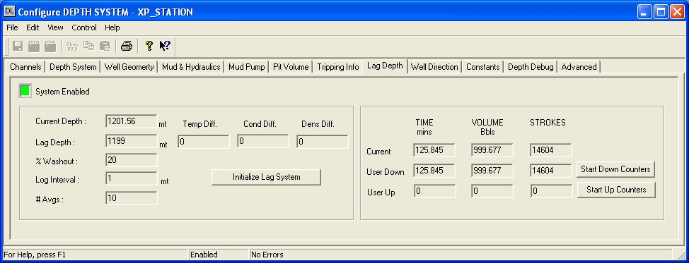

Lag Depth
This is the current sample depth that has arrived at the surface. An annular volume table is maintained and updated every time a new log section interval is completed. When that volume has been pumped, cuttings representative of that interval are computed to have arrived at the surface.

% Washout
Enter the percentage of open-hole washout as may be indicated by lag testing using tracer material or carbide. Logically, it is assumed by the calculations that washout can only occur in the open-hole section.

Log Interval
Enter the "Logging Interval" or depth based interval over which samples and data should be collected.

# Avgs
This entry defines the depth-based number of log intervals over which averages will be calculated. Reference DL channels 86 through 100.

Lag Differentials
The system maintains parameters that have relevance to their properties when entering the drill string verses exiting the annulus. Note that a full cycle of down pipe and bottoms-up must be completed before these differentials can be correctly computed.

Initialise Lag System
Clicking this button will clear the volume pumped table and begin accruing lag data from the current bottom-hole depth. Any lag references contained within the lag processor will be lost.

User counters
At all times, the current annular volume, in terms of Bbls and equivalent pump strokes, is maintained along with the bottoms-up time in minute based on the current pump rate. The start down and up counters, when clicked, provide a useful reference when pumping slugs or viewing bottoms-up status from a random user start point. The down counter will show negative values after bottoms-up has been passed. Click to start and click to reset either button to return the values to their idle state.

Well Direction

TVD and Directional Dialog.
Provides a means of calculating well measured depth corrected for deviation from vertical using survey data.
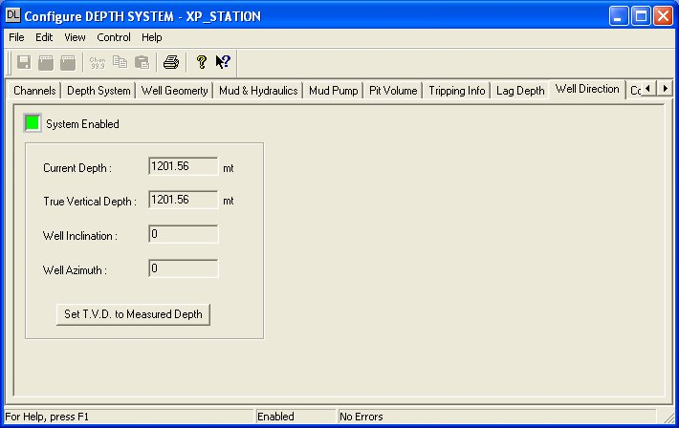

TVD.
Current depth and calculated TVD are displayed and can both be edited from this location. The TVD calculation is based on the last survey data and TVD information provided and assumes that azimuth and inclination remain constant. When new survey is made available correct the current TVD as may be required and enter the new direction parameters, calculations will continue using the latest data. To set the TVD equal to the measured depth, simply click the button as annotated.

TVD Calculations Used

Constants

Pore pressure & Fracture Gradients Dialog.
This facility is provided to give information as to formation characteristics, as indicated by typical drilling models, in respect to pressure and fracture strength. To use this data, the user must be familiar with the limitations and practical application of these models.

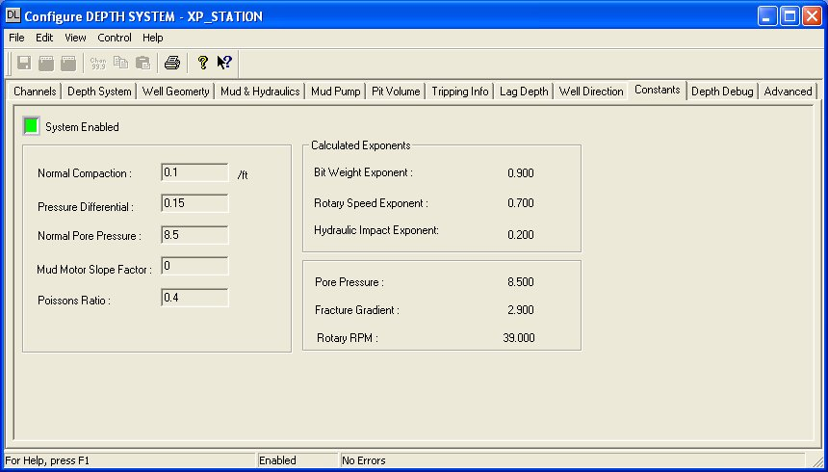

Constants
Enter the normal constants as used for your geographical area for normal compaction, pressure differential, normal pore pressure and poissions ratio.

Mud motor slope factor
This entry is used to compensate rotary RPM when a mud motor is in use. Mud motor RPM is proportional to flow rate so the value entered here is multiplied by pump output and the result is added to string RPM to give total bit RPM. Enter zero when a mud moter isn’t in use.

Calculated Exponents.
Unless overrides are used in channels DL 461-464, these values will show the results of pressure model intermediate calculations. The final pressure and gradient calculations represent model predictions at total current well depth.

Pore Pressure Formulae.
Calculated Pore Pressure (DL455) = Normal PP + ( ^{(Kp1-A1)}/ A₃D).
Where: Normal PP = Normal Pore Pressure as user entered in channel DL412.

K_{p}1 = K_{p} + A₂ + A₃D

Where K_{p} = Log₁₀ K_{f}

And K_{f} = ^{ROP}/((^{WOB}/_{4*Bit diameter})^{Bit Weight exp} )*(^{RPM}/₁₀₀)^{Rotary exp.})*( ^{jet impact force}/₁₀₀₀)^{Hydraulic exp.}))

Bit Weight (WOB) Exponent equals 0.9 for Gulf Coast sediments or is calculated as follows: Log₁₀ ^{(ROP2/ROP1)}/Log₁₀ _{(WOB2/WOB1)}. See channel DL461.

Rotary speed (RPM) Exponent equals 0.7 for Gulf Coast sediments or is calculated as follows: Log₁₀ ^{(ROP2/ROP1)}/Log₁₀ _{(RPM2/RPM1)}. See channel DL462.

Hydraulic Impact (IF) Exponent equals 0.2 for Gulf Coast sediments or is calculated as follows: Log₁₀ ^{(ROP2/ROP1)}/Log₁₀ _{(IF2/IF1)}. See channel DL463.

A₂ = ^{(Depth-10,000)}/₍₁₀₀₀₎. Normal Compaction exponent per 1000 Feet (channel DL459). For Gulf Coast sediments the normal compaction is approximately 1 psi/foot and an exponent of 0.1 is used. See channel DL460.

A₁ = (Kp1- A₃D)

A₃D equals 0.15 for Gulf Coast sediments or is calculated as follows: ECD at Total Depth (DL122)-Mud Weight out (DL14) i.e. the difference between static mud weight and equivalent circulating density.

Normal Pore Pressure
In part, normal pore pressure is a function of pore fluid salinity. The following table gives a guide to typical normal pore fluid pressure gradients in both psi/ft and equivalent mud weights for varies geographical areas.

Region | Gradient (psi/ft.) | Density (PPG)
North Sea | 0.452 | 8.71
Gulf of Mexico | 0.465 | 8.96
West Texas | 0.433 | 8.34
Malaysia | 0.422 | 8.52
Mackenzie Delta | 0.442 | 8.52
West Africa | 0.442 | 8.52
Anadarko Basin | 0.433 | 9.79
Rocky Mountains | 0.436 | 8.40

D and D_{c} Exponent.
D and D_{c} Exponent calculation results are returned in channels DL 410 and 411 respectively. The following equations are used:
Log₁₀ (^{ROP}/_{60*PM})
D = ---------------------------
Log₁₀ (^{12*WOB}/₁₀⁶_{*bit dia})

Log₁₀ (^{ROP}/_{60*PM})
D_{c} = --------------------------- * (^{Static mud weight}/_{ECD})
Log₁₀ (^{12*WOB}/₁₀⁶_{*bit dia})

Fracture Gradient Formulae.
FG = (S-PP)*(^{poissons ratio}/_{1- poissons ratio}) + PP (channel DL455). The result is placed in channel DL456.

Where S = Overburden gradient and PP = Current Pore Pressure. For Gulf Coast sediments "S" is typically 1 psi/ft and normal "PP" is 0.467 psi/ft. Typical Poissons ratio for Gulf Coast shale sediments is 0.4 - see chart below for other suggested value selections. See channel DL464.

Sediment | Ratio | Sediment | Ratio | Sediment | Ratio
Clay Very wet | 0.5 | Limestone stylotitic | 0.27 | Sandstone fossiliferous | 0.01
Clay | 0.17 | Limestone fossiliferous | 0.17 | Shale calcareous | 0.14
Conglomerate | 0.2 | Limestone bedded fossils | 0.17 | Shale dolomitic | 0.28
Dolomite | 0.21 | Limestone shaly | 0.17 | Shale siliceous | 0.12
Greywacke coarse | 0.07 | Sandstone course | 0.05 | Shale silty | 0.17
Greywacke fine | 0.23 | Sandstone course cement | 0.1 | Shale sandy | 0.12
Greywacke medium | 0.24 | Sandstone fine | 0.03 | Siltstone | 0.08
Limestone fine | 0.28 | Sandstone very fine | 0.04 | Slate | 0.13
Limestone medium | 0.31 | Sandstone medium | 0.06 | Tuff | 0.34
Limestone porous | 0.2 | Sandstone poorly sorted | 0.24

Advanced Device Configuration

Advanced configuration dialog.
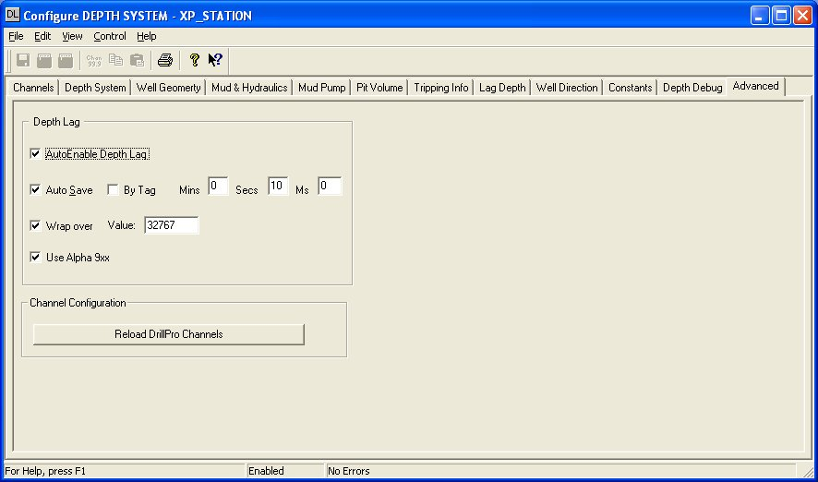

AutoEnable Device
To ensure that the device is enabled whenever the system in enabled check the AutoEnable Device box.

Save Outputs
To enable this utility check the Save Outputs flag. All values in output channels are saved to disk when the system is disabled. The next time the system is restarted the values which were previously in output channels will be restored to the appropriate channel number(s).

By Tag
Channel values can be saved and restored to channels using the channel tag instead of the channel number. In this way, channels can be rearranged within the modules and as long as the channel tags remain the same, the correct channel values will be restored to the appropriate channel number.

Wrap Over Box
If the wrap over box is checked enter the value at which counter channels wrap over.

Use Alpha 9xx
Check this box if your I/O device supports quadrature encoder signal conditioning that resolves the Up and down counts in to a single up/down counter. If not checked, the software will monitor the up and down count values from the two specified channels to determine distance and direction.

Reload DrillPro Channels
Only used when updating to a new version. Click this bar if installation instructions advise that a new channel layout requires a reload of channel definitions.

Channel Listing

