Partnership Courtyard, The Ramparts,
Dundalk, Ireland

Version 1.4.9.0
January 27, 2017
www.measuresoft.com
+353 42 933 2399

This document is the copyright of Measuresoft and may not be modified, copied or distributed in any form whatsoever without the prior permission of Measuresoft.

Site to Office Rig Operators Guide

Contents
1. Introduction 3
2. Configuring STO loggers to use Web Service or VPN 5
3. Test Connection 6
3.1. Test Web Service Connection 6
3.2. Start and Test VPN Connection 8
4. Start Job 14
5. Stop Job 17
6. Copy Incomplete Job 20
7. Publish Buffer Size 21
8. Backfill 22
9. Channel Filter 23
10. Logger Status 23
11. HIST Number 24
12. Generated Key Channels 24

Introduction

SiteToOffice is a solution for delivering real-time data from the rig site to customers.

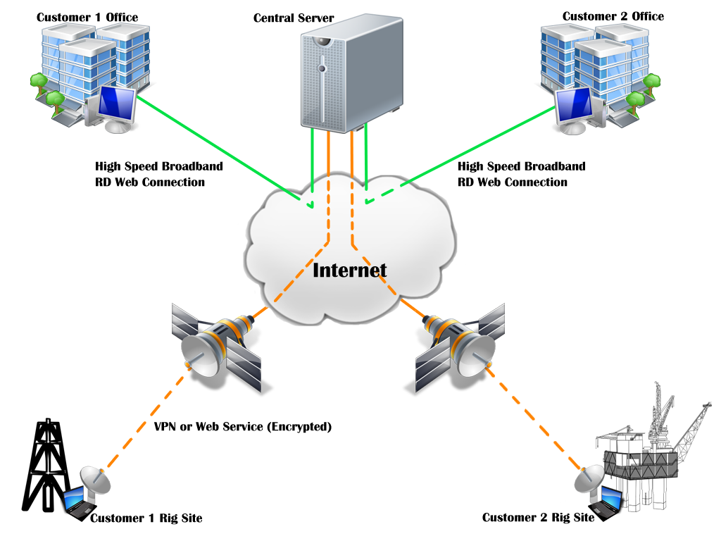

Data is securely collected and buffered at the rig site by a company, and then forwarded to a ScadaPro central server over low bandwidth communication links. The data on the central server is then made available to multiple customers over higher performance links.

To make Rig data available via SiteToOffice, the Rig system must have access to the ScadaPro VPN via a wireless or wired connection on the rig.

Successful transmission of data from a Site to an Office is achieved by using standard loggers to log data on the Rig system and using replication publication loggers to copy the locally logged data to the SiteToOffice Server.

This means that the locally logged data is retained for trending and reports and SiteToOffice data is made available if and when the VPN connection to the SiteToOffice server is available.
Communication recovery is performed without operator intervention and current real-time data is immediately made available to the customer upon the recovery of communications.

Feedback of the current state of SiteToOffice communications is provided. Enabling and disabling SiteToOffice logger controls when SiteToOffice communications is on and off allows control of when real-time data is made available to the customer.
In addition to data, operator ‘sequence of event’ messages are also made available to the customer.

Configuring STO loggers to use Web Service or VPN

- Data can be delivered using a Web Service or VPN connection. It is recommended to use a Web Service connection. (This includes when using an internal ScadaPro network).

- VPN should only be used if data is to be transmitted to an alternate location or if the Web Service is unavailable from the rig location.

- To change the logs between VPN and Web Service methods, follow these steps.

- From the Start Job screen, select the SiteToOffice publication logger configuration.
- From the pop-up window, choose the “General” tab.
- In the “Connection Type” drop down menu, select the method which is required to transmit the data (either Web Service or LAN/VPN.

Web Service

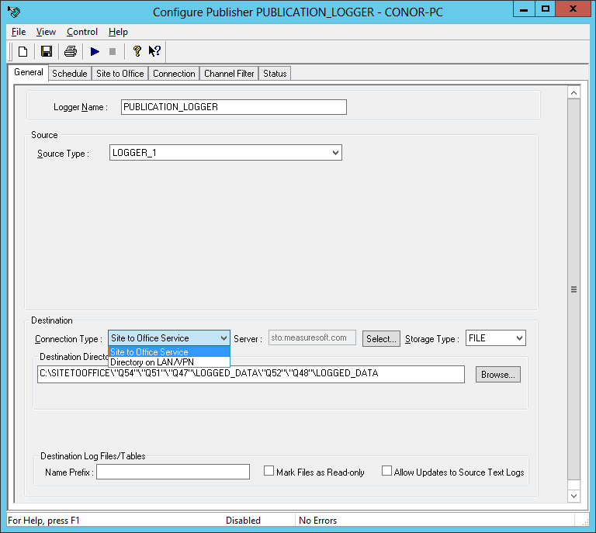

LAN/ VPN
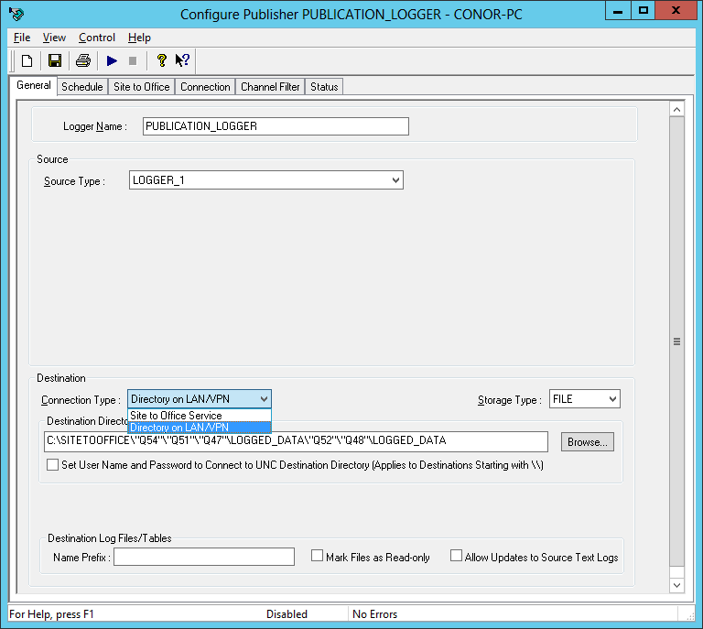

Test Connection
Before starting a job, the connection between the Rig and the SiteToOffice Server must be tested. Depending on the configuration of the STO Logger’s connection type, either the Web Service or the VPN connection needs to be tested.

Test Web Service Connection

- To test the web service connection, select the Internet Explorer button on the right hand side of the Start Job Screen.

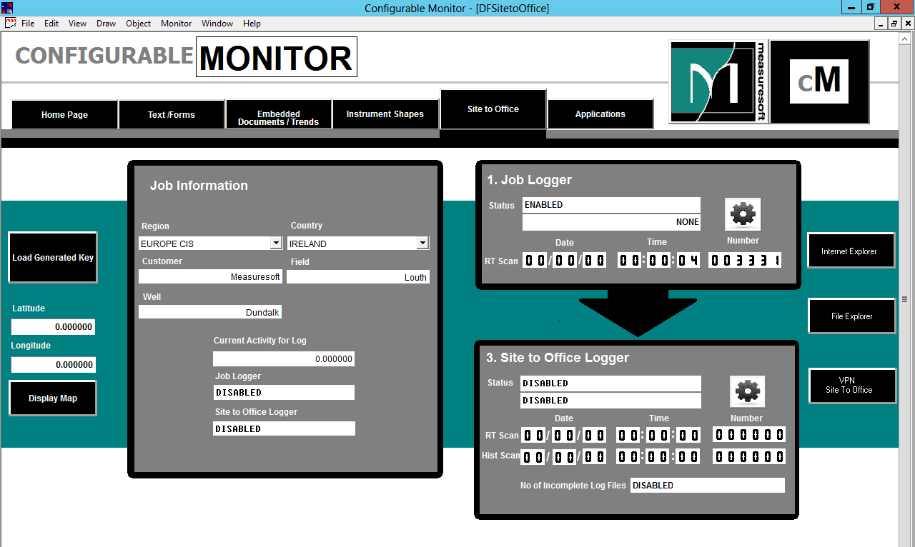

- This will prompt to enter a user name and password.
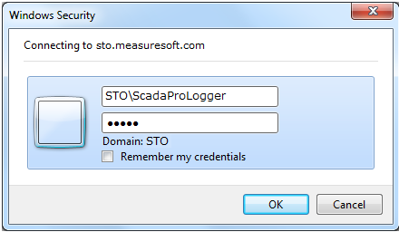

- Enter Username: STO\STOLogger
Enter Password: S1t0f

- If the connection is successful you should see the following screen:
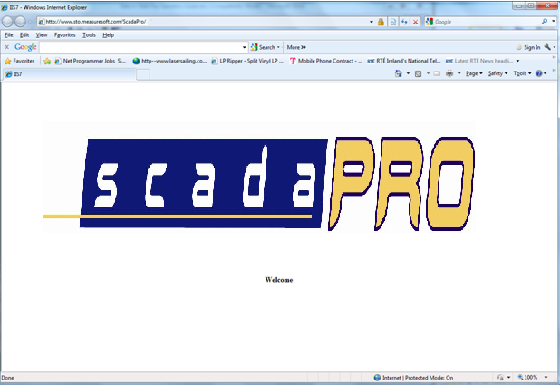

- Enter the address https://datatodesk.ScadaProgroup.com/Rig/BIN/mod_gsoap.dll?service and you should see
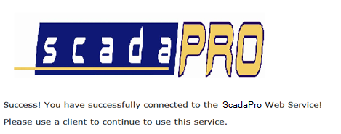

Start and Test VPN Connection

- Starting a VPN is not required if using SiteToOffice Web Service connection. Skip this step if you are using a SiteToOffice Web Service connection.
(Note: If you are using an internal ScadaPro network, it is recommended to use a Web Service connection).

- Before starting a job make sure that the VPN to the SiteToOffice server is running by selecting the VPN SiteToOffice button on bottom RHS of the screen.

- The Cisco Any Connect VPN client is launched.

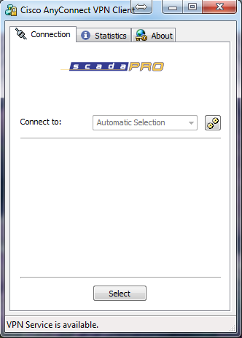

- Press Select and enter the password D4tatoD3sk.

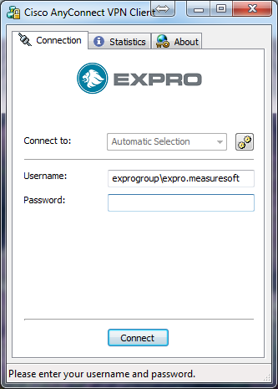

- Click Accept to comply with ScadaPro VPN Use Policy.

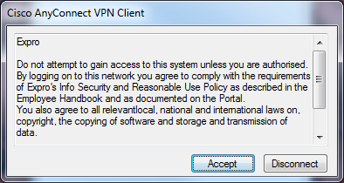

- Click Yes to proceed
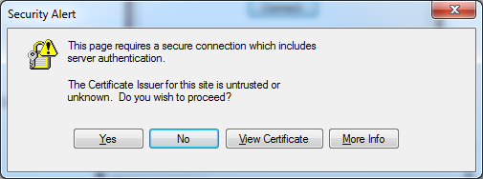

- The VPN will iconise but can be run from the task bar and will display the following if the connection is successful.

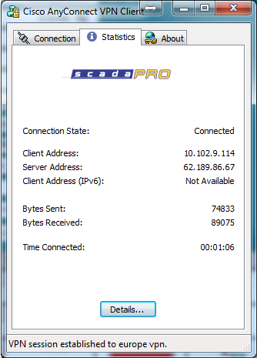

- A test can now be performed by selecting the File Explorer button from the Start Job screen.

- Enter the directory \\10.44.0.66\SITETOOFFICE to display the client directories on the SiteToOffice server. The following logon is displayed. Enter user name: STOLogger and password S1t0f.

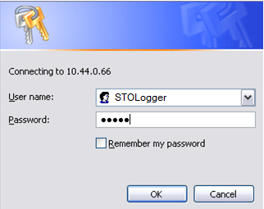
- Upon logon the following a directory similar to the one below is displayed

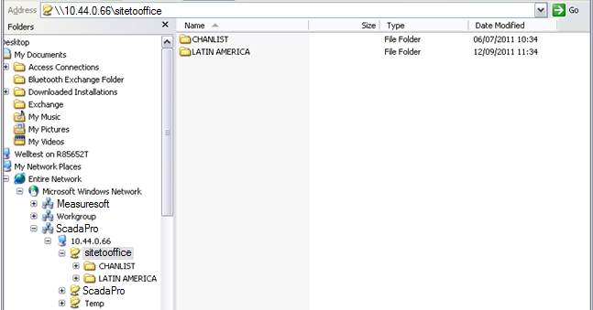

- The SiteToOffice directory hierarchy is structured as Region\Country\Client\Field/Well, for example:

- \\10.44.0.66\SITETOOFFICE\LATIN AMERICIA\BRAZIL\PETROBAS\TEST_FIELD
  - Region = Latin America
  - Country = Brazil
  - Client = Petrobas
  - Field = Test_Field

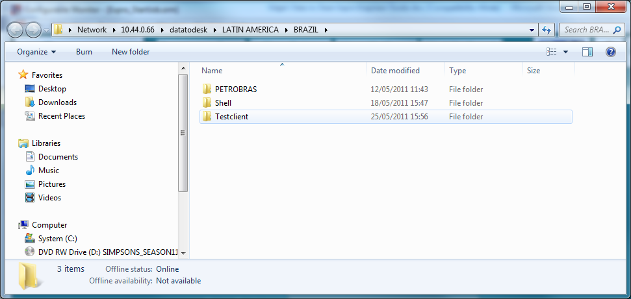

Start Job

- The Site To Office screen contains all the relative job information.

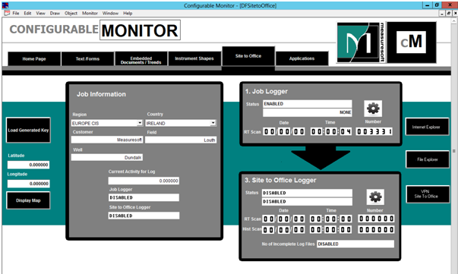
(Note: Before Starting a job make sure to check for any past jobs that need uploaded, simply click the icon on the logging screen and check status and upload any file if necessary.
To upload select log file and click Start)
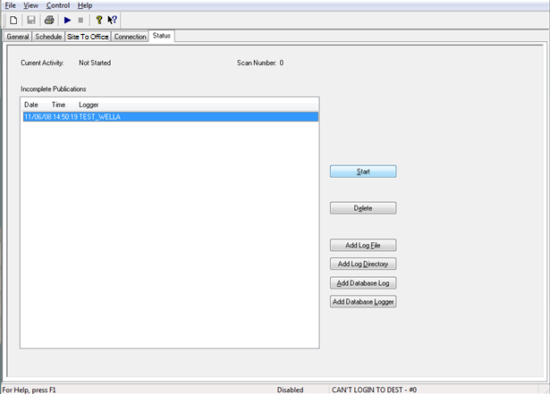

- Once the incomplete logs have been manually loaded:
  - Select the Start screen again.
  - Load a key into the system by clicking on load gen key.
  - Select the key from the location where you stored the key.

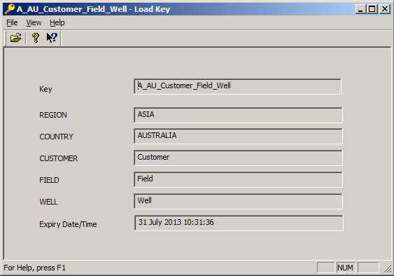

- Once the key is loaded into the system select Logging Screen.

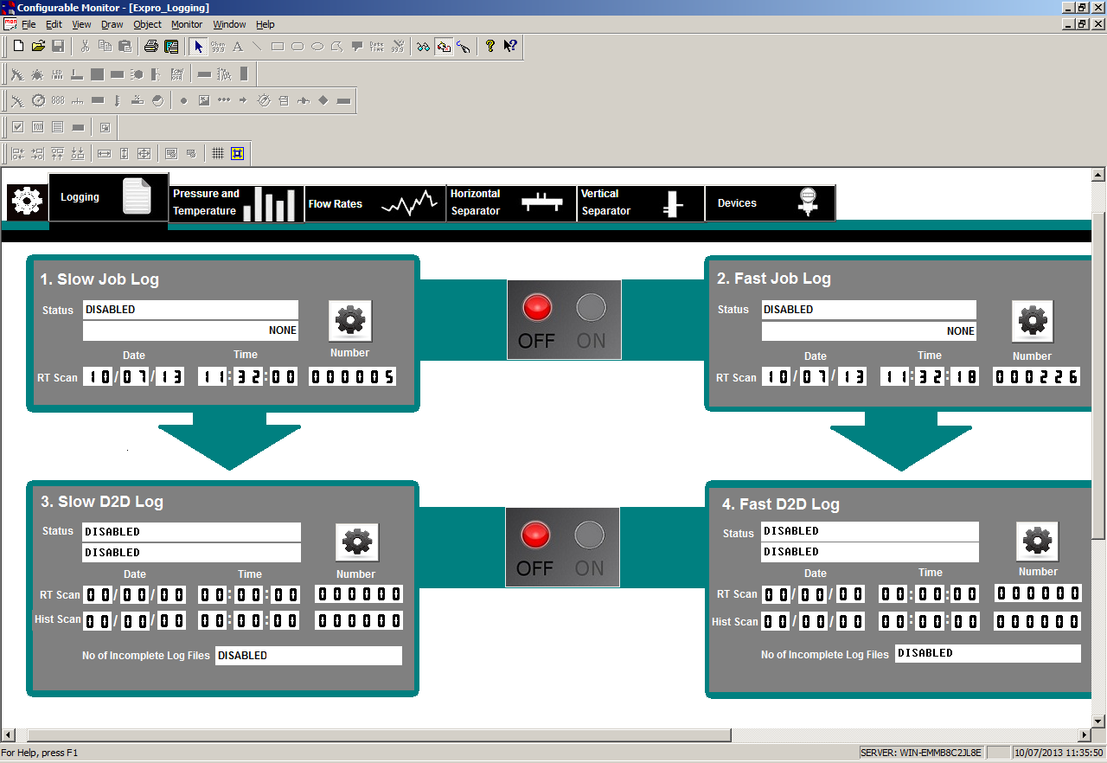

- On the logging screen, select the ‘On’ button to enable to loggers to begin logging.

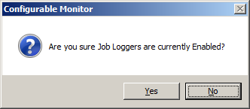

- Once you have selected ‘Yes’ the light will change from red to green on the ‘On’ button.

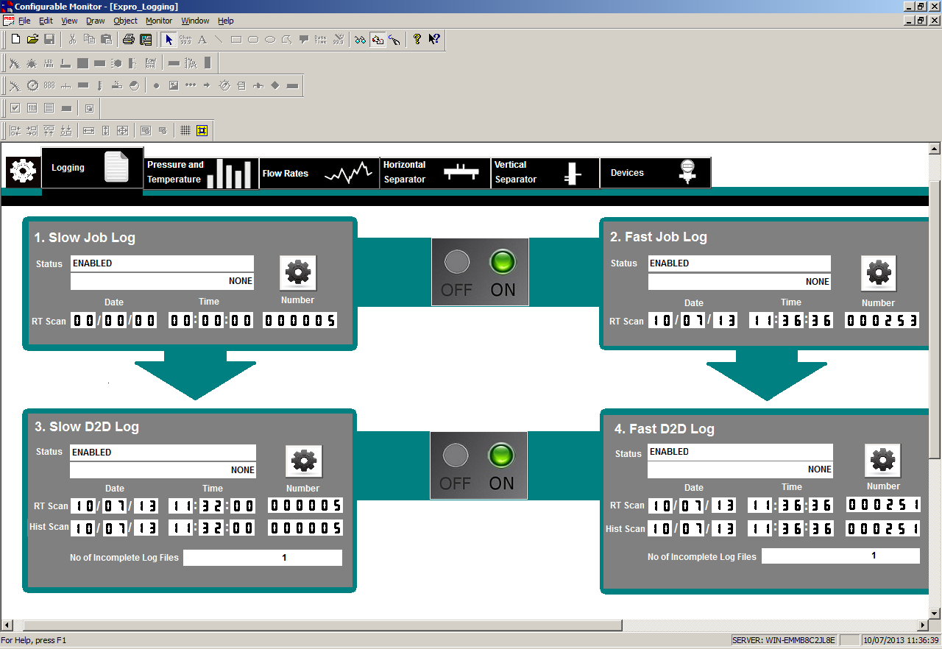

Stop Job

- Click the ‘Off’ button to disable the local loggers.

- Wait for the STO scan numbers to be same as the local loggers.

- Disable the STO loggers by clicking the ‘Off’ button.

- To help ensure that the loggers are stopped in the correct order, the system will prompt the user to ensure that the STO loggers are still running while the Job Loggers are being stopped.

- The following prompt is displayed before disabling the loggers.
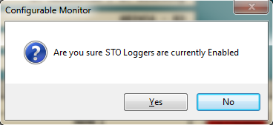

- The following prompt is displayed before disabling the STO loggers.
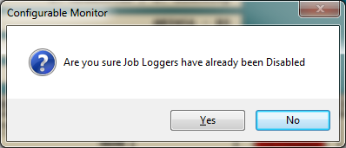

LIST OF ACTIVITIES: | MEANING:
Not Started | Logger has not yet started
Preparing To Log | For the Job loggers, the log directory and file is being prepard.  For STO loggers, connection is being made to STO server
Logging | Logger is currently logging
Finished Succesfully | Logger has successfully finished logging

LIST OF ERROR STATES: | MEANING:
NO ERROR | No error occuring
CAN'T CREATE INCOMPLETE DIR | Cannot create or access the C:\EDGE\INCOMPLETE directory to record jobs which have not been completely moved to the STO server.
CAN'T OPEN INCOMPLETE FILE | Cannot create or access the C:\EDGE\INCOMPLETE\LOGGER.text file to record jobs which have not been completely moved to the STO server.
CAN'T PARSE SELECTED INCOMPLETE LOG | Name of incomplete log to transfer cannot be read.
CAN'T UPDATE INCOMPLETE FILE | Cannot update the C:\EDGE\INCOMPLETE\LOGGER.text file to record jobs which have not been completely moved to the STO server.
CAN'T OPEN CONTROL PIPE | Can’t start the logger due to internal system error.
CAN'T GET CONFIG DIR | Can’t determine the C:\RIG\CURRENT_CONFIG\LOGGERS folder.
CAN'T ACCESS CONFIG DIR | -Can’t create or access the C:\RIG\CURRENT_CONFIG\LOGGERS folder
CAN'T READ CONFIGURATION | Can’t read the C:\RIG\CURRENT_CONFIG\LOGGER\republish file.
START TIME > STOP TIME | Start and stop time specified in the logger configuration is inconsistent.
CAN'T LOGIN TO OURCE | Can’t login to access the networked source directory.
CAN'T CREATE COLLECTION | Internal memory problem
CAN'T LOGIN TO DEST | Can’t login to access the networked destination directory.
WARNING NO SRC LOGS AVAILABLE | Job logger has not started
CAN'T INITIALISE SOURCE | Internal memory problem
CAN'T ENABLE CONNECTION | Can’t start the network connection to the STO server
CAN'T INITIALISE SOURCE TEXT | Internal memory problem
CAN'T UPDATE MANUAL INPUT | Can’t apply manual input updates
CAN'T COPY MANUAL INPUTS | Can’t copy manual inputs updates
CAN'T UPDATE SOURCE TEXT | Can’t apply updated text to source
CAN'T UPDATE DEST TEXT | Can’t apply updated text to destination
CAN'T COPY DEST TEXT | Can’t copy updated text to destination
CAN'T READ SRC LAG LOG | Can’t read source lag log record
CAN'T WRITE DEST LAG LOG | Can’t update destination lag log record

Copy Incomplete Job

- If a job has not been completely copied to the SiteToOffice server, the incomplete job is maintained in a list for the STO loggers.
- Select the icon on the logging screen to display the incomplete jobs of the SiteToOffice logger.
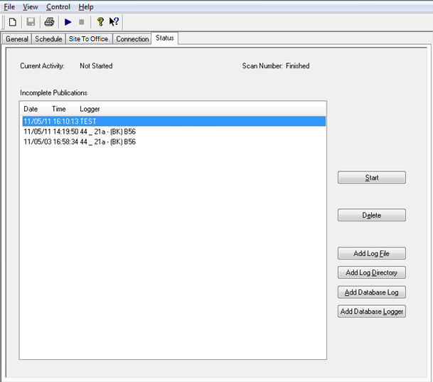

- Select the job to be copied and press the Start button.
- This will enable the Site To Office logger to copy the job in the background. When the copy is complete the logger will automatically disable. A job copy can be cancelled by disabling the logger during the job copy.
- (Note: Normal SiteToOffice operation cannot be performed during manual job copies.)
- Jobs to be copied can be added to the incomplete list by selecting a log file or directory and then perfroming the Start.
- Jobs can also be deleted from the incomplete list. Do not delete a job which is currently active.
- If a job was logged but no internet connection was available at the time of logging the test, or the operator decided to stop the upload and did not restart. You can upload the file by adding it to the Incomplete publication by clicking add log file and selecting the log file you want to upload then select file and click start.

Publish Buffer Size

- This field determines how many scans of the source logger are transmitted to the SiteToOffice central server in a single network transaction.
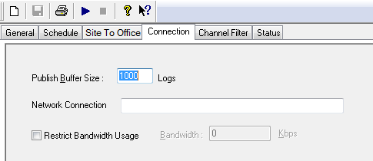

- If it is set too low then it will take a lot of time to update a file, as too many transactions will be needed.

- If it is set too high then it will take a lot of time to get feedback on progress, as each transaction will take a lot of time to transmit.

- For example: Assuming the optimum transaction size is 500Kb and with a scan size of 500 bytes then the optimum publish buffer size should be set at 500Kb/500bytes per scan = 1000 scans.

- For example assuming the optimum transaction size is 500Kb with a scan size of 100 bytes then the optimum publish buffer size should be set at 500Kb/100bytes per scan = 5000 scans.

- The optimum setting is dependent on the network type and the scan size is dependent on the source logger or channel filter that is being used.

Backfill

- When the connection to the SiteToOffice server is lost, the publisher logger continues to attempt to make a connection with the server whilst the data continues to be logged locally. When the connection is re-established the publisher goes into a mode where it has to perform ‘Backfill’.

- In ‘Backfill’ mode the publisher transmits the most recent real-time logged scans and historical data which have not yet been transmitted. The operator on the rig will see the real-time scans, and the historical scan numbers of the publisher logger, increase as the publisher logger performs the backfill. The historical scan number will lag the real-time scan number when in backfill mode. When the real-time scan and historical scans are the same number, the backfill is complete and the logger is no longer playing catch-up.

- Backfill is also initiated if a manual input updates the log file. The historical scan is set to the scan number of the manual input, and backfill is then performed on all the scans which have been updated. If a second manual input is performed during backfill, the process will restart the scan number of the second manual input which is lower than the current historical scan number.

- Once backfill is complete the trends currently being displayed by SiteToOffice users on the central server are automatically refreshed.

Channel Filter

- The channel filter tab is located on the tab bar in the SiteToOffice logger window. In order to maximize bandwidth usage, a channel filter can be applied to only transfer from specific logged channels to the SiteToOffice central server.

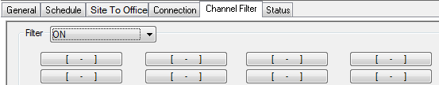

- Select the ‘filter’ drop down to ON and choose which channels from the logger are to be used to transfer to the SiteToOffice central server.

- A scan size total will be displayed at the bottom in bytes to help to ascertain the exact volume being transferred.

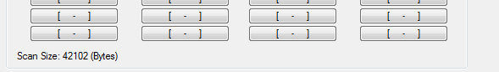

Logger Status

- The Logger Status Channels contain all the information relevant to a job logger. This information contains status, directory, prefix, scan numbers, date and time of last write and lag status information.

- There are a total of 25 status channels for each logger running. The screen shot below shows and example of a SLOW_LOG running.

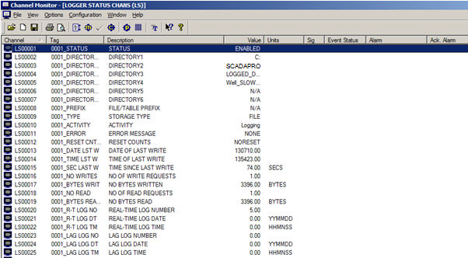

HIST Number

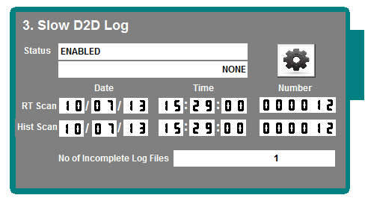

- HIST Scan Number is the ‘Historical scans’ from an STO logger on the rig system. HIST scan will give the date and time and the number of scans it carried out in a previous logging season. The real-time scan and the historical scan numbers of the publisher logger will increase as the publisher logger performs the backfill, and all of this will be seen by the rig operator. The historical scan number will lag the real-time scan number when in backfill mode. When the real-time scan and historical scans are the same, backfill is then complete and the logger is no longer playing catch-up.

Generated Key Channels

- The following channels are required on the Rig when loading generated key. These channels store the key information.
Latitude
Longitude
Expiry Flag
Expiry Year
Expiry Month
Expiry Day
Expiry Hour
Expiry Minute
Expiry Second
User Analog Channels:

Countdown
Countdown Days
Countdown Hours
Countdown Minute
Countdown Second
Calculator Channels:

