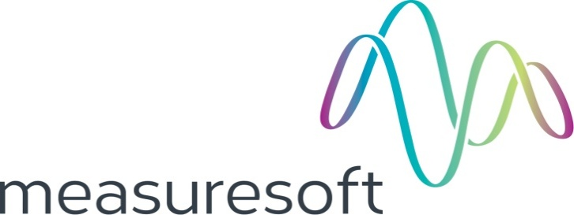
Partnership Courtyard, The Ramparts,
Dundalk, Ireland

Version 6.6.0.0
March 12, 2021
www.measuresoft.com
+353 42 933 2399

This document is the copyright of Measuresoft and may not be modified, copied or distributed in any form whatsoever without the prior permission of Measuresoft.

WITSML User Manual

Table of Contents

1 Configuration 3
2 Channel Configuration 4
2.1 Enable Channel 4
2.2 Tag 4
2.3 Description 4
2.4 Engineering Units 4
2.4.1 Minimum 4
2.4.2 Maximum 5
2.4.3 Descriptor 5
2.5 Device Specific Button 5
2.5.1 Source Channel 5
2.5.2 Update Rate 5
2.5.3 Data Type 5
2.5.4 Calculation 5
2.5.5 WITSML Class 5
3 Advanced Device Configuration 6
3.1 AutoEnable Device 6
3.2 Scan Rate 6
3.3 Save Outputs 6
3.3.1 By Tag 6
3.4 Device Specific Button 7
3.4.1 Server URL 7
3.4.2 User Name 7
3.4.3 Password 7
3.4.4 GetVersion 7
3.4.5 Fast Update Rate 7
3.4.6 Slow Update Rate 7
3.4.7 Tag Offset for Generating Channel Mnemonic 8
3.4.8 Description Offset for Generating Channel Description 8
3.4.9 Well uid 8
3.4.10 Wellbore Uid 8
3.4.11 Well Name 8
3.4.12 Wellbore Name 8
3.4.13 Service Company 8
3.4.14 Run Number 8
3.4.15 Pass 8
3.4.16 Output Realtime records 8
3.4.16.1 Fast sub uid 8
3.4.16.2 Slow sub uid 8
3.4.16.3 Activity Code 8
3.4.16.4 Sequence Channel 9
3.4.16.5 Persist Log 9
3.4.16.6 Persist Well Log 9
3.4.17 Output log records 9
3.4.17.1 Fast log uid 9
3.4.17.2 Slow sub uid 9
3.4.17.3 Log Name 9

Configuration

The first time the system is configured it is necessary to enable and configure all devices you require. To configure a particular device select the Devices option from the main menu followed by the WITSML device. This will launch an application to configure the device.

From the list provided select a channel and double-click. Alternatively you can select a channel and then click on the Configure Channel button.

This will launch a channel configuration dialog which enables you to configure individual channels.

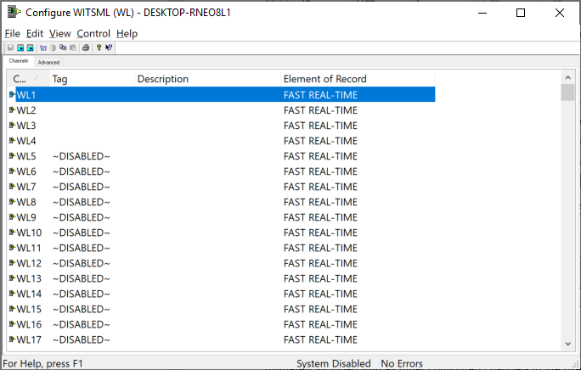

Channel Configuration

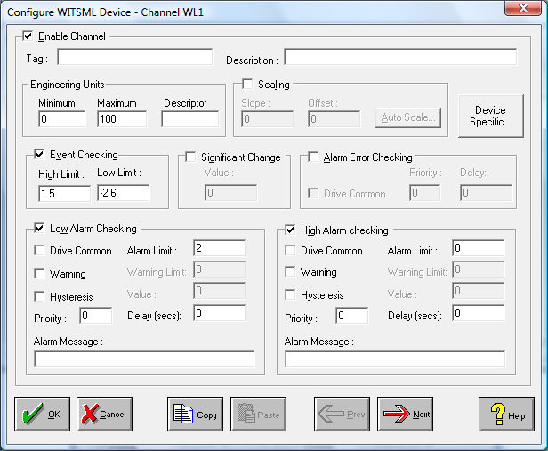

Enable Channel
The Enable Channel check box must be checked to enable and allow a channel to be configured and ultimately included with all other configured channels in the overall system.

Tag
The Tag field is a 12 character alphanumeric field that can contain channel information or wiring schedule references.

Description
The Description field is a 32 character alphanumeric field in which a description of the channel can be detailed.

Engineering Units
Specifies engineering details for this channel.

Minimum
Minimum engineering value for all Analog channels in addition to the unit field. The default is 0.

Maximum
Maximum engineering value for all Analog channels in addition to the unit field. The default is 100.

Descriptor
A four character field available to describe the units of the measurement.

Device Specific Button
When the Device Specific Button is pressed the following dialog appears to allow specific device configuration of the particular channel.

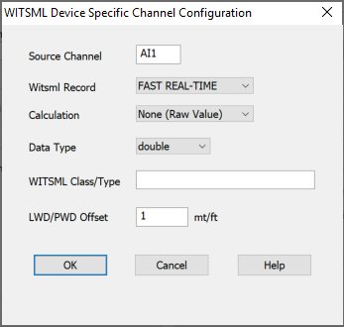

Source Channel
This is the source of the data to be output.

Update Rate
Fast or Slow update rates can be selected for the channel

Data Type
If the data type is string and source is set to a digital channel and calculation type is raw, the current channel off/on description is output.

Calculation
Statistics are calculated over the time of device/system enable.

WITSML Class
This is the measurement type of the channel e.g. porosity.

LWD/PWD Offset
If the depth associated with an MWD element such as resivity, gamma ray or porosity is unavailable on a WITS input record, this is the offset to add to the WITS input depth to yield the depth of the MWD element.

Advanced Device Configuration

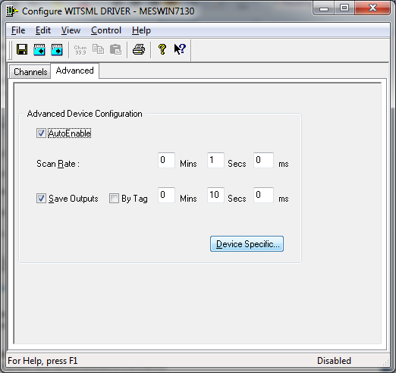

AutoEnable Device
To ensure that the device is enabled on the system check the Enable Device box.

Scan Rate
To set the rate at which the device will scan, edit the text boxes associated with the Scan Rate field.

Save Outputs
To enable this utility check the Save Outputs flag. All values in output channels are saved to disk when the system is disabled. The next time the system is restarted the values which were previously in output channels will be restored to the appropriate channel number.

By Tag
Channel values can be saved and restored to channels using the channel tag instead of the channel number. In this way, channels can be rearranged within the modules and as long as the channel tags remain the same, the correct channel values will be restored to the appropriate channel number.

Device Specific Button
When the Device Specific Button is pressed the following dialog appears to allow specific communication settings to be configured for the device.

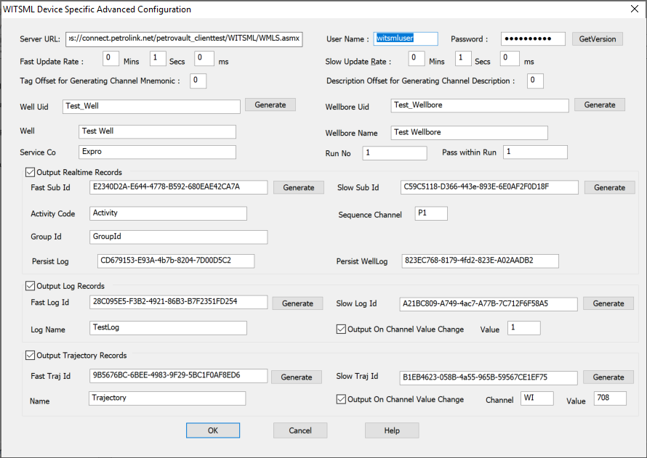

Server URL
This is the URL address of the WMLS service. This is normally a http address.

User Name
The user authentication required to access the Server URL.

Password
The password authentication required to access the Server URL.

GetVersion
This can be used to verify the Server URL, User Name and Password. The version numbers supported by the server are displayed if the call works. Otherwise, a detailed error description is displayed.

Fast Update Rate
This is the rate at which channels nominated as FAST are added as real-time records. Fast Update Rate must be a multiple of the scan rate. If the channels linked to a WITSML record are all from the same WITS input record, the WITS input record time item must change in order for the Fast Updates to be transmitted.

Slow Update Rate
This is the rate at which channels nominated as SLOW are added as real-time records. Slow Update Rate must be a multiple of the scan rate. If the channels linked to a WITSML record are all from the same WITS input record, the WITS input record time item must change in order for the Fast Updates to be transmitted.

Tag Offset for Generating Channel Mnemonic
If WELL01_HKLOAD is the tag and the Mnemonic is HKLOAD then offset should be set to 7.

Description Offset for Generating Channel Description
If WELL01 HOOKLOAD is the description and the Description is HOOKLOAD then offset should be set to 7.

Well uid
Unique Identifier for the well that contains the wellbore. The Generate button will generate a new unique identifier.

Wellbore Uid
Unique Identifier for wellbore that contains the tubular. The Generate button will generate a new unique identifier.

Well Name
Human recognizable context for the well that contains the wellbore.

Wellbore Name
Human recognizable context for the wellbore that contains the tubular.

Service Company
Name of contractor who provides the service.

Run Number
Log run number. This should normally be a number; however some legacy systems encode other information in this value.

Pass
Identifies the pass within the run

Output Realtime records
To switch on output of realtime records

Fast sub uid
Unique Identifier for the fast realtime subscription. The Generate button will generate a new unique identifier.

Slow sub uid
Unique Identifier for the slow realtime subscription. The Generate button will generate a new unique identifier.

Activity Code
A code used to define rig activity.

Sequence Channel
The sequence number for each update is maintained in a channel so that the sequence number can be monitored or reset. If no channel is specified sequence number starts from 1 every time the device/system is enabled.

Persist Log
A pointer to the log (within the context of the current wellbore) that will be used to persist this
data

Persist WellLog
A pointer to the well log (within the context of the current wellbore) that will be used to persist this data.

Output log records
To switch on output of log records.

Fast log uid
Unique Identifier for the fast log records. The Generate button will generate a new unique identifier.

Slow log uid
Unique Identifier for the slow log records. The Generate button will generate a new unique
identifier.

Log Name
A name describing the log records.

Output on Value Change
Output on a value change if the first channel linked to the record changes by a certain value.

Output on Value Change Value
Change trigger value.

Output trajectory records
To switch on output of trajectory records.

Fast log uid
Unique Identifier for the fast trajectory records. The Generate button will generate a new unique identifier.

Slow log uid
Unique Identifier for the slow trajectory records. The Generate button will generate a new unique
identifier.

Name
A name describing the trajectory records.

Output on Value Change
Output on a value change if a channel changes by a certain value.

Output on Value Change Channel
Change trigger channel.

Output on Value Change Value
Change trigger value.

