Partnership Courtyard, The Ramparts,
Dundalk, Ireland

Version 6.4.11.0
January 27, 2017
www.measuresoft.com
+353 42 933 2399

This document is the copyright of Measuresoft and may not be modified, copied or distributed in any form whatsoever without the prior permission of Measuresoft.

Wits Input User Manual

Table of Contents

1. Configuration 3
1.1. Communications 3
Enable Wits Receiver Interface 3
Scan Rate 4
Report time out if no Records Received after 4
1.2. Connection 4
Serial connection 4
TCP Connection 4
Echo Input to Secondary WITS Input Connection 4
2. Channel Configuration 5
Enable Channel 6
Tag 6
Description: 6
Units 6
Scaling 6
Event Checking 7
Significant Change 7
Low and High Alarm Checking 7
3. Encoding Channel Values 9
4. Debug View 9
Capture Output 10
Insert Comments 10
Clearing the Display 10
Searching 10
Filtering 10
Highlighting 11
History Depth 11
File 11
Edit 11
Capture 11
Options 12
Computer 12
Help 12

Configuration

The first time the system is configured it is necessary to enable and configure all devices you require. To configure a particular device select the Devices option from the main menu followed by the WITS Input device. This will launch an application to configure the device. The following dialog will be displayed.

This dialog displays the status, errors, and the achieved scan time of the device. In order to communicate with the device the communication settings will need to be configured, they are described in detail below.

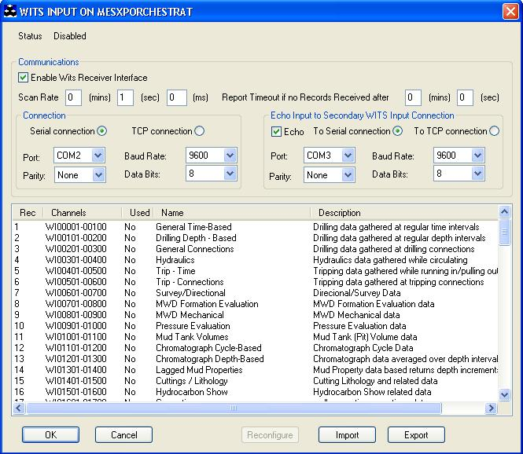

Communications

Enable Wits Receiver Interface
For the wits receiver interface to be operative and therefore configurable the Enable Wits Receiver Interface check box must be checked.

Scan Rate
To set the rate at which the device will scan, edit the text boxes associated with the Scan Rate field to the desired rate.

Report time out if no Records Received after
This allows the maximum time the scanner will wait for a received record which is set in minutes and seconds.

Connection

Serial connection

Comm Port
For serial connections, this allows you to select the port to which your WITs Input device will be connected. To choose a port, click on the down arrow to the right of the port field. The drop down list will contain a list of all available ports on your system. Choose the one you want.

Parity
There are 5 types of parity available
None
Odd
Even
Space
Mark
Parity is selected in the same way as the port – Click on the down arrow and select from the provided list.

Baud Rate
This allows you to select your desired baud rate. The baud rate is selected in the same way as the port and parity – click on the down arrow and choose from the provided list.

Data Bits
Select the appropriate amount of data bits to be used. The data bits amount is selected in the same way as the port and parity – click on the down arrow and choose from the provided list.

TCP Connection

Port
For TCP/IP connections, this allows you to select the TCP/IP port number. This is defaulted to 7.

Echo Input to Secondary WITS Input Connection

Echo

This allows you to echo the input to a secondary connection, either Serial Connection or TCP Connection, with the same options as the primary connection.

Channel Configuration

To perform channel configuration double click on the required record within the Wits Input dialog to display its corresponding list of channels.

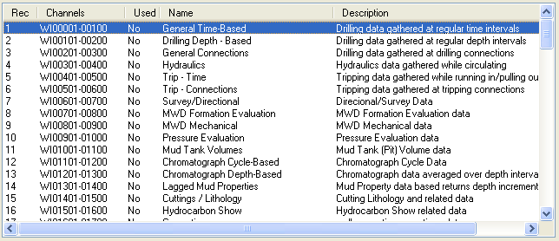

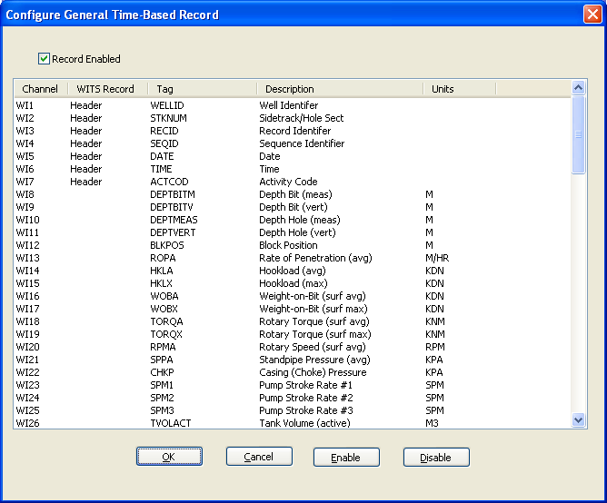

To configure a channel double click on the required channel to edit its configuration properties.

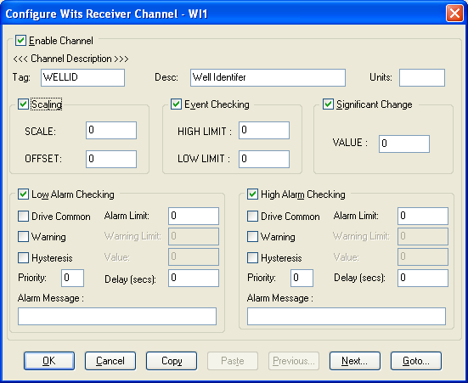

Enable Channel
For a channel to be operative and therefore configurable the Enable Channel check box must be checked.

Tag
A 15 characters alphanumeric field that can contain channel information or wiring schedule references.

Description:
A 32 channel alphanumeric field in which a description of the channel can be detailed.

Units
An 8 character field available to describe the units of the measurement.

Scaling
To enable the utility check the Scaling Check box. The Scale and Offset values can be entered directly into the text boxes. The formula applied is:
y = mx + c where: m is SCALE
x is the measured value.
c is the OFFSET

Event Checking
Event checking is used, if required to trigger a logger to record information on an event. Check the Event Checking check box if this facility is needed.

High Limit
A value entered in this text box will define the level that if exceeded, by the channel result will cause an event trigger.

Low Limit
A value entered in this text box will define the level that if the channel result falls below will cause an event trigger.

Significant Change
To enable check the Significant Change check box.

This facility allows filtering of data on channels on which significant change is of interest. Such changes can cause an event, which can be logged.

The figure entered in the Value text box is the rate of change in engineering units, which, if the measured channel exceeds per scan, either increasing or decreasing will cause the significant change event trigger.

Low and High Alarm Checking
Alarm checking is available on all channels throughout the ScadaPro system. Low Alarm and High Alarm levels can be configured independent of each other. All the values entered are in engineering units. If a channel reading exceeds the High Alarm limit then an alarm will be triggered as it will if the channel goes below the Low Alarm limit.
When monitoring channels, if the high or low alarm is triggered, then the fact will be annotated alongside the other channel information in the Monitor Window.

Enable Alarm Checking
Check either the Low Alarm Checking or High Alarm Checking or both check boxes to enable the facility.

Alarm Limit:
The value at which the channel will flag an alarm.

Warning and Limit:
If required, a warning can be displayed when a channel reaches a limit close to the alarm limit. For low alarm checking, the alarm limit must be less than the warning limit. For high alarm checking, the warning limit must be less than the alarm limit.

Delay:
Specify the number of seconds the channel must be in the alarm zone before an alarm will be flagged within the system.

Hysteresis
Hysteresis can prevent 'noisy' channels from reporting multiple alarms when the average reading is close to the alarm or warning threshold. The Hysteresis value is relative to the alarm or warning limit.
For example, if a channel’s high alarm is set to 80 degrees C, Hysteresis is enabled and a Hysteresis value of 5 degrees C is specified the system will respond as follows:
When the channel reading goes above the high alarm limit of 80 it will trigger the alarm. The alarm will not be reset until the channel reading falls below 75, the high limit - Hysteresis value.
Check the box if this feature is needed. Enter the value of the dead band in the text box.

Priority
Enter or edit the number in the text box to allocate the priority of this alarm.

Drive Common Alarm:
A common alarm is a single digital output, which will switch on when any channel with the Drive Common Alarm enabled goes into an alarm state.
Check this box if a link to the Common Alarm is required.

Alarm Message:
An Alarm Message can be defined to be displayed on the Status line of the ScadaPro Main Window when a channel goes into an alarm state.
Enter the message, up to 32 characters.

Encoding Channel Values

Alphanumeric record items can be received by mapping the expected input to an analog value.

Survey type Record 7 Item 12 – Channel 612 is recommended to have the following values.

MWD (1) (Measurement While Drilling)
Mag-SS (2) (Magnetic Single Shot)
Mag-MS (3) (Magnetic Multi Shot)
Gyr-Free (4) (Gyro-Free)
Gyr-Rate (5) (Gyro-Rate Integrating )
Inertial (6) (Inertial Navigation System)

Using the above mapping the alphanumeric value e.g. the item value received as MWD can be converted to a value of 1 by setting up a value.txt file in the
<Install Directory>\CURRENT_CONFIG\WITSO_<n> directory.

[Channel612]
1=MWD
2=Mag-SS
3=Mas-MS
4=Gyr-Free
5=Gyr-Rate
6=Inertial
0=*

The last entry indicates that an unmatched received value sets the input value to 0.

Debug View
There is now a debug utility available to use within Wits that allows you to monitor debug output on the local machine or on any computer over the network via TCP/IP. To launch the debug utility click on Control then Debug on the Configure screen.

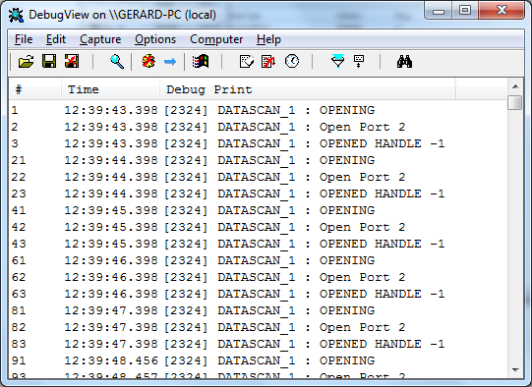

Capture Output
When you start the utility it will begin capturing debug output by default. You can toggle between capture on and capture off with the following toolbar icon: Alternatively you can use Capture Menu > Capture Events or using the Ctrl + E hotkey. When capture mode is off the utility will not capture any debug output until it is turned back on. The kind of output that is captured is determined on whether Win32 or Kernel capture is on or off.

Insert Comments
You can insert comments in the output log by clicking on Edit>Append Comment. Comments insert into the currently viewed output. Type comments into the dialog followed by the Enter key and then close the dialog when you are done entering comments.

Clearing the Display
To clear the output screen simply click on the toolbar or go to Edit>Clear display on the menu.

Searching
You can search for a line of text that is of interest by clicking on the toolbar or going to Edit>Find on the menu. If the search matches what you specified then it will be highlighted on the output window while disabling the auto-scroll feature. To repeat a successful search you can use the F3 hotkey.

Filtering
Another way of picking out debug output is to use the filtering feature. You can use it by clicking on the toolbar or going to Edit>Filter/Highlight on the menu. The Filter/Highlight feature contains two edit fields: include and exclude. The Include field is where you enter substring expressions that match debug output lines that you want the utility to display, and the exclude field is where you enter text for debug output lines that you do not want the utility to display. You can enter multiple expressions, separating each with a semicolon (‘;’). Do not include spaces in the filter expression unless you want the spaces to be part of the filter. Note that the filters are interpreted in a case-insensitive manner, and that you should use ‘*’ as a wildcard.

Highlighting
If you want output lines that contain certain text to be highlighted in the utility output window, enter a highlight filter. The utility implements support for up to five different highlight filters, each with its own foreground and background color settings. Use the filter drop-down in the highlight filter area of the filter dialog to select which highlight filter you want to edit. Use the same syntax just described for include and exclude filters when defining a highlight filter.

Use the Load and Save buttons on the filter dialog to save and restore filter settings, including the include, exclude and highlighting filters, as well as the highlighting colors settings.

History Depth
Another way of controlling the debug output is to limit the number of lines that are retained in the window. You can do this by clicking on the toolbar or Edit>History Depth on the menu. Once opened enter the number of output lines you want the utility to retain and it will keep only that number of the most recent debug output lines, discarding older ones. A history-depth of 0 represents no limit on output lines retained.

Menu Items

File
Item | Description
New Window… | Opens a new debug window.
Open… | Open a saved debug window.
Save | Save the current debug window.
Save As… | Specifies what to save the current debug as.
Log to File… | Creates a log file of the debug output
Log to File As… | Specifies what to save the log file as.
Print… | Prints the debug output.
Print Range… | Specifies what range to print of the debug output.
Process Crash Dump… | Creates a crash dump of the output up until the crash.
Exit | Exit the utility.

Edit
Item | Description
Append Comment | Write a comment for the current output.
Copy | Copy the selected text.
Find | Find a specific piece of text.
Filter/Highlight | Filter the output to include or exclude certain string values.
Clear Display | Clear the debug output window.

Capture
Item | Description
Capture Win32 | Will register to receive and print debug output generated by Win32 programs that call OutputDebugString.
Capture Global Win32 | Let’s you enable and disable the capture of debug output that is generated in the console (global) session.
Capture Kernel | Captures kernel-mode debug output generated by device drivers and/or the Windows kernel
Enable Verbose Kernel Output | Outputs kernel mode in verbose.
Pass-through | Allows you to see kernel-mode debug output in the output buffers of a conventional kernel-mode debugger while at the same time viewing it in the utility.
Capture Events | You can toggle on or off and it will capture events and display on the debug output.
Log Boot | Toggle on or off to enable the utility to log on Windows startup.

Options
Item | Description
Win32 PIDs | Information identifying processes that generate Win32 debug output is prefixed to each line of Win32 debug output.
Force Carriage Returns | Forces carriage returns on the debug output.
History Depth… | Limits the number of lines that are retained in the window.
Clock Time | Toggles between setting the time in seconds or HH:MM:SS.ms
Show Milliseconds | Toggle whether to show milliseconds in the time stamp.
Font | Change the debug output font style, size, and type.
Hide When Minimized | Hides the utility to the taskbar when minimized.
Hide Toolbar | Hides the toolbar on the utility.
Auto Scroll | Toggle between the debug output automatically scrolling down as
Always on Top | Utility window will always appear on top even when it loses focus.

Computer
Item | Description
Connect | Connect to a computer over the network.
Connect Local | Connect to the local machine
Disconnect | Disconnect from the current computer on the network.
COMPUTER_NAME | The current machine you are connected to.

Help
Item | Description
Help… | Displays a help file to explain the utility.
About | Displays current software version and details.

Toolbar

Name | Icon
Open
Save
Log to File
Capture
Capture Kernel
Passthrough Kernel
Capture Win32
Clear
Autoscroll
Time Format
Filter/Highlight
History Depth
Find

