Partnership Courtyard, The Ramparts,
Dundalk, Ireland

Version 6.6.0.0
March 12, 2021
www.measuresoft.com
+353 42 933 2399

This document is the copyright of Measuresoft and may not be modified, copied or distributed in any form whatsoever without the prior permission of Measuresoft.

Vestas Driver User Manual

Table of Contents

1 Configuration 3
2 Channel Configuration 3
2.1 Enable Channel 3
2.2 Tag 3
2.3 Description 3
2.4 Engineering Units 3
2.4.1 Minimum 3
2.4.2 Maximum 3
2.4.3 Descriptor 3
2.5 Device Specific Button 3
3 Advanced Device Configuration 3
3.1 AutoEnable Device 3
3.2 Scan Rate 3
3.3 Save Outputs 3
3.3.1 By Tag 3
3.4 Device Specific Button 3
3.4.1 URL 3
3.4.2 User 3
3.4.3 Pass 3

Configuration
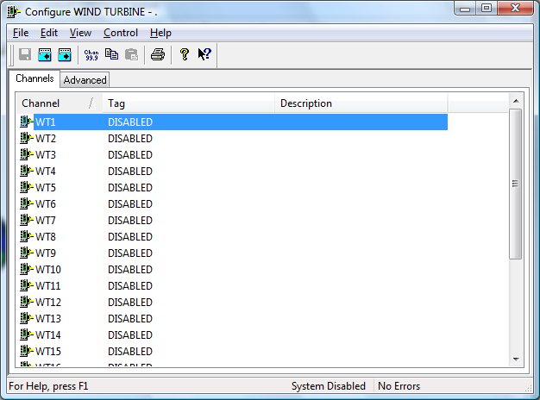

The first time the system is configured it is necessary to enable and configure all devices you require. To configure a particular device select the Devices option from the main menu followed by the Wind Turbine device. This will launch an application to configure the device.

From the list provided select a channel and double-click. Alternatively you can select a channel and then click on the Configure Channel button.

This will launch a channel configuration dialog which enables you to configure individual channels.

Channel Configuration

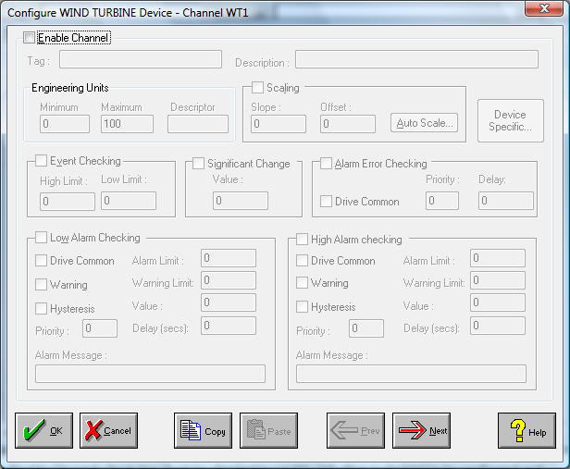

Enable Channel
The Enable Channel check box must be checked to enable and allow a channel to be configured and ultimately included with all other configured channels in the overall system.

Tag
The Tag field is a 12 character alphanumeric field that can contain channel information or wiring schedule references.

Description
The Description field is a 32 character alphanumeric field in which a description of the channel can be detailed.

Engineering Units
Specifies engineering details for this channel.

Minimum
Minimum engineering value for all Analog channels in addition to the unit field. The default is 0.

Maximum
Maximum engineering value for all Analog channels in addition to the unit field. The default is 100.

Descriptor
A four character field available to describe the units of the measurement.

Device Specific Button
When the Device Specific Button is pressed a dialog appears detailing the Analog Value Mapping between the channel being configured and the ID of the data associated with that channel.

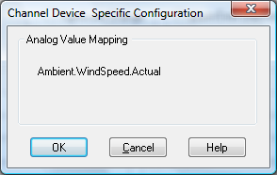

Advanced Device Configuration

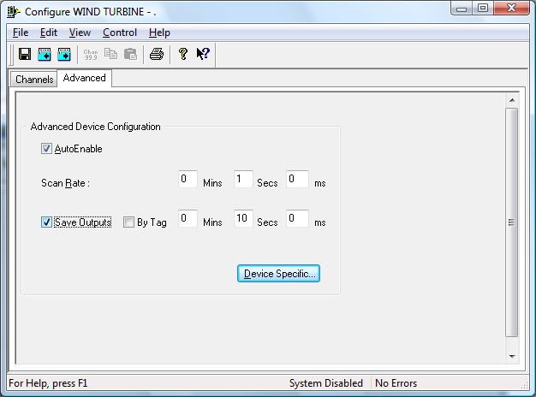

AutoEnable Device
To ensure that the device is enabled on the system check the Enable Device box.

Scan Rate
To set the rate at which the device will scan, edit the text boxes associated with the Scan Rate field.

Save Outputs
To enable this utility check the Save Outputs flag. All values in output channels are saved to disk when the system is disabled. The next time the system is restarted the values which were previously in output channels will be restored to the appropriate channel number.

By Tag
Channel values can be saved and restored to channels using the channel tag instead of the channel number. In this way, channels can be rearranged within the modules and as long as the channel tags remain the same, the correct channel values will be restored to the appropriate channel number.

Device Specific Button
When the Device Specific Button is pressed the following dialog appears:
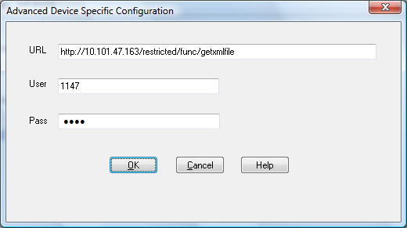

URL
The URL for the XML file being used for the configuration of the channels is specified here.

User
The username used to connect to the URL of the XML page.

Pass
The password used to connect to the URL of the XML page.

