Partnership Courtyard, The Ramparts,
Dundalk, Ireland

Version 6.6.0.0
March 12, 2021
www.measuresoft.com
+353 42 933 2399

This document is the copyright of Measuresoft and may not be modified, copied or distributed in any form whatsoever without the prior permission of Measuresoft.

SIMATIC 505 TI Orchestrator Driver User Manual

1. Configuration 2
2. Channel Configuration 2
2.1 Enable Channel 2
2.2 Tag 2
2.3 Description 2
2.4 Engineering Units 2
2.4.1 Minimum 2
2.4.2 Maximum 2
2.4.3 Descriptor 2
2.5 Scaling 2
2.5.1 Auto Scaling 2
2.6 Event Checking 2
2.6.1 High Limit 2
2.6.2 Low Limit 2
2.7 Significant Change 2
2.8 Alarm Error Checking 2
2.8.1 Drive Common 2
2.8.2 Priority 2
2.8.3 Delay 2
2.9 Alarm Checking 2
2.9.1 Enable Alarm Checking 2
2.9.2 Drive Common Alarm 2
2.9.3 Alarm Limit 2
2.9.4 Warning and Limit 2
2.9.5 Hysteresis 2
2.9.6 Priority 2
2.9.7 Alarm Delay 2
2.9.8 Alarm Message 2
2.10 Device Specific Button 2
2.10.1 Analog channel specific configuration 2
2.10.2 Digital channel specific configuration 2
3. Advanced Device Configuration 2
3.1 AutoEnable Device 2
3.2 Scan Rate 2
3.3 Save Outputs 2
3.3.1 By Tag 2
3.4 Device Specific Button 2
3.4.1 Com port Settings 2
3.4.2 Output Scan Options 2
4. SIMATIC 505 TI Driver Errors 2
4.1 Format Of Error Messages 2
4.2 Error Codes 2

Configuration

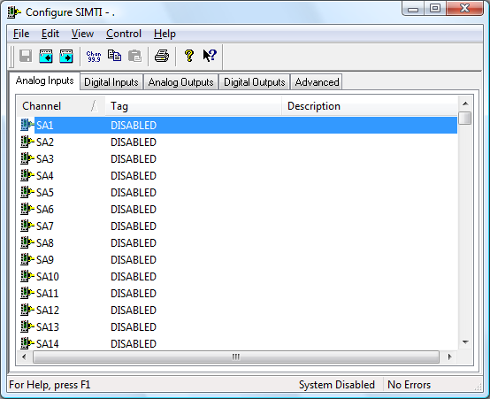

The first time the system is configured it is necessary to enable and configure all devices you require. To configure a particular device select the Devices option from the main menu followed by the appropriate device.
This will launch an application to configure the device. You will be presented with a set of tabs as shown above.
To configure a channel select a group of channels by clicking on the appropriate channel tab. From the list provided select a channel and double-click. Alternatively you can select a channel and then click on the Configure Channel button. This will launch a channel configuration dialog which enables you to configure individual channels.

Channel Configuration

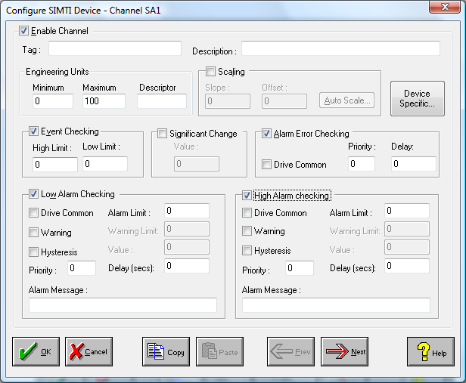

Enable Channel
The Enable Channel check box must be checked to enable, and allow this channel to be configured and ultimately included with all other configured channels in the overall system.

Tag
The Tag field is a 12 character alphanumeric field that can contain channel information or wiring schedule references.

Description
The Description field is a 32 character alphanumeric field in which a description of the channel can be detailed.

Engineering Units
Specifies egnineering details for this channel.

Minimum
Minimum engineering value for all analog channels in addition to the unit field. The default is 0

Maximum
Maximum engineering value for all analog channels in addition to the unit field. The default is 100

Descriptor
A 4 character field available to describe the units of the measurement

Scaling
NB. Scaling is only available to Analog channels that are not Output channels.

Some transducers give a number of pulses, or a frequency output proportional to their full scale range. To enable the Scaling utility check the Scaling Check box. The Slope and Offset values can be entered directly into the text boxes. The formula applied is:

y = mx + c where: m is SLOPE
x is the measured value.
c is the OFFSET

Auto Scaling
Click On the Auto Scale button if you want the scale and offset values calculated automatically. A dialog box will be displayed. Enter the values in the text boxes. The low measured value, and the high measured value, the output range of the transducer. When the fields have been completed, and assuming the System is enabled click on the Apply button. Under the heading Current Values the actual measured value will be shown, as well as the Engineering Value.

Click on OK to accept the scaling, or Cancel to abort the Auto Scaling feature.

NB. Scaling will not be applied to the channel, even if the system is enabled, until the system is next enabled or the Intercole LDAS Series Device is reconfigured

Event Checking
Event checking is used, if required to trigger a logger to record information on a number of channels during an event. Check the Event Checking check box if this channel is to trigger an event.

High Limit
A value, in engineering units, entered in this text box will define the level that, if exceeded, will cause an event trigger.

Low Limit
A value entered in this text box will define the level that if the channel result falls below will cause an event trigger.

Significant Change
To enable the Significant Change feature check the Sig Change check box. This facility allows filtering of data on channels on which significant change is of interest. Such changes can cause an event, which can be logged.
The figure entered in the Value text box, is the rate of change that if the output level exceeds per scan, either increasing or decreasing will cause the significant change event trigger. The scan rate is determined in the Advanced Device configuration
If a logger is configured each time the significant change trigger operates information on the channels defined in the logger will be recorded . A significant change event only lasts one scan, unless the next reading also changes greater than the Significant change value

When monitoring channels, if the Significant Change is triggered, then the fact will be annotated alongside the other channel information in the Channel Monitor. The significant change events are in addition to those caused by an Event.

Alarm Error Checking
Drives a common alarm when an error occurs on this channel.

Drive Common
A common alarm is a single digital output which will switch on when any channel with the Drive Common Alarm enabled goes into an alarm state. Check this box if a link to the Common Alarm is required.

Priority
Enter or edit the number in the text box to allocate the priority of this channels alarm.

Delay
Enter the time, in seconds, between the channel value entering the alarm state and the system flagging an alarm.

Alarm Checking
Alarm checking is available on all channels throughout the system. Low Alarm and High Alarm levels can be configured independent of each other. If the channel output exceeds the High Alarm limit then an alarm will be triggered as it will if the output goes below the Low Alarm limit.

When monitoring channels, if the high or low alarm is triggered, then the fact will be annotated alongside the other channel information in the Channel Monitor. To configure the Alarm Checking section of the device complete the options as follows for either or both the High Alarm and Low Alarm checking.

Enable Alarm Checking
Check either the Low Alarm Checking or High Alarm Checking or both check boxes to enable the facility.

Drive Common Alarm
A common alarm is a single digital output which will switch on when any channel with the Drive Common Alarm enabled goes into an alarm state. Check this box if a link to the Common Alarm is required.

Alarm Limit
Specifies the value which will trigger this alarm. for Low Alarm Checking it will be any value <= the Alarm Limit and for High Alarm Checking it will be any value >= the Alarm Limit.

Warning and Limit
If required, a warning can be displayed when a channel reaches a limit close to the alarm limit. For low alarm checking, the limit must be less than the alarm limit. For high alarm checking, the warning limit must be less than the alarm limit

Hysteresis
Hysteresis can prevent 'noisy' channels from reporting multiple alarms when the average reading is close to the alarm threshold. Check the box if this feature if needed. Enter the value of the dead band in the corresponding value field.

Priority
Enter or edit the number in the text box to allocate the priority of this alarm. Alarm priority ranges are from 0 to 255.

Alarm Delay
Enter the time, in seconds, between the channel value entering the alarm state and the system flagging an alarm.

Alarm Message
An Alarm Message can be defined to be displayed on the Status line of the Main Window when a channel goes into an alarm state. Enter the message, up to 32 characters, that is to appear in the event of an alarm.

Device Specific Button
When the Device Specific Button is pressed, the following will apply :

Analog channel specific configuration
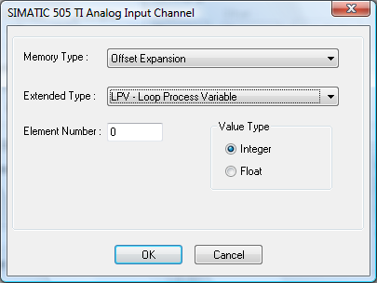

Memory Type
List of available memory types

Extended Type
List of additional memory types (if applicable)

Element Number
Memory element number (must be 1 or greater)

Value Type
Memory element datatype (if applicable)

Digital channel specific configuration
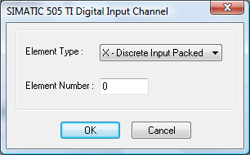

Element Type
List of available element types

Element Number
Memory element number (must be 1 or greater)

Advanced Device Configuration

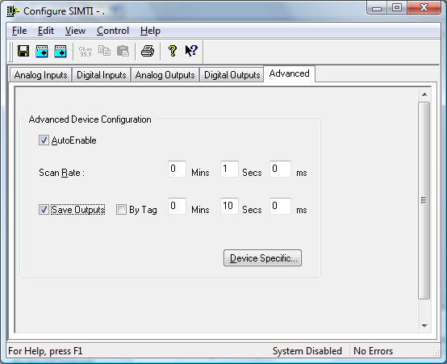

When the system is enabled and the device is enabled this window will display the Achieved Scan Rate . If the device is not scanning then any error associated with the device will be displayed instead.

AutoEnable Device
To ensure that the device is enabled on the system check the Enable Device box.

Scan Rate
To set the rate at which the device will scan, edit the text boxes associated with the Scan Rate field.

Save Outputs
To enable this utility check the Save Outputs flag. All values in output channels are saved to disk when the system is disabled. The next time the system is restarted the values which were previously in output channels will be restored to the appropriate channel number.

By Tag
Channel values can be saved and restored to channels using the channel tag instead of the channel number. In this way, channels can be rearranged within the modules and as long as the channel tags remain the same, the correct channel values will be restored to the appropriate channel number.

Device Specific Button
When the Device Specific Button is pressed, the following will apply :

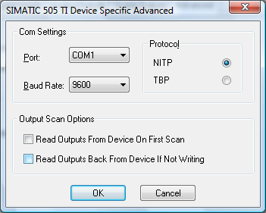

Com port Settings

This section relates to the physical communications between the PC and the Modbus stations. The fields to be configured are:

Port
ComPort to which PLC is Connected..

Baud Rate
Serial Connunication Baud Rate to be used.

Protocol
NITP or TBP Protocol to be used.

Output Scan Options

This section relates to the scanning of outputs. To select / deselect either option, click on the appropriate check box.

Read Outputs From Device On First Scan
This decides what type of scan to do on Outputs the first time that scanning actually commences.

Read Outputs Back From Device When Not Writing
If selected
If outputs have not changed then
The values don’t need to be written to file.
The values will be read back from the device.
If not selected
If outputs have not changed then
The values don’t need to be written to file.
No update occurs.

SIMATIC 505 TI Driver Errors

Format Of Error Messages

Error Codes

Error Code
00 | Command is not implemented
01 | Data type is not defined in attached device
02 | Data element location is out of range
03 | Command is too long
04 | Command is too short
05 | Command length does not match value in length field
06 | Device is in wrong mode
07 | User program in device has disabled communication to network module
08 | Written data type location did not verify
09 | Data type location is write protected
0a | Device fails to respond
0b | Command aborted due a fatal error condition
0c | Data type now has an invalid value due a command execution
0d | An error was encountered while executing the requested command with specified data type
0e | Command not valid for the specified data type
0f | Data pattern requested was not found
10 | The number of locations requested exceeds the maximum allowed
11 | The number assigned to data acquisition block exceeds the maximum allowed
12 | The block number requested has not been defined
13 | The number of data bytes in the requested block exceeds the maximum allowed
14 | The request number report by condition data type locations exceeds the maximum allowed
15 | Command not allowed while device is in local mode
16 | Data type has not been programmed in the attached device
17 | The attached device did not respond properly
18 | Data type in not implemented in the NIM
19 | The resulting data element location is out of range
1a | The attached device communications is not established
1b | The store and forward buffer is full and store and forward message discarded
1c | The data element field is improperly formatted
80 | Exception generated in the attached device is not identified

