Partnership Courtyard, The Ramparts,
Dundalk, Ireland

Version 6.6.0.0
March 12, 2021
www.measuresoft.com
+353 42 933 2399

This document is the copyright of Measuresoft and may not be modified, copied or distributed in any form whatsoever without the prior permission of Measuresoft.

Alpha Driver User Manual

Table of Contents
Configuring an Alpha Device 5
Advance Alpha Configuration 6
Alpha Scan Rate 6
Save Outputs 6
Listener Mode 7
Comm Port Settings 8
Network RS485 8
Single RS232 8
Comm Port 8
Baud Rate 8
Read Outputs when not writing 8
Read Outpts on initial scan 8
Use high speed 485 8
Event Logging 8
OK 9
Cancel 9
Configuring an Alpha Module 10
Module Type 10
Address 10
Acquisition Rate 10
Auxiliary Channels 11
Extra Command(n) 11
Configure Channel 11
OK 11
Cancel 11
Help 11
Set Module Address 12
Product Code 12
Serial Num 12
Address 12
Set Now 12
Autoset Module Address 12
Ok 12
Cancel 12
Configure Analog Input Modules 13
13
Enable Channel 13
Listner Mode 13
Tag 13
Description 13
Current Value 14
CM Parameters 14
Extra Commands 14
Reference 14
Engineering Units 14
Scaling 14
Auto Scale 14
Significant Change 15
Event Checking 15
Low and High Alarm Checking 15
Alarm Error Checking 16
Use Alpha Alarm Scheme 16
Configure Analog Output Modules 17
17
Enable Channel 17
Listner Mode 17
Tag 17
Description 17
Current Value 18
CM Parameters 18
Extra Commands 18
Reference 18
Engineering Units 18
Significant Change 18
Event Checking 18
Low and High Alarm Checking 19
Alarm Error Checking 19
Use Alpha Alarm Scheme 20
Configure Counter Input Modules 21
Enable Channel 21
Listener Mode 21
Tag 21
Description 21
Current Value 22
CM Parameters 22
Extra Commands 22
Engineering Units 22
Scaling 22
Auto Scale 22
Significant Change 22
Event Checking 23
Low and High Alarm Checking 23
Alarm Error Checking 24
Use Alpha Alarm Scheme 24
Configure Digital Input Channels. 25
25
Enable Channel 25
Listener Mode 25
Tag 25
Description 25
Current Value 26
CM Parameters 26
Extra Commands 26
Low State Description 26
High State Description 26
Event Checking 26
Alarm Error Checking 26
Alarms 26
Use Alpha Alarm Scheme 27
Configure Digital Output Channels. 28
Enable Channel 28
Listner Mode 28
Tag 28
Description 28
Current Value 29
CM Parameters 29
Extra Commands 29
Low State Description 29
High State Description 29
Event Checking 29
Alarm Error Checking 29
Alarms 29
Use Alpha Alarm Scheme 30
Interrogate Alpha Modules 31
Error Codes 33
Alpha Error Codes 33
Comms Error Codes 33
System Error Codes 34
Debug Facility 35
Switching Debugging On 35
Selecting the Debug Type 35
Debug View 36
Capture Output 36
Insert Comments 36
Clearing the Display 37
Searching 37
Filtering 37
Highlighting 37
History Depth 37
Menu Items 37
File 37
Edit 38
Capture 38
Options 38
Computer 39
Help 39
Toolbar 39
Extra User Commands 40

Configuring an Alpha Device

The first time the system is configured it is necessary to enable and configure the way you wish the overall Alpha Device to operate. To configure the Alpha System either select Devices from the menu bar on the Main Window and then Alpha or double click the Alpha Icon in the Application Program Group.

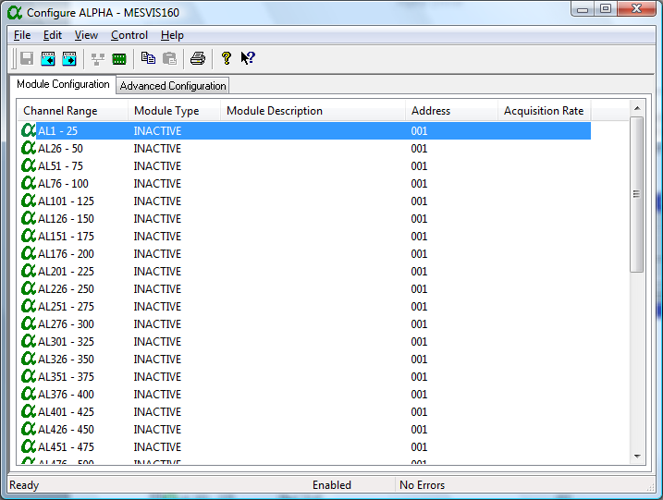
To configure the operation of the whole Alpha Device choose the Advanced ConfigurationTab.
To configure a Alpha Module point to the appropriate module in the Module Configuration Tab and double click.

Advance Alpha Configuration

The Advanced Configuration windows appears as follows.

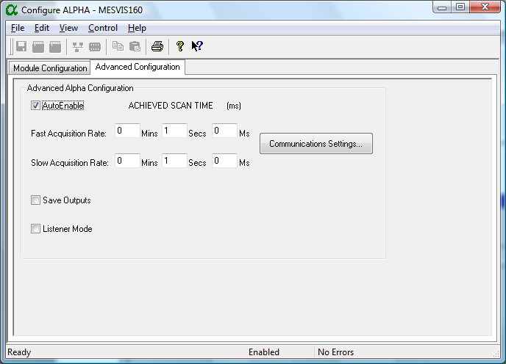

To ensure that the Aplha Service is included in the system check the Auto-Enable Device box.

Alpha Scan Rate
The Alpha device can work in a dual ring mode. This allows a small number of channels to be sampled on the FAST RING more frequently than those on the SLOW RING. All channels on one Alpha Module are sampled at the same rate.
To set the rates, edit the text boxes associated with the Slow Ring A and the Fast Ring B. The values entered should take into account the number of channels on the Alpha Network. The times selected should be greater than the time taken for Alpha to sample all the configured channels. If a faster time or 0 (Zero) is entered then the device will scan as fast as possible. The Fast Ring must be a rate which is a multiple faster than that of Slow Ring.

Save Outputs
To enable this utility check the Save Outputs flag. All values in output channels are saved to disk when the system is disabled. The next time the system is restarted the values which were previously in output channels will be restored to the appropriate channel number.

By Tag
Channel values can be saved and restored to channels using the channel tag instead of the channel number. In this way, channels can be rearranged within the modules and as long as the channel tags remain the same, the correct channel values will be restored to the appropriate channel number.

Listener Mode
The Alpha Device can be configured so that all Channels are in Listener Mode. To enable this check the Listener Mode CheckBox

CommPort Settings
This dialog is used to configure the communications link between the Alpha Network and the computer. From the resulting AlphaComPort dialog box complete as follows :

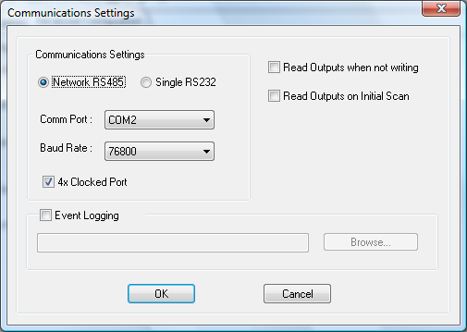

Network RS485
If we’re communicating through the RS485 Network then select this.option

Single RS232
If we’re communicating through an RS232 Link then select this option.

CommPort
From the drop down list select the serial port to be used.

Baud Rate
Select appropriate baud rate for the link.

Read Outputs when not writing
Allows analog outputs to be read if they have not changed in the last scan

Read Outpts on initial scan
Reads outputs on the first scan

Use high speed 485
Check this option if the RS485 card is operating in high speed mode

Event Logging
Check this if you wish to output event data from modules

OK
Click on the OK button to accept the changes

Cancel
Selecting Cancel will abort any changes, reverting back to previous configuration of the port

Configuring an Alpha Module

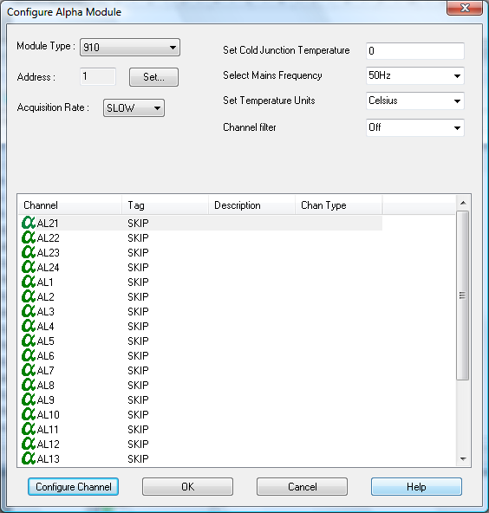

Module Type
From the Module Type drop down list select the Alpha Module type to be configured. The module type number is prominent on the front of each Alpha Unit.

Address
This specifies the address for this module. This can be set at configuration time using the Set button.

Acquisition Rate
From the drop down list select the Acquisition Rate that this unit is to operate on.

Auxiliary Channels
If this module support Auxiliary Channels the you will be given the option to use these channels as Auxiliary Outputs or to use them for the Alpha Alarm Scheme.

Extra Command(n)
Up to six extra commands are added at installation time. These can take the form of Edit Boxes, Check Boxes or Drop Down Lists. The function of these commands should be clear from their descriptors.

Configure Channel
This button takes you to the Channel Configuration Dialog for the selected channel.

OK
When advanced device configuration is complete click on this button to accept and move back to previous Window.

Cancel
Nullify any changes made to both the module and channels configurations during this configuration session. The system will retain the previous configuration.

Help
Online Help for Configuring Alpha Module.

Set Module Address
This dialog allows the useer to set the module address given its Product Code and Serial Number.

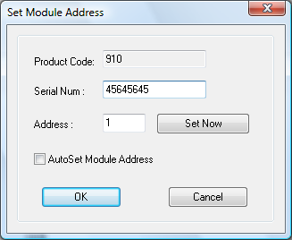

Product Code
The field will display the module Product Code. The user cannot edit this field.

Serial Num
The user must enter the Serial Number of the connected module.

Address
The user must enter the Address that the module described by the above to fields should be set to.

Set Now
The Set Now button gives the user the ability to set the module address there and then. DefaultCommunicationPort settings are used if none have been configured through the Advanced Tab.

Autoset Module Address
This field instructs the driver to always set the Module Address at start-up.

Ok
Exits this dialog and saves options.

Cancel
Exits this dialog without saving options.

Configure Analog Input Modules

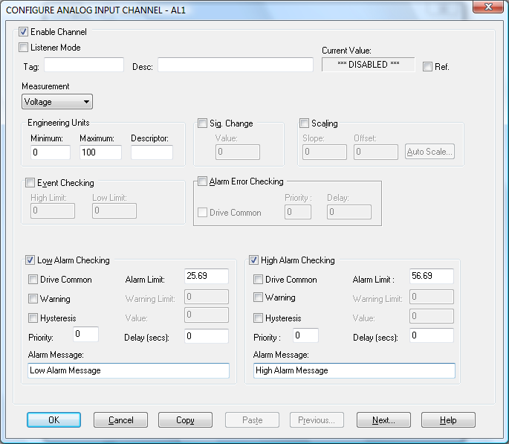

Enable Channel
The Enable Channel check box must be checked to enable, and allow this channel to be configured and ultimately included with all other configured channels in the overall System

Listner Mode
To make make this channel operate in listener mode select this option.

Tag
The tag is an 15 character alphanumeric field that can contain channel information or wiring schedule references.

Description
The Description field is a 32 character alphanumeric field in which a description of the channel can be detailed.

Current Value
Displays the current value of this channel if the scanner is running else it displays “***Disabled***”

CM Parameters
Up to 4 fields will be added at installation time. These alow the user to select the parameter values for the CM command. These can take the form of Edit Boxes, Check Boxes or Drop Down Lists The values for these fields will be downloaded to the Alpha Module at run-time. The function of these fields should be clear from their descriptors.

Extra Commands
Up to two extra commands are added at installation time. These can take the form of Edit Boxes, Check Boxes or Drop Down Lists. The function of these commands should be clear from their descriptors.

Reference
When the Reference check box is checked then this channel has been defined as a Reference Channel. Values of a Reference channel are displayed as the measured value - zero (reference) value. When the System is enabled the zero value can be initialized using one of the following methods::
i) From the Alpha Device Main Window choose Initialize from the Control
menu.
ii) From the Main Window choose Initialise from the Control menu.
iii) Press the keys CTRL + I together.

Engineering Units

Minimum
Minimum engineering value for all analog channels in addition to the unit field. The default is 0

Maximum
Maximum engineering value for all analog channels in addition to the unit field. The default is 100

Descriptor
An 8 character field available to describe the units of the measurement

Scaling
To enable the utility check the Scaling Check box. The Slope and Offset values can be entered directly into the text boxes. The formula applied is:
y = mx + c where: m is SLOPE
x is the measured value.
c is the OFFSET

Auto Scale
Click On the Auto Scale button if you want the scale and offset values calculated automatically. In the dialog box enter the values in the text boxes. The low measured value, and the high measured value, the output range of the transducer.

NB.
Scaling will not be applied to the channel, even if the system is enabled, until the system is next enabled or the Alpha Device is reconfigured.

Significant Change
To enable the Significant Change feature check the Sig Change check box. This facility allows filtering of data on channels on which significant change is of interest. Such changes can cause an event, which can be logged.
The figure entered in the Value text box, in engineering units is the rate of change that if the measured channel exceeds per scan, either increasing or decreasing will cause the significant change event trigger. The scan rate is determined in the Advanced Configuration Tab.
If a logger is configured in Event mode, or Period-Event, each time the significant change trigger operates information on the channels defined in the logger will be recorded . A significant change event only lasts one scan, unless the next reading also changes greater than the Significant change value
When monitoring channels, if the Significant Change is triggered, then the fact will be annotated alongside the other channel information in the Monitor Window.
The significant change events are in addition to those caused by an Event.

Event Checking
Event checking is used, if required to trigger a logger to record information on a number of channels during an event. Check the Event Checking check box if this facility is needed.

High Limit
A value, in engineering units, entered in this text box will define the level that, if
exceeded, will cause an event trigger.

Low Limit
A value entered in this text box will define the level that if the channel result falls below
will cause an event trigger.

Low and High Alarm Checking
Alarm checking is available on all channels throughout the system. Low Alarm and High Alarm levels can be configured independent of each other. All the values entered are in engineering units. If a channel reading exceeds the High Alarm limit then an alarm will be triggered as it will if the channel goes below the Low Alarm limit.
When monitoring channels, if the high or low alarm is triggered, then the fact will be annotated alongside the other channel information in the Monitor Window.

Enable Alarm Checking
Check either the Low Alarm Checking or High Alarm Checking or both check boxes to enable the facility.

Drive Common Alarm
A common alarm is a single digital output which will switch on when any channel with the Drive Common Alarm enabled goes into an alarm state.
Check this box if a link to the Common Alarm is required.

Alarm Limit
The value at which the channel will flag an alarm

Warning and Limit (Analog channel only)
If required, a warning can be displayed when a channel reaches a limit close to the alarm limit. For low alarm checking, the limit must be less than the alarm limit. For high alarm checking, the warning limit must be less than the alarm limit

Hysteresis
Check the box if this feature if needed. Enter the value of the dead band in the text box.
Hysteresis can prevent 'noisy' channels from reporting multiple alarms when the average reading is close to the alarm or warning threshold. The Hysteresis value is relative to the warning or alarm limit.

Priority
Enter or edit the number in the text box to allocate the priority of this alarm.

Alarm Delay
Enter the time, in seconds, between the channel value entering the alarm state and the system flagging an alarm.

Alarm Message
An Alarm Message can be defined to be displayed on the Status line of the application Main Window when a channel goes into an alarm state.
Enter the message, up to 32 characters.

Alarm Error Checking

Drive Common
A common alarm is a single digital output which will switch on when any channel with the Drive Common Alarm enabled goes into an alarm state.
Check this box if a link to the Common Alarm is required.

Priority
Enter or edit the number in the text box to allocate the priority of this channels alarm.

Delay
Enter the time, in seconds, between the channel value entering the alarm state and the system
flagging an alarm.

Use Alpha Alarm Scheme
If this option is present it allows the Alarm Limits to be dowloaded to the Alpha Module. These limits will be used to drive the Alpha Alarm Channel.

Configure Analog Output Modules

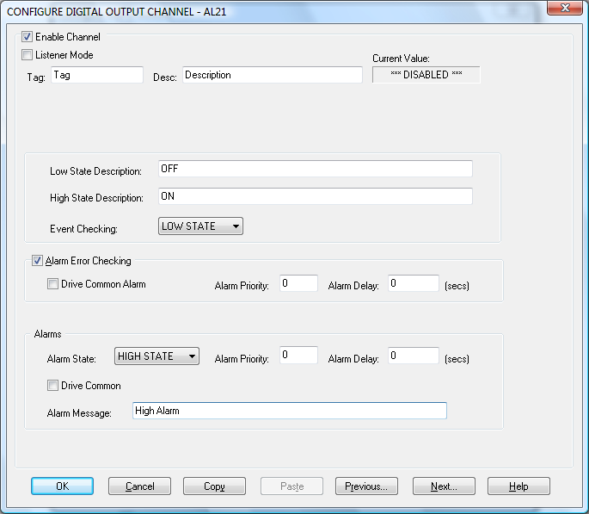

Enable Channel
The Enable Channel check box must be checked to enable, and allow this channel to be configured and ultimately included with all other configured channels in the overall System

Listner Mode
To make make this channel operate in listener mode select this option.

Tag
The tag is an 15 character alphanumeric field that can contain channel information or wiring schedule references.

Description
The Description field is a 32 character alphanumeric field in which a description of the channel can be detailed.

Current Value
Displays the current value of this channel if the scanner is running else it displays “***Disabled***”

CM Parameters
Up to 4 fields will be added at installation time. These alow the user to select the parameter values for the CM command. These can take the form of Edit Boxes, Check Boxes or Drop Down Lists The values for these fields will be downloaded to the Alpha Module at run-time. The function of these fields should be clear from their descriptors.

Extra Commands
Up to two extra commands are added at installation time. These can take the form of Edit Boxes, Check Boxes or Drop Down Lists. The function of these commands should be clear from their descriptors.

Reference
When the Reference check box is checked then this channel has been defined as a Reference Channel. Values of a Reference channel are displayed as the measured value - zero (reference) value. When the System is enabled the zero value can be initialized using one of the following methods::
i) From the Alpha Device Main Window choose Initialize from the Control
menu.
ii) From the Main Window choose Initialise from the Control menu.
iii) Press the keys CTRL + I together.

Engineering Units

Minimum
Minimum engineering value for all analog channels in addition to the unit field. The default is 0

Maximum
Maximum engineering value for all analog channels in addition to the unit field. The default is
100

Descriptor
An 8 character field available to describe the units of the measurement

Significant Change
To enable the Significant Change feature check the Sig Change check box. This facility allows filtering of data on channels on which significant change is of interest. Such changes can cause an event, which can be logged.
The figure entered in the Value text box, in engineering units is the rate of change that if the measured channel exceeds per scan, either increasing or decreasing will cause the significant change event trigger. The scan rate is determined in the Advanced Configuration Tab.
If a logger is configured in Event mode, or Period-Event, each time the significant change trigger operates information on the channels defined in the logger will be recorded . A significant change event only lasts one scan, unless the next reading also changes greater than the Significant change value
When monitoring channels, if the Significant Change is triggered, then the fact will be annotated alongside the other channel information in the Monitor Window.
The significant change events are in addition to those caused by an Event.

Event Checking
Event checking is used, if required to trigger a logger to record information on a number of channels during an event. Check the Event Checking check box if this facility is needed.

High Limit
A value, in engineering units, entered in this text box will define the level that, if exceeded, will cause an event trigger.

Low Limit
A value entered in this text box will define the level that if the channel result falls below will cause an event trigger.

Low and High Alarm Checking
Alarm checking is available on all channels throughout the system. Low Alarm and High Alarm levels can be configured independent of each other. All the values entered are in engineering units. If a channel reading exceeds the High Alarm limit then an alarm will be triggered as it will if the channel goes below the Low Alarm limit.
When monitoring channels, if the high or low alarm is triggered, then the fact will be annotated alongside the other channel information in the Monitor Window.

Enable Alarm Checking
Check either the Low Alarm Checking or High Alarm Checking or both check boxes to enable the facility.

Drive Common Alarm
A common alarm is a single digital output which will switch on when any channel with the Drive Common Alarm enabled goes into an alarm state.
Check this box if a link to the Common Alarm is required.

Alarm Limit
The value at which the channel will flag an alarm

Warning and Limit (Analog channel only)
If required, a warning can be displayed when a channel reaches a limit close to the alarm limit. For low alarm checking, the limit must be less than the alarm limit. For high alarm checking, the warning limit must be less than the alarm limit

Hysteresis
Check the box if this feature if needed. Enter the value of the dead band in the text box.
Hysteresis can prevent 'noisy' channels from reporting multiple alarms when the average reading is close to the alarm or warning threshold. The Hysteresis value is relative to the warning or alarm limit.

Priority
Enter or edit the number in the text box to allocate the priority of this alarm.

Alarm Delay
Enter the time, in seconds, between the channel value entering the alarm state and the system flagging an alarm.

Alarm Message
An Alarm Message can be defined to be displayed on the Status line of the application Main Window when a channel goes into an alarm state.
Enter the message, up to 32 characters.

Alarm Error Checking

Drive Common
A common alarm is a single digital output which will switch on when any channel with the Drive Common Alarm enabled goes into an alarm state.
Check this box if a link to the Common Alarm is required.

Priority
Enter or edit the number in the text box to allocate the priority of this channels alarm.

Delay
Enter the time, in seconds, between the channel value entering the alarm state and the system flagging an alarm.

Use Alpha Alarm Scheme
If this option is present it allows the Alarm Limits to be downloaded to the Alpha Module. These limits will be used to drive the Alpha Alarm Channel.

Configure Counter Input Modules

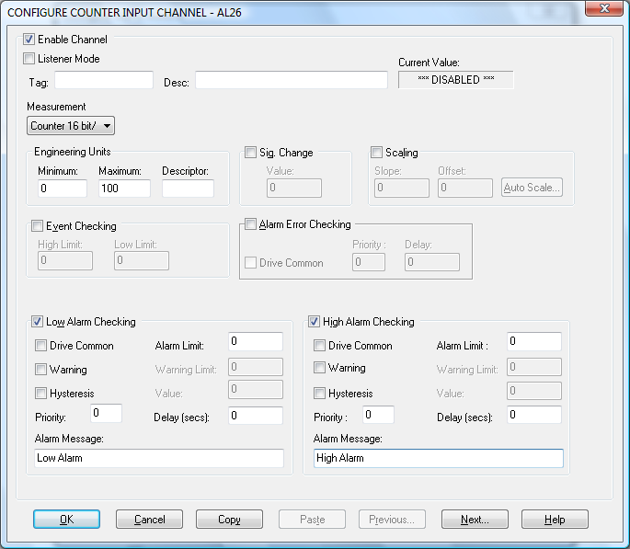

Enable Channel
The Enable Channel check box must be checked to enable, and allow this channel to be configured and ultimately included with all other configured channels in the overall System

Listener Mode
To make this channel operate in listener mode select this option.

Tag
The tag is an 15 character alphanumeric field that can contain channel information or wiring schedule references.

Description
The Description field is a 32 character alphanumeric field in which a description of the channel can be detailed.

Current Value
Displays the current value of this channel if the scanner is running else it displays “***Disabled***”

CM Parameters
Up to 4 fields will be added at installation time. These allow the user to select the parameter values for the CM command. These can take the form of Edit Boxes, Check Boxes or Drop Down Lists The values for these fields will be downloaded to the Alpha Module at run-time. The function of these fields should be clear from their descriptors.

Extra Commands
Up to two extra commands are added at installation time. These can take the form of Edit Boxes, Check Boxes or Drop Down Lists. The function of these commands should be clear from their descriptors.

Engineering Units
Minimum
Minimum engineering value for all analog channels in addition to the unit field. The default is 0

Maximum
Maximum engineering value for all analog channels in addition to the unit field. The default is
100

Descriptor
An 8 character field available to describe the units of the measurement

Scaling
To enable the utility check the Scaling Check box. The Slope and Offset values can be entered directly into the text boxes. The formula applied is:
y = mx + c where: m is SLOPE
x is the measured value.
c is the OFFSET

Auto Scale
Click On the Auto Scale button if you want the scale and offset values calculated automatically. In the dialog box enter the values in the text boxes. The low measured value, and the high measured value, the output range of the transducer.

NB.
Scaling will not be applied to the channel, even if the system is enabled, until the system is next enabled or the Alpha Device is reconfigured.

Significant Change
To enable the Significant Change feature check the Sig Change check box. This facility allows filtering of data on channels on which significant change is of interest. Such changes can cause an event, which can be logged.
The figure entered in the Value text box, in engineering units is the rate of change that if the measured channel exceeds per scan, either increasing or decreasing will cause the significant change event trigger. The scan rate is determined in the Advanced Configuration Tab.
If a logger is configured in Event mode, or Period-Event, each time the significant change trigger operates information on the channels defined in the logger will be recorded . A significant change event only lasts one scan, unless the next reading also changes greater than the Significant change value
When monitoring channels, if the Significant Change is triggered, then the fact will be annotated alongside the other channel information in the Monitor Window.
The significant change events are in addition to those caused by an Event.

Event Checking
Event checking is used, if required to trigger a logger to record information on a number of channels during an event. Check the Event Checking check box if this facility is needed.

High Limit
A value, in engineering units, entered in this text box will define the level that, if exceeded, will cause an event trigger.

Low Limit
A value entered in this text box will define the level that if the channel result falls below will cause an event trigger.

Low and High Alarm Checking
Alarm checking is available on all channels throughout the system. Low Alarm and High Alarm levels can be configured independent of each other. All the values entered are in engineering units. If a channel reading exceeds the High Alarm limit then an alarm will be triggered as it will if the channel goes below the Low Alarm limit.
When monitoring channels, if the high or low alarm is triggered, then the fact will be annotated alongside the other channel information in the Monitor Window.

Enable Alarm Checking
Check either the Low Alarm Checking or High Alarm Checking or both check boxes to enable the facility.

Drive Common Alarm
A common alarm is a single digital output which will switch on when any channel with the Drive Common Alarm enabled goes into an alarm state.
Check this box if a link to the Common Alarm is required.

Alarm Limit
The value at which the channel will flag an alarm

Warning and Limit (Analog channel only)
If required, a warning can be displayed when a channel reaches a limit close to the alarm limit. For low alarm checking, the limit must be less than the alarm limit. For high alarm checking, the warning limit must be less than the alarm limit

Hysteresis
Check the box if this feature if needed. Enter the value of the dead band in the text box.
Hysteresis can prevent 'noisy' channels from reporting multiple alarms when the average reading is close to the alarm or warning threshold. The Hysteresis value is relative to the warning or alarm limit.

Priority
Enter or edit the number in the text box to allocate the priority of this alarm.

Alarm Delay
Enter the time, in seconds, between the channel value entering the alarm state and the system flagging an alarm.

Alarm Message
An Alarm Message can be defined to be displayed on the Status line of the application Main Window when a channel goes into an alarm state.
Enter the message, up to 32 characters.

Alarm Error Checking

Drive Common
A common alarm is a single digital output which will switch on when any channel with the Drive
Common Alarm enabled goes into an alarm state.
Check this box if a link to the Common Alarm is required.

Priority
Enter or edit the number in the text box to allocate the priority of this channels alarm.

Delay
Enter the time, in seconds, between the channel value entering the alarm state and the
system flagging an alarm.

Use Alpha Alarm Scheme
If this option is present it allows the Alarm Limits to be downloaded to the Alpha Module. These limits will be used to drive the Alpha Alarm Channel.

Configure Digital Input Channels.

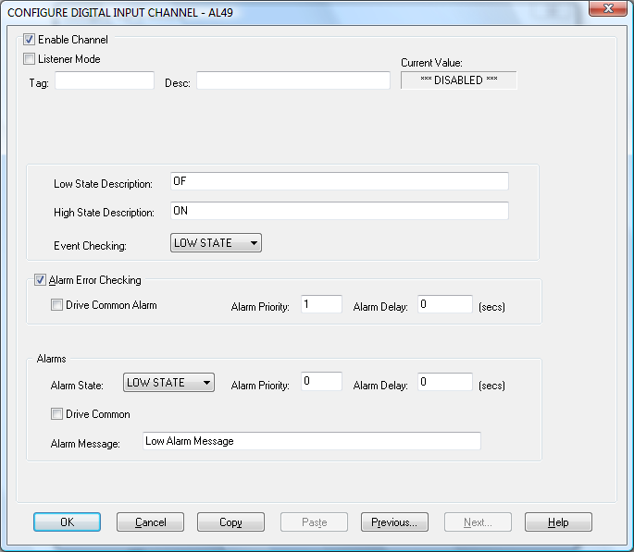

Enable Channel
The Enable Channel check box must be checked to enable, and allow this channel to be configured and ultimately included with all other configured channels in the System.

Listener Mode
To make this channel operate in listener mode select this option.

Tag
The Tag field is an 12 character alphanumeric field that can contain channel information or wiring schedule references.

Description
The Description field is a 16 character alphanumeric field in which a description of the channel can be detailed.

Current Value
Displays the current value of this channel if the scanner is running else it displays “***Disabled***”

CM Parameters
Up to 4 fields will be added at installation time. These alow the user to select the parameter values for the CM command. These can take the form of Edit Boxes, Check Boxes or Drop Down Lists The values for these fields will be downloaded to the Alpha Module at run-time. The function of these fields should be clear from their descriptors.

Extra Commands
Up to two extra commands are added at installation time. These can take the form of Edit Boxes, Check Boxes or Drop Down Lists. The function of these commands should be clear from their descriptors.

LowState Description
A 32 character field in which to enter a description of the low state of the channel.

HighState Description
A 32 character field in which to enter a description of the high state of the channel.

Event Checking
Event checking is used, if required to trigger a logger to record information on an event. If this facility is required click on the drop down list box and select OFF, HIGHSTATE, or LOWSTATE as appropriate

Alarm Error Checking

Drive Common
A common alarm is a single digital output which will switch on when any channel with the Drive
Common Alarm enabled goes into an alarm state.
Check this box if a link to the Common Alarm is required.

Priority
Enter or edit the number in the text box to allocate the priority of this channels alarm.

Delay
Enter the time, in seconds, between the channel value entering the alarm state and the
system flagging an alarm.

Alarms
AlarmState
Alarm checking is available on all channels throughout the System. To configure alarm checking on this channel click on the drop down box and select OFF, HIGHSTATE, or LOWSTATE as appropriate. If the channel's output state changes to an AlarmState an alarm will be triggered on the channel. When monitoring channels, if the alarm is triggered, the fact will be annotated alongside the other channel information in the Monitor Window.

Alarm Priority
Enter the priority of the alarm triggered by this channel.

Common Alarm
Channels can be configured to trigger a Common Alarm. A common alarm is a single digital output which will switch on when any channel with the Drive Common Alarm enabled goes intoan alarm state.

Alarm Message
An Alarm Message can be defined to be displayed on the Status line of the Main Window when a channel goes into an alarm state.

Use Alpha Alarm Scheme
If this option is present it allows the Alarm Limits to be dowloaded to the Alpha Module. These limits will be used to drive the Alpha Alarm Channel.

Configure Digital Output Channels.

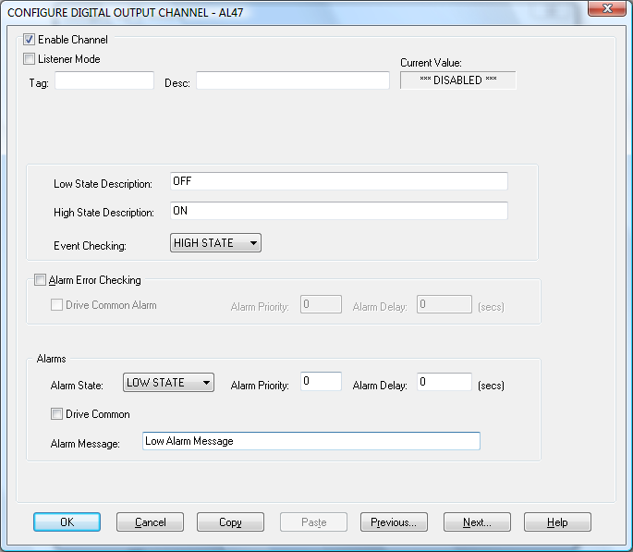

Enable Channel
The Enable Channel check box must be checked to enable, and allow this channel to be configured and ultimately included with all other configured channels in the System.

Listner Mode
To make make this channel operate in listener mode select this option.

Tag
The Tag field is an 12 character alphanumeric field that can contain channel information or wiring schedule references.

Description
The Description field is a 16 character alphanumeric field in which a description of the channel can be detailed.

Current Value
Displays the current value of this channel if the scanner is running else it displays “***Disabled***”

CM Parameters
Up to 4 fields will be added at installation time. These alow the user to select the parameter values for the CM command. These can take the form of Edit Boxes, Check Boxes or Drop Down Lists The values for these fields will be downloaded to the Alpha Module at run-time. The function of these fields should be clear from their descriptors.

Extra Commands
Up to two extra commands are added at installation time. These can take the form of Edit Boxes, Check Boxes or Drop Down Lists. The function of these commands should be clear from their descriptors.

LowState Description
A 32 character field in which to enter a description of the low state of the channel.

HighState Description
A 32 character field in which to enter a description of the high state of the channel.

Event Checking
Event checking is used, if required to trigger a logger to record information on an event. If this facility is required click on the drop down list box and select OFF, HIGHSTATE, or LOWSTATE as appropriate.

Alarm Error Checking

Drive Common
A common alarm is a single digital output which will switch on when any channel with the Drive
Common Alarm enabled goes into an alarm state.
Check this box if a link to the Common Alarm is required.

Priority
Enter or edit the number in the text box to allocate the priority of this channels alarm.

Delay
Enter the time, in seconds, between the channel value entering the alarm state and the
system flagging an alarm.

Alarms
AlarmState
Alarm checking is available on all channels throughout the System. To configure alarm checking on this channel click on the drop down box and select OFF, HIGHSTATE, or LOWSTATE as appropriate. If the channel's output state changes to an AlarmState an alarm will be triggered on the channel. When monitoring channels, if the alarm is triggered, the fact will be annotated alongside the other channel information in the Monitor Window.

Alarm Priority
Enter the priority of the alarm triggered by this channel.

Common Alarm
Channels can be configured to trigger a Common Alarm. A common alarm is a single digital output which will switch on when any channel with the Drive Common Alarm enabled goes into an alarm state.

Alarm Message
An Alarm Message can be defined to be displayed on the Status line of the Main Window when a channel goes into an alarm state.

Use Alpha Alarm Scheme
If this option is present it allows the Alarm Limits to be dowloaded to the Alpha Module. These limits will be used to drive the Alpha Alarm Channel.

Interrogate Alpha Modules

The user can interrogate the alpha module to determine what modules are present on the Network and read there configuration into the next available slot.

This can be achieved by clicking on the Network Modules option in the Edit menu. The user will be presented with the following dialog:

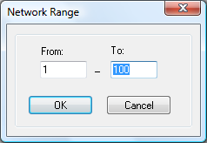
The range limits for the address of the modules to search for must first be entered.

Note: The more modules in the search the longer this will take.

When Searching is complete the user is presented with the following listview:

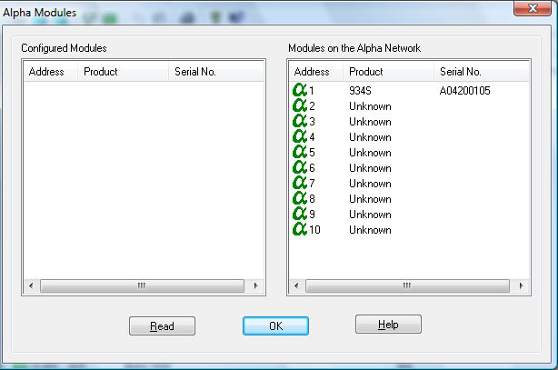

The left hand pane describes the modules that are currently configured in the system whilst the right hand pane displays the details for the modules that where within the search range.

By clicking the Read button any modules that appear in the right hand pane and don’t have a corresponding module in the left hand pane (i.e. the address doesn’t appear in the left hand pane) will have their configuration copied into the system.

Error Codes
Error messages will be reported to users in the Error Banner of both the Main Application and the Alpha Configurations Main View. They will take the following format:

M:nnnXXA:nnnC:nnnS:nnnnn

M: - Details the Module reporting the error.
XX - Details the Command causing the error.
A: - Details the associated Alpha error code.
C: - Details the associated Comms error code.if appropriate.
S: - Details the associated System error code if appropriate.

Alpha Error Codes

001 | If this code appears you should look to the C: to get a descrition of the problem
002 | The selected baudrate is unsupported on this system
003 | Not all of the packet was received within the timeout period for the command
004 | The packing framing characters received were incorrect
005 | A invalid checksum was received
006 | An address was expected int the packet but was not found
007 | An unkown command was sent to the module
008 | The parameters sent with this request were unexpected
009 | The parameter sent with this command was out of range
010 | The channel range specified for this command was invalid
011 | No data was returned for the query
012 | Unkown error returned from the Alpha
013 | The return address on the packet was not what was expected
014 | Unexpected address for this command
015 | The contents of the returned packet was unexpected
016 | An unexpected token was encountered int he return packet
017 | The start channel number for the data packet was not what was expected
018 | The data packet was incomplete
019 | The returned data format was not what was expected
020 | An invlaid range of channels was requested
021 | The channel range in the return packet was unexpected
022 | The report format of the return packet was unexpected
023 | The data packet received exceeds that which was expected

Comms Error Codes

001 | If this code appears you should look to the S: to get a descrition of the problem
002 | The selected communication port is already in use
003 | Could not write all the data to the communication port
004 | Could not read all the requested data on the communication port
005 | The operation being performed on the communication port timed out
006 | The communications handle is invalid
007 | The hardware detected a break condition
008 | Windows 95/98/Me: A parallel device is not selected
009 | The hardware detected a framing error
010 | An I/O error occurred during communications with the device
011 | The requested mode is not supported
012 | Windows 95/98/Me: A parallel device signaled that it is out of paper
013 | A character-buffer overrun has occurred. The next character is lost
014 | Windows 95/98/Me: A time-out occurred on a parallel device
015 | An input buffer overflow has occurred. There is either no room in the input buffer, or a  character was received after the end-of-file (EOF) character
016 | The hardware detected a parity error
017 | The application tried to transmit a character, but the output buffer was full
018 | An unknown error was encountered

System Error Codes

Refer to the operating system documentation.

Debug Facility

The Alpha driver contains a debug facility which allows it to be debugged at run-time should an error occur. To enable this facility a number of Registry Entries must be set:

Switching Debugging On
To switch debugging on simply add the following registry key

HKEY_LOCAL_MACHINE\SOFTWARE\Measuresoft\<ProductName>\ALPHA_<dev_number>_Debugand set its value to “ON”.

Selecting the Debug Type
The Alpha Driver allows you to output the debug information to a Console Window, Text File or as a Trace Statement which can be displayed by applications such as DBWIN32.EXE. To enable these facilities add the following registry key

HKEY_LOCAL_MACHINE\SOFTWARE\Measuresoft\<ProductName>\ALPHA_<dev_number>_DebugType

The values of this key can be as follows:

“CON” to send output to a console window
“FILE” to send the output to a text file or
“TRACE” to send the output as a trace statement.

These can be concatenated to send the output to multiple types by using the | symbol.
e.g. “FILE|CON” would send the output to both File and Console Window.

When sending output to the FILE type you must specify the file. To do this add the following registry entry

HKEY_LOCAL_MACHINE\SOFTWARE\Measuresoft\<ProductName>\ALPHA_<dev_number>_DebugFile

Its value should contain the name of the file you wish to output debug information too.

The number of bytes received and transmitted can be stored in a user analog channel.

To enable counting add the following registry keys
HKEY_LOCAL_MACHINE\SOFTWARE\Measuresoft\<ProductName>\ALPHA_<dev_number>_DebugRxCount
HKEY_LOCAL_MACHINE\SOFTWARE\Measuresoft\<ProductName>\ALPHA_<dev_number>_DebugTxCount

The values of these keys specify a channel used to store the count e.g. P1

The channel used must be configured. To reset the counts, use a calculation function.

Note: Debugging must be switched ON

Note: Console (CON) is not supported on Windows Vista. Instead set the output mode to TRACE, and to view the debug data you must use SysInternals Debug Viewer. This can be downloaded from http://www.microsoft.com/technet/sysinternals/Utilities/DebugView.mspx
In order for Console mode to work on Windows XP the service must be configured to logon as the System Account with Interact with Desktop enabled

Debug View
There is now a debug utility available to use within Alpha that allows you to monitor debug output on the local machine or on any computer over the network via TCP/IP. To launch the debug utility click on Control then Debug on the Configure screen.

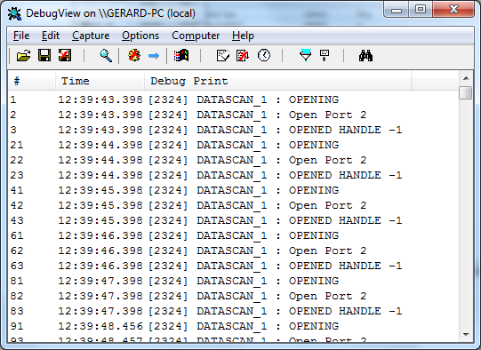

Capture Output
When you start the utility it will begin capturing debug output by default. You can toggle between capture on and capture off with the following toolbar icon: Alternatively you can use Capture Menu > Capture Events or using the Ctrl + E hotkey. When capture mode is off the utility will not capture any debug output until it is turned back on. The kind of output that is captured is determined on whether Win32 or Kernel capture is on or off.

Insert Comments
You can insert comments in the output log by clicking on Edit>Append Comment. Comments insert into the currently viewed output. Type comments into the dialog followed by the Enter key and then close the dialog when you are done entering comments.

Clearing the Display
To clear the output screen simply click on the toolbar or go to Edit>Clear display on the menu.

Searching
You can search for a line of text that is of interest by clicking on the toolbar or going to Edit>Find on the menu. If the search matches what you specified then it will be highlighted on the output window while disabling the auto-scroll feature. To repeat a successful search you can use the F3 hotkey.

Filtering
Another way of picking out debug output is to use the filtering feature. You can use it by clicking on the toolbar or going to Edit>Filter/Highlight on the menu. The Filter/Highlight feature contains two edit fields: include and exclude. The Include field is where you enter substring expressions that match debug output lines that you want the utility to display, and the exclude field is where you enter text for debug output lines that you do not want the utility to display. You can enter multiple expressions, separating each with a semicolon (‘;’). Do not include spaces in the filter expression unless you want the spaces to be part of the filter. Note that the filters are interpreted in a case-insensitive manner, and that you should use ‘*’ as a wildcard.

Highlighting
If you want output lines that contain certain text to be highlighted in the utility output window, enter a highlight filter. The utility implements support for up to five different highlight filters, each with its own foreground and background color settings. Use the filter drop-down in the highlight filter area of the filter dialog to select which highlight filter you want to edit. Use the same syntax just described for include and exclude filters when defining a highlight filter.

Use the Load and Save buttons on the filter dialog to save and restore filter settings, including the include, exclude and highlighting filters, as well as the highlighting colors settings.

History Depth
Another way of controlling the debug output is to limit the number of lines that are retained in the window. You can do this by clicking on the toolbar or Edit>History Depth on the menu. Once opened enter the number of output lines you want the utility to retain and it will keep only that number of the most recent debug output lines, discarding older ones. A history-depth of 0 represents no limit on output lines retained.

Menu Items

File
Item | Description
New Window… | Opens a new debug window.
Open… | Open a saved debug window.
Save | Save the current debug window.
Save As… | Specifies what to save the current debug as.
Log to File… | Creates a log file of the debug output
Log to File As… | Specifies what to save the log file as.
Print… | Prints the debug output.
Print Range… | Specifies what range to print of the debug output.
Process Crash Dump… | Creates a crash dump of the output up until the crash.
Exit | Exit the utility.

Edit
Item | Description
Append Comment | Write a comment for the current output.
Copy | Copy the selected text.
Find | Find a specific piece of text.
Filter/Highlight | Filter the output to include or exclude certain string values.
Clear Display | Clear the debug output window.

Capture
Item | Description
Capture Win32 | Will register to receive and print debug output generated by Win32 programs that call OutputDebugString.
Capture Global Win32 | Let’s you enable and disable the capture of debug output that is generated in the console (global) session.
Capture Kernel | Captures kernel-mode debug output generated by device drivers and/or the Windows kernel
Enable Verbose Kernel Output | Outputs kernel mode in verbose.
Pass-through | Allows you to see kernel-mode debug output in the output buffers of a conventional kernel-mode debugger while at the same time viewing it in the utility.
Capture Events | You can toggle on or off and it will capture events and display on the debug output.
Log Boot | Toggle on or off to enable the utility to log on Windows startup.

Options
Item | Description
Win32 PIDs | Information identifying processes that generate Win32 debug output is prefixed to each line of Win32 debug output.
Force Carriage Returns | Forces carriage returns on the debug output.
History Depth… | Limits the number of lines that are retained in the window.
Clock Time | Toggles between setting the time in seconds or HH:MM:SS.ms
Show Milliseconds | Toggle whether to show milliseconds in the time stamp.
Font | Change the debug output font style, size, and type.
Hide When Minimized | Hides the utility to the taskbar when minimized.
Hide Toolbar | Hides the toolbar on the utility.
Auto Scroll | Toggle between the debug output automatically scrolling down as
Always on Top | Utility window will always appear on top even when it loses focus.

Computer
Item | Description
Connect | Connect to a computer over the network.
Connect Local | Connect to the local machine
Disconnect | Disconnect from the current computer on the network.
COMPUTER_NAME | The current machine you are connected to.

Help
Item | Description
Help… | Displays a help file to explain the utility.
About | Displays current software version and details.

Toolbar

Name | Icon
Open
Save
Log to File
Capture
Capture Kernel
Passthrough Kernel
Capture Win32
Clear
Autoscroll
Time Format
Filter/Highlight
History Depth
Find

Extra User Commands

The Alpha driver contains a facility to allow a set of commands to be downloaded to the Alpha at various points in the scanning cycle. The commands can be configured in the following files in the ALPHA_<n> subdirectory of the CURRENT_CONFIG directory.

Open.txt – When communication to the Alpha network is initially established

Config.txt - – When configuration is downloaded to the Alpha

Initialise.txt – When analog input channels are initialized to zero readings

Reset.txt – When counter channels are reset to sero

Close.txt - When communication to the Alpha network is shut down

The format of the lines in these file for commands not expecting a response is as follows:

0,0,Command

The format of the lines in these file for commands not expecting a response is as follows:

1,<timeout in milliseconds>,Command
e.g.
1,300,@01:AO1

