Measuresoft Development Ltd.

Sigma Driver Manual

Version: 6.4.12.0

Table of Contents
Configuring a Sigma Device 3
Advance Sigma Configuration 3
Sigma Scan Rate 3
Save Outputs 3
Listener Mode 3
Comm Port Settings 3
Network RS485 3
Single RS232 3
Comm Port 3
Baud Rate 3
Read Outputs when not writing 3
Read Outpts on initial scan 3
Use high speed 485 3
Event Logging 3
OK 3
Cancel 3
Configuring a Sigma Module 3
Module Type 3
Address 3
Acquisition Rate 3
Auxiliary Channels 3
Extra Command(n) 3
Configure Channel 3
OK 3
Cancel 3
Help 3
Set Module Address 3
Product Code 3
Serial Num 3
Address 3
Set Now 3
Autoset Module Address 3
Ok 3
Cancel 3
Configure Analog Input Modules 3
Enable Channel 3
Listner Mode 3
Tag 3
Description 3
Current Value 3
CM Parameters 3
Extra Commands 3
Reference 3
Engineering Units 3
Scaling 3
Auto Scale 3
Significant Change 3
Event Checking 3
Low and High Alarm Checking 3
Alarm Error Checking 3
Use Sigma Alarm Scheme 3
Configure Analog Output Modules 3
Enable Channel 3
Listner Mode 3
Tag 3
Description 3
Current Value 3
CM Parameters 3
Extra Commands 3
Reference 3
Engineering Units 3
Significant Change 3
Event Checking 3
Low and High Alarm Checking 3
Alarm Error Checking 3
Use Sigma Alarm Scheme 3
Configure Counter Input Modules 3
Enable Channel 3
Listner Mode 3
Tag 3
Description 3
Current Value 3
CM Parameters 3
Extra Commands 3
Engineering Units 3
Scaling 3
Auto Scale 3
Significant Change 3
Event Checking 3
Low and High Alarm Checking 3
Alarm Error Checking 3
Use Sigma Alarm Scheme 3
Configure Digital Input Channels. 3
Enable Channel 3
Listner Mode 3
Tag 3
Description 3
Current Value 3
CM Parameters 3
Extra Commands 3
Low State Description 3
High State Description 3
Event Checking 3
Alarm Error Checking 3
Alarms 3
Use Sigma Alarm Scheme 3
Configure Digital Output Channels. 3
Enable Channel 3
Listner Mode 3
Tag 3
Description 3
Current Value 3
CM Parameters 3
Extra Commands 3
Low State Description 3
High State Description 3
Event Checking 3
Alarm Error Checking 3
Alarms 3
Use Sigma Alarm Scheme 3
Interrogate Sigma Modules 3
Error Codes 3
Sigma Error Codes 3
Comms Error Codes 3
System Error Codes 3
Debug Facility 3
Switching Debugging On 3
Selecting the Debug Type 3

Configuring a Sigma Device

The first time the system is configured it is necessary to enable and configure the way you wish the overall Sigma Device to operate. To configure the Sigma System either select Devices from the menu bar on the Main Window and then Sigma or double click the Sigma Icon in the Application Program Group.
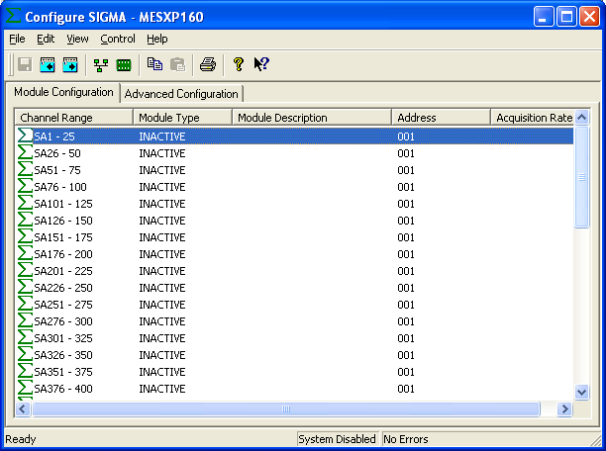

To configure the operation of the whole Sigma Device choose the Advanced Configuration Tab.
To configure a Sigma Module point to the appropriate module in the Module Configuration Tab and double click.

Advance Sigma Configuration

The Advanced Configuration windows appears as follows.

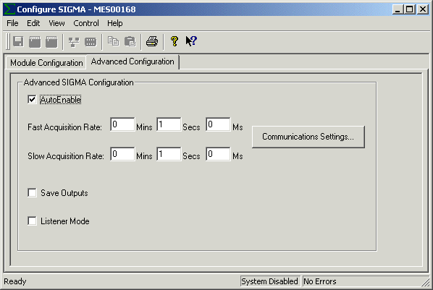

To ensure that the Aplha Service is included in the system check the Auto-Enable Device box.

Sigma Scan Rate
The Sigma device can work in a dual ring mode. This allows a small number of channels to be sampled on the FAST RING more frequently than those on the SLOW RING. All channels on one Sigma Module are sampled at the same rate.
To set the rates, edit the text boxes associated with the Slow Ring A and the Fast Ring B. The values entered should take into account the number of channels on the Sigma Network. The times selected should be greater than the time taken for Sigma to sample all the configured channels. If a faster time or 0 (Zero) is entered then the device will scan as fast as possible. The Fast Ring must be a rate which is a multiple faster than that of Slow Ring.

Save Outputs
To enable this utility check the Save Outputs flag. All values in output channels are saved to disk when the system is disabled. The next time the system is restarted the values which were previously in output channels will be restored to the appropriate channel number.

By Tag
Channel values can be saved and restored to channels using the channel tag instead of the channel number. In this way, channels can be rearranged within the modules and as long as the channel tags remain the same, the correct channel values will be restored to the appropriate channel number.

Listener Mode
The Sigma Device can be configured so that all Channels are in Listener Mode. To enable this check the Listener Mode CheckBox

Comm Port Settings
This dialog is used to configure the communications link between the Sigma Network and the computer. From the resulting Sigma Com Port dialog box complete as follows :

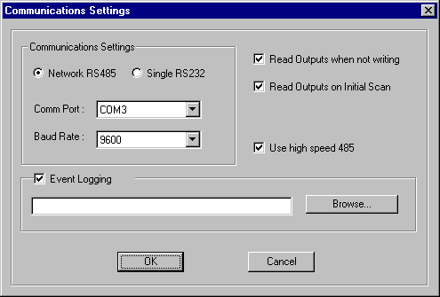

Network RS485
If we’re communicating through the RS485 Network then select this.option

Single RS232
If we’re communicating through an RS232 Link then select this option.

Comm Port
From the drop down list select the serial port to be used.

Baud Rate
Select appropriate baud rate for the link.

Read Outputs when not writing
Allows analog outputs to be read if they have not changed in the last scan

Read Outpts on initial scan
Reads outputs on the first scan

Use high speed 485
Check this option if the RS485 card is operating in high speed mode

Event Logging
Check this if you wish to output event data from modules

OK
Click on the OK button to accept the changes

Cancel
Selecting Cancel will abort any changes, reverting back to previous configuration of the port

Configuring a Sigma Module

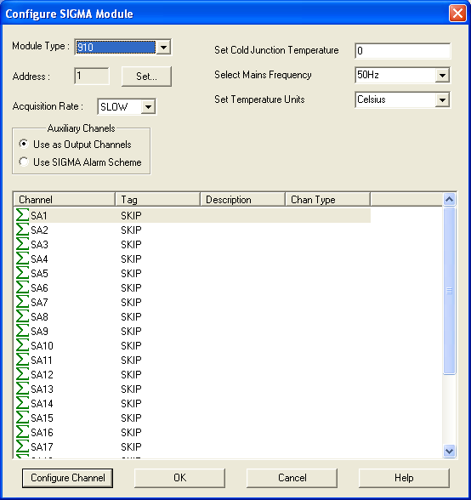

Module Type
From the Module Type drop down list select the Sigma Module type to be configured. The module type number is prominent on the front of each Sigma Unit.

Address
This specifies the address for this module. This can be set at configuration time using the Set button.

Acquisition Rate
From the drop down list select the Acquisition Rate that this unit is to operate on.

Auxiliary Channels
If this module support Auxiliary Channels the you will be given the option to use these channels as Auxiliary Outputs or to use them for the Sigma Alarm Scheme.

Extra Command(n)
Up to six extra commands are added at installation time. These can take the form of Edit Boxes, Check Boxes or Drop Down Lists. The function of these commands should be clear from their descriptors.

Configure Channel
This button takes you to the Channel Configuration Dialog for the selected channel.

OK
When advanced device configuration is complete click on this button to accept and move back to previous Window.

Cancel
Nullify any changes made to both the module and channels configurations during this configuration session. The system will retain the previous configuration.

Help
Online Help for Configuring Sigma Module.

Set Module Address
This dialog allows the useer to set the module address given its Product Code and Serial Number.

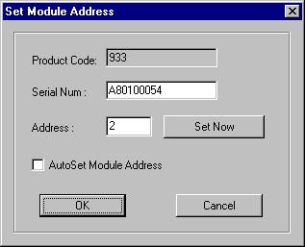

Product Code
The field will display the module Product Code. The user cannot edit this field.

Serial Num
The user must enter the Serial Number of the conected module.

Address
The user must enter the Address that the module described by the above to fields should be set to.

Set Now
The Set Now button gives the user the ability to set the module address there and then. Default Communication Port settings are used if none have been configured through the Advanced Tab.

Autoset Module Address
This field instructs the driver to always set the Module Address at startup.

Ok
Exits this dialog and saves options.

Cancel
Exits this dialog without saving options.

Configure Analog Input Modules

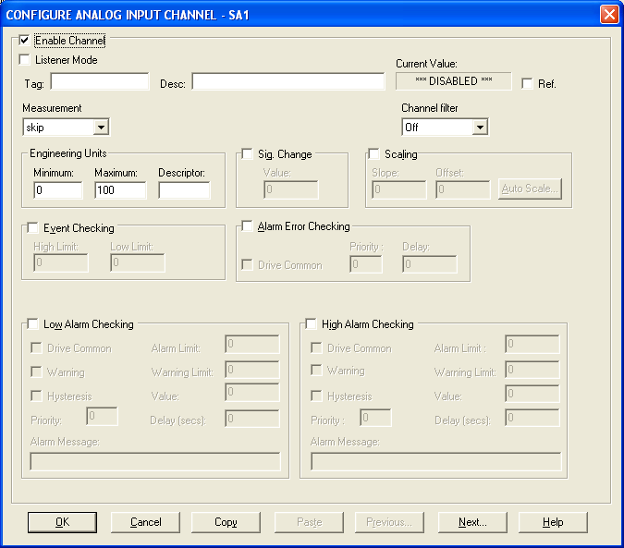

Enable Channel
The Enable Channel check box must be checked to enable, and allow this channel to be configured and ultimately included with all other configured channels in the overall System

Listner Mode
To make make this channel operate in listener mode select this option.

Tag
The tag is an 12 character alphanumeric field that can contain channel information or wiring schedule references.

Description
The Description field is a 32 character alphanumeric field in which a description of the channel can be detailed.

Current Value
Displays the current value of this channel if the scanner is running else it displays “***Disabled***”

CM Parameters
Up to 4 fields will be added at installation time. These alow the user to select the parameter values for the CM command. These can take the form of Edit Boxes, Check Boxes or Drop Down Lists The values for these fields will be downloaded to the Sigma Module at run-time. The function of these fields should be clear from their descriptors.

Extra Commands
Up to two extra commands are added at installation time. These can take the form of Edit Boxes, Check Boxes or Drop Down Lists. The function of these commands should be clear from their descriptors.

Reference
When the Reference check box is checked then this channel has been defined as a Reference Channel. Values of a Reference channel are displayed as the measured value - zero (reference) value. When the System is enabled the zero value can be initialized using one of the following methods::
i) From the Sigma Device Main Window choose Initialize from the Control
menu.
ii) From the Main Window choose Initialise from the Control menu.
iii) Press the keys CTRL + I together.

Engineering Units

Minimum
Minimum engineering value for all analog channels in addition to the unit field. The default is 0

Maximum
Maximum engineering value for all analog channels in addition to the unit field. The default is 100

Descriptor
A 4 character field available to describe the units of the measurement

Scaling
To enable the utility check the Scaling Check box. The Slope and Offset values can be entered directly into the text boxes. The formula applied is:
y = mx + c where: m is SLOPE
x is the measured value.
c is the OFFSET

Auto Scale
Click On the Auto Scale button if you want the scale and offset values calculated automatically. In the dialog box enter the values in the text boxes. The low measured value, and the high measured value, the output range of the transducer.

NB.
Scaling will not be applied to the channel, even if the system is enabled, until the system is next enabled or the Sigma Device is reconfigured.

Significant Change
To enable the Significant Change feature check the Sig Change check box. This facility allows filtering of data on channels on which significant change is of interest. Such changes can cause an event, which can be logged.
The figure entered in the Value text box, in engineering units is the rate of change that if the measured channel exceeds per scan, either increasing or decreasing will cause the significant change event trigger. The scan rate is determined in the Advanced Configuration Tab.
If a logger is configured in Event mode, or Period-Event, each time the significant change trigger operates information on the channels defined in the logger will be recorded . A significant change event only lasts one scan, unless the next reading also changes greater than the Significant change value
When monitoring channels, if the Significant Change is triggered, then the fact will be annotated alongside the other channel information in the Monitor Window.
The significant change events are in addition to those caused by an Event.

Event Checking
Event checking is used, if required to trigger a logger to record information on a number of channels during an event. Check the Event Checking check box if this facility is needed.

High Limit
A value, in engineering units, entered in this text box will define the level that, if
exceeded, will cause an event trigger.

Low Limit
A value entered in this text box will define the level that if the channel result falls below
will cause an event trigger.

Low and High Alarm Checking
Alarm checking is available on all channels throughout the system. Low Alarm and High Alarm levels can be configured independent of each other. All the values entered are in engineering units. If a channel reading exceeds the High Alarm limit then an alarm will be triggered as it will if the channel goes below the Low Alarm limit.
When monitoring channels, if the high or low alarm is triggered, then the fact will be annotated alongside the other channel information in the Monitor Window.

Enable Alarm Checking
Check either the Low Alarm Checking or High Alarm Checking or both check boxes to enable the facility.

Drive Common Alarm
A common alarm is a single digital output which will switch on when any channel with the Drive Common Alarm enabled goes into an alarm state.
Check this box if a link to the Common Alarm is required.

Alarm Limit
The value at which the channel will flag an alarm

Warning and Limit (Analog channel only)
If required, a warning can be displayed when a channel reaches a limit close to the alarm limit. For low alarm checking, the limit must be less than the alarm limit. For high alarm checking, the warning limit must be less than the alarm limit

Hysteresis
Check the box if this feature if needed. Enter the value of the dead band in the text box.
Hysteresis can prevent 'noisy' channels from reporting multiple alarms when the average reading is close to the alarm or warning threshold. The Hysteresis value is relative to the warning or alarm limit.

Priority
Enter or edit the number in the text box to allocate the priority of this alarm.

Alarm Delay
Enter the time, in seconds, between the channel value entering the alarm state and the system flagging an alarm.

Alarm Message
An Alarm Message can be defined to be displayed on the Status line of the application Main Window when a channel goes into an alarm state.
Enter the message, up to 32 characters.

Alarm Error Checking

Drive Common
A common alarm is a single digital output which will switch on when any channel with the Drive Common Alarm enabled goes into an alarm state.
Check this box if a link to the Common Alarm is required.

Priority
Enter or edit the number in the text box to allocate the priority of this channels alarm.

Delay
Enter the time, in seconds, between the channel value entering the alarm state and the system
flagging an alarm.

Use Sigma Alarm Scheme
If this option is present it allows the Alarm Limits to be dowloaded to the Sigma Module. These limits will be used to drive the Sigma Alarm Channel.

Configure Analog Output Modules

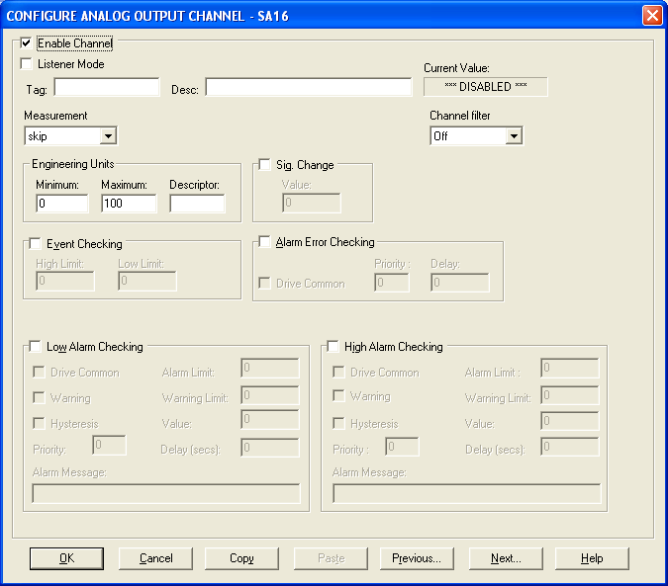

Enable Channel
The Enable Channel check box must be checked to enable, and allow this channel to be configured and ultimately included with all other configured channels in the overall System

Listner Mode
To make make this channel operate in listener mode select this option.

Tag
The tag is an 12 character alphanumeric field that can contain channel information or wiring schedule references.

Description
The Description field is a 32 character alphanumeric field in which a description of the channel can be detailed.

Current Value
Displays the current value of this channel if the scanner is running else it displays “***Disabled***”

CM Parameters
Up to 4 fields will be added at installation time. These alow the user to select the parameter values for the CM command. These can take the form of Edit Boxes, Check Boxes or Drop Down Lists The values for these fields will be downloaded to the Sigma Module at run-time. The function of these fields should be clear from their descriptors.

Extra Commands
Up to two extra commands are added at installation time. These can take the form of Edit Boxes, Check Boxes or Drop Down Lists. The function of these commands should be clear from their descriptors.

Reference
When the Reference check box is checked then this channel has been defined as a Reference Channel. Values of a Reference channel are displayed as the measured value - zero (reference) value. When the System is enabled the zero value can be initialized using one of the following methods::
i) From the Sigma Device Main Window choose Initialize from the Control
menu.
ii) From the Main Window choose Initialise from the Control menu.
iii) Press the keys CTRL + I together.

Engineering Units

Minimum
Minimum engineering value for all analog channels in addition to the unit field. The default is 0

Maximum
Maximum engineering value for all analog channels in addition to the unit field. The default is
100

Descriptor
A 4 character field available to describe the units of the measurement

Significant Change
To enable the Significant Change feature check the Sig Change check box. This facility allows filtering of data on channels on which significant change is of interest. Such changes can cause an event, which can be logged.
The figure entered in the Value text box, in engineering units is the rate of change that if the measured channel exceeds per scan, either increasing or decreasing will cause the significant change event trigger. The scan rate is determined in the Advanced Configuration Tab.
If a logger is configured in Event mode, or Period-Event, each time the significant change trigger operates information on the channels defined in the logger will be recorded . A significant change event only lasts one scan, unless the next reading also changes greater than the Significant change value
When monitoring channels, if the Significant Change is triggered, then the fact will be annotated alongside the other channel information in the Monitor Window.
The significant change events are in addition to those caused by an Event.

Event Checking
Event checking is used, if required to trigger a logger to record information on a number of channels during an event. Check the Event Checking check box if this facility is needed.

High Limit
A value, in engineering units, entered in this text box will define the level that, if exceeded, will cause an event trigger.

Low Limit
A value entered in this text box will define the level that if the channel result falls below will cause an event trigger.

Low and High Alarm Checking
Alarm checking is available on all channels throughout the system. Low Alarm and High Alarm levels can be configured independent of each other. All the values entered are in engineering units. If a channel reading exceeds the High Alarm limit then an alarm will be triggered as it will if the channel goes below the Low Alarm limit.
When monitoring channels, if the high or low alarm is triggered, then the fact will be annotated alongside the other channel information in the Monitor Window.

Enable Alarm Checking
Check either the Low Alarm Checking or High Alarm Checking or both check boxes to enable the facility.

Drive Common Alarm
A common alarm is a single digital output which will switch on when any channel with the Drive Common Alarm enabled goes into an alarm state.
Check this box if a link to the Common Alarm is required.

Alarm Limit
The value at which the channel will flag an alarm

Warning and Limit (Analog channel only)
If required, a warning can be displayed when a channel reaches a limit close to the alarm limit. For low alarm checking, the limit must be less than the alarm limit. For high alarm checking, the warning limit must be less than the alarm limit

Hysteresis
Check the box if this feature if needed. Enter the value of the dead band in the text box.
Hysteresis can prevent 'noisy' channels from reporting multiple alarms when the average reading is close to the alarm or warning threshold. The Hysteresis value is relative to the warning or alarm limit.

Priority
Enter or edit the number in the text box to allocate the priority of this alarm.

Alarm Delay
Enter the time, in seconds, between the channel value entering the alarm state and the system flagging an alarm.

Alarm Message
An Alarm Message can be defined to be displayed on the Status line of the application Main Window when a channel goes into an alarm state.
Enter the message, up to 32 characters.

Alarm Error Checking

Drive Common
A common alarm is a single digital output which will switch on when any channel with the Drive Common Alarm enabled goes into an alarm state.
Check this box if a link to the Common Alarm is required.

Priority
Enter or edit the number in the text box to allocate the priority of this channels alarm.

Delay
Enter the time, in seconds, between the channel value entering the alarm state and the system flagging an alarm.

Use Sigma Alarm Scheme
If this option is present it allows the Alarm Limits to be dowloaded to the Sigma Module. These limits will be used to drive the Sigma Alarm Channel.

Configure Counter Input Modules

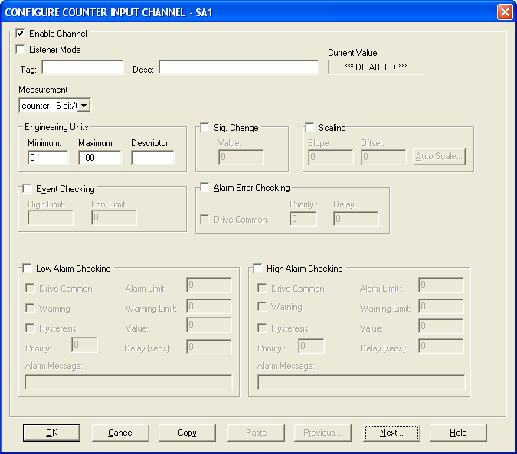

Enable Channel
The Enable Channel check box must be checked to enable, and allow this channel to be configured and ultimately included with all other configured channels in the overall System

Listner Mode
To make make this channel operate in listener mode select this option.

Tag
The tag is an 12 character alphanumeric field that can contain channel information or wiring schedule references.

Description
The Description field is a 32 character alphanumeric field in which a description of the channel can be detailed.

Current Value
Displays the current value of this channel if the scanner is running else it displays “***Disabled***”

CM Parameters
Up to 4 fields will be added at installation time. These alow the user to select the parameter values for the CM command. These can take the form of Edit Boxes, Check Boxes or Drop Down Lists The values for these fields will be downloaded to the Sigma Module at run-time. The function of these fields should be clear from their descriptors.

Extra Commands
Up to two extra commands are added at installation time. These can take the form of Edit Boxes, Check Boxes or Drop Down Lists. The function of these commands should be clear from their descriptors.

Engineering Units
Minimum
Minimum engineering value for all analog channels in addition to the unit field. The default is 0

Maximum
Maximum engineering value for all analog channels in addition to the unit field. The default is
100

Descriptor
A 4 character field available to describe the units of the measurement

Scaling
To enable the utility check the Scaling Check box. The Slope and Offset values can be entered directly into the text boxes. The formula applied is:
y = mx + c where: m is SLOPE
x is the measured value.
c is the OFFSET

Auto Scale
Click On the Auto Scale button if you want the scale and offset values calculated automatically. In the dialog box enter the values in the text boxes. The low measured value, and the high measured value, the output range of the transducer.

NB.
Scaling will not be applied to the channel, even if the system is enabled, until the system is next enabled or the Sigma Device is reconfigured.

Significant Change
To enable the Significant Change feature check the Sig Change check box. This facility allows filtering of data on channels on which significant change is of interest. Such changes can cause an event, which can be logged.
The figure entered in the Value text box, in engineering units is the rate of change that if the measured channel exceeds per scan, either increasing or decreasing will cause the significant change event trigger. The scan rate is determined in the Advanced Configuration Tab.
If a logger is configured in Event mode, or Period-Event, each time the significant change trigger operates information on the channels defined in the logger will be recorded . A significant change event only lasts one scan, unless the next reading also changes greater than the Significant change value
When monitoring channels, if the Significant Change is triggered, then the fact will be annotated alongside the other channel information in the Monitor Window.
The significant change events are in addition to those caused by an Event.

Event Checking
Event checking is used, if required to trigger a logger to record information on a number of channels during an event. Check the Event Checking check box if this facility is needed.

High Limit
A value, in engineering units, entered in this text box will define the level that, if exceeded, will cause an event trigger.

Low Limit
A value entered in this text box will define the level that if the channel result falls below will cause an event trigger.

Low and High Alarm Checking
Alarm checking is available on all channels throughout the system. Low Alarm and High Alarm levels can be configured independent of each other. All the values entered are in engineering units. If a channel reading exceeds the High Alarm limit then an alarm will be triggered as it will if the channel goes below the Low Alarm limit.
When monitoring channels, if the high or low alarm is triggered, then the fact will be annotated alongside the other channel information in the Monitor Window.

Enable Alarm Checking
Check either the Low Alarm Checking or High Alarm Checking or both check boxes to enable the facility.

Drive Common Alarm
A common alarm is a single digital output which will switch on when any channel with the Drive Common Alarm enabled goes into an alarm state.
Check this box if a link to the Common Alarm is required.

Alarm Limit
The value at which the channel will flag an alarm

Warning and Limit (Analog channel only)
If required, a warning can be displayed when a channel reaches a limit close to the alarm limit. For low alarm checking, the limit must be less than the alarm limit. For high alarm checking, the warning limit must be less than the alarm limit

Hysteresis
Check the box if this feature if needed. Enter the value of the dead band in the text box.
Hysteresis can prevent 'noisy' channels from reporting multiple alarms when the average reading is close to the alarm or warning threshold. The Hysteresis value is relative to the warning or alarm limit.

Priority
Enter or edit the number in the text box to allocate the priority of this alarm.

Alarm Delay
Enter the time, in seconds, between the channel value entering the alarm state and the system flagging an alarm.

Alarm Message
An Alarm Message can be defined to be displayed on the Status line of the application Main Window when a channel goes into an alarm state.
Enter the message, up to 32 characters.

Alarm Error Checking

Drive Common
A common alarm is a single digital output which will switch on when any channel with the Drive
Common Alarm enabled goes into an alarm state.
Check this box if a link to the Common Alarm is required.

Priority
Enter or edit the number in the text box to allocate the priority of this channels alarm.

Delay
Enter the time, in seconds, between the channel value entering the alarm state and the
system flagging an alarm.

Use Sigma Alarm Scheme
If this option is present it allows the Alarm Limits to be dowloaded to the Sigma Module. These limits will be used to drive the Sigma Alarm Channel.

Configure Digital Input Channels.

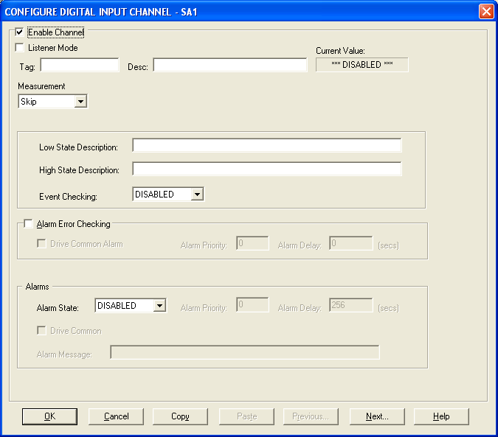

Enable Channel
The Enable Channel check box must be checked to enable, and allow this channel to be configured and ultimately included with all other configured channels in the System.

Listner Mode
To make make this channel operate in listener mode select this option.

Tag
The Tag field is an 12 character alphanumeric field that can contain channel information or wiring schedule references.

Description
The Description field is a 16 character alphanumeric field in which a description of the channel can be detailed.

Current Value
Displays the current value of this channel if the scanner is running else it displays “***Disabled***”

CM Parameters
Up to 4 fields will be added at installation time. These alow the user to select the parameter values for the CM command. These can take the form of Edit Boxes, Check Boxes or Drop Down Lists The values for these fields will be downloaded to the Sigma Module at run-time. The function of these fields should be clear from their descriptors.

Extra Commands
Up to two extra commands are added at installation time. These can take the form of Edit Boxes, Check Boxes or Drop Down Lists. The function of these commands should be clear from their descriptors.

Low State Description
A 32 character field in which to enter a description of the low state of the channel.

High State Description
A 32 character field in which to enter a description of the high state of the channel.

Event Checking
Event checking is used, if required to trigger a logger to record information on an event. If this facility is required click on the drop down list box and select OFF, HIGH STATE, or LOW STATE as appropriate

Alarm Error Checking

Drive Common
A common alarm is a single digital output which will switch on when any channel with the Drive
Common Alarm enabled goes into an alarm state.
Check this box if a link to the Common Alarm is required.

Priority
Enter or edit the number in the text box to allocate the priority of this channels alarm.

Delay
Enter the time, in seconds, between the channel value entering the alarm state and the
system flagging an alarm.

Alarms
Alarm State
Alarm checking is available on all channels throughout the System. To configure alarm checking on this channel click on the drop down box and select OFF, HIGH STATE, or LOW STATE as appropriate. If the channel's output state changes to an Alarm State an alarm will be triggered on the channel. When monitoring channels, if the alarm is triggered, the fact will be annotated alongside the other channel information in the Monitor Window.

Alarm Priority
Enter the priority of the alarm triggered by this channel.

Common Alarm
Channels can be configured to trigger a Common Alarm. A common alarm is a single digital output which will switch on when any channel with the Drive Common Alarm enabled goes into an alarm state.

Alarm Message
An Alarm Message can be defined to be displayed on the Status line of the Main Window when a channel goes into an alarm state.

Use Sigma Alarm Scheme
If this option is present it allows the Alarm Limits to be dowloaded to the Sigma Module. These limits will be used to drive the Sigma Alarm Channel.

Configure Digital Output Channels.

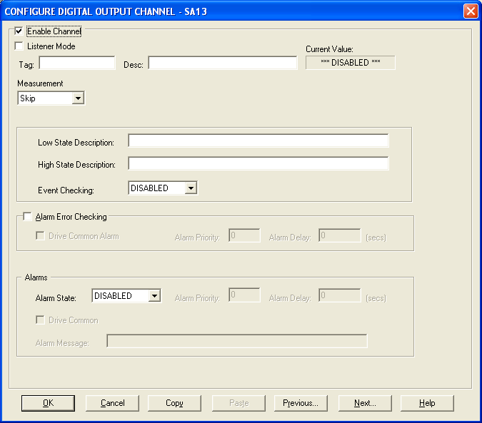

Enable Channel
The Enable Channel check box must be checked to enable, and allow this channel to be configured and ultimately included with all other configured channels in the System.

Listner Mode
To make make this channel operate in listener mode select this option.

Tag
The Tag field is an 12 character alphanumeric field that can contain channel information or wiring schedule references.

Description
The Description field is a 16 character alphanumeric field in which a description of the channel can be detailed.

Current Value
Displays the current value of this channel if the scanner is running else it displays “***Disabled***”

CM Parameters
Up to 4 fields will be added at installation time. These alow the user to select the parameter values for the CM command. These can take the form of Edit Boxes, Check Boxes or Drop Down Lists The values for these fields will be downloaded to the Sigma Module at run-time. The function of these fields should be clear from their descriptors.

Extra Commands
Up to two extra commands are added at installation time. These can take the form of Edit Boxes, Check Boxes or Drop Down Lists. The function of these commands should be clear from their descriptors.

Low State Description
A 32 character field in which to enter a description of the low state of the channel.

High State Description
A 32 character field in which to enter a description of the high state of the channel.

Event Checking
Event checking is used, if required to trigger a logger to record information on an event. If this facility is required click on the drop down list box and select OFF, HIGH STATE, or LOW STATE as appropriate.

Alarm Error Checking

Drive Common
A common alarm is a single digital output which will switch on when any channel with the Drive
Common Alarm enabled goes into an alarm state.
Check this box if a link to the Common Alarm is required.

Priority
Enter or edit the number in the text box to allocate the priority of this channels alarm.

Delay
Enter the time, in seconds, between the channel value entering the alarm state and the
system flagging an alarm.

Alarms
Alarm State
Alarm checking is available on all channels throughout the System. To configure alarm checking on this channel click on the drop down box and select OFF, HIGH STATE, or LOW STATE as appropriate. If the channel's output state changes to an Alarm State an alarm will be triggered on the channel. When monitoring channels, if the alarm is triggered, the fact will be annotated alongside the other channel information in the Monitor Window.

Alarm Priority
Enter the priority of the alarm triggered by this channel.

Common Alarm
Channels can be configured to trigger a Common Alarm. A common alarm is a single digital output which will switch on when any channel with the Drive Common Alarm enabled goes into an alarm state.

Alarm Message
An Alarm Message can be defined to be displayed on the Status line of the Main Window when a channel goes into an alarm state.

Use Sigma Alarm Scheme
If this option is present it allows the Alarm Limits to be dowloaded to the Sigma Module. These limits will be used to drive the Sigma Alarm Channel.

Interrogate Sigma Modules

The user can interrogate the Sigma module to determine what modules are present on the Network and read there configuration into the next available slot.

This can be achieved by clicking on the Network Modules option in the Edit menu. The user will be presented with the following dialog:

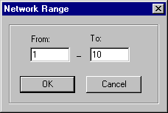
The range limits for the address of the modules to search for must first be entered.

Note: The more modules in the search the longer this will take.

When Searching is complete the user is presented with the following listview:

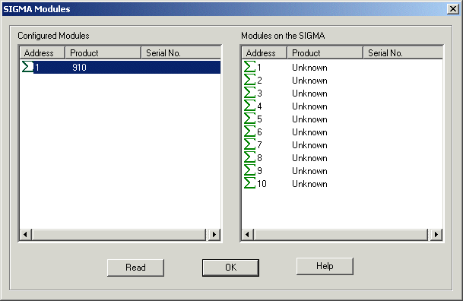

The left hand pane describes the modules that are currently configured in the system whilst the right hand pane displays the details for the modules that where within the search range.

By clicking the Read button any modules that appear in the right hand pane and don’t have a corresponding module in the left hand pane (i.e. the address doesn’t appear in the left hand pane) will have their configuration copied into the system.

Error Codes
Error messages will be reported to users in the Error Banner of both the Main Application and the Sigma Configurations Main View. They will take the following format:

M:nnn XX A:nnn C:nnn S:nnnnn

M: - Details the Module reporting the error.
XX - Details the Command causing the error.
A: - Details the associated Sigma error code.
C: - Details the associated Comms error code.if appropriate.
S: - Details the associated System error code if appropriate.

Sigma Error Codes

001 | If this code appears you should look to the C: to get a descrition of the problem
002 | The selected baudrate is unsupported on this system
003 | Not all of the packet was received within the timeout period for the command
004 | The packing framing characters received were incorrect
005 | A invalid checksum was received
006 | An address was expected int the packet but was not found
007 | An unkown command was sent to the module
008 | The parameters sent with this request were unexpected
009 | The parameter sent with this command was out of range
010 | The channel range specified for this command was invalid
011 | No data was returned for the query
012 | Unkown error returned from the Sigma
013 | The return address on the packet was not what was expected
014 | Unexpected address for this command
015 | The contents of the returned packet was unexpected
016 | An unexpected token was encountered int he return packet
017 | The start channel number for the data packet was not what was expected
018 | The data packet was incomplete
019 | The returned data format was not what was expected
020 | An invlaid range of channels was requested
021 | The channel range in the return packet was unexpected
022 | The report format of the return packet was unexpected
023 | The data packet received exceeds that which was expected

Comms Error Codes

001 | If this code appears you should look to the S: to get a descrition of the problem
002 | The selected communication port is already in use
003 | Could not write all the data to the communication port
004 | Could not read all the requested data on the communication port
005 | The operation being performed on the communication port timed out
006 | The communications handle is invalid
007 | The hardware detected a break condition
008 | Windows 95/98/Me: A parallel device is not selected
009 | The hardware detected a framing error
010 | An I/O error occurred during communications with the device
011 | The requested mode is not supported
012 | Windows 95/98/Me: A parallel device signaled that it is out of paper
013 | A character-buffer overrun has occurred. The next character is lost
014 | Windows 95/98/Me: A time-out occurred on a parallel device
015 | An input buffer overflow has occurred. There is either no room in the input buffer, or a  character was received after the end-of-file (EOF) character
016 | The hardware detected a parity error
017 | The application tried to transmit a character, but the output buffer was full
018 | An unknown error was encountered

System Error Codes

Refer to the operating system documentation.

Debug Facility

The Sigma driver contains a debug facility which allows it to be debugged at run-time should an error occur. To enable this facility a number of Registry Entries must be set:

Switching Debugging On
To switch debugging on simply add the following registry key

HKEY_LOCAL_MACHINE\SOFTWARE\Measuresoft\<ProductName>\SIGMA_<dev_number>_Debug and set its value to “ON”.

Selecting the Debug Type
The Sigma Driver allows you to output the debug information to a Console Window, Text File or as a Trace Statement which can be displayed by applications such as DBWIN32.EXE. To enable these facilities add the following registry key

HKEY_LOCAL_MACHINE\SOFTWARE\Measuresoft\<ProductName>\SIGMA_<dev_number>_DebugType

The values of this key can be as follows:

“CON” to send output to a console window
“FILE” to send the output to a text file or
“TRACE” to send the output as a trace statement.

These can be concatenated to send the output to multiple types by using the | symbol.
e.g. “FILE|CON” would send the output to both File and Console Window.

When sending output to the FILE type you must specify the file. To do this add the following registry entry

HKEY_LOCAL_MACHINE\SOFTWARE\Measuresoft\<ProductName>\SIGMA_<dev_number>_DebugFile

Its value should contain the name of the file you wish to output debug information too.

