Partnership Courtyard, The Ramparts,
Dundalk, Ireland

Version 6.8.0.0
March 7, 2022
www.measuresoft.com
+353 42 933 2399

This document is the copyright of Measuresoft and may not be modified, copied or distributed in any form whatsoever without the prior permission of Measuresoft.

Siemens S5 3964R Driver User Manual

Siemens S5 3964R Driver

Siemens S5 3964R Driver Channel Configuration 3
Steps for Siemens S5 3964R Channel Configuration 3
Channel Device Specific Fields. 3
Type 3
Data Address 3
Data Type 3
Data Bit Number 3
Example 3
Siemens S5 3964R Driver Advanced Configuration 3
Step for Siemens S5 3964R Advanced Configuration 3
Advanced Device Specific Fields 3
Comport Settings 3
Port 3
Parity 3
Baud Rate 3
Protocol Mode 3
Data Format 3
Timeouts 3
Character Delay Time 3
Block Wait Time 3
Timeout 3
Output Scan Options 3
Read Outputs From Device On First Scan 3
Read Outputs Back From Device 3
Siemens S5 3964R Driver Errors 3
Types Of Errors 3
Format Of Error Messages 3
Explanation Of Error Codes 3
Type 1 : Siemens S5 3964R Errors 3
Type 2 : Data Link Layer Errors 3
Type 3 : Win32 Errors 3

Siemens S5 3964R Driver Channel Configuration

Steps for Siemens S5 3964R Channel Configuration
- Choose Siemens S5 3964R selection from the Devices menu.
The following screen appears :

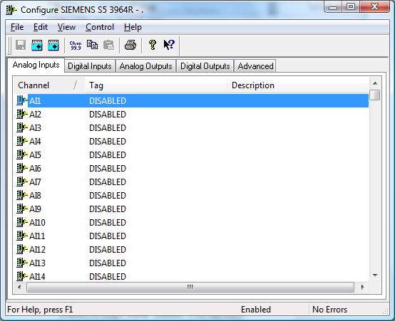

- Choose the type of channel you want to configure. You can choose from the selection on the Tab - Analog Inputs, Digital Inputs, Analog Outputs, Digital Outputs. When you have selected the type of channel that you want to configure, you will be presented with a list of those channels, configured or otherwise. Channels which have been configured and are enabled, have their tag and description displayed here. Channels which have not been enabled will simply display “Disabled” in the tag column.
- To actually configure the channel, select the channel and :
Double Click the desired channel,
or
Select the “Configure Channel” button :
The following dialog will appears :

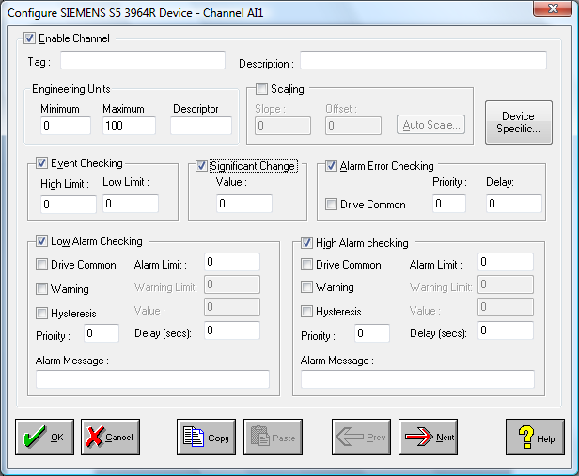

- All fields are “Disabled” initially. Click the “Enable Channel” button in order allow editing of the other fields on the dialog. Fill in the required fields, including: Tag, Description, Scaling, Event Checking, etc. (See the manual for more details).
- Choose the “Device Specific” button to configure Siemens S5 3964R specific parameters. The Channel Device Specific Configuration dialog box appears :

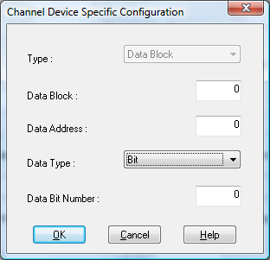

You can now begin to map a channel to the desired PLC data item. For further details on this dialog and it’s fields, see the section on Channel Device Specific Configuration.
- Choose either the OK or CANCEL button to return to the “Configure Siemens S5 3964R Device” dialog, and choose either the OK or CANCEL button again to return to the main “Device Configuration” screen.
- If desired the changes to the configuration can be saved, or discarded by exiting the configuration utility without saving. Only changes to configurations which have been saved will be used by the system.
- In order for the changes to take effect, the system must reload the configurations and restart the device scanner. For channel specific changes described in this section, this requires calling only the reconfigure command from the Control menu either in main menu or the configuration utility. For Advanced configuration changes, the system must be disabled and re-enabled for the changes to take effect.

The same procedure can be repeated to configure as many channels as desired, and the same steps are used for all the channel types (Analog Inputs, Digital Inputs, Analog Outputs, Digital Outputs).

Channel Device Specific Fields.
This section will go through the various fields which must be configured to map a channel to a particular PLC data item.
Below is a summary of all the fields which appear in this dialog.

Field | Meaning
Type | Specifies the type of Siemens S5 3964R Data Item.
Data Block | Data block number.
Data Address | Data Item’s address within selected block.
Data Type | Data Item’s type for interpretation purposes.
Data Bit Number | Data Item’s bit index number.

Type
The possible Siemens S5 3964R types are as follows :

Type | Description
Data Block | One of up to 255 standard S5 PLC Data Blocks.
Extended Data Block | One of the extended S5 PLC Data Blocks.
Input | Input image block.
Output | Output image block.
Input/ Output | Input/ Output image block.
Extended Input/ Output | Extended Input/ Output image block.
Flag | S5 PLC’s internal Flags block.
Counter | S5 PLC’s internal Counters block.
Timer | S5 PLC’s internal Timers block.
System Address | S5 PLC’s System memory.
Absolute Address | S5 PLC’s Absolute memory.

For most of the above types the selection of the type alone will specify the exact block being accessed. For the Data Block however, an explicit data block number must be provided after the type is selected. For this reason the Block edit field is only displayed for this type of Data Item.
Note: Data blocks 0 & 1 are reserved and should never be read / written. Other data blocks will contain data which should never be written to, depending on the particular program installed in the PLC. In the sample program provided, data block 9 should never be written to, as it contains data critical for the 3964R communications.
Note: At present, only Data Blocks can be directly accessed by the scanner. This means that any other values required from the PLC must be mapped within the PLC to Data Blocks. For this reason the Type field is not changeable in the current scanner configuration utility.

Data Address
This is the index of the required Siemens S5 data item, within the specified block.

Data Type
This field determines how the data item will be interpreted once it has been scanned in. For instance, data blocks contain words of data. However, when they are mapped to channel, it may be desired to access a byte or bit only, depending on the application. In addition, an analog value may be interpreted as either a signed or unsigned value.

Data Bit Number
Where Bit is specified as the data type, this field will allow the user to configure a bit number offset into the data item specified above.

Example
16 digital inputs have been mapped within the PLC to Data Block 2, Data Word 0. To map the sixth of these inputs to digital input channel DI1, carry out the following steps : Set the Type to Data Block, set the Data Block to 2, set the Data Address to 0, set the Data Type to Bit, and set the Bit number to 5.
A counter has been mapped within the PLC to Data Block 2, Data Word 1. To map the counter to analog input channel AI1, carry out the following steps : Set the Type to Data Block, set the Data Block to 2, set the Data Address to 1, and set the Data Type to Unsigned Word.

Siemens S5 3964R Driver Advanced Configuration

Step for Siemens S5 3964R Advanced Configuration
- Choose Devices | Siemens S5 3964R on the main menu.
- From the Tab menu, Choose “Advanced” (See diagram above).
- The following screen then appears :

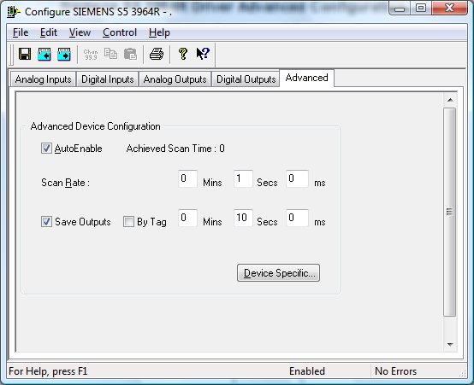

Advanced configuration applies to the device as a whole (e.g. Scan Rate).
- To see any extra device specific configuration that has to be applied to your device, choose the “Device Specific” button. The following dialog appears :

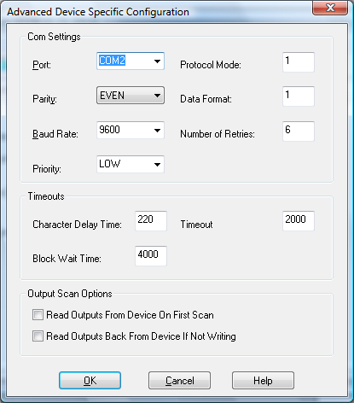

For further information on the fields in this dialog, see the section on Advanced Device Specific Configuration. Choose either the OK or CANCEL button to return to the “Device Configuration - Siemens S5 3964R” dialog.

- If desired the changes to the configuration can be saved, or discarded by exiting the configuration utility without saving. Only changes to configurations which have been saved will be used by the system.

- In order for the changes to take effect, the system must reload the configurations and restart the device scanner. For channel specific changes this requires calling only the reconfigure command from the Control menu either in main menu or the configuration utility. For Advanced configuration changes described in this section, the system must be disabled and re-enabled for the changes to take effect.

Advanced Device Specific Fields
The fields in the “Advanced Device Specific Configuration” dialog are broken into three categories :
Com Settings
Timeouts
Output Scan Options

Comport Settings
This section relates to the physical communications and protocols between the PC and the Siemens S5 3964R station. The configuration of these fields must match that on the connected PLC.

Port
This allows you to select the port to which your PLC will be connected. To choose a port, click on the down arrow to the right of the Port field. The drop down list will contain a list of all available ports on your system. Simply choose the one you want.

Parity
There are five types of parity available:

NONE
ODD
EVEN
MARK
SPACE

Parity is selected in the same way as the port (click on the arrow and choose from the provided list). The value set here should be the same as the value set for PRTY in the DB1 data block on the PLC. The parity will default to the standard EVEN for Siemens S5 3964R PLCs.

Baud Rate
This allows you to set your desired baud rate. The baud rate is selected in the same way as the port (click on the arrow and choose from the provided list). The value set here should be the same as the value set for BDR in the DB1 data block on the PLC. The baud rate will default to the standard 9600 for Siemens S5 3964R PLCs. The supported baud rates are:

75 | 600 | 7200 | 57600
110 | 1200 | 9600 | 115200
134 | 1800 | 14400
150 | 2400 | 19200
300 | 4800 | 38400

Protocol Mode
This allows the user to decide which of the two supported protocol modes to use, either 3964 or 3964R. The value set here should be the same as the value set for MOD in the DB1 data block on the PLC. The difference between the two protocols is that the 3964R protocol adds a block check character to the end of each message transferred in order to detect transmission errors. The default for Siemens S5 3964R PLCs is to set the mode to 1, which is 3964R.

Mode | Protocol
1 | 3964R | Mesasage Error Checking Enabled
2 | 3964 | Mesasage Error Checking Disabled

Data Format
This allows the user to configure the data byte transmission format. The value set here should be the same as the value set for DF in the DB1 data block on the PLC. The table below shows details of the actual byte transfer characteristics associated with each valid value for the data format. The default value for Siemens S5 3964R PLCs is 1.

Data  Format | Num  Start Bits | Num  Data Bits | Num  Parity Bits. | Num  Stop Bits | Num  Total Bits
0 | 1 | 7 | 1 | 2 | 11
1 (Default) | 1 | 8 | 1 | 1 | 11
2 | 1 | 8 | 0 | 2 | 11
3 | 1 | 7 | 0 | 2 | 10
4 | 1 | 7 | 1 | 1 | 10
5 | 1 | 8 | 0 | 1 | 10
6 (Invalid) | * | * | * | * | *
7 | 1 | 7 | 1 | 2 | 11
8 | 1 | 8 | 1 | 1 | 11

Timeouts
This section relates to the physical communications between the PC and the Modbus stations. The fields to be configured are:

Character Delay Time
Timeout between successive characters.

Block Wait Time
Maximum time for a complete data exchange.

Timeout
Timeout on a PLC response to a request.

Output Scan Options
This section relates to the scanning of outputs. To select / deselect either option, click on the appropriate check box.

Read Outputs From Device On First Scan
This decides what type of scan to do on Outputs the first time that scanning actually commences.

Read Outputs Back From Device

If selected
If outputs have not changed then
The values don’t need to be written to file.
The values will be read back from the device.
If not selected

If outputs have not changed then
The values don’t need to be written to file.
No update occurs.

Siemens S5 3964R Driver Errors

Types Of Errors
There are a number of different categories of error message. They are as follows :

Type Of Error | Related To
Siemens S5 3964R Errors | Errors detected by the Siemens S5 3964R PLC
Data Link Layer Errors | Errors detected in Serial Communications
Win32 Errors | Standard Windows Errors
Time Out Errors | Siemens S5 PLC is Not Responding

Format Of Error Messages

Note :

The Data Address refers to the first address of a block that an error occured in.

Example :
A PLC has 5 analog values in Data Block 2, starting at Data Word 0, and these are all the values which were allocated in Data Block 2. The Siemens S5 3964R Driver tries to read data items DB2DW10 - DB2DW14 as these have all been configured to channels by a user. The read will fail, and an error message will be reported.

The errors are displayed :

At the bottom of the Main Menu screen
and

At the bottom of the Siemens S5 3964R Configuration screen

Explanation Of Error Codes

Here, we will :

- Name the type of error message
- Give its format/syntax
- Describe the error codes contained in the category
- Document the meaning of each of the errors
- Give appropriate examples

_____________________________________________________________________

Type 1 : Siemens S5 3964R Errors

Syntax : <Data Address> : S5 3964R <Error Code>

Error Code | Meaning
0x0A | Message parameter illegal / not-permissible.
0x0C | Data type illegal / not-permissible.
0x10 | Bad message / data type.
0x12 | System command “XM” not-permissible.
0x14 | Data block illegal / too short / non-existent.
0x16 | 3964R comand illegal / non-existent.
0x2A | CPU in stop mode.
0x32 | Data block disabled.
0x34 | Bad message length value.
0x36 | Unexpected message.

Example : DB2DW30: S5 3964R 0x14

Meaning : Data Block 2, Data Word 30, Error 14Hex = Data block too short.

Type 2 : Data Link Layer Errors

Syntax : <Data Address> : DATA LINK <Error Code>

Error Code | Meaning
0x01 | Timed out.
0x02 | Unexpected control character received.
0x03 | Buffer overrun.
0x04 | Bad error check.
0x05 | Duplicate packet received.
0x06 | NAK received.
0x07 | Packet is too small.
0x08 | Unexpected character received.
0x11 | Unexpected STX received.

Example : DB2DW1: DATA LINK 0x08

Meaning : Data Block 2, Data Word 1, Error 8Hex = Unexpected character received.
Probable Cause : Incorrect protocol being used.
_____________________________________________________________________

Type 3 : Win32 Errors

Syntax : <Data Address> : WIN32 <Error Code>

Error Codes
The error codes for Win32 related errors can be found in the Win32 documentation.
_____________________________________________________________________

