Partnership Courtyard, The Ramparts,
Dundalk, Ireland

Version 6.8.0.0
March 7, 2022
www.measuresoft.com
+353 42 933 2399

This document is the copyright of Measuresoft and may not be modified, copied or distributed in any form whatsoever without the prior permission of Measuresoft.

ScaniValve DSA Driver User Manual

Table of Contents

1 Configuration 3
2 Channel Configuration 3
2.1 Enable Channel 3
2.2 Tag 3
2.3 Description 3
2.4 Engineering Units 3
2.4.1 Minimum 3
2.4.2 Maximum 3
2.4.3 Descriptor 3
2.5 Device Specific Button 3
3 Advanced Device Configuration 3
3.1 AutoEnable Device 3
3.2 Scan Rate 3
3.3 Save Outputs 3
3.4 Device Specific Button 3
3.4.1 IP Address 3
3.4.2 Scan Units 3
3.4.3 Calibrate Zero 3
3.4.4 Telnet 3

Configuration

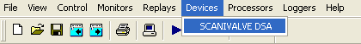

The first time the system is configured it is necessary to enable and configure all devices you require. To configure a particular device select the Devices option from the main menu followed by the SCANIVALVE DSA device. This will launch an application to configure the device.

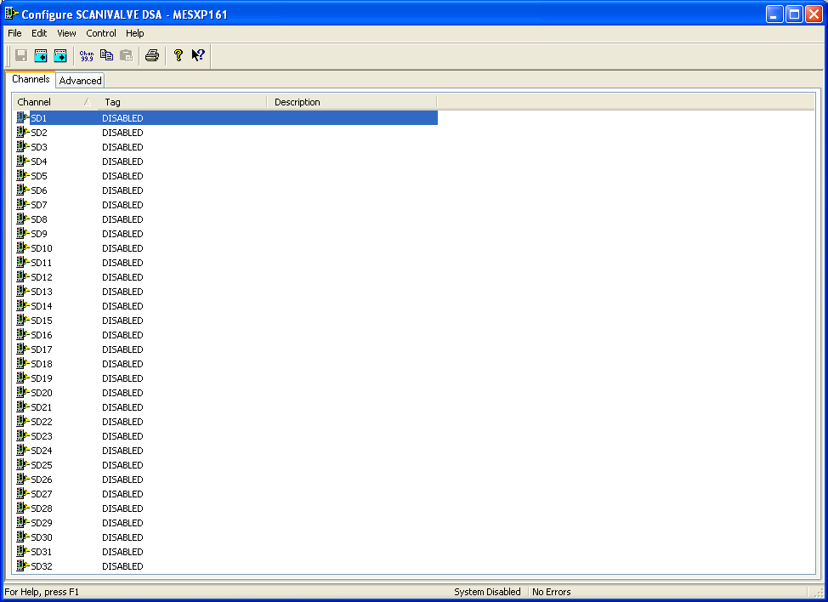

From the list provided select a channel and double-click. Alternatively you can select a channel and then click on the Configure Channel button.

This will launch a channel configuration dialog which enables you to configure individual channels.

Channel Configuration
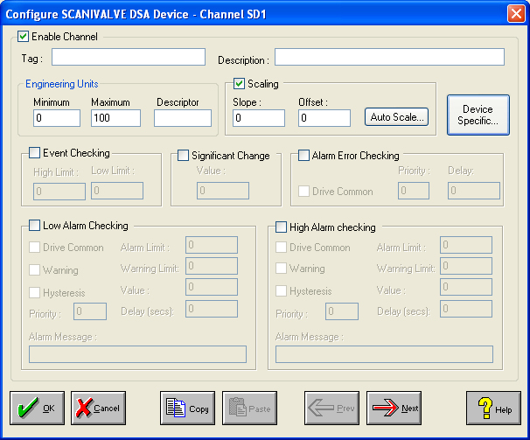

Enable Channel
The Enable Channel check box must be checked to enable and allow a channel to be configured and ultimately included with all other configured channels in the overall system.

Tag
The Tag field is a 12 character alphanumeric field that can contain channel information or wiring schedule references.

Description
The Description field is a 32 character alphanumeric field in which a description of the channel can be detailed.

Engineering Units
Specifies engineering details for this channel.

Minimum
Minimum engineering value for all Analog channels in addition to the unit field. The default is 0.

Maximum
Maximum engineering value for all Analog channels in addition to the unit field. The default is 100.

Descriptor
A four character field available to describe the units of the measurement.

Device Specific Button
When the Device Specific Button is pressed a dialog appears detailing the channel type and channel number on the DSA module.

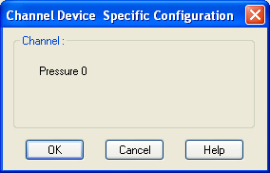

Advanced Device Configuration
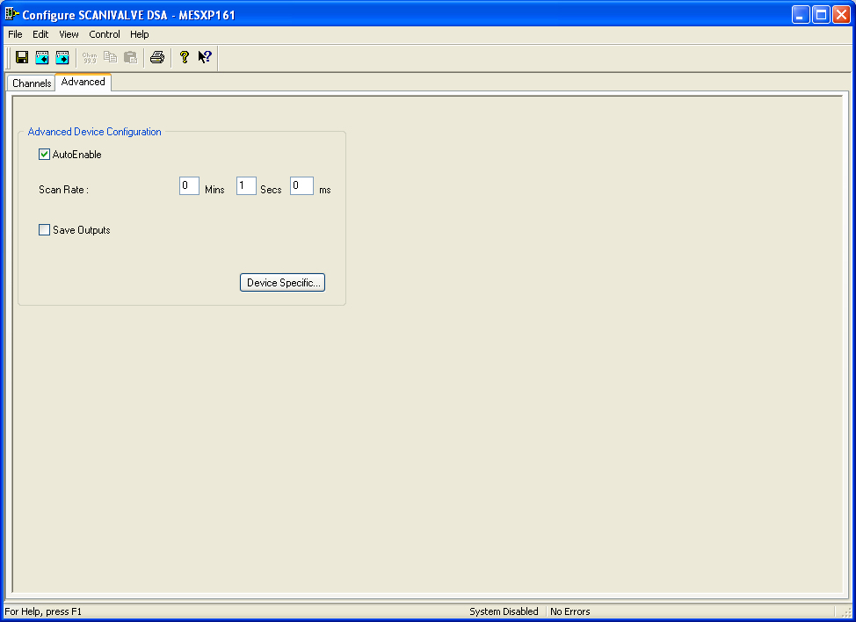

AutoEnable Device
To ensure that the device is enabled on the system check the Enable Device box.

Scan Rate
To set the rate at which the device will scan, edit the text boxes associated with the Scan Rate field.

Save Outputs
To enable this utility check the Save Outputs flag. All values in output channels are saved to disk when the system is disabled. The next time the system is restarted the values which were previously in output channels will be restored to the appropriate channel number.

Device Specific Button
When the Device Specific Button is pressed the following dialog appears to allow specific communication settings to be configured for the device.

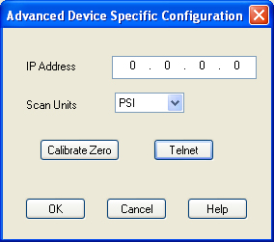

IP Address
The IP address required to communicate with the device.

Scan Units
The units of pressure to be returned from the device.

Calibrate Zero
When the device is disabled and the calibrate zero button is pressed the system with perform a quick zero calibration. Select the Calibrate Zero button only when the device is disabled to perform a quick zero calibration.

Telnet
When the device is disabled and the telnet button is pressed the system will communicate directly with the device. Select the Telnet button only when the device is disabled to communicate directly with the device.

