Partnership Courtyard, The Ramparts,
Dundalk, Ireland

Version 6.8.0.0
March 7, 2022
www.measuresoft.com
+353 42 933 2399

This document is the copyright of Measuresoft and may not be modified, copied or distributed in any form whatsoever without the prior permission of Measuresoft.

SAIS Master Driver User Manual

1. Configuration 3
2. Channel Configuration (Analogs) 3
2.1 Enable Channel 3
2.2 Tag 3
2.3 Description 3
2.4 Units 3
2.5 Device Specific Button 3
2.6 Scaling 3
2.6.1 Auto Scaling 3
2.7 Significant Change 3
2.8 Event Checking 3
2.8.1 High Limit 3
2.8.2 Low Limit 3
2.9 Alarm Checking 3
2.9.1 Enable Alarm Checking 3
2.9.2 Drive Common Alarm 3
2.9.3 Alarm Limit 3
2.9.4 Warning and Limit (Analogue channel only) 3
2.9.5 Hysteresis 3
2.9.6 Priority 3
2.9.7 Alarm Delay 3
2.9.8 Alarm Message 3
2.9.9 Alarm Error Checking 3
2.9.10 Device Specific Button 3
3. Channel Configuration (Digitals) 3
3.1 Enable Channel 3
3.2 Tag 3
3.3 Description 3
3.4 Low State Description 3
3.5 High State Description 3
3.6 Event Checking 3
3.7 Alarm Checking 3
3.7.1 Alarm State 3
3.7.2 Alarm Priority 3
3.7.3 Common Alarm 3
3.7.4 Alarm Delay 3
3.7.5 Alarm Message 3
3.7.6 Alarm Error Checking 3
3.7.7 Device Specific Button 3
4. Advanced Device Configuration 3
4.1 Enable Device 3
4.2 Scan Rate 3
4.3 Save Outputs 3
4.4 Device Specific Button 3
4.4.1 Primary Port 3
4.4.2 Secondary Port 3
4.4.3 Station Configuration 3
4.4.4 Import Configuration 3
4.4.5 Export Configuration 3
5. Scanner Run Time Characteristics 3
5.1 Configuring the DEVCAP Entry 3
5.2 Update Order 3
5.2.1 Channel Numbers 3
5.2.2 Channel Types 3
5.3 Input/Output Control 3
5.3.1 Outputs 3
5.3.2 Inputs 3
5.3.3 Important Points Regarding Object Updates 3
5.3.4 Device I/O times 3

Configuration

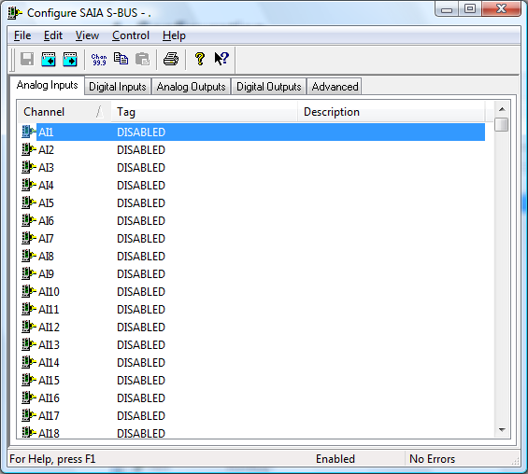

The first time the system is configured it is necessary to enable and configure the way you wish any devices to operate. To configure a particular device select Devices from the main menu bar and then the device name.
This will launch an application to configure the device. You will be presented with a set of tabs. Each tab window has its own list of channels associated with the device.
To configure the operation of the whole device click on the Advanced tab in the main configuration window
To configure a channel select a group of channels by clicking on a channel tab. From the list box select a channel and double-click. Alternatively you can select a channel and then click on the Configure Channel button. This will launch a channel configuration dialog which enables you to configure individual channels.

Channel Configuration (Analogs)

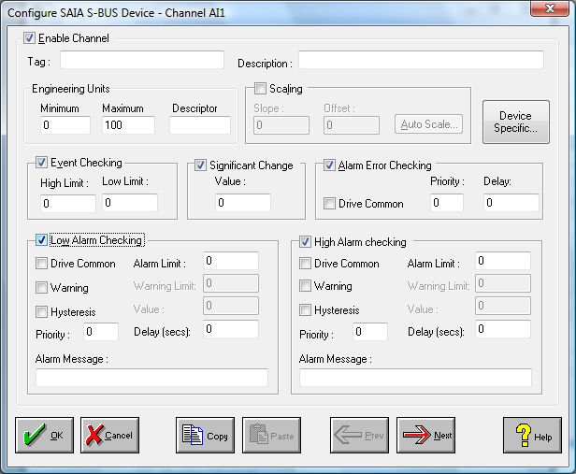

Enable Channel
The Enable Channel check box must be checked to enable, and allow this channel to be configured and ultimately included with all other configured channels in the overall system.

Tag
The Tag field is a 15 character alphanumeric field that can contain channel information or wiring schedule references.

Description
The Description field is a 32 character alphanumeric field in which a description of the channel can be detailed.

Units
An 8 character field available to describe the units of the output.

Device Specific Button
This application can be use as a generic device configuration program. If the Device Specific Button is visible, then click on it to configure channel features that are specific only to the type of device you are configuring.

Scaling
NB. Scaling is only available to Analog channels that are not Output channels.

Some transducers give a number of pulses, or a frequency output proportional to their full scale range. To enable the Scaling utility check the Scaling Check box. The Slope and Offset values can be entered directly into the text boxes. The formula applied is:

y = mx + c where: m is SLOPE
x is the measured value.
c is the OFFSET

Auto Scaling
Click On the Auto Scale button if you want the scale and offset values calculated automatically. A dialog box will be displayed. Enter the values in the text boxes. The low measured value, and the high measured value, the output range of the transducer. When the fields have been completed, and assuming the System is enabled click on the Apply button. Under the heading Current Values the actual measured value will be shown, as well as the Engineering Value.

Click on OK to accept the scaling, or Cancel to abort the Auto Scaling feature.

NB. Scaling will not be applied to the channel, even if the system is enabled, until the system is next enabled or the Device is reconfigured

Significant Change
To enable the Significant Change feature check the Sig Change check box. This facility allows filtering of data on channels on which significant change is of interest. Such changes can cause an event, which can be logged.
The figure entered in the Value text box, is the rate of change that if the output level exceeds per scan, either increasing or decreasing will cause the significant change event trigger. The scan rate is determined in the Advanced Device configuration
If a logger is configured each time the significant change trigger operates information on the channels defined in the logger will be recorded . A significant change event only lasts one scan, unless the next reading also changes greater than the Significant change value

When monitoring channels, if the Significant Change is triggered, then the fact will be annotated alongside the other channel information in the Channel Monitor. The significant change events are in addition to those caused by an Event.

Event Checking
Event checking is used, if required to trigger a logger to record information on a number of channels during an event. Check the Event Checking check box if this channel is to trigger an event.

High Limit
A value, in engineering units, entered in this text box will define the level that, if exceeded, will cause an event trigger.

Low Limit
A value entered in this text box will define the level that if the channel result falls below will cause an event trigger.

Alarm Checking
Alarm checking is available on all channels throughout the system. Low Alarm and High Alarm levels can be configured independent of each other. If the channel output exceeds the High Alarm limit then an alarm will be triggered as it will if the output goes below the Low Alarm limit.

When monitoring channels, if the high or low alarm is triggered, then the fact will be annotated alongside the other channel information in the Channel Monitor. To configure the Alarm Checking section of the device complete the options as follows for either or both the High Alarm and Low Alarm checking.

Enable Alarm Checking
Check either the Low Alarm Checking or High Alarm Checking or both check boxes to enable the facility.

Drive Common Alarm
A common alarm is a single digital output which will switch on when any channel with the Drive Common Alarm enabled goes into an alarm state. Check this box if a link to the Common Alarm is required.

Alarm Limit
Specifies the value which will trigger this alarm. for Low Alarm Checking it will be any value <= the Alarm Limit and for High Alarm Checking it will be any value >= the Alarm Limit.

Warning and Limit (Analogue channel only)
If required, a warning can be displayed when a channel reaches a limit close to the alarm limit. For low alarm checking, the limit must be less than the alarm limit. For high alarm checking, the warning limit must be less than the alarm limit

Hysteresis
Hysteresis can prevent 'noisy' channels from reporting multiple alarms when the average reading is close to the alarm threshold. Check the box if this feature if needed. Enter the value of the dead band in the corresponding value field.

Priority
Enter or edit the number in the text box to allocate the priority of this alarm. Alarm priority ranges are from 0 to 255.

Alarm Delay
Enter the time, in seconds, between the channel value entering the alarm state and the system flagging an alarm.

Alarm Message
An Alarm Message can be defined to be displayed on the Status line of the Main Window when a channel goes into an alarm state. Enter the message, up to 32 characters, that is to appear in the event of an alarm.
the event of an alarm.

Alarm Error Checking
If this option is checked the system will generate an alarm if the channel goes into error.

Device Specific Button

When the Device Specific Button is pressed for Analog Channels the following dialog is presented.

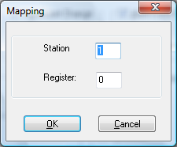

In the above Dialog the Channel is being mapped onto Register 1 on station number 1.

Station
This field specifies the Station that the channel will be mapped to. It can range from station 0 - 254. In order for data to be retrieved from the station must have been configured in the advanced configuration.

Register
This field specifies the Register that the Channel will be mapped to. In the case of registers this field can have a value between 1-64.

Channel Configuration (Digitals)

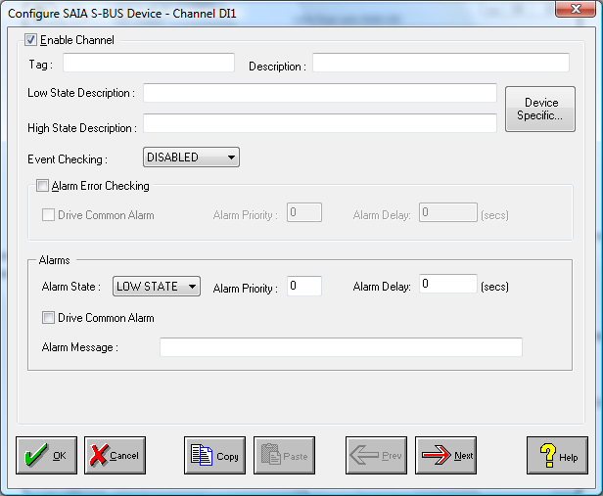

Enable Channel
The Enable Channel check box must be checked to enable, and allow this channel to be configured and ultimately included with all other configured channels in the overall system.

Tag
The Tag field is an 12 character alphanumeric field that can contain channel information or wiring schedule references.

Description
The Description field is a 32 character alphanumeric field in which a description of the channel can be detailed.

LowState Description
A 32 character field in which to enter a description of the low state of the channel.

HighState Description
A 32 character field in which to enter a description of the high state of the channel.

Event Checking
Event checking is used, if required to trigger a logger to record information on an event. If this facility is required click on the drop down list box and select OFF, HIGHSTATE, or LOWSTATE as appropriate

Alarm Checking

AlarmState
Alarm checking is available on all channels throughout the system. To configure alarm checking on this channel click on the drop down box and select OFF, HIGHSTATE, or LOWSTATE as appropriate. If the channel's output state changes to an AlarmState an alarm will be triggered on the channel. When monitoring channels, if the alarm is triggered, the fact will be annotated alongside the other channel information in the Channel Monitor .

Alarm Priority
Enter the priority of the alarm triggered by this channel. Alarm priority ranges are from 0 to 255.

Common Alarm
Channels can be configured to trigger a Common Alarm. A common alarm is a single digital output which will switch on when any channel with the Drive Common Alarm enabled goes into an alarm state.

Alarm Delay
Enter the time, in seconds, between the channel value entering the alarm state and the system flagging an alarm.

Alarm Message
An Alarm Message can be defined to be displayed on the Status line of the Main Window when a channel goes into an alarm state.

Alarm Error Checking
If this option is checked the system will generate an alarm if the channel goes into error.

Device Specific Button

When the Device Specific Button is pressed for Digital Channels the following dialog is presented.

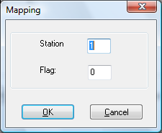

In the above Dialog the Channel is being mapped onto Flag 1 on station number 1.

Station
This field specifies the Station that the channel will be mapped to. It can range from station 0 - 254. In order for data to be retrieved from the station must have been configured in the advanced configuration.

Flag
This field specifies the Flag that the Channel will be mapped to. In the case of flags it can be 1-128.

Advanced Device Configuration

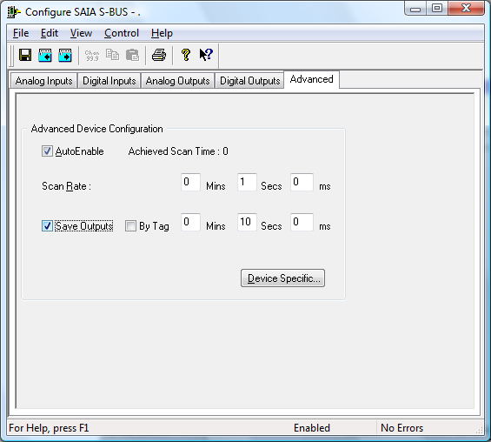

When the system is enabled and the device is enabled this window will display the Achieved Scan Rate . If the device is not scanning then any error associated with the device will be displayed instead.

Enable Device
To ensure that the device is included in the system, check the Enable Device box.

Scan Rate
Sets the rate at which the driver will refresh the channels.

Save Outputs
To enable this utility check the Save Outputs flag. All values in output channels are saved to disk when the system is disabled. The next time the system is restarted the values which were previously in output channels will be restored to the appropriate channel number.

By Tag
Channel values can be saved and restored to channels using the channel tag instead of the channel number. In this way, channels can be rearranged within the modules and as long as the channel tags remain the same, the correct channel values will be restored to the appropriate channel number.

Device Specific Button
If the Device Specific Button is visible, then click on it to configure features that are specific only to the type of device you are configuring.

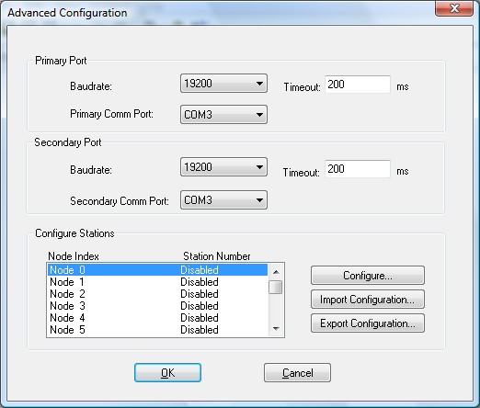

To configure the SAIA S-bus device complete the following fields :

On a SAIA S-bus PCD2 station it is possible to connect to two ports. It is therefore necessary to configure details for both of these ports.

PrimaryPort

Baudrate
The most common baudrates are 9600,19200 and 34200. However, when two ports are being used on one station the highest baudrate is 19,200 (the sum of the baudrates for both ports must not exceed 32,400).

Timeout
A default timeout will be applied when the user changes baud rates. If the user wishes to modify this default timeout then he must manually edit the value in the field.

PrimaryCommunicationPort
A valid CommunicationPort must be selected from the drop down list.

SecondaryPort

Baudrate
The most common baudrates are 9600,19200 and 34200. However, when two ports are being used on one station the highest baudrate is 19,200 (the sum of the baudrates for both ports must not exceed 32,400).

Timeout
A default timeout will be applied when the user changes baud rates. If the user wishes to modify this default timeout then he must manually edit the value in the field.

SecondaryCommunicationPort
A valid CommunicationPort must be selected from the drop down list.

Configure Stations
Up to 24 stations can be configured for scanning. For each of these it is necessary to configure details such as the scan base address, send base address etc. To configure station details simply double click on the required node in the list or select the required node and then the configure button.

Import
Import a predefined configuration for the stations. If the Import facility is used then any other configuration for Stations or Channels will be overwritten.

Export
Export the current system configuration. This writes out all configuration values for the Stations and the Channels.

Station Configuration

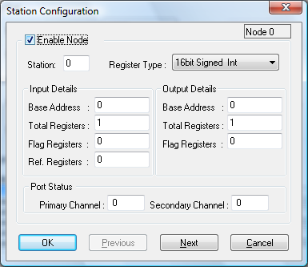

Enable Station
Check this box if you wish to enable configuration.

Station
The Station field specifies the station number that will be associated with this node. The station can be any station number between 0 and 254. It is possible for a user to configure two or more nodes to the same station but in this scenario it will be the details of the first node configured that will be used.

Input Details

Base Address
The Base Address specifies the starting register address for the Analog and Digital
Input packet for the specified station.

Total Registers
The Total Registers field specifies the total number of registers to transfer per input packet.

Flag Registers
The Flag Register field specifies how many of the initial registers in the input packet
are to be used as flag registers.

Reference Registers
The Reference Registers field specifies how many reference registers are contained in the input packet.

Output Details

Base Address
This Base Address specifies the starting register address for the Analog and Digital
Output packet for the specified station.

Total Registers
The Number of Registers field specifies the total number of registers to transfer per
output packet.

Flag Registers
The Flag Register field specifies how many of the initial registers in the output packet are to be used as flag registers.

Example Packet :

Number of Registers : 14
Flag Registers : 4
Reference Registers : 2

Flag Register 1 | 32-25 | 24-17 | 16-9 | 8-1
Flag Register 2 | 64-57 | 56-49 | 48-41 | 40-33
Flag Register 3 | 96-89 | 88-81 | 80-73 | 72-65
Flag Register 4 | 128-121 | 120-113 | 112-105 | 104-97
Ref Register 1 | 32-25 | 24-17 | 16-9 | 8-1
Ref Register 2 | 64-57 | 56-49 | 48-41 | 40-33
Value Register | Register | 2 | Register | 1
Value Register | Register | 4 | Register | 3
Value Register | Register | 6 | Register | 5
Value Register | Register | 8 | Register | 7
Value Register | Register | 10 | Register | 9
Value Register | Register | 12 | Register | 11
Value Register | Register | 14 | Register | 13
Value Register | Register | 16 | Register | 15

Port Status
For each port on a station you can specify a channel that will indicate the port status. If the channel is set to 1 then the port is operational if otherwise the port is inoperable.

Import Configuration

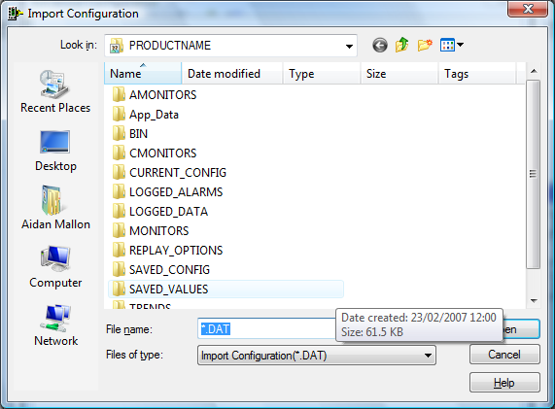

Select the file which contains the configuration you wish to import.

Export Configuration

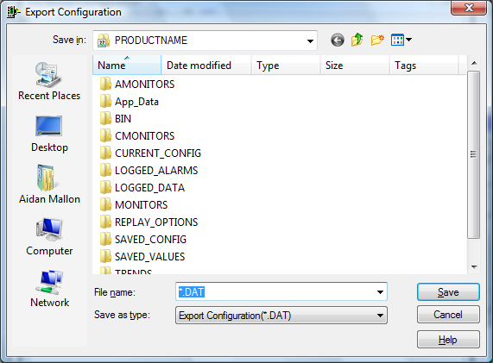

Select the file which you wish to export the configuration to.

See Appendix A for structure of Configuration File.

Scanner Run Time Characteristics

Configuring the DEVCAP Entry
If no entry exists in the ‘devcap.txt’ file for the SAIA S-bus then one must be entered. The entry consists of the following format :

Dev Name , Number , Print Name , an ips, dig ips, an ops, dig ops,

where Dev Name - Device Name (maximum length 8 characters)
Dev Number - Device Number (1 <= device number <= 99)
Print Name - device name displayed menus (max 16 chars)
an ips - analog input channel range
dig ips - digital input channel range
an ops - analog output channel range
dig ops - digital output channel range

E.G.
saias,1,SAIA S-bus,AI:100,DI:100,AO:100,DO:100,

There must be an entry for ALL of these fields to ensure that the scanner operates correctly.

Update Order

Channel Numbers
Channels of the same type are updated in order of ascending channel number.

Channel Types
Channels of different types are updated in the order:

• Digital Outputs
• Analog Outputs
• Digital Inputs
• Analog Inputs

Input/Output Control

Outputs
If the system has control of the Analog and Digital Outputs, which is the case when the first flag in the packet is set to 1, the outputs will be written to the device if a change has occurred on the channel. If, however, this flag is set to 0 then we will read the outputs from the device.
Outputs will always be read on startup of the scanner.

Inputs
The Inputs will be read on each scan of a Station.

Important Points Regarding Object Updates

• Objects are only updated if they are being accessed by an channel.

• All inputs are read on every scan.

• All objects connected to Output channels are either read on
every scan if the system does not have output control, or written only
when a change occurs and the system does have output control.

• If the exact same object element is being accessed by two different Analog Outputs then only the one with the higher channel number will actually drive the object.

• If the exact same object element is being accessed by both an Analog and a Digital Output then it is the Digital Output that will determine it’s value.

Device I/O times
The following are some transmission times

3*32bit Registers : 30ms
14*32bit Registers : 62.7ms
32*32bit Registers : 120ms

Appendix A

Import Export Acronym Listing

Header
Stn | Station Number
Scba | Scan Base Address
Scnrg | Number of Registers
Scfrg | Number of Flag Registers
Scrrf | Number of Reference Registers
seba | Send Base Address
senrg | Number of Registers
sefrg | Number of Flag Registers
sergt | Register Type
pch | Primary Status Channel
sch | Secondary Status Channel

N.B. For ‘rgt’ the following abbreviations apply : 16s - 16 bit Signed Integer
16u - 16 bit UnSigned Integer
32s - 32 bit Signed Integer
32u - 32 bit Unsigned Integer
32f - 32 bit Float

Row
typ | Channel Type
chan | Channel
reg flag num | Register or Flag Number mapped to the Channel
tag name | Channel Tag
desc | Channel Description
eng unt | Engineering Units
sc | Scaling Flag
slope | Slope
offset | Offset
si | Significant Change Flag
signif change | Significant Change Value
ec | Event Checking Flag
event high | Event High Limit
event lo | Event Low Limit
alc | Low Alarm Checking Flag
alarm lo limit | Alram Low Limit
al lo pri | Alarm Low Priority
alw | Alarm Low Warning Flag
alarm lo warning | Alarm Low Earning Value
alh | Alarm Low Hysteresis Flag
alarm lo hyster | Alarm Low Hysteresis Value
ald | Alarm Low Drive Common Alarm Output
alarm lo message | Alarm Low Message
ahc | Low High Checking Flag
alarm hi limit | Alram High Limit
al hi pri | Alarm High Priority
ahw | Alarm High Warning Flag
alarm hi warning | Alarm High Earning Value
ahh | Alarm High Hysteresis Flag
alarm hi hyster | Alarm High Hysteresis Value
ahd | Alarm High Drive Common Alarm Output
alarm hi message | Alarm High Message
digital low state description | DigitalLowState Description
digital high state description | DigitalHighState Description
aldl | Alarm Low Delay
ahdl | Alarm High Delay

