Partnership Courtyard, The Ramparts,
Dundalk, Ireland

Version 6.8.0.0
March 7, 2022
www.measuresoft.com
+353 42 933 2399

This document is the copyright of Measuresoft and may not be modified, copied or distributed in any form whatsoever without the prior permission of Measuresoft.

Pumpworks User Manual

Table of Contents

1 Configuration 3
2 Advanced Device Configuration 4
2.1 AutoEnable Device 4
2.2 Scan Rate 4
2.3 Save Outputs 4
2.3.1 By Tag 5
2.4 Device Specific Button 5
2.4.1.1 Port 5
2.4.1.2 Baud Rate 5
2.4.1.3 Parity 5
2.4.1.4 Data Bits 5
3 Analog Input Channel Configuration 6
3.1 Enable Channel 6
3.2 Tag 6
3.3 Description 6
3.4 Engineering Units 6
3.4.1 Minimum 7
3.4.2 Maximum 7
3.4.3 Descriptor 7
3.5 Device Specific Button 7
3.5.1 Pump No. 7
3.5.2 Pumpworks Item 7
4 Digital Input Channel Configuration 8
4.1 Enable Channel 8
4.2 Tag 8
4.3 Description 8
4.4 Low State Description 8
4.5 High State Description 8
4.6 Event Checking 9
4.7 Alarm Checking 9
4.7.1 Alarm State 9
4.7.2 Alarm Priority 9
4.7.3 Common Alarm 9
4.7.4 Alarm Delay 9
4.7.5 Alarm Message 9
4.8 Device Specific Button 9
4.8.1 Pump No. 10
4.8.2 Pumpworks Item 10

Configuration

The first time the system is configured it is necessary to enable and configure all devices you require. To configure a particular device select the Devices option from the main menu followed by the Pumpworks device. This will launch an application to configure the device.

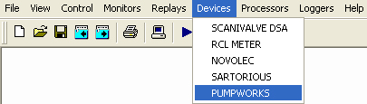

From the list provided select a channel and double-click. Alternatively you can select a channel and then click on the Configure Channel button.

This will launch a channel configuration dialog which enables you to configure individual channels.

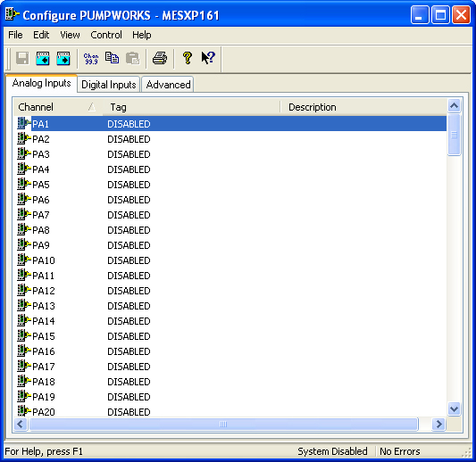

Advanced Device Configuration

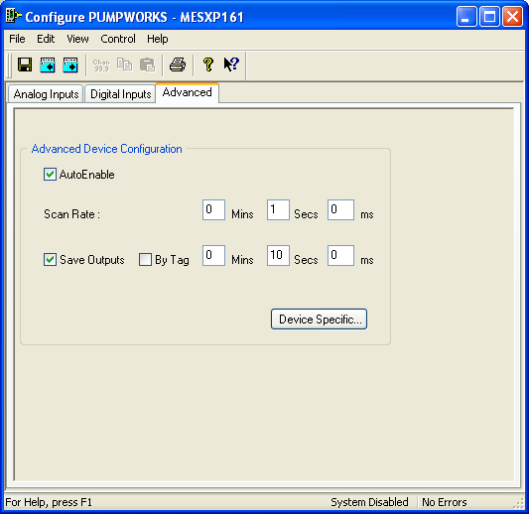

AutoEnable Device
To ensure that the device is enabled on the system check the Enable Device box.

Scan Rate
To set the rate at which the device will scan, edit the text boxes associated with the Scan Rate field.

Save Outputs
To enable this utility check the Save Outputs flag. All values in output channels are saved to disk when the system is disabled. The next time the system is restarted the values which were previously in output channels will be restored to the appropriate channel number.

By Tag
Channel values can be saved and restored to channels using the channel tag instead of the channel number. In this way, channels can be rearranged within the modules and as long as the channel tags remain the same, the correct channel values will be restored to the appropriate channel number.

Device Specific Button
When the Device Specific Button is pressed the following dialog appears to allow specific communication settings to be configured for the device.

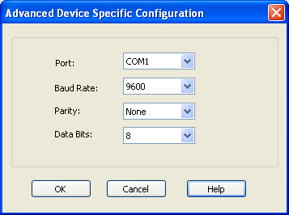

Port
Displays communications ports available on your computer

Baud Rate
Lists the baud rates that are supported by the hardware on your PC. Choose the highest speed that is supported by the hardware. If you encounter problems, you may have to adjust this to a slower speed at a later time.

Parity
Displays the various choices that can be implemented for parity checking.

Data Bits
Displays the various sizes of data bits to send.

Analog Input Channel Configuration

Autoscanning is used to scan analog inputs.

When the user selects an analog input to be configured the following is displayed.

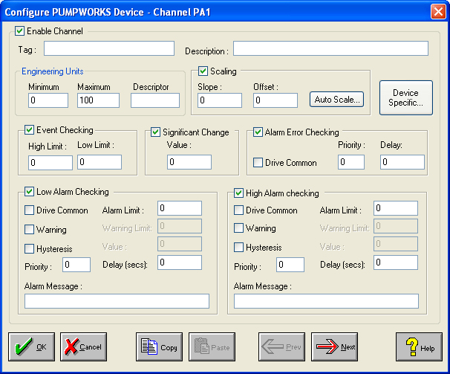

Enable Channel
The Enable Channel check box must be checked to enable and allow a channel to be configured and ultimately included with all other configured channels in the overall system.

Tag
The Tag field is a 12 character alphanumeric field that can contain channel information or wiring schedule references.

Description
The Description field is a 32 character alphanumeric field in which a description of the channel can be detailed.

Engineering Units
Specifies engineering details for this channel.

Minimum
Minimum engineering value for all Analog channels in addition to the unit field. The default is 0.

Maximum
Maximum engineering value for all Analog channels in addition to the unit field. The default is 100.

Descriptor
Describe the units of the measurement.

Device Specific Button
When the Device Specific Button is pressed the following dialog appears to allow specific device configuration of the particular channel.

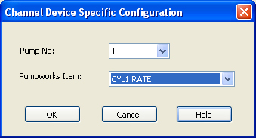

Pump No.
A drop down list allowing the pump (1-8) to be selected.

Pumpworks Item
The data item to read for the pump selected.
For analog channels note that all of these channels are read ‘Raw’ and may need to be scaled

Digital Input Channel Configuration
Digital Inputs are only supported on the 340 Model

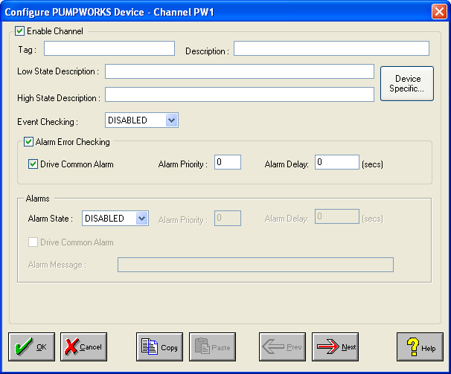

Enable Channel
The Enable Channel check box must be checked to enable, and allow this channel to be configured and ultimately included with all other configured channels in the overall system.

Tag
The Tag field is an 12 character alphanumeric field that can contain channel information or wiring schedule references.

Description
The Description field is a 32 character alphanumeric field in which a description of the channel can be detailed.

LowState Description
A 32 character field in which to enter a description of the low state of the channel.

HighState Description
A 32 character field in which to enter a description of the high state of the channel.

Event Checking
Event checking is used, if required to trigger a logger to record information on an event. If this facility is required click on the drop down list box and select OFF, HIGHSTATE, or LOWSTATE as appropriate. Events are detected on inputs using data acquired at 1Khz. Events are detected on outputs using the configured scan rate.

Alarm Checking

AlarmState
Alarm checking is available on all channels throughout the system. To configure alarm checking on this channel click on the drop down box and select OFF, HIGHSTATE, or LOWSTATE as appropriate. If the channel's output state changes to an AlarmState an alarm will be triggered on the channel. When monitoring channels, if the alarm is triggered, the fact will be annotated alongside the other channel information in the Channel Monitor . Alarms and warnings are detected at the configured scan rate.

Alarm Priority
Enter the priority of the alarm triggered by this channel. Alarm priority ranges are from 0 to 255.

Common Alarm
Channels can be configured to trigger a Common Alarm. A common alarm is a single digital output which will switch on when any channel with the Drive Common Alarm enabled goes into an alarm state.

Alarm Delay
Enter the time, in seconds, between the channel value entering the alarm state and the system flagging an alarm.

Alarm Message
An Alarm Message can be defined to be displayed on the Status line of the Main Window when a channel goes into an alarm state.

Device Specific Button
When the Device Specific Button is pressed the following dialog appears to allow specific device configuration of the particular channel.

Pump No.
A drop down list allowing the pump (1-8) to be selected.

Pumpworks Item
The data item to read for the pump selected.
For analog channels note that all of these channels are read ‘Raw’ and may need to be scaled

