Partnership Courtyard, The Ramparts,
Dundalk, Ireland

Version 6.4.1.2
January 26, 2017
www.measuresoft.com
+353 42 933 2399

This document is the copyright of Measuresoft and may not be modified, copied or distributed in any form whatsoever without the prior permission of Measuresoft.

PSI 8400 Driver User Manual

1. Main Menu 2
2. Channel Configuration (Analogs) 2
2.1 Enable Channel 2
2.2 Tag 2
2.3 Description 2
2.4 Units 2
2.5 Scaling 2
2.5.1 Auto Scaling 2
2.6 Significant Change 2
2.7 Event Checking 2
2.7.1 High Limit 2
2.7.2 Low Limit 2
2.8 Alarm Checking 2
2.8.1 Enable Alarm Checking 2
2.8.2 Drive Common Alarm 2
2.8.3 Alarm Limit 2
2.8.4 Warning and Limit (Analogue channel only) 2
2.8.5 Hysteresis 2
2.8.6 Priority 2
2.8.7 Alarm Delay 2
2.8.8 Alarm Message 2
2.8.9 Alarm Error Checking 2
2.9 Device Specific Button 2
2.9.1 Scanner 2
2.9.2 Port 2
2.9.3 PCU CRS 2
3. Advanced Device Configuration 2
3.1 Enable Device 2
3.2 Scan Rate 2
3.3 Save Outputs 2
3.4 Device Specific Button 2
3.4.1 PSI GPIB Address 2
3.4.2 Timeout 2
3.4.3 Configure SDU’s 2
3.4.4 Valve CRS 2
3.4.5 Cal. Pulse Duration 2
3.4.6 Delay after app. pressure 2
3.4.7 Calibration 2
3.4.8 ReZero Calibration 2
3.4.9 Purge Time 2
3.4.10 Purge 2
3.4.11 Calibrate System on startup 2
3.4.12 O/P Cal. Results 2
3.5 Configure SDU’s 2
3.5.1 SDU CRS 2
3.5.2 Scans Per Meaurement 2
3.5.3 SDU Rate 2
3.5.4 Scanner Configurations 2
3.6 Scanner Add & Edit 2
3.6.1 Scanner CRS 2
3.6.2 No. of ch/Units 2
3.6.3 Logical Range # 2
3.7 PCU Configuration 2
3.7.1 Address for PCU 2
3.7.2 Accuracy 2
3.7.3 Max Pressure 2
3.7.4 Calibration Pressures 2

Main Menu

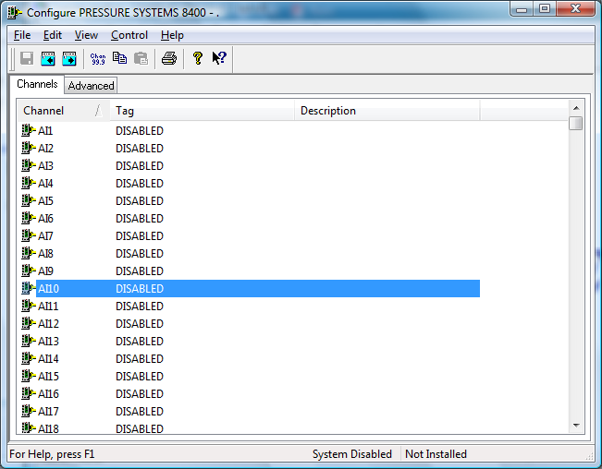

The first time the system is configured it is necessary to enable and configure all devices you require. To configure a particular device select the Devices option from the main menu followed by the appropriate device.
This will launch an application to configure the device. You will be presented with a set of tabs as shown above.
To configure a channel select a group of channels by clicking on the appropriate channel tab. From the list provided select a channel and double-click. Alternatively you can select a channel and then click on the Configure Channel button. This will launch a channel configuration dialog which enables you to configure individual channels.

Channel Configuration (Analogs)

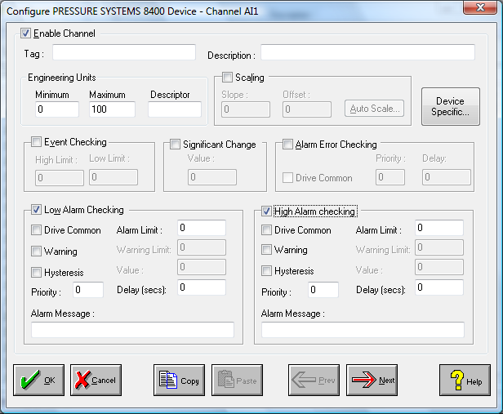

Enable Channel
The Enable Channel check box must be checked to enable, and allow this channel to be configured and ultimately included with all other configured channels in the overall system.

Tag
The Tag field is a 12 character alphanumeric field that can contain channel information or wiring schedule references.

Description
The Description field is a 32 character alphanumeric field in which a description of the channel can be detailed.

Units
A 4 character field available to describe the units of the output.

Scaling
NB. Scaling is only available to Analog channels that are not Output channels.

Some transducers give a number of pulses, or a frequency output proportional to their full scale range. To enable the Scaling utility check the Scaling Check box. The Slope and Offset values can be entered directly into the text boxes. The formula applied is:

y = mx + c where: m is SLOPE
x is the measured value.
c is the OFFSET

Auto Scaling
Click On the Auto Scale button if you want the scale and offset values calculated automatically. A dialog box will be displayed. Enter the values in the text boxes. The low measured value, and the high measured value, the output range of the transducer. When the fields have been completed, and assuming the System is enabled click on the Apply button. Under the heading Current Values the actual measured value will be shown, as well as the Engineering Value.

Click on OK to accept the scaling, or Cancel to abort the Auto Scaling feature.

NB. Scaling will not be applied to the channel, even if the system is enabled, until the system is next enabled or the PSI8400 Device is reconfigured

Significant Change
To enable the Significant Change feature check the Sig Change check box. This facility allows filtering of data on channels on which significant change is of interest. Such changes can cause an event, which can be logged.
The figure entered in the Value text box, is the rate of change that if the output level exceeds per scan, either increasing or decreasing will cause the significant change event trigger. The scan rate is determined in the Advanced Device configuration
If a logger is configured each time the significant change trigger operates information on the channels defined in the logger will be recorded . A significant change event only lasts one scan, unless the next reading also changes greater than the Significant change value

When monitoring channels, if the Significant Change is triggered, then the fact will be annotated alongside the other channel information in the Channel Monitor. The significant change events are in addition to those caused by an Event.

Event Checking
Event checking is used, if required to trigger a logger to record information on a number of channels during an event. Check the Event Checking check box if this channel is to trigger an event.

High Limit
A value, in engineering units, entered in this text box will define the level that, if exceeded, will cause an event trigger.

Low Limit
A value entered in this text box will define the level that if the channel result falls below will cause an event trigger.

Alarm Checking
Alarm checking is available on all channels throughout the system. Low Alarm and High Alarm levels can be configured independent of each other. If the channel output exceeds the High Alarm limit then an alarm will be triggered as it will if the output goes below the Low Alarm limit.

When monitoring channels, if the high or low alarm is triggered, then the fact will be annotated alongside the other channel information in the Channel Monitor. To configure the Alarm Checking section of the device complete the options as follows for either or both the High Alarm and Low Alarm checking.

Enable Alarm Checking
Check either the Low Alarm Checking or High Alarm Checking or both check boxes to enable the facility.

Drive Common Alarm
A common alarm is a single digital output which will switch on when any channel with the Drive Common Alarm enabled goes into an alarm state. Check this box if a link to the Common Alarm is required.

Alarm Limit
Specifies the value which will trigger this alarm. for Low Alarm Checking it will be any value <= the Alarm Limit and for High Alarm Checking it will be any value >= the Alarm Limit.

Warning and Limit (Analogue channel only)
If required, a warning can be displayed when a channel reaches a limit close to the alarm limit. For low alarm checking, the limit must be less than the alarm limit. For high alarm checking, the warning limit must be less than the alarm limit

Hysteresis
Hysteresis can prevent 'noisy' channels from reporting multiple alarms when the average reading is close to the alarm threshold. Check the box if this feature if needed. Enter the value of the dead band in the corresponding value field.

Priority
Enter or edit the number in the text box to allocate the priority of this alarm. Alarm priority ranges are from 0 to 255.

Alarm Delay
Enter the time, in seconds, between the channel value entering the alarm state and the system flagging an alarm.

Alarm Message
An Alarm Message can be defined to be displayed on the Status line of the Main Window when a channel goes into an alarm state. Enter the message, up to 32 characters, that is to appear in the event of an alarm.
the event of an alarm.

Alarm Error Checking
When this option is checked, the system will generate an alarm if the channel goes into error.

Device Specific Button

When the Device Specific Button is pressed the following dialog is presented.

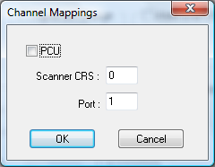

If PCU is not checked the above fields are available.

Scanner
Specifies the Scanner CRS that this channel is mapped to.

Port
Specifies the port the this channel is mapped to.

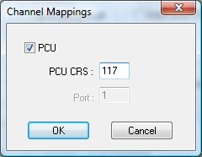

If PCU is checked the above fields are available.

PCU CRS
Specifies the PCU Cluster/Rack/Slot that this channel is mapped too.

Advanced Device Configuration

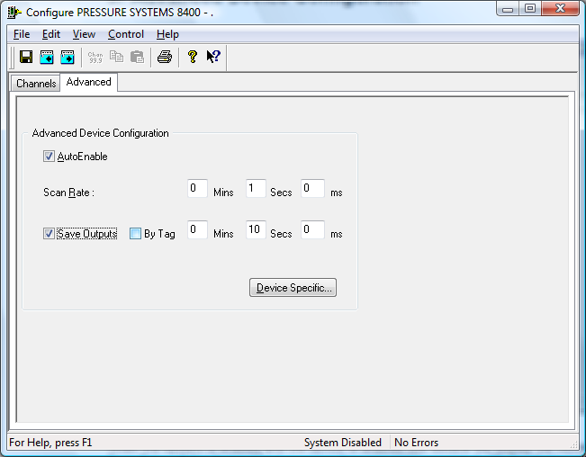

When the system is enabled and the device is enabled this window will display the Achieved Scan Rate . If the device is not scanning then any error associated with the device will be displayed instead.

Enable Device
To ensure that the device is included in the system check the Enable Device box.

Scan Rate
To set the rate at which the device will scan, edit the text boxes associated with the Scan Rate field.

Save Outputs
To enable this utility check the Save Outputs flag. All values in output channels are saved to disk when the system is disabled. The next time the system is restarted the values which were previously in output channels will be restored to the appropriate channel number.

By Tag
Channel values can be saved and restored to channels using the channel tag instead of the channel number. In this way, channels can be rearranged within the modules and as long as the channel tags remain the same, the correct channel values will be restored to the appropriate channel number.

Device Specific Button
If the Device Specific Button is visible, then click on it to configure features that are specific only to the type of device you are configuring. In the case of the PSI-8400 the following dialog will appear.

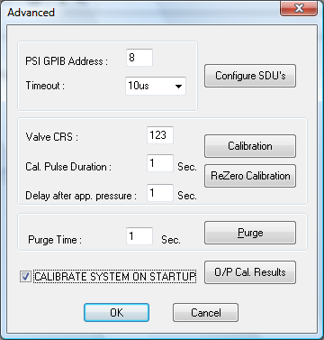

PSI GPIB Address
Specifies the Address of the PSI-8400 on the network.

Timeout
Specifies the timeout associated with the device at the specified address.

Configure SDU’s
Allows you to enter the SDU configuration menu where you can configure the SDU’s for the system.

Valve CRS
Specifies the valve CRS that will be used during calibration.

Cal. Pulse Duration
Specifies the calibration pulse duration in seconds

Delay after app. pressure
Specifies the delay after calibration has been applied before the calibration starts.

Calibration
Performs full calibration

ReZero Calibration
Performs rezero calibration.

Purge Time
Specifies the purge time.

Purge
Performs the purge.

Calibrate System on startup
If this box is checked the system will be calibrated on startup.

O/P Cal. Results
This button will cause the following dialog to be displayed.

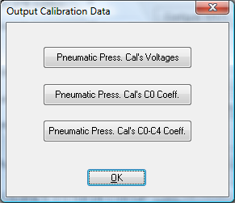

If the user selects any of the above, the following dialog will be displayed to allow him/her to select a file to output the data too.

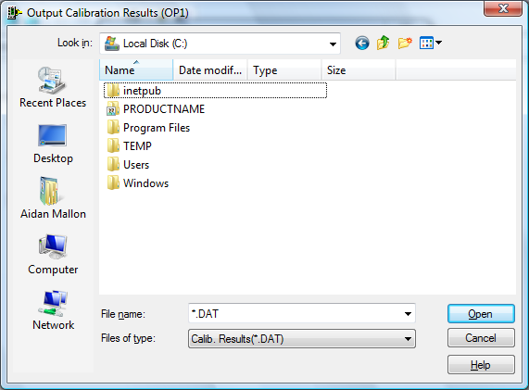

Once the file is selected the appropriate function is carried out.

Configure SDU’s

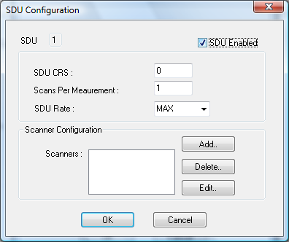

It will be possible to configure 4 SDU’s for the system. By default SDU 1
is displayed first as can be seen in the upper left hand corner of the dialog. To enable this SDU simply click on the SDU enabled button and complete all other fields, which are explained below.
Simply use the Next and Previous buttons to scroll through the other 3 SDU’s ,if required, and complete their fields also.

SDU CRS
Specifies the Cluster, Rack and Slot for the systems SDU.

Scans Per Meaurement
Specifies the number of scans made for each measurement.

SDU Rate
Specifies the SDU rate. It can be MAX,
40,
35,
30,
25,
20,
15,
10

Scanner Configurations
A drop down list shows the location of scanners that have already been configured for the current SDU. If the user wishes to modify any of these scanners he simply selects it from the drop down list and select the ‘Edit...’ button.
To delete a scanner select it from the drop down list and simply click the ‘Delete...’ button.
To Add a new scanner select the ‘Add...’ button.

Scanner Add & Edit

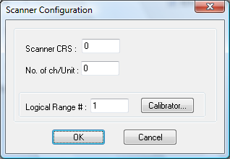

When a user selects the Add... or Edit... button he/she will be presented with the following dialog. If the user is adding then these fields will be empty and will need to be completed otherwise they will contain the scanners configuration and may modified by the user.

Scanner CRS
Defines the location of the scanner.

No. of ch/Units
Defines the number of ports on the scanner.

Logical Range #
Defines the logical range number for the associated PCU. With each LRN the PCU configuration must be specified. This can be achieved by clicking on the “Calibrator” button.

PCU Configuration
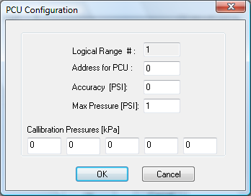

If the configuration has already been defined for this LRN it will be displayed and may be modified. Otherwise the above fields must be completed.

Address for PCU
This field indicates the address of the PCU unit on the PSI8400

Accuracy
This specifies the accuracy of the PCU in PSI.

Max Pressure
This specifies the maximum allowable pressure for the PCU.

Calibration Pressures
This specifies the 5 calibration constants for this PCU.

