Partnership Courtyard, The Ramparts,
Dundalk, Ireland

Version 6.8.0.0
March 7, 2022
www.measuresoft.com
+353 42 933 2399

This document is the copyright of Measuresoft and may not be modified, copied or distributed in any form whatsoever without the prior permission of Measuresoft.

DH485 User Manual

Configuration Of Allen-Bradley DH485 SLC500 PLCs

Channel Configuration 3
Steps to configure an Allen Bradley DH485 SLC500 channel 3
Channel Device Specific Configuration. 4
Station Number 4
File Type 4
Address 4
File Types 4
Output File Type 4
Input File Type 4
Status File Type 4
Binary File Type 4
Timer File Type 4
Counter File Type 4
Control File Type 4
Integer File Type 4
Float File Type 4
Word File Type 4
Advanced Configuration 4
Step for carrying out Advanced Configuration 4
Advanced Device Specific Configuration 4
Comport Settings 4
Output Scan Options 4

Channel Configuration

Steps to configure an Allen Bradley DH485 SLC500 channel
- Choose DH485 selection from the Devices menu.
The following screen appears :

- Choose the type of channel you want to configure. You can choose from the selection on the Tab - Analog Inputs, Digital Inputs, Analog Outputs, Digital Outputs. When you have selected the type of channel that you want to configure, you will be presented with a list of those channels, configured or otherwise. Channels which have been configured and are enabled, have their tag and description displayed here. Channels which have not been enabled will simply display “Disabled” in the tag column.
- To actually configure the channel, select the channel and :
Double Click the desired channel,
or
Select the “Configure Channel” button :
The following dialog will appear :

Analogs

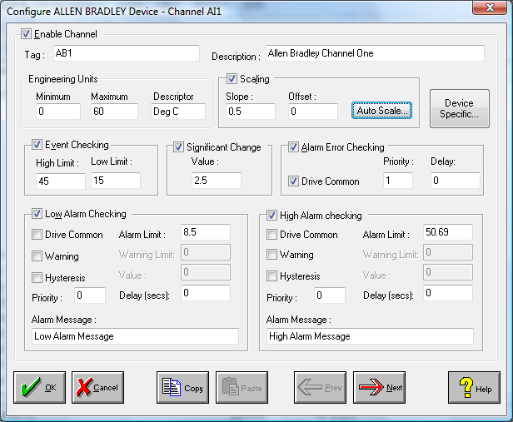

Digitals

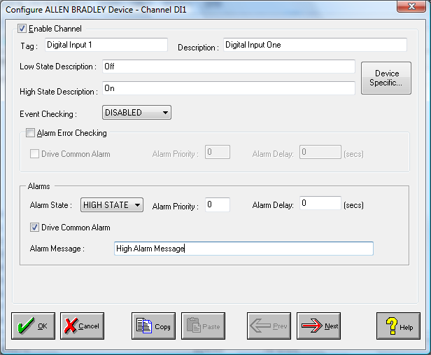

- All fields are “Disabled” initially. Click the “Enable Channel” button in order allow editing of the other fields on the dialog. Fill in the required fields, including: Tag, Description, Scaling(Analog Input only), Event Checking, etc.
- Choose the “Device Specific” button to configure DH485 SLC500 specific parameters. The Channel Device Specific Configuration dialog box appears :

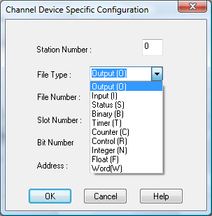

The screen shown here is only a sample dialog screen. Different dialog screens will appear depending on the choices you make. You can now begin to map your channel to the desired PLC data item. For further details on this dialog and it’s fields, see the section on Channel Device Specific Configuration.
- Choose either the OK or CANCEL button to return to the “Configure DH485 Device” dialog, and choose either the OK or CANCEL button again to return to the main “Device Configuration” screen.
- If desired the changes to the configuration can be saved, or discarded by exiting the configuration utility without saving. Only changes to configurations which have been saved will be used by the system.
- In order for the changes to take effect, the system must reload the configurations and restart the device scanner. For channel specific changes described in this section, this requires calling only the reconfigure command from the Control menu either in the main menu or the configuration utility. For Advanced configuration changes, the system must be disabled and re-enabled for the changes to take effect.

The same procedure can be repeated to configure as many channels as desired, and the same steps are used for each channel types (Analog Inputs, Digital Inputs, Analog Outputs, Digital Outputs).

Channel Device Specific Configuration.
This section will go through the various fields which must be configured to map a channel to a particular PLC data item.
Below is a summary of all the possible fields which may appear in this dialog. Some of the fields differ according to what type of channel is being configured and which file type the channel is being mapped to. The fields which do not change are detailed here, while the fields which change depending on the file type chosen are detailed in the section for the particular file type.

Field | Meaning
Station Number | PLC Station Address on DH485 network.
File Type | Specifies the type of PLC file being mapped to.
File Number | PLC File to map channel to.
Slot Number | Slot index within rack which the I/O module resides.
Element Number | Element index into file.
Word Number | Word index of value within I/O module.
Bit Number | Bit index of value within I/O module or element.
Mnemonic | Field within element structure.
Address | Address (in standard AB notation) of Data Item within SLC500.

Station Number
This refers to the address of the station you are talking to.
Example : Your network might look like follows:

File Type
The possibile SLC500 file types are as follows :
Output
Input
Status
Binary
Timer
Counter
Control
Integer
Float
Word
Different fields are displayed on the dialog depending on which file type you choose. Also, for the first 3 file types (Output, Input and Status), different fields will be displayed depending on whether the channel being configured is an analog or digital channel. For extra details on configuration of the various file types select the approriate file type above.

Address
This displays the data item’s address in standard Allen Bradley format, to which the channel is mapped.
Examples: The formats for each type of file will look as follows :
Outputs | $O0:0
Inputs | $I1:0
Status | $S2:0
Binary | $B3:0/0
Timer | $T4:0.ACC
Counter | $C5:0.PRE
Control | $R6:0.POS
Integer | $N7:0
Float | $F8:0
Word | $W8:0
Different fields are displayed on the dialog depending on which file type you choose. Also, for the first 3 file types (Output, Input and Status), different fields will be displayed depending on whether the channel being configured is an analog or digital channel.

The configuration of the various file types is explained in more detail in the following pages.

File Types

Output File Type
If “Output” is chosen as the file type, one of the following dialogs will appear, depending on the type of channel which is being configured :

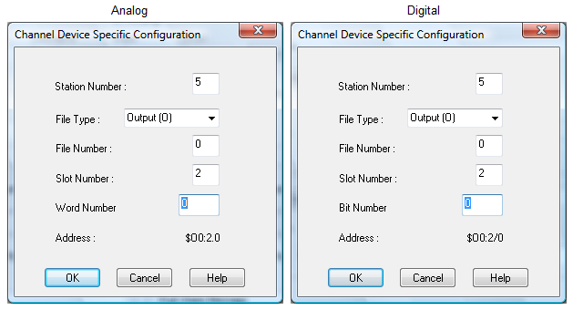

Output Fields.

Field | Value | Meaning
File Number | 0 | PLC File to map channel to.
Slot Number | 0 - 30 | Slot number within rack which the Output module resides.
Word Number | ≥ 0 | Word index of Output within module.
Bit Number | ≥ 0 | Bit index of Output within module.

Points Of Note
- The Output file number must be 0.
- The slot number will depend on the size of the rack you are using. The value above is the maximum value the slot number can have.
- The word number and bit number is an index into the output in a particular slot. Analog outputs are dealt with in 16 bit words. Digital outputs are dealt with in bits.

_____________________________________________________________________

Input File Type
If “Input” is chosen as the file type, one of the following dialogs will appear, depending on the type of channel which is being configured :

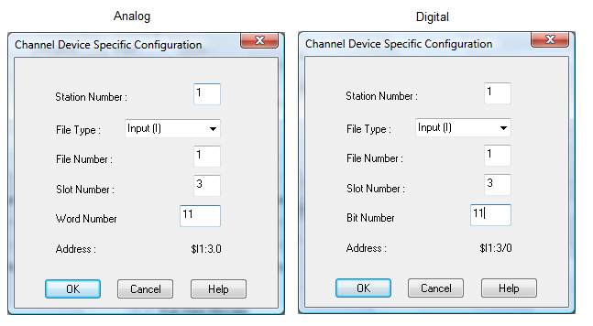

Input Fields.

Field | Value | Meaning
File Number | 1 | PLC File to map channel to.
Slot Number | 0 - 30 | Slot index within rack which the Input module resides.
Word Number | ≥ 0 | Word index of Input within module.
Bit Number | ≥ 0 | Bit index of Input within module.

Points Of Note
- The Input file number must be 1.
- The slot number will depend on the size of the rack you are using. The value above is the maximum value the slot number can have.
- The word number and bit number are indexes into the input in a particular slot. Analog inputs are dealt with in 16 bit words. Digital inputs are dealt with in bits.

_____________________________________________________________________

Status File Type
If “Status” is chosen as the file type, one of the following dialogs will appear, depending on the type of channel which is being configured :

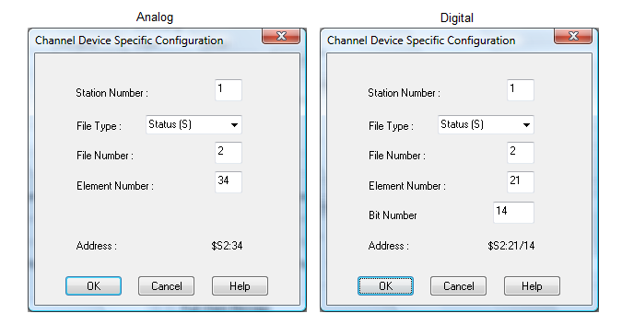

Status Fields.

Field | Value | Meaning
File Number | 2 | PLC File to map channel to.
Element Number | 0 - 255 | Element index into file. A status element is a 16 bit word.
Bit Number | ≥ 0 | Bit index within element.

Points Of Note
- The Status file number must be 2.
- Analog channels are always mapped to 16 bit status words. Digital channels are always mapped to status bits.

_____________________________________________________________________

Binary File Type
If “Binary” is chosen as the file type the following dialog will appear :

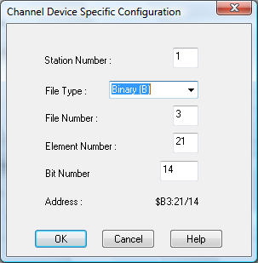

Binary Fields.

Field | Value | Meaning
File Number | 3, 10 - 255 | PLC File to map channel to.
Element Number | 0 - 255 | Element index into file. A binary element is a 16 bit word.
Bit Number | ≥ 0 | Bit index within element.

Points Of Note
- Binary file numbers must be either 3, or reside in the user defined files numbered 10 to 255.
- Channels are always mapped to bits in a binary file, regardless of whether they are analog or digital channels.

_____________________________________________________________________

Timer File Type
If “Timer” is chosen as the file type, the following dialog will appear :

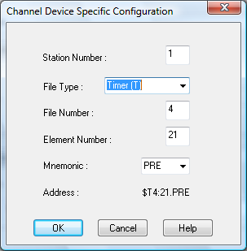

Timer Fields.

Field | Value | Meaning
File Number | 4, 10 - 255 | PLC File to map channel to.
Element Number | 0 - 255 | Element index into file. A timer element is a 48 bit  structure.
Mnemonic |  | Field within timer element.
 | EN | Enabled
 | TT | Timer Timing
 | DN | Done
 | PRE | Preset
 | ACC | Accumulator

Points Of Note
- Timer file numbers must be either 4, or reside in the user defined files numbered 10 to 255.
- Channels are always mapped to the selected timer mnemonic, regardless of whether they are analog or digital channels (and regardless of the mnemonics physical type).

_____________________________________________________________________

Counter File Type
If “Counter” is chosen as the file type, the following dialog will appear :

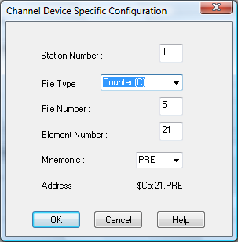

Counter Fields.

Field | Value | Meaning
File Number | 5, 10 - 255 | PLC File to map channel to.
Element Number | 0 - 255 | Element index into file. A counter element is a 48 bit  structure.
Mnemonic |  | Field within counter element structure.
 | CU | Count Up
 | CD | Count Down
 | DN | Done
 | OV | Overflow
 | UN | Underflow
 | UA | Update Accumilate
 | PRE | Preset
 | ACC | Accumulator

Points Of Note

- Counter file numbers must be either 5 or reside in the user defined files numbered 10 to 255.
- Channels are always mapped to the selected counter mnemonic, regardless of whether they are analog or digital channels (and regardless of the mnemonics physical type).

_____________________________________________________________________

Control File Type
If “Control” is chosen as the file type, the following dialog will appear :

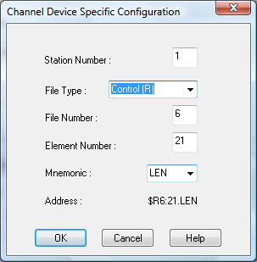

Control Fields.

Field | Value | Meaning
File Number | 6, 10 - 255 | PLC File to map channel to.
Element Number | 0 - 255 | Element index into file. A control element is a 48 bit  structure.
Mnemonic |  | Field within counter element structure.
 | EN | Enable Control
 | EU | Enable Upload
 | DN | Done
 | EM | Empty
 | ER | Error
 | UL | Upload
 | IN | Inhibit
 | FD | Found
 | LEN | Length
 | POS | Position

Points Of Note
- Control file numbers must be either 6 or reside in the user defined files numbered 10 to 255.
- Channels are always mapped to the selected control mnemonic regardless of whether they are analog or digital channels (and regardless of the mnemonics physical type).

_____________________________________________________________________

Integer File Type
If “Integer” is chosen as the file type, the following dialog will appear :

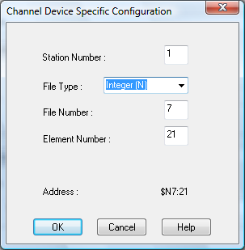

Integer Fields.

Field | Value | Meaning
File Number | 7, 10 - 255 | PLC File to map channel to.
Element Number | 0 - 255 | Element index into file. An integer element is a 16 bit  integer value.

Points Of Note
- Integer file numbers must be either 7 or reside in the user defined files numbered 10 to 255.
- Channels are always mapped to 16 bit unsigned integers, regardless of whether they are analog or digital channels. If the data item is mapped to a digital channel, a value of zero will be taken as LOW state, and any non-zero value will be taken as the HIGH state.

_____________________________________________________________________

Float File Type
If “Float” is chosen as the file type, the following dialog will appear :

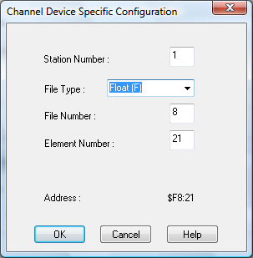

Float Fields
.
Field | Value | Meaning
File Number | 8, 10 - 255 | PLC File to map channel to.
Element Number | 0 - 255 | Element index into file. A float element is a 32 bit IEEE  floating point value.

Points Of Note
- Float file numbers must be either 8 or reside in the user defined files numbered 10 to 255.
- Channels are always mapped to 32 bit IEEE format floating point numbers, regardless of whether they are analog or digital channels. If the data item is mapped to a digital channel, a value ≥ 0.0 and < 1.0 will be taken as LOW state, and any other value will be taken as the HIGH state.

_____________________________________________________________________

Word File Type
If “Word” is chosen as the file type, the following dialog will appear :

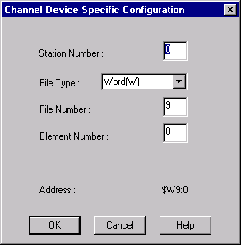

Word Fields

Field | Value | Meaning
File Number | 9 | PLC File to map channel to.
Element Number | 0 - 255 | Memory Address to Read.

Points Of Note
- Word file numbers always 9 and represent memory.
- Analog channels are always mapped to 16 bit status words. Digital channels are always mapped to status bits.

_____________________________________________________________________

Advanced Configuration

Step for carrying out Advanced Configuration

From the Tab menu, Choose “Advanced” (See diagram above).
- The following screen then appears :

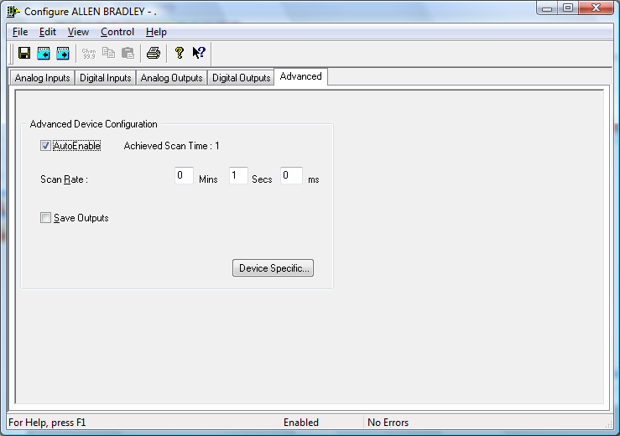

Advanced configuration applies to the device as a whole (e.g. Scan Rate).
- To see any extra device specific configuration that has to be applied to your device, choose the “Device Specific” button. The following dialog appears :

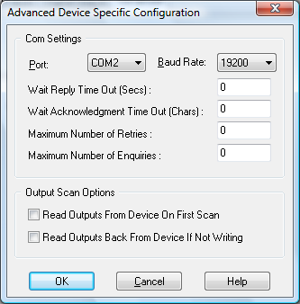

For further information on the fields in this dialog, see the section on Advanced Device Specific Configuration. Choose either the OK or CANCEL button to return to the “Device Configuration - DH485” dialog.

- If desired the changes to the configuration can be saved, or discarded by exiting the configuration utility without saving. Only changes to configurations which have been saved will be used by the system.

- In order for the changes to take effect, the system must reload the configurations and restart the device scanner. For channel specific changes this requires calling only the reconfigure command from the Control menu either in the main menu or the configuration utility. For Advanced configuration changes described in this section, the system must be disabled and re-enabled for the changes to take effect.

Advanced Device Specific Configuration
The fields in the “Advanced Device Specific Configuration” dialog are broken into two categories :
Com Settings
Output Scan Options

Comport Settings
This section relates to the physical communications between the PC and the DH485 stations.

Port
This allows you to select the port to which your 1747-KE interface module will be connected. To choose a port click on the down arrow to the right of the Port field. The drop down list will contain a list of all available ports on your system. Simply choose the one you want.

Baud Rate
This allows you to set your desired baud rate. The baud rate is selected in the same way as the port (click on the arrow and choose from the provided list). The provided baud rates are:
300
1200
9600
19200
38400

Wait Reply Timeout
This allows the maximum time the scanner will wait for a reply to any particular request to be set in seconds. A large value may cause a large delay before the system will realise there is a problem with the Allen Bradley DH485 network and time out. A small value may cause the system to timeout, thinking there is a problem with the network when in actual fact it may only be that the PLC or network is particularly busy. A value of 0 will cause the system to use defaults which should be sufficient in most scenarios. If it is found that the system is returning timeout errors when there is nothing physically wrong with the comms, then a value greater than say 5 seconds may be used.

Wait Acknowledgment Timeout
This allows the maximum time the scanner will wait for a message sent to be acknowledged. The value is set in character transmission times and therefore the actual timeout in seconds will depend on the baud rate used. A large value may cause a large delay before the system will realise there is a problem with the Allen Bradley DH485 network and time out. A small value may cause a timeout, indicating there is a problem with the network when in actual fact it may only be that the interface module or network is particularly busy. A value of 0 will cause the system to use defaults which should be sufficient in most scenarios. If it is found that the system is returning timeout errors when there is nothing physically wrong with the comms, then a value greater than say 10 character transmission times may be used.

Maximum Number of Retries
This specifies the maximum number of times a message will be resent before the system will give up trying to send the message. The default is 2.

Maximum Number of Enquiries
This specifies the maximum number of enquiry messages sent before giving up trying to send the message. The default is 3.

Output Scan Options
This section relates to the scanning of outputs. To select / deselect either option, click on the appropriate check box.

Read Outputs From Device On First Scan
This decides what type of scan to do on Outputs the first time that scanning actually commences.

Read Outputs Back From Device
If selected
If outputs have not changed then
The values don’t need to be written to file.
The values will be read back from the device.
If not selected
If outputs have not changed then
The values don’t need to be written to file.
No update occurs.

