Partnership Courtyard, The Ramparts,
Dundalk, Ireland

Version 6.8.0.0
March 7, 2022
www.measuresoft.com
+353 42 933 2399

This document is the copyright of Measuresoft and may not be modified, copied or distributed in any form whatsoever without the prior permission of Measuresoft.

Novolec User Manual

Table of Contents

1 Introduction 3
2 Scanner Configuration 3
3 Configuration 5
4 Advanced Device Configuration 7
4.1 AutoEnable Device 7
4.2 Scan Rate 7
4.3 Save Outputs 7
4.3.1 By Tag 8
4.4 Device Specific Button 8
4.4.1.1 Port 8
4.4.1.2 Baud Rate 8
4.4.1.3 Parity 8
4.4.1.4 Data Bits 8
5 Analog Input Channel Configuration 9
5.1 Enable Channel 9
5.2 Tag 9
5.3 Description 9
5.4 Engineering Units 9
5.4.1 Minimum 10
5.4.2 Maximum 10
5.4.3 Descriptor 10

Introduction

The Novolec scanner allows procedures to be set up and run that control the logging rate and number of logs performed by the Novolec. Procedures are saved in named files. Each procedure can have up to five cycles defined, The cycles are executed in order. The scanner does not attempt to communicate with the Novolec unless a procedure is running. A logger may be associated with the scanner, the logger will be enabled automatically when a procedure is started and stopped when the procedure terminates.

Scanner Configuration

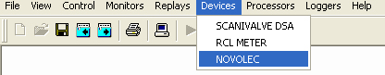

When the Novolec scanner configuration option is chosen from the Scada Device tab the following menu will appear:

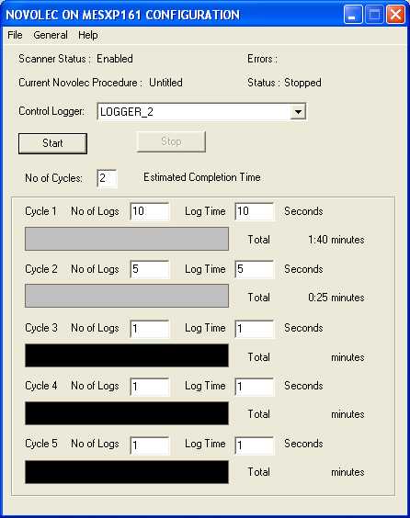

The menu entries at the top of the menu are drop down lists of options . The file menu is a standard windows file menu that allows procedures to be saved and loaded from named files. These files are specific to the scanner incarnation, i.e. if two scanners are operating on the same system they do not share procedure files.

Scanner Status: Indicates whether the scanner is enabled or disabled. If the scanner is disabled then procedures may not be started.

Errors: Reports any errors from the scanner. The only error currently reported is TIMEOUT, this implies that the scanner is expecting results from the Novolec and did not get any.

Current Novolec Procedure: This is the name of the current procedure file loaded, if a new file is created this will say Untitled until the data is saved and given a name.

Status: This is the current status of the procedure. The states are:

Running : The procedure is running.
Stopped: The procedure finished normally.
Aborted: The procedure was stopped by the user.

The status may be followed with the text /Editing. This means that the procedure that was last run (or is currently running) is not the same as the procedure displayed on screen. This can occur if another procedure is loaded, or if the configuration of the procedure is changed on screen. Saving the procedure that is being edited will automatically cause the procedure that was last run (or is running) to be re-loaded.

Control Logger: This is a drop down box giving a list of the names of all loggers defined in the system. The logger chosen is enabled when the procedure starts and disabled when it stops.

Start: When this button is pressed the procedure is started; while the procedure is running the button is disabled. If changes have been made to the procedure and not saved the following prompt appears:

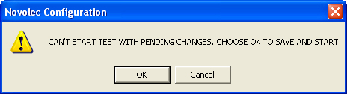

Selecting OK saves the procedure and starts it. If the selected logger is already running the following prompt appears:

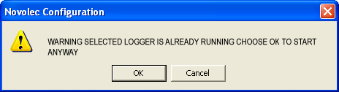

If the OK button is selected the procedure is started and the logger carries on running, when the procedure stops the logger will be stopped.

Stop: When this button is pressed the currently running procedure is stopped. This button is only enabled if a procedure is running and another procedure is not being edited. When a procedure is stopped the logger is disabled and a measure off command sent to the Novolec.

No of Cycles: This is an edit box where the number of cycles is entered; the number entered must be between one and five.

Estimated Completion Time: This field is only displayed when the procedure is running and displays the date and time when it is estimated the procedure will finish.

The box below No of cycles shows how each individual cycle is set up. For each cycle two values must be configured, the number of logs and the log time. Beneath each cycle entry is a box that fills up as the cycle progresses. Cycle entries not used have a black bar. The total time to complete the cycle is shown to the right of the progress bar this is expressed as minutes and seconds. The following menu is an example of the menu when a procedure is running. The progress bars are green when the procedure is running, red when stopped or aborted.

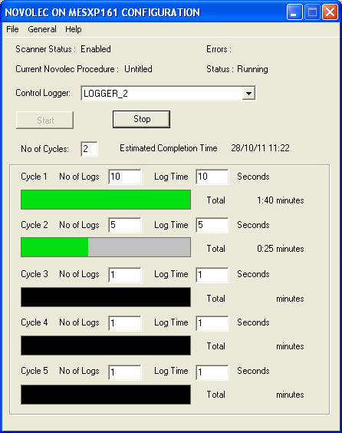

Configuration

The first time the system is configured it is necessary to enable and configure all devices you require. To configure the Novolec deviceclick on the General option from the menu followed by Configure Device.

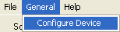

This will launch an application to configure the device.

From the list provided select a channel and double-click. Alternatively you can select a channel and then click on the Configure Channel button.

This will launch a channel configuration dialog which enables you to configure individual channels.

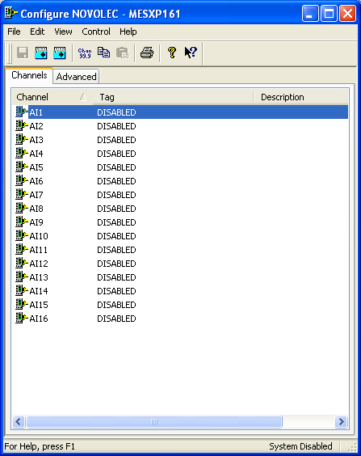

Advanced Device Configuration

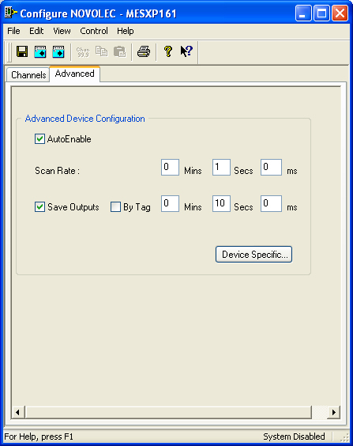

AutoEnable Device
To ensure that the device is enabled on the system check the Enable Device box.

Scan Rate
To set the rate at which the device will scan, edit the text boxes associated with the Scan Rate field.

Save Outputs
To enable this utility check the Save Outputs flag. All values in output channels are saved to disk when the system is disabled. The next time the system is restarted the values which were previously in output channels will be restored to the appropriate channel number.

By Tag
Channel values can be saved and restored to channels using the channel tag instead of the channel number. In this way, channels can be rearranged within the modules and as long as the channel tags remain the same, the correct channel values will be restored to the appropriate channel number

Device Specific Button
When the Device Specific Button is pressed the following dialog appears to allow specific communication settings to be configured for the device.

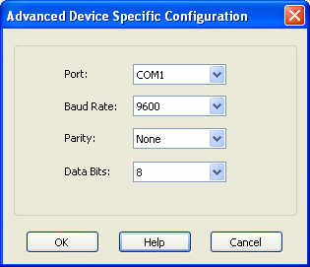

Port
Displays communications ports available on your computer

Baud Rate
Lists the baud rates that are supported by the hardware on your PC. Choose the highest speed that is supported by the hardware. If you encounter problems, you may have to adjust this to a slower speed at a later time.

Parity
Displays the various choices that can be implemented for parity checking.

Data Bits
Displays the various sizes of data bit to send.

Analog Input Channel Configuration

Autoscanning is used to scan analog inputs.

When the user selects an analog input to be configured the following is displayed.

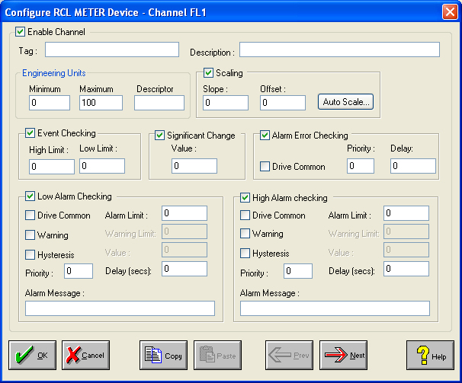

Enable Channel
The Enable Channel check box must be checked to enable and allow a channel to be configured and ultimately included with all other configured channels in the overall system.

Tag
The Tag field is a 12 character alphanumeric field that can contain channel information or wiring schedule references.

Description
The Description field is a 32 character alphanumeric field in which a description of the channel can be detailed.

Engineering Units
Specifies engineering details for this channel.

Minimum
Minimum engineering value for all Analog channels in addition to the unit field. The default is 0.

Maximum
Maximum engineering value for all Analog channels in addition to the unit field. The default is 100.

Descriptor
Describe the units of the measure.

