Partnership Courtyard, The Ramparts,
Dundalk, Ireland

Version 6.8.0.0
March 7, 2022
www.measuresoft.com
+353 42 933 2399

This document is the copyright of Measuresoft and may not be modified, copied or distributed in any form whatsoever without the prior permission of Measuresoft.

TABLE OF CONTENTS
TABLE OF CONTENTS 2
Introduction 4
Installing the Modbus Slave Processor 5
Notes: 5
Steps Involved: 5
Configuring the Modbus Slave Processor 6
Starting the Application: 6
Adding a Link 7
Steps Involved: 7
Scada Data Item 7
Modbus Data Item 7
Override Station Addr. 8
Modifying a Link 9
Steps Involved: 9
Deleting a Link 10
Steps Involved: 10
Advanced Configuration 11
Steps Involved: 11
Advanced Modbus Slave Parameters 12
Auto Enable Modbus Slave Check Box 12
Verify Configuration at Startup 12
Default Slave Station 12
Connection 12
Communication Settings 12
Serial Settings 12
Port 12
Parity 12
Baud Rate 12
Timeout (Msecs) 13
Protocol 13
TCP Settings 13
Port 13
Swap Double Registers 13
Offset Registers 13
Errors and The Modbus Slave Processor 15
Error 15
Probable Cause 15
Debug View 15
Capture Output 16
Insert Comments 16
Clearing the Display 16
Searching 16
Filtering 16
Highlighting 17
History Depth 17
Menu Items 17
File 17
Edit 17
Capture 17
Options 18
Computer 18
Help 18
Toolbar 18

Introduction
The Modbus Slave Processor acts as a Modbus slave on a Modbus Network it allows System Channels to be accessed by Modbus masters, using Modbus addresses.

This configuration utility allows the communications parameters to be setup so that the Modbus Slave processor can access the Modbus Network. It also allows the user to create mappings between Modbus addresses and System Channels. These mappings between Modbus addresses and System Channels are referred to as Links within the application and documentation.

Installing the Modbus Slave Processor

Notes:
Before installing the Modbus Slave Processor, the system and all other device drivers should have been installed on the current machine.

Note that the installation procedure will stop the Applications service in order to ass the new processor. For this reason all System clients (e.g. Main Menu, Trends etc…) should be closed before beginning the installation.

Steps Involved:
The Modbus Slave Processor disk should be inserted into the floppy drive and then the setup.exestarted using the following method.

- From Windows Explorer, browse to the \Drivers\Modbus_Slave\DISK1 directory on the installation CD and double-click on setup.exe

The Modbus Slave Processor setup utility will startup, introduce itself, and ask are you sure you wish to continue with the installation, it will then ask you to select a directory and a program group for the Modbus Slave Processor. Simply follow the instructions until setup is complete.

Once the installation has been completed, the Service must be restarted. This is done by starting the main System application. The Modbus Slave should now appear in the processors menu. This can be used to launch the Modbus Slave configuration application. There will also be an icon for the New Processor in the Application’s Program Group on the Task Bar.

The next step is to configure the Modbus Slave Links and Modbus Advanced Parameters. The following sections outline how this can be done.

Configuring the Modbus Slave Processor

Starting the Application:
- Select the Modbus Slave option from the Application’s Processors menu. The following application window will then appear.

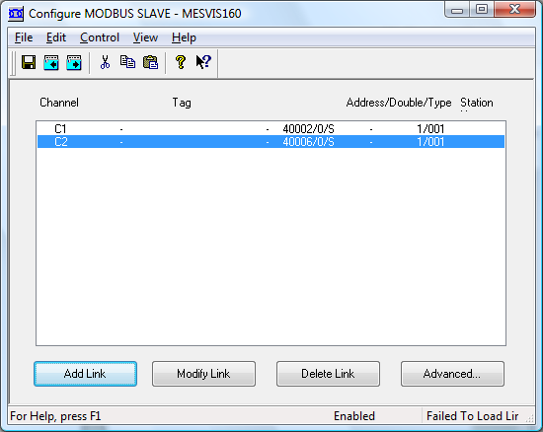

This dialog shows a list of all existing links ( between System Channels & Modbus addresses) together with the configuration utility options (Add, Modify, Delete, and Advanced)

Adding a Link

Steps Involved:
1.Click the ADD LINK button on the Modbus Slave Configuration dialog
OR
Select the ADD LINK form the Edit menu of the Modbus Slave Configuration window

- The Modbus Slave Channel Link dialog appears :

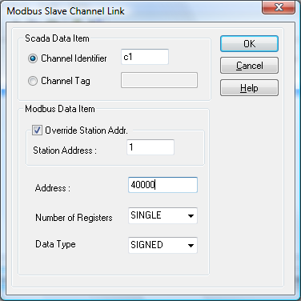

This dialog is broken down into two sections :

Scada Data Item
In this field type the channel that you want to use for the new link (e.g. P1, Q1, etc.), or enter the channel tag.

Modbus Data Item
In this field type the Modbus address that you want the channel to be ‘linked’ up with (or associated).

Modbus

Address
40001

Scada
Data Item
P1

If Double Number of Registers is specified then the driver will store the converted Scada Data Item value as two registers at Modbus Address and Modbus (Address+1) respectively.

E.G. If the Address is 40001 and Use Double Register is selected. Then P1 will be mapped to 40001 and 40002.
Note: In the case above 40001 and 40002 should not be used in any other mapping within this configuration.

Data can be converted to/from signed and unsigned integer format or IEEE single precision floating point format. If Single Number of Registers is specified then the driver will store the converted Scada Data Item value as a 16-bit signed or unsigned integer. If Double Number of Registers is specified then the driver will store the converted Scada Data Item value as a 32-bit signed or unsigned integers or single precision floating point value.

Override Station Addr.
You may also override the default slave address within this dialog. By checking the ‘Override Station Addr.’ field and entering the appropriate modbus station address. This configured link will act as if it is a separate modbus slave device. If this box is left unchecked then the default station address configured in the Advanced section is used.

3.Choose either OK or CANCEL button to return to the Modbus Slave Configuration dialog.

4. Be sure to save the configuration before :
- Enabling the System
- Restarting the Processor (i.e. Enabling the Processor)

You can save your configuration using one of the methods :
- Click on the save icon on the toolbar
- Select the Save option command from the file menu on the Modbus Slave Configuration window.
- Hold down CTRL+S
5. On completion of the above, the new link will be appended to the list of existing links or if none exist it will appear as the first link.

6. Your link is now established.
Note :
See section entitled “Running your Processor”

Modifying a Link
A link can only be modified/ altered after it has first been created.

Steps Involved:
- Using the mouse, select the link you want to modify/change. The selected link should be highlighted.
- Next, do one of the following :
Click the Modify Link button on the Modbus Slave Configuration dialog
OR
Select the Modify Link command for the Edit Menu of the Modbus Slave Configuration Window
OR
Double Click on the selected link
- The Modbus Slave Channel Link dialog will appear (See Above)
- You can then alter the channel and address values as required.
- Choose either the OK or CANCEL button to return the Modbus Slave Configuration dialog.
- Be sure to save the configuration before
- Enabling the System
- Restarting the Processor
You can save the configuration using one of the following methods :
- Click the save icon on the toolbar
- Select the Save option command from the file menu on the Modbus Slave Configuration window.
- Keys : Hold down the CTRL+S
Note:
See section entitled “Running Your Processor”.

Deleting a Link
A link can only be deleted/removed after it has first been created.

Steps Involved:

- Using the mouse, select the link you want to delete remove. The selected link should be highlighted.
- Next, do one of the following.
Click on the Delete Link command from the Edit menu of the Modbus Slave Configuration dialog.

OR
Select Delete Link command from the Edit menu of the Modbus Slave Configuration window.
3.The selected Link will then be deleted. The removal of the link from the Links list will signify this.

Note :
See section entitled “Running Your Processor”.

Advanced Configuration

Steps Involved:
- Click the Advanced button on the Modbus Slave Configuration window
- One of the following dialogs will then appear

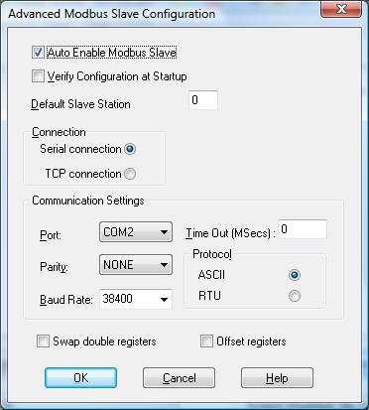

- There are a number of fields in on this dialog which must be set. The fields are detailed in the section Advanced Modbus Slave Parameters.

- Choose either the OK or CANCEL button to return to the Modbus Slave configuration dialog.

- Ensure that the configuration is saved before :
- Enabling the System
- Restarting the Processor

You can save the configuration using one of the following methods :
- Click the save icon on the toolbar
- Select the Save option command from the file menu on the Modbus Slave
- Keys : Hold down the CTRL+S

- Advanced Configuration is complete.

Advanced Modbus Slave Parameters

Auto Enable Modbus Slave Check Box
The auto enable modbus slave check box needs to be checked. This has the effect of enabling the processor.

Verify Configuration at Startup
This verifies the existence of the channels linked to Modbus registers. If any of the links are invalid, the Modbus slave will not start.

Default Slave Station
This refers to the address of a Modbus module on the Modbus network. This address can be overridden when configuring Links.

Connection
This allows you to select whether a serial connection or a TCP/IP connection is being used.

Communication Settings

Serial Settings

Port
For serial connections, this allows you to select the port to which your Slave will be connected. To choose a port, click on the down arrow to the right of the Port field. The Drop down list will contain a list of all available ports on your system. Simply choose the one you want.

Parity
There are 3 types of parity available here :
None
Odd
Even
Parity is selected in the same way as the port – Click on the down arrow and choose from the provided list.

Baud Rate
This allows you to set your desired baud rate. The baud rate is selected in the same way as the port and parity – Click on the down arrow and choose from the provided list. The supported Baud rates are:

75 | 600 | 7200 | 57600
110 | 1200 | 9600 | 115200
134 | 1800 | 14400
150 | 2400 | 19200
300 | 4800 | 38400

Timeout (Msecs)
This allows the maximum time the scanner will wait for a reply to any particular request to be set in seconds. A large value may cause a large delay before the System will realise there is a problem with the Modbus network and will time out. A small value may cause the System to timeout, thinking there is a problem with the network when in actual fact it may only be that the PLC or network is particularly busy. A value of 0 will cause the System to use defaults, which should be sufficient in most scenarios. If it is found that the System is returning timeout errors there is nothing physically wrong with the communications, then a value greater than say 5000 milliseconds may be used.

Protocol
This allows use you to select which of the two Modbus protocols you want to use:

ASCII
Each 8-bit type message is sent as two ASCII characters

RTU
Each 8-bit type message is sent in binary form.

TCP Settings

Port
For TCP/IP connections, this allows you to select the TCP/IP port number. This is defaulted to 502.

Swap Double Registers

This option allows use you to swap the floating point double registers.

Offset Registers

If this option is set off, the modbus register numbers used correspond to the register numbers used at the protocol level. If this option is set on, the modbus register numbers used correspond to the register numbers used at the protocol level plus one e.g. Modbus holding register 40001 matches to register number 40000 at the protocol level.

Running the Modbus Slave Processor
To run the Modbus Slave Processor, it first must be enabled and the configuration saved before enabling the System, otherwise the Modbus Slave Processor will not be started.

If the System is disabled, then the following steps should be taken to start the processor with your desired settings:
- Change Your Settings
- Save the new Settings
- Enable the System
- The System will start the Modbus Slave Processor with the saved configuration

If the System is enabled, then the following steps should be taken to restart the processor with your desired settings.
- Change your settings
- Save the new settings
- Select the Restart command from the Control menu of the Modbus Slave Configuration
- The System will start the Modbus slave Processor with the saved configuration

Note:
If the Modbus Slave Processor was disabled when the System was last enabled, then the System must be disabled and re-enabled with the Modbus slave Processor enabled (See Enabled Check Box In Advanced Configuration)

Errors and The Modbus Slave Processor

The Right hand area of the status bar indicates if there are any errors to be reported by the Modbus Slave Processor. This will read “No Errors” if there are no problems with the processor, otherwise it will display the error message reported by the processor. Some of the possible errors for the Modbus Slave Processor are listed below :

Error | Probable Cause
Failed to start System Link | System Resources Low
Failed to start Modbus Service | System Resources Low
Failed to open COM Port | COM Port invalid or in use by another application.
Failed to Load Links. | Links have not been Configured
Listen Only Mode | Modbus Master has put Modbus slave Processor into Listen Only Mode

An error code is usually printed in brackets after the error message. This is a standard WIN32 error code.

Note that the standard Modbus and other communications errors detected by the Modbus Slave are not reported locally, even when they are returned to the Modbus Master. This is due to the fact that such errors are usually detected and corrected from the Master Side of a connection.

Debug View
There is now a debug utility available to use within Modbus Slave that allows you to monitor debug output on the local machine or on any computer over the network via TCP/IP. To launch the debug utility click on Control then Debug on the Configure screen.

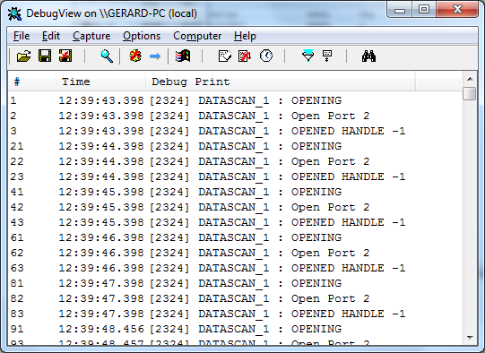

Capture Output
When you start the utility it will begin capturing debug output by default. You can toggle between capture on and capture off with the following toolbar icon: Alternatively you can use Capture Menu > Capture Events or using the Ctrl + E hotkey. When capture mode is off the utility will not capture any debug output until it is turned back on. The kind of output that is captured is determined on whether Win32 or Kernel capture is on or off.

Insert Comments
You can insert comments in the output log by clicking on Edit>Append Comment. Comments insert into the currently viewed output. Type comments into the dialog followed by the Enter key and then close the dialog when you are done entering comments.

Clearing the Display
To clear the output screen simply click on the toolbar or go to Edit>Clear display on the menu.

Searching
You can search for a line of text that is of interest by clicking on the toolbar or going to Edit>Find on the menu. If the search matches what you specified then it will be highlighted on the output window while disabling the auto-scroll feature. To repeat a successful search you can use the F3 hotkey.

Filtering
Another way of picking out debug output is to use the filtering feature. You can use it by clicking on the toolbar or going to Edit>Filter/Highlight on the menu. The Filter/Highlight feature contains two edit fields: include and exclude. The Include field is where you enter substring expressions that match debug output lines that you want the utility to display, and the exclude field is where you enter text for debug output lines that you do not want the utility to display. You can enter multiple expressions, separating each with a semicolon (‘;’). Do not include spaces in the filter expression unless you want the spaces to be part of the filter. Note that the filters are interpreted in a case-insensitive manner, and that you should use ‘*’ as a wildcard.

Highlighting
If you want output lines that contain certain text to be highlighted in the utility output window, enter a highlight filter. The utility implements support for up to five different highlight filters, each with its own foreground and background color settings. Use the filter drop-down in the highlight filter area of the filter dialog to select which highlight filter you want to edit. Use the same syntax just described for include and exclude filters when defining a highlight filter.

Use the Load and Save buttons on the filter dialog to save and restore filter settings, including the include, exclude and highlighting filters, as well as the highlighting colors settings.

History Depth
Another way of controlling the debug output is to limit the number of lines that are retained in the window. You can do this by clicking on the toolbar or Edit>History Depth on the menu. Once opened enter the number of output lines you want the utility to retain and it will keep only that number of the most recent debug output lines, discarding older ones. A history-depth of 0 represents no limit on output lines retained.

Menu Items

File
Item | Description
New Window… | Opens a new debug window.
Open… | Open a saved debug window.
Save | Save the current debug window.
Save As… | Specifies what to save the current debug as.
Log to File… | Creates a log file of the debug output
Log to File As… | Specifies what to save the log file as.
Print… | Prints the debug output.
Print Range… | Specifies what range to print of the debug output.
Process Crash Dump… | Creates a crash dump of the output up until the crash.
Exit | Exit the utility.

Edit
Item | Description
Append Comment | Write a comment for the current output.
Copy | Copy the selected text.
Find | Find a specific piece of text.
Filter/Highlight | Filter the output to include or exclude certain string values.
Clear Display | Clear the debug output window.

Capture
Item | Description
Capture Win32 | Will register to receive and print debug output generated by Win32 programs that call OutputDebugString.
Capture Global Win32 | Let’s you enable and disable the capture of debug output that is generated in the console (global) session.
Capture Kernel | Captures kernel-mode debug output generated by device drivers and/or the Windows kernel
Enable Verbose Kernel Output | Outputs kernel mode in verbose.
Pass-through | Allows you to see kernel-mode debug output in the output buffers of a conventional kernel-mode debugger while at the same time viewing it in the utility.
Capture Events | You can toggle on or off and it will capture events and display on the debug output.
Log Boot | Toggle on or off to enable the utility to log on Windows startup.

Options
Item | Description
Win32 PIDs | Information identifying processes that generate Win32 debug output is prefixed to each line of Win32 debug output.
Force Carriage Returns | Forces carriage returns on the debug output.
History Depth… | Limits the number of lines that are retained in the window.
Clock Time | Toggles between setting the time in seconds or HH:MM:SS.ms
Show Milliseconds | Toggle whether to show milliseconds in the time stamp.
Font | Change the debug output font style, size, and type.
Hide When Minimized | Hides the utility to the taskbar when minimized.
Hide Toolbar | Hides the toolbar on the utility.
Auto Scroll | Toggle between the debug output automatically scrolling down as
Always on Top | Utility window will always appear on top even when it loses focus.

Computer
Item | Description
Connect | Connect to a computer over the network.
Connect Local | Connect to the local machine
Disconnect | Disconnect from the current computer on the network.
COMPUTER_NAME | The current machine you are connected to.

Help
Item | Description
Help… | Displays a help file to explain the utility.
About | Displays current software version and details.

Toolbar

Name | Icon
Open
Save
Log to File
Capture
Capture Kernel
Passthrough Kernel
Capture Win32
Clear
Autoscroll
Time Format
Filter/Highlight
History Depth
Find

