Partnership Courtyard, The Ramparts,
Dundalk, Ireland

Version 6.8.0.0
March 7, 2022
www.measuresoft.com
+353 42 933 2399

This document is the copyright of Measuresoft and may not be modified, copied or distributed in any form whatsoever without the prior permission of Measuresoft.

Modbus Master User Manual

Modbus Master Driver

Modbus Master Driver 2
Modus Master Driver Channel Configuration 4
Steps for Modbus Channel Configuration 4
Channel Device Specific Fields. 8
Slave Address 8
Data Type 8
Data Index 8
Address 9
Example 9
Modus Master Driver Advanced Configuration 9
Step for Modbus Advanced Configuration 9
Advanced Device Specific Fields 11
Master Station Address 11
Connection 11
Connection Settings 11
Port 11
Server 11
Parity 11
Baud Rate 11
Protocol 12
ASCII 12
RTU (Remote Terminal Unit) 12
Timeout (Msecs) 13
Swap Float Registers 13
Output Scan Options 13
Read Outputs From Device On First Scan 13
Read Outputs Back From Device 13
Modbus Master Driver Errors 14
Types Of Errors 14
Format Of Error Messages 14
Explanation Of Error Codes 15
Type 1: Modbus Errors 15
Type 2: Data Link Layer Errors 16
Type 3: Application Layer Errors 16
Type 4: Win32 Errors 16
West and Jumo Controllers 17
Debug View 18
Capture Output 18
Insert Comments 18
Clearing the Display 18
Searching 18
Filtering 19
Highlighting 19
History Depth 19
Menu Items 19
File 19
Edit 20
Capture 20
Options 20
Computer 21
Help 21
Toolbar 21

Modus Master Driver Channel Configuration

Steps for Modbus Channel Configuration
- Choose Modbus Master selection from the Devices menu.
The following screen appears:

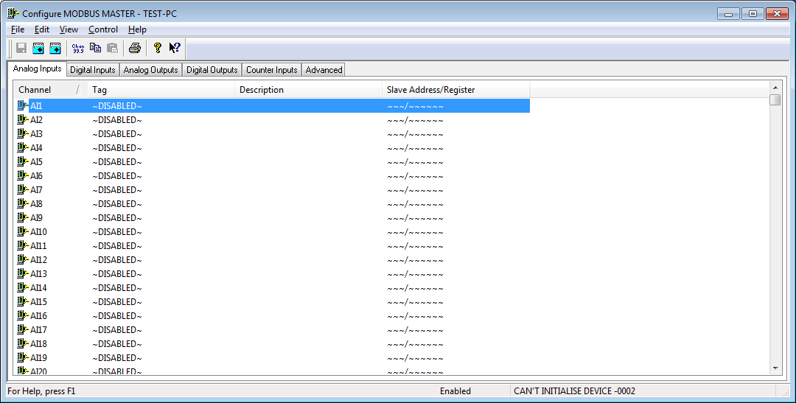

- Choose the type of channel you want to configure. You can choose from the selection on the Tab - Analog Inputs, Digital Inputs, Analog Outputs, Digital Outputs. When you have selected the type of channel that you want to configure, you will be presented with a list of those channels, configured or otherwise. Channels which have been configured and are enabled have their tag and description displayed here. Channels which have not been enabled will simply display “Disabled” in the tag column.
To actually configure the channel, select the channel and :
Double Click the desired channel,
or
Select the “Configure Channel” button:
The following dialog will appear:

Analogs

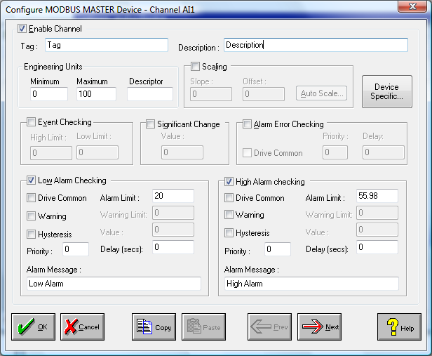

Digitals

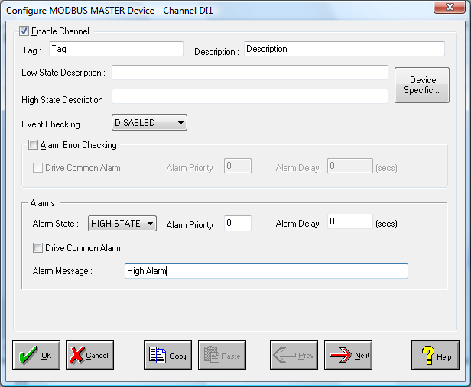

- All fields are “Disabled” initially. Click the “Enable Channel” button in order allow editing of the other fields on the dialog. Fill in the required fields, including: Tag, Description, Scaling, Event Checking, etc.
- Choose the “Device Specific” button to configure Modbus specific parameters. The Channel Device Specific Configuration dialog box appears :

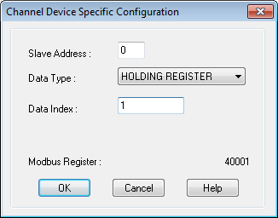

You can now begin to map your channel to the desired PLC data item. For further details on this dialog and its fields, see the section on Channel Device Specific Configuration.
- Choose either the OK or CANCEL button to return to the “Configure Modbus Device” dialog, and choose either the OK or CANCEL button again to return to the main “Device Configuration” screen.
- If desired the changes to the configuration can be saved, or discarded by exiting the configuration utility without saving. Only changes to configurations which have been saved will be used by the system.
- In order for the changes to take effect, the system must reload the configurations and restart the device scanner. For channel specific changes described in this section, this requires calling only the reconfigure command from the Control menu either in main menu or the configuration utility. For Advanced configuration changes, the system must be disabled and re-enabled for the changes to take effect.

The same procedure can be repeated to configure as many channels as desired, and the same steps are used for all the channel types (Analog Inputs, Digital Inputs, Analog Outputs, Digital Outputs).

Channel Device Specific Fields.
This section will go through the various fields which must be configured to map a channel to a particular PLC data item.
Below is a summary of all the fields which appear in this dialog.

Field | Meaning
Slave Address | Modbus Slave Address on Modbus network.
Data Type | Specifies the type of Modbus data item.
Data Index | Modbus Register or Status index.
Address | Modbus Address of Data Item.
Use Double Register as Float | This option is only available for Register/Reference Data Types. If checked this forces the driver to request two Registers beginning at the specified Data Index. These two registers will be interpreted as representing a modbus floating point number and will be displayed as such.

Slave Address
This refers to the address of the slave you are talking to, previously known as Station number.
Example: Your network might look like follows:

Data Type
The possible Modbus file types are as follows:

Type | Address Range | Description
Coil Status | 00000 - 09999 | Digital Outputs
Input Status | 10000 - 19999 | Digital Inputs
Holding Register | 40000 - 49999 | Analog Outputs
Input Register | 30000 - 39999 | Analog Inputs
General Reference | 60000 - 69999 | Memory Regions

Data Index
This is the index of the required modbus register or status from its types base Address.

Address
This displays the data item’s address in standard Modbus format, to which the channel is mapped.

Example
Data Address for the third Holding Register is 40002 (Starting at 40000). The Data Type is Holding Register. This type’s base Address is 40000. The Data Index is 2.

Modus Master Driver Advanced Configuration

Step for Modbus Advanced Configuration
- Choose Devices | Modbus on the main menu.
- From the Tab menu, Choose “Advanced”.
- The following screen then appears :

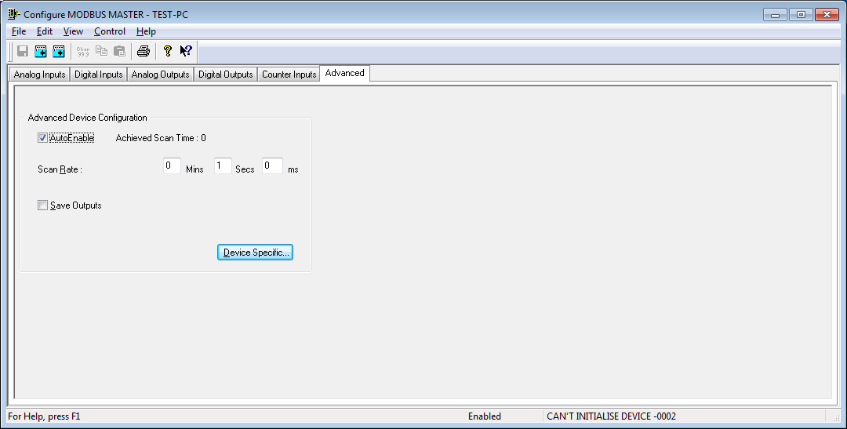

Advanced configuration applies to the device as a whole (e.g. Scan Rate).
To see any extra device specific configuration that has to be applied to your device, choose the “Device Specific” button. The following dialog appears :

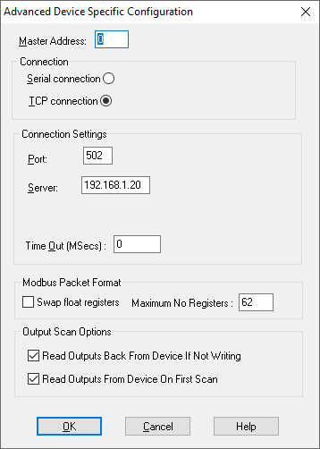

For further information on the fields in this dialog, see the section on Advanced Device Specific Configuration. Choose either the OK or CANCEL button to return to the “Device Configuration - Modbus” dialog.

- If desired the changes to the configuration can be saved, or discarded by exiting the configuration utility without saving. Only changes to configurations which have been saved will be used by the system.

- In order for the changes to take effect, the system must reload the configurations and restart the device scanner. For channel specific changes this requires calling only the reconfigure command from the Control menu either in main menu or the configuration utility. For Advanced configuration changes described in this section, the system must be disabled and re-enabled for the changes to take effect.

Advanced Device Specific Fields
The fields in the “Advanced Device Specific Configuration” dialog is broken into three categories:
Connection
Connection Settings
Output Scan Options

Master Station Address
The Master Station Address within the Advanced Configuration Dialog is the Modbus Network address of the Modbus Master.

Connection
This allows you to select whether a serial connection or a TCP/IP connection is being used.

Connection Settings
This section relates to the physical communications between the PC and the Modbus stations based on the connection type chosen (Serial or TCP/IP):

Port
This allows you to select the port to which your module will be connected. To choose a port, click on the down arrow to the right of the Port field. The drop down list will contain a list of all available ports on your system. Simply choose the one you want.

For TCP/IP connections, this allows you to select the TCP/IP port number the default of which is 502.

Server
For TCP/IP connections only, this is the name of remote modus slave server.

Parity
There are three types of parity available:

None
Odd
Even

Parity is selected in the same way as the port (click on the arrow and choose from the provided list).

Baud Rate
This allows you to set your desired baud rate. The baud rate is selected in the same way as the port (click on the arrow and choose from the provided list). The supported baud rates are:

75 | 600 | 7200 | 57600
110 | 1200 | 9600 | 115200
134 | 1800 | 14400
150 | 2400 | 19200
300 | 4800 | 38400

Protocol
The Modbus Master Driver can operate using two defined Modbus protocols. They are:

- ASCII
- RTU

ASCII
When controllers are setup to communicate on a Modbus network using ASCII (American Standard Code for Information Interchange) mode, each 8-bit byte in a message is sent as two ASCII characters.

The format for each byte in ASCII mode is:

Coding System | 7 bit ASCII.
Bits Per Byte | 1 start bit  7 data bits, least significant bit sent first  1 bit for even/odd parity; no bit for no parity  1 stop bit if parity is used; 2 bits if no parity
Error Check Field | Longitudinal Redundancy Check (LRC)

RTU (Remote Terminal Unit)

This is the second mode of operation possible with Modbus.

When controllers are setup to communicate on a Modbus network using RTU (Remote Terminal Unit) mode, each 8-bit byte in a message is sent as one binary character. The main advantage of this mode is that its greater character density allows better data throughput than ASCII for the same baud rate. Each message must be transmitted in a continuous stream.

The format for each byte in RTU is:

Coding System | 8-bit binary.
Bits per Byte | 1 start bit  8 data bits, least significant bit sent first  1 bit for even/odd parity; no bit for no parity  1 stop bit if parity is used; 2 bits if no parity
Error Check Field | Cyclical Redundancy Check (CRC)

Timeout (Msecs)
This allows the maximum time the scanner will wait for a reply to any particular request to be set in seconds. A large value may cause a large delay before the system will realise there is a problem with the Modbus network and time out. A small value may cause a timeout, indicating there is a problem with the network when in actual fact it may only be that the PLC or network is particularly busy. A value of 0 will cause the system to use defaults which should be sufficient in most scenarios. If it is found that the system is returning timeout errors there is nothing physically wrong with the communications, then a value greater than say 5000 milliseconds may be used.

Modbus Packet Format - Swap Float Registers
This option allows use you to swap the floating point registers.

Modbus Packet Format – Maximum Number of Registers
This option allows use you to specify the maximum number of registers per Modbus packet. Modbus packets are up to 256 bytes in size and when overhead is taken into consideration the maximum number of holding registers per packet is 127. However some devices can only process a lower number of registers. Use this option to restrict the number of registers per Modbus request.

Output Scan Options
This section relates to the scanning of outputs. To select / deselect either option, click on the appropriate check box.

Read Outputs From Device On First Scan
This decides what type of scan to do on Outputs the first time that scanning actually commences.

Read Outputs Back From Device

If selected
If outputs have not changed then
The values don’t need to be written to file.
The values will be read back from the device.
If not selected

If outputs have not changed then
The values don’t need to be written to file.
No update occurs.

Modbus Master Driver Errors

Types Of Errors
There are a number of different categories of error message. They are as follows:

Type Of Error | Related To
Modbus Errors | Errors detected by the Modbus module
Data Link Layer Errors | Errors detected in Serial Communications
Application Layer Errors | Errors detected in Serial Communications
Win32 Errors | Standard Windows Errors
Time Out Errors | Slave Device is Not Responding

Format Of Error Messages

Note:

The Data Address refers to the first address of a block that an error occurred in.

Example:
A PLC has 20 Holding Registers (40001 - 40020). The Modbus Master Driver tries to read data items 42000 - 42010 as these have all been configured to channels. The read will fail, and an error message will be reported.

The errors are displayed:

At the bottom of the main screen
and

At the bottom of the Modbus Master Configuration screen

Explanation Of Error Codes

Here, we will:

- Name the type of error message
- Give its format/syntax
- Describe the error codes contained in the category
- Document the meaning of each of the errors
- Give appropriate examples

_____________________________________________________________________

Type 1: Modbus Errors

Syntax: S<Number>, D<Data Address>: MODBUS<Error Code>

Error Code | Meaning
01 | Illegal Function
02 | Illegal Data Address
03 | Illegal Data Value
04 | Slave Device Failure
05 | Acknowledge Received
06 | Slave Device Busy
07 | NAK Received
08 | Memory Parity Error
09 | Zone Overlap
0A | Header Error
0B | Slave absent
0C | CRC Error
0D | Transmission Blocked
0E | Incorrect Length
0F | Slave Timeout

Example: S 2, D40001 : MODBUS 0E

Meaning : Station Number 2 , Data Address 40001 = Incorrect Length

Type 2: Data Link Layer Errors

Syntax: S <Number>, D <Data Address> : DATA LINK (Error Code>

Error Code | Meaning
01 | Timed Out
02 | Unexpected Control
03 | Buffer Overrun
04 | Bad error check
05 | Duplicate Packet
06 | NAK received
07 | Packet is too small

Example : S 2, D40001 : DATA LINK 02

Meaning : Station Number 2 , Data Address 40001 = Unexpected Control
_____________________________________________________________________

Type 3: Application Layer Errors

Syntax: S <Number>, D <Data Address> : APP <Error Code>

Error Code | Meaning
01 | Wrong Station
02 | Wrong Command
03 | Wrong Transaction
04 | Write Failed

Example : S 2, D40001 : APP 01

Meaning : Station Number 2, Data Address 40001 = Wrong Station
_____________________________________________________________________

Type 4: Win32 Errors

Syntax: S <Number>, D <Data Address> : WIN32 <Error Code>

Error Codes
The error codes for Win32 related errors can be found in the Win32 documentation.
_____________________________________________________________________

West and Jumo Controllers

In order to setup the Modbus driver to be compatible with West and Jumo controller devices follow these instructions.

- Examine the <ROOT> \CURRENT_CONFIG\devcap.txt using an editor such as Notepad. Ensure that you make no changes to the file. You need to determine the name of the Datascan device by looking for the MODBUS MASTER entry in the file.

- If the entry is
modbu,1,….. Modbus Name is MODBU_1 modbu,2,….. Modbus Name is MODBU_2

- Now run the registry editor. The executable is typically installed to <drive>\WINNT\SYSTEM32\regedt32.exe. No icon for the editor is automatically installed when Windows-NT is installed. Be careful when using this tool as you have the opportunity to corrupt the system configuration.

- Locate the following entry HKEY_LOCAL_MACHINE\SYSTEM\CurrentControlSet\SessionManager\Environment.
- Select the Add Value option from the Edit Menu as displayed below.

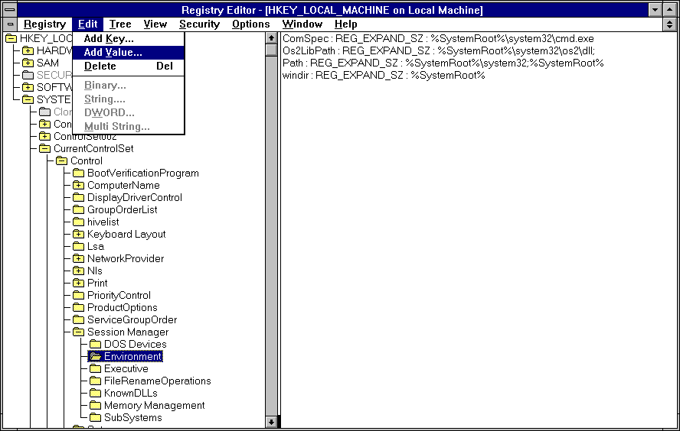

- The Add Value dialog is displayed. Insert the Modbus Name in the Value Name e.g.MODBU_1

- The String Editor dialog is now displayed. Enter the string WEST or JUMO in upper case into the String field.

- The setting for the environment string should now be displayed in the registry. Exit the registry editor, re-boot your machine and run the system.

Debug View
There is now a debug utility available to use within Modbus Master that allows you to monitor debug output on the local machine or on any computer over the network via TCP/IP. To launch the debug utility click on Control then Debug on the Configure screen.

Capture Output
When you start the utility it will begin capturing debug output by default. You can toggle between capture on and capture off with the following toolbar icon: Alternatively you can use Capture Menu > Capture Events or using the Ctrl + E hotkey. When capture mode is off the utility will not capture any debug output until it is turned back on. The kind of output that is captured is determined on whether Win32 or Kernel capture is on or off.

Insert Comments
You can insert comments in the output log by clicking on Edit>Append Comment. Comments insert into the currently viewed output. Type comments into the dialog followed by the Enter key and then close the dialog when you are done entering comments.

Clearing the Display
To clear the output screen simply click on the toolbar or go to Edit>Clear display on the menu.

Searching
You can search for a line of text that is of interest by clicking on the toolbar or going to Edit>Find on the menu. If the search matches what you specified then it will be highlighted on the output window while disabling the auto-scroll feature. To repeat a successful search you can use the F3 hotkey.

Filtering
Another way of picking out debug output is to use the filtering feature. You can use it by clicking on the toolbar or going to Edit>Filter/Highlight on the menu. The Filter/Highlight feature contains two edit fields: include and exclude. The Include field is where you enter substring expressions that match debug output lines that you want the utility to display, and the exclude field is where you enter text for debug output lines that you do not want the utility to display. You can enter multiple expressions, separating each with a semicolon (‘;’). Do not include spaces in the filter expression unless you want the spaces to be part of the filter. Note that the filters are interpreted in a case-insensitive manner, and that you should use ‘*’ as a wildcard.

Highlighting
If you want output lines that contain certain text to be highlighted in the utility output window, enter a highlight filter. The utility implements support for up to five different highlight filters, each with its own foreground and background color settings. Use the filter drop-down in the highlight filter area of the filter dialog to select which highlight filter you want to edit. Use the same syntax just described for include and exclude filters when defining a highlight filter.

Use the Load and Save buttons on the filter dialog to save and restore filter settings, including the include, exclude and highlighting filters, as well as the highlighting colors settings.

History Depth
Another way of controlling the debug output is to limit the number of lines that are retained in the window. You can do this by clicking on the toolbar or Edit>History Depth on the menu. Once opened enter the number of output lines you want the utility to retain and it will keep only that number of the most recent debug output lines, discarding older ones. A history-depth of 0 represents no limit on output lines retained.

Menu Items

File
Item | Description
New Window… | Opens a new debug window.
Open… | Open a saved debug window.
Save | Save the current debug window.
Save As… | Specifies what to save the current debug as.
Log to File… | Creates a log file of the debug output
Log to File As… | Specifies what to save the log file as.
Print… | Prints the debug output.
Print Range… | Specifies what range to print of the debug output.
Process Crash Dump… | Creates a crash dump of the output up until the crash.
Exit | Exit the utility.

Edit
Item | Description
Append Comment | Write a comment for the current output.
Copy | Copy the selected text.
Find | Find a specific piece of text.
Filter/Highlight | Filter the output to include or exclude certain string values.
Clear Display | Clear the debug output window.

Capture
Item | Description
Capture Win32 | Will register to receive and print debug output generated by Win32 programs that call OutputDebugString.
Capture Global Win32 | Let’s you enable and disable the capture of debug output that is generated in the console (global) session.
Capture Kernel | Captures kernel-mode debug output generated by device drivers and/or the Windows kernel
Enable Verbose Kernel Output | Outputs kernel mode in verbose.
Pass-through | Allows you to see kernel-mode debug output in the output buffers of a conventional kernel-mode debugger while at the same time viewing it in the utility.
Capture Events | You can toggle on or off and it will capture events and display on the debug output.
Log Boot | Toggle on or off to enable the utility to log on Windows startup.

Options
Item | Description
Win32 PIDs | Information identifying processes that generate Win32 debug output is prefixed to each line of Win32 debug output.
Force Carriage Returns | Forces carriage returns on the debug output.
History Depth… | Limits the number of lines that are retained in the window.
Clock Time | Toggles between setting the time in seconds or HH:MM:SS.ms
Show Milliseconds | Toggle whether to show milliseconds in the time stamp.
Font | Change the debug output font style, size, and type.
Hide When Minimized | Hides the utility to the taskbar when minimized.
Hide Toolbar | Hides the toolbar on the utility.
Auto Scroll | Toggle between the debug output automatically scrolling down as
Always on Top | Utility window will always appear on top even when it loses focus.

Computer
Item | Description
Connect | Connect to a computer over the network.
Connect Local | Connect to the local machine
Disconnect | Disconnect from the current computer on the network.
COMPUTER_NAME | The current machine you are connected to.

Help
Item | Description
Help… | Displays a help file to explain the utility.
About | Displays current software version and details.

Toolbar

Name | Icon
Open
Save
Log to File
Capture
Capture Kernel
Passthrough Kernel
Capture Win32
Clear
Autoscroll
Time Format
Filter/Highlight
History Depth
Find

