Partnership Courtyard, The Ramparts,
Dundalk, Ireland

Version 6.8.0.0
March 12, 2021
www.measuresoft.com
+353 42 933 2399

This document is the copyright of Measuresoft and may not be modified, copied or distributed in any form whatsoever without the prior permission of Measuresoft.

Lakeshore User Manual

Table of Contents

1 Configuration 4
2 Advanced Device Configuration 5
2.1 AutoEnable Device 5
2.2 Scan Rate 5
2.3 Save Outputs 5
2.3.1 By Tag 5
2.4 Device Specific Button 6
2.4.1 Model 6
2.4.2 Excitation Frequency 6
2.4.3 GPIB 6
2.4.3.1 Board 6
2.4.3.2 Address 6
2.4.4 RS-232 6
2.4.4.1 Port 7
2.4.4.2 Speed 7
2.4.4.3 Parity 7
2.4.5 Command 7
2.4.6 Curves 7
2.4.7 Curve No 8
3 Analog Input Channel Configuration 9
3.1 Enable Channel 9
3.2 Tag 9
3.3 Description 9
3.4 Engineering Units 9
3.4.1 Minimum 10
3.4.2 Maximum 10
3.4.3 Descriptor 10
3.5 Device Specific Button 10
3.5.1 Input number 10
3.5.2 Reading 10
3.5.3 Configure 11
3.5.4 Sensor Type 11
3.5.5 Coefficient 11
3.5.6 Sensor Units/Excitation Mode 11
3.5.7 Input Excitation 11
3.5.8 Range 11
3.5.9 Dwell Time 11
3.5.10 Pause Time 12
3.5.11 Compensation 12
3.5.12 Curve No 12
3.5.13 Filter 12
3.5.13.1 Points 12
3.5.13.1 Settle Time 12
3.5.13.2 Window 12
4 Digital Input Channel Configuration 13
4.1 Enable Channel 13
4.2 Tag 13
4.3 Description 13
4.4 Low State Description 13
4.5 High State Description 14
4.6 Event Checking 14
4.7 Alarm Checking 14
4.7.1 Alarm State 14
4.7.2 Alarm Priority 14
4.7.3 Common Alarm 14
4.7.4 Alarm Delay 14
4.7.5 Alarm Message 14
4.8 Device Specific Button 14
4.8.1 Input number 15
5 Analog Output Channel Configuration 16
5.1 Direct Analog Outputs 16
5.1.1 Output number 16
5.1.2 Bipolar 16
5.1.3 PID Controlled 16
5.1.4 -100% and 100% Output Values 16
5.2 Control Loop Parameters 17
5.2.1 Loop number 17
5.2.2 Loop parameters 18
6 Digital Output Channel Configuration 20
6.1 Device Specific Button 20
6.1.1 Type 20
6.1.2 Output 20
6.1.3 Alarm 20
6.1.4 Alarm Channel 21

Configuration

The first time the system is configured it is necessary to enable and configure all devices you require. To configure a particular device select the Devices option from the main menu followed by the Lakeshore device. This will launch an application to configure the device.

From the list provided select a channel and double-click. Alternatively you can select a channel and then click on the Configure Channel button.

This will launch a channel configuration dialog which enables you to configure individual channels.

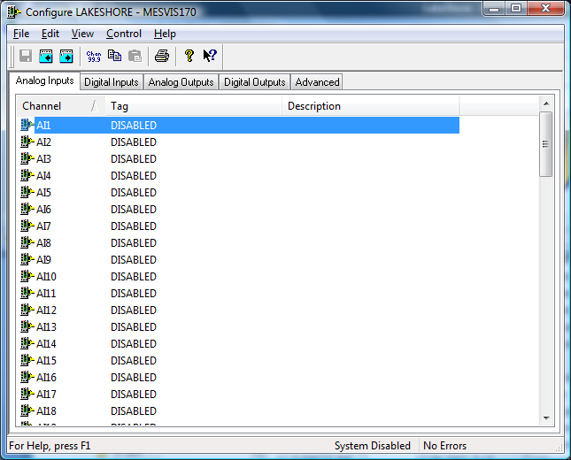

Advanced Device Configuration

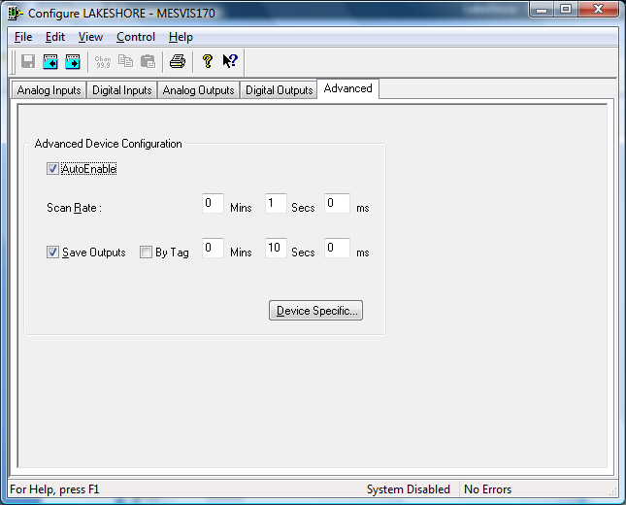

AutoEnable Device
To ensure that the device is enabled on the system check the Enable Device box.

Scan Rate
To set the rate at which the device will scan, edit the text boxes associated with the Scan Rate field.

Save Outputs
To enable this utility check the Save Outputs flag. All values in output channels are saved to disk when the system is disabled. The next time the system is restarted the values which were previously in output channels will be restored to the appropriate channel number.

By Tag
Channel values can be saved and restored to channels using the channel tag instead of the channel number. In this way, channels can be rearranged within the modules and as long as the channel tags remain the same, the correct channel values will be restored to the appropriate channel number.

Device Specific Button
When the Device Specific Button is pressed the following dialog appears to allow specific communication settings to be configured for the device.

Model
The model can be set to one of the following

218 – Temperature Monitor
340 – Temperature Controller
350 – Temperature Controller
370 – AC Resistance Bridge

Excitation Frequency
This field is only displayed for the 370 Model. Specifies the instruments excitation frequency. 9.8 Hz, 13.7 Hz and 16.2 Hz

GPIB
The GPIB communication settings are use to establish a GPIB link to the device.

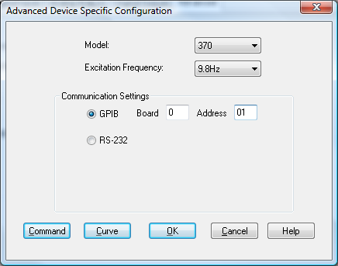

The GPIB Gateway Communication Settings

Board
Enter the board number of the controller to which the instrument is attached.

Address
Enter the address of the controller to which the instrument is attached.

RS-232
The RS-232 Serial Port Communication Settings are used to establish a serial communication link to the device.

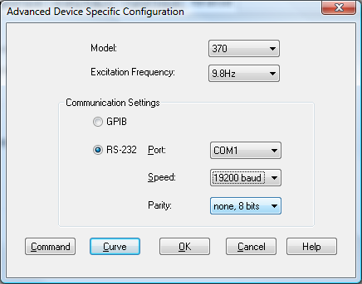

Port
Displays communications ports available on your computer

Speed
Lists the baud rates that are supported by the hardware on your PC. Choose the highest speed that is supported by the hardware. If you encounter problems, you may have to adjust this to a slower speed at a later time.

Parity
Displays the various choices that can be implemented for parity checking.

Ethernet
The Ethernet Communication Settings are used to establish a Ethernet communication link to the device.

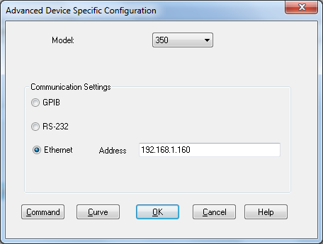

Address
Displays the IP address or node name of the Lakeshore device

Command
The command button is used to launch the send command dialog to communicate with the device.

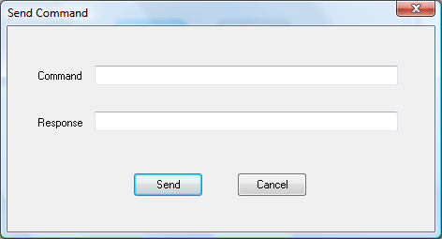

The command *IDN? is useful for testing model type and version number.

Curves
Curves can be manually loaded into the device using the Load Curve dialog

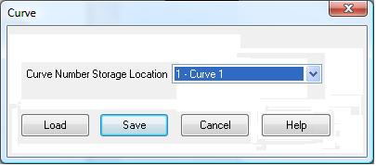

Curve No

Curve Number Storage Location specifies the user curve to load.

For the 218, valid user curve numbers are 21 to 28..

For the 340, valid user curve numbers are 21 to 60.

For the 350, valid user curve numbers are 21 to 59.

For the 370, valid user curve numbers are 1 to 20.

When the user selects the Load button, a file selection dialog is presented to select a file in 340 format. The file is parsed and the curve is stored on the Lakeshore device.

When the user selects the Save button, a file selection dialog is presented to select a file in 340 format. The curve is extracted from the Lakeshore device.

Analog Input Channel Configuration

Autoscanning is used to scan analog inputs.

When the user selects an analog input to be configured the following is displayed.

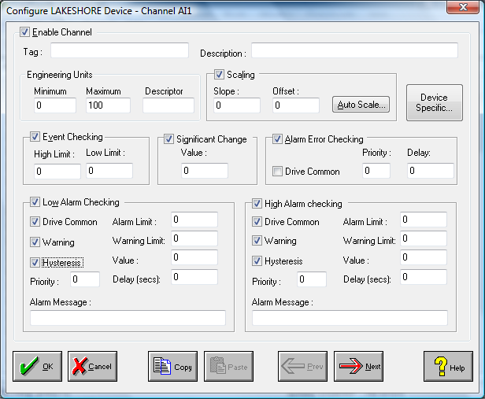

Enable Channel
The Enable Channel check box must be checked to enable and allow a channel to be configured and ultimately included with all other configured channels in the overall system.

Tag
The Tag field is a 12 character alphanumeric field that can contain channel information or wiring schedule references.

Description
The Description field is a 32 character alphanumeric field in which a description of the channel can be detailed.

Engineering Units
Specifies engineering details for this channel.

Minimum
Minimum engineering value for all Analog channels in addition to the unit field. The default is 0.

Maximum
Maximum engineering value for all Analog channels in addition to the unit field. The default is 100.

Descriptor
Describe the units of the measurement.

Device Specific Button
When the Device Specific Button is pressed the following dialog appears to allow specific device configuration of the particular channel.

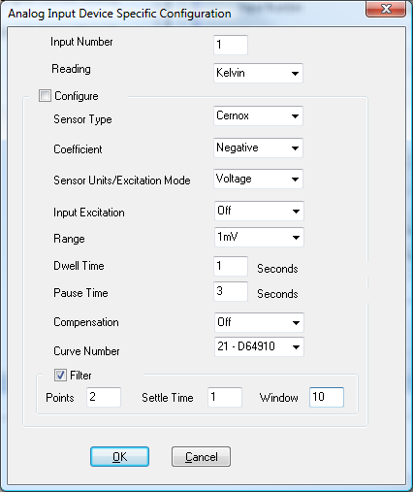

Input number
Input number on the device. For 218 this can be 1 to 8 and for 340 and 370 models this can be 1 to 16. For the 350 it can be A – D (D1 – D5 for 3062 option)

Reading
The type of reading to be performed on the channel For the 218 and the 340, the reading can be Kelvin, Celsius or Sensor Units. For the 370 the reading can be Kelvin, Excitation Power or Resistance.

Configure
The configure option is used to flag if the configuration options are applied to the channel. This is to permit different reading types to be taken from the one input into several channels and only have to provide one set of configuration options on one of the channels.

Sensor Type
This option is only available on the 218 and the 340 and specifies the input sensor type.

For the 218 model valid sensor types are 2.5V Diode, 7.5V Diode, 250Ω Platinum, 500Ω Platinum, 5kΩ Platinum and Cernox.

For the 340 model valid sensor types are Special, Silicon Diode, GaAlAs Diode,Platinum 100 (250Ω), Platinum 100 (500Ω), Platinum 1000, Rhodium Iron, Carbon-Glass, Cernox, RuOx, Germanium, Capacitor and Thermocouple.

For the 350 model valid sensor types are Diode(3062 option only), PTC RTD, NTC RTD, Thermocouple and Capacitance

Coefficient
This option is only available on the special sensor types on the 340and sensors on the 370. For the 340 this specifies the input coefficient and for the 370 the temperature coefficient if no curve is present. Coefficient can be positive or negative.

Sensor Units/Excitation Mode
This option is only available on the special sensor types on the 340 and sensors on the 370. For the 340 this option specified the sensor type and on the 370 it specifies the excitation mode. Specified as Volatge or Current

Input Excitation
This option is only available on the special sensor types on the 340 and on the 370 and on NTC RTD sensors on the 350.

For special sensor types on the 340, valid selections are Off, 30 nA, 100 nA, 300 nA, 1 μA, 3 μA, 10 μA, 30 μA, 100 μA, 300 μA, 1 mA, 10 mV and 1 mV.

For NTC RTD sensors on the 350, valid selections are 1mV and 10mV.

For voltage sensors on the 370, valid selections are Off, 2.00 μV, 6.32 μV, 20.0 μV, 63.2 μV, 200 μV, 632 μV, 2.00 mV, 6.32 mV, 20.0 mV, 63.2 mV, 200 mV and 632 mV.

For current sensors on the 370 valid selections areOff, 1.00 pA,3.16 pA,10.0 pA,31.6 pA,100 pA, 316 pA, 1.00 nA, 3.16 nA, 10.0 nA, 31.6 nA, 100 nA, 316 nA, 1.00 μA, 3.16 μA, 10.0 μA, 31.6 μA, 100 μA, 316 μA, 1.00 mA, 3.16 mA, 10.0 mA and 31.6 mA.

Range
This option is only available on the special sensor types on the 340 and on the 370. For the 340 this specifies the input range in volts, for the 350 it specifies the range in voltage, ohms or Farad and for the 370 this specifies the resistance range in ohms.

For special sensor types on the 340, valid selections are
1 mV, 2.5 mV, 5 mV, 10 mV, 25 mV, 50 mV, 100 mV, 250 mV, 500 mV, 1 V, 2.5 V, 5 V and 7.5 V.

1 mV;2.5 mV;5 mV;10 mV;25 mV;50 mV;100 mV;250 mV;500 mV;1 V;2.5 V;5 V;7.5 V

For sensors on the 370, valid selections are Autorange,2.00 mΩ,6.32 mΩ,20.0 mΩ,63.2 mΩ,200 mΩ,632 mΩ,2.00 Ω,6.32 Ω,20.0 Ω,63.2 Ω,200 Ω,632 Ω,2.00 kΩ,6.32 kΩ,20.0 kΩ,63.2 kΩ,200 kΩ, 632 kΩ, 2.00 MΩ, 6.32 MΩ, 20.0 MΩ and 63.2 MΩ.

Dwell Time
This option is only available on sensors on the 370 and specifies a value for the autoscanning dwell time: 1–200 seconds.

Pause Time
This option is only available on sensors on the 370 and specifies a value for the change pause time: 3–200 seconds.

Compensation
This option is only available on the special and NTC resistor sensor types on the 340.
Specifies whether to use compensation for this input. Valid entries areOff, On andPause.

Curve No
Specifies the curve an input uses for temperature conversion.

For the 218, valid entries are: 0 = none, 1-5 = Standard DiodeCurves, 6-9 = Standard Platinum Curves, 21-28 = User curves.

For the 340, valid entries are: 0 = none, 1 -20 = standard curves, 21 - 60 = user curves.

For the 350, valid entries are: 0 = none, 1 -20 = standard curves, 21 - 59 = user curves.

For the 370, valid entries are: 0 = none, 1–20 = user curves.

Filter
Allows a filter function to be applied to an input.

Points
This option is only available on the 218, 340 and 350. Specifies how many data points the filtering function uses (2-64).

Settle Time
This option is only available on the 370 and valid entry is 1-200 seconds.

Window
Specifies what percent of full scale reading limits the filtering function (1-10). Reading changes greater than this percentage reset the filter.

Digital Input Channel Configuration

Digital Inputs are only supported on the 340 Model

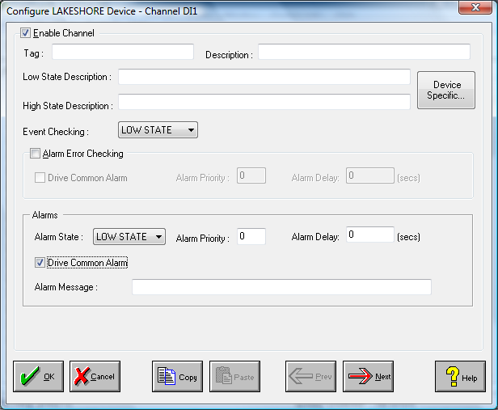

Enable Channel
The Enable Channel check box must be checked to enable, and allow this channel to be configured and ultimately included with all other configured channels in the overall system.

Tag
The Tag field is an 12 character alphanumeric field that can contain channel information or wiring schedule references.

Description
The Description field is a 32 character alphanumeric field in which a description of the channel can be detailed.

LowState Description
A 32 character field in which to enter a description of the low state of the channel.

HighState Description
A 32 character field in which to enter a description of the high state of the channel.

Event Checking
Event checking is used, if required to trigger a logger to record information on an event. If this facility is required click on the drop down list box and select OFF, HIGHSTATE, or LOWSTATE as appropriate. Events are detected on inputs using data acquired at 1Khz. Events are detected on outputs using the configured scan rate.

Alarm Checking

AlarmState
Alarm checking is available on all channels throughout the system. To configure alarm checking on this channel click on the drop down box and select OFF, HIGHSTATE, or LOWSTATE as appropriate. If the channel's output state changes to an AlarmState an alarm will be triggered on the channel. When monitoring channels, if the alarm is triggered, the fact will be annotated alongside the other channel information in the Channel Monitor . Alarms and warnings are detected at the configured scan rate.

Alarm Priority
Enter the priority of the alarm triggered by this channel. Alarm priority ranges are from 0 to 255.

Common Alarm
Channels can be configured to trigger a Common Alarm. A common alarm is a single digital output which will switch on when any channel with the Drive Common Alarm enabled goes into an alarm state.

Alarm Delay
Enter the time, in seconds, between the channel value entering the alarm state and the system flagging an alarm.

Alarm Message
An Alarm Message can be defined to be displayed on the Status line of the Main Window when a channel goes into an alarm state.

Device Specific Button
When the Device Specific Button is pressed the following dialog appears to allow specific device configuration of the particular channel.

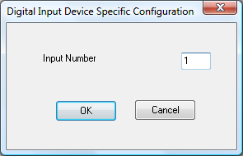

Input number
Input number on the device. This can be 1 to 8

Analog Output Channel Configuration

Current Analog Outputs values are read from the device when the scanning starts. If the output changes on the device e.g. from the front panel the new value is read into channels. If the output changes via system channels e.g. from the calculator or a monitor the output is written to the device.

See Analog Input for an explanation of the standard channel configuration. The device specific configuration provides for linking a channel to either a direct analog output or a Contol Loop Parameter.

Direct Analog Outputs
When the Device Specific Button is pressed the following dialog appears to allow specific device configuration of analog outputs. Direct analog outputs are supported on all model types.

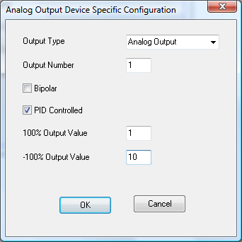

Output type
Analog Output for direct analog outputs on all devices. Heater Output on the

Output number
Input number on the device. On the 218 this is 1-2

Bipolar
If the output is bipolar. On allows a range of -10V to +10V and off allows a range of 0-10V on the 218.

PID Controlled
If the output is controlled by a PID loop. This option only applies on the 340 and 370.

-100% and 100% Output Values
Output range of the output if it is controlled by a PID loop.

Control Loop Parameters
When the Device Specific Button is pressed the following dialog appears to allow specific device configuration of PID Control Loop Paramaeters. PID Control Loop parameters are set up as analog outputs so that they can be controlled as channel values. PID Control loops are only supported on the 340 and 370 model types.

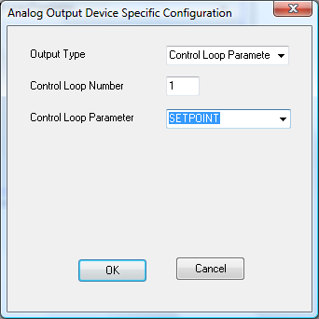

Loop number

Control Loop Number.

On the 340 loop number is 1 or 2.

On the 370 loop number is always 1.

Loop parameters

Parameters and their channel values are as follows. Where a channel is set to an invalid value, the set value will be overwritten with current value of the parameter on the Lakeshore device.

PARAMETER | Model 340 | Model 350 | Model 370
Control Filter Enable | Specifies controlling on unfiltered or filtered readings: 0 = unfiltered, 1 = filtered | N/A | Specifies controlling on unfiltered or filtered readings: 0 = unfiltered, 1 = filtered
Setpoint Limit | Value at which turns off  Output | N/A | N/A
Positive Slope | Maximum positive change in output | N/A | N/A
Negative Slope | Maximum negative change in output. | N/A | N/A
Max Current | Value in Amps  Requires firmware version 01.03.08 and later. | Value in Amps | N/A
Setpoint Delay | N/A | N/A | Delay in seconds for setpoint change.  1-255
Heater Output Display | Specifies heater output display in current or power  1 – Current  2- Power | Specifies heater output display in current or power  1 – Current  2- Power | Specifies heater output display in current or power  1 – Current  2- Power
Heaters Limit | N/A | N/A | 1-8
Heater Resistance | Heater load resistance  1-1000 | Heater load in ohms  1 - 25Ohms  2 – 50Ohms | Heater load in ohms  1-100000
Heater Range | 0-5  0 turns off heater | 1-2  0 = Off, 1 = Range1, 2 = Range 2, 3 = Range 3, 4 = Range 4,  5 = Range 5  3-4  0 = Off, 1 = On | 0-8  0 = Off, 1 = 31.6 μA, 2 = 100 μA, 3 = 316 μA, 4 = 1.00 mA,  5 = 3.16 mA, 6 = 10.0 mA, 7 = 31.6 mA, 8 = 100 mA
Mode | 1 - Manual PID  2- Zone,  3- Open Loop  4- Autotune PID  5- Autotune PI  6 - Autotune P | 0 - Off  1 - Close Loop PID,  2- Zone Tuning,  3- Open Loop,  4- Monitor Out  5- Warmup Supply | 1 - Close Loop PID,  2- Zone Tuning,  3- Open Loop,  4- Off
Control Input | 1 – A  2 – B  3 – C1  4 - D1 | 0 – None  1 – A  2 – B  3 – C  4 – D  5 – D2  6 – D3  7 – D4  8 - D5 | 1-16
Setpoint Units | 1 - Kelvin  2 - Celsius  3 – Sensor Units | N/A | 1 – Kelvin  2 – Ohms
Enable | 0 - Off  1 – On | N/A | N/A
Power up enable | 0 – Off  1 – On | N/A | N/A
Proportional (gain) | Value | Value .1 to 1000 | Value .001 to 1000
Integral (reset) | Value in seconds | Value in seconds 0.1 to 1000 | Value in seconds 0 to 10000
Derivative (rate) | Value in seconds | Value in seconds 0 to 200 | Value in seconds 0 to 2500
Ramp Enable | 0 - Off  1 – On | 0 – Off  1 - On | 0 – Off  1 - On

PARAMETER | Model 340 | Model 350 | Model 370
Ramp Rate | Value in Kelvin per minute from 0.001 to 100.  The rate is always positive. but will respond to ramps up or down.. | Value in Kelvin per minute from 0.1 to 100.  The rate is always positive. but will respond to ramps up or down. | Value in Kelvin per minute from 0.001 to 100.  The rate is always positive. but will respond to ramps up or down.
Setpoint | Value in units selected | Value in preferred units of control loop sensor | Value
Manual Output | Value in % | Value in % | Value
AutoTune | N/A | 0 – P  1 – P and I  2 – P, I and D | N/A

Digital Output Channel Configuration

Current Digital Outputs values are read from the device when the scanning starts. If the output changes on the device e.g. from the front panel the new value is read into channels. If the output changes via system channels e.g. from the calculator or a monitor the output is written to the device.

See Digital Input for an explanation of the standard channel configuration. The device specific configuration provides for linking a channel to either a direct analog output or a Contol Loop Parameter.

Device Specific Button
When the Device Specific Button is pressed the following dialog appears to allow specific device configuration of the particular channel.

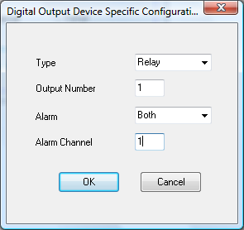

Type
For 218 type is always set to relay. For 340 and 370, type can be set to relay or digital output.

Output
This specified digital output or relay number. For relays on the 218 this is 1 to 8. For relays on the 340 and 370, this is 1 (low) or 2 (high). For digital outputs on the 340 and 370 valid values are 1 to 5.

Alarm
This specifies if relays are controlled by alarms on a specific channel.

For the 218 and 370 this can be set to None, Low , High or Both.

For the 340 this can be set to None or Both.

Alarm Channel
On the 218, this specifies the input channel (1-8) if the output is controlled by alarms on an input channel.

On the 370, this specifies the input channel (1-16) if the output is controlled by alarms on an input channel.

