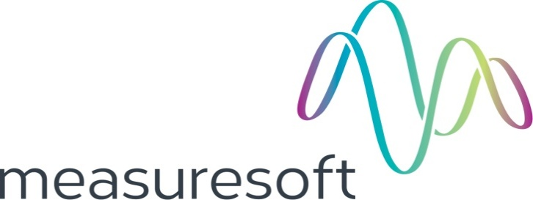
Partnership Courtyard, The Ramparts,
Dundalk, Ireland

Version 6.8.0.0
March 7, 2022
www.measuresoft.com
+353 42 933 2399

This document is the copyright of Measuresoft and may not be modified, copied or distributed in any form whatsoever without the prior permission of Measuresoft.

Intercole LDAS User Manual

1. Configuration 2
2. Channel Configuration 2
2.1 Enable Channel 2
2.2 Tag 2
2.3 Description 2
2.4 Engineering Units 2
2.4.1 Minimum 2
2.4.2 Maximum 2
2.4.3 Descriptor 2
2.5 Scaling 2
2.5.1 Auto Scaling 2
2.6 Event Checking 2
2.6.1 High Limit 2
2.6.2 Low Limit 2
2.7 Significant Change 2
2.8 Alarm Error Checking 2
2.8.1 Drive Common 2
2.8.2 Priority 2
2.8.3 Delay 2
2.9 Alarm Checking 2
2.9.1 Enable Alarm Checking 2
2.9.2 Drive Common Alarm 2
2.9.3 Alarm Limit 2
2.9.4 Warning and Limit 2
2.9.5 Hysteresis 2
2.9.6 Priority 2
2.9.7 Alarm Delay 2
2.9.8 Alarm Message 2
2.10 Device Specific Button 2
2.10.1 Analog input channel specific configuration 2
2.10.2 Digital channel specific configuration 2
2.10.3 Analog output channel configuration 2
2.10.4 Counter input channel configuration 2
3. Advanced Device Configuration 2
3.1 AutoEnable Device 2
3.2 Scan Rate 2
3.3 Save Outputs 2
3.3.1 By Tag 2
3.4 Device Specific Button 2
3.4.1 Node name 2
3.4.2 Frequency scan interval 2
3.4.3 Use database integration 2
3.4.4 Scanivalve configuration 2
3.4.5 ADC Number 2
3.4.6 PRT scan interval 2
3.4.7 Open circuit limit 2
3.4.8 RRS configuration 2
3.4.9 Scanivalve configuration 2
4. Intercole LDAS Driver Errors 2
4.1 Format Of Error Messages 2
4.2 Network Error Codes 2
4.3 Configuration and Runtime Error Codes 2
4.4 Diagnostic Error Codes 2
4.5 Open Circuit Check Error Codes 2

Configuration

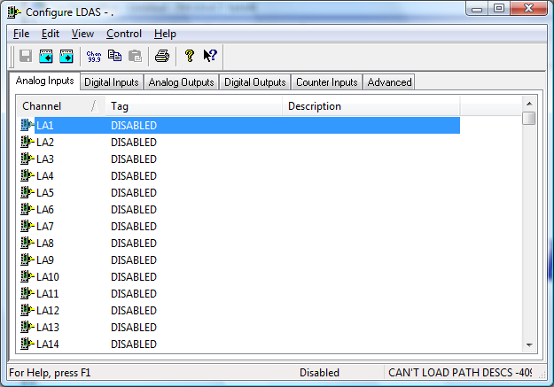

The first time the system is configured it is necessary to enable and configure all devices you require. To configure a particular device select the Devices option from the main menu followed by the appropriate device.
This will launch an application to configure the device. You will be presented with a set of tabs as shown above.
To configure a channel select a group of channels by clicking on the appropriate channel tab. From the list provided select a channel and double-click. Alternatively you can select a channel and then click on the Configure Channel button. This will launch a channel configuration dialog which enables you to configure individual channels.

Channel Configuration

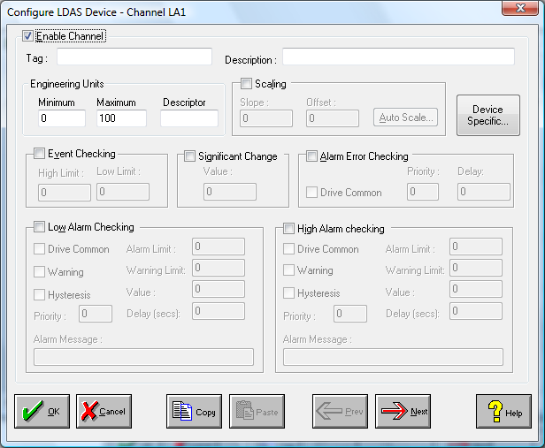

Enable Channel
The Enable Channel check box must be checked to enable, and allow this channel to be configured and ultimately included with all other configured channels in the overall system.

Tag
The Tag field is a 12 character alphanumeric field that can contain channel information or wiring schedule references.

Description
The Description field is a 32 character alphanumeric field in which a description of the channel can be detailed.

Engineering Units
Specifies egnineering details for this channel.

Minimum
Minimum engineering value for all analog channels in addition to the unit field. The default is 0

Maximum
Maximum engineering value for all analog channels in addition to the unit field. The default is 100

Descriptor
A 4 character field available to describe the units of the measurement

Scaling
NB. Scaling is only available to Analog channels that are not Output channels.

Some transducers give a number of pulses, or a frequency output proportional to their full scale range. To enable the Scaling utility check the Scaling Check box. The Slope and Offset values can be entered directly into the text boxes. The formula applied is:

y = mx + c where: m is SLOPE
x is the measured value.
c is the OFFSET

Auto Scaling
Click On the Auto Scale button if you want the scale and offset values calculated automatically. A dialog box will be displayed. Enter the values in the text boxes. The low measured value, and the high measured value, the output range of the transducer. When the fields have been completed, and assuming the System is enabled click on the Apply button. Under the heading Current Values the actual measured value will be shown, as well as the Engineering Value.

Click on OK to accept the scaling, or Cancel to abort the Auto Scaling feature.

NB. Scaling will not be applied to the channel, even if the system is enabled, until the system is next enabled or the Intercole LDAS Series Device is reconfigured

Event Checking
Event checking is used, if required to trigger a logger to record information on a number of channels during an event. Check the Event Checking check box if this channel is to trigger an event.

High Limit
A value, in engineering units, entered in this text box will define the level that, if exceeded, will cause an event trigger.

Low Limit
A value entered in this text box will define the level that if the channel result falls below will cause an event trigger.

Significant Change
To enable the Significant Change feature check the Sig Change check box. This facility allows filtering of data on channels on which significant change is of interest. Such changes can cause an event, which can be logged.
The figure entered in the Value text box, is the rate of change that if the output level exceeds per scan, either increasing or decreasing will cause the significant change event trigger. The scan rate is determined in the Advanced Device configuration
If a logger is configured each time the significant change trigger operates information on the channels defined in the logger will be recorded . A significant change event only lasts one scan, unless the next reading also changes greater than the Significant change value

When monitoring channels, if the Significant Change is triggered, then the fact will be annotated alongside the other channel information in the Channel Monitor. The significant change events are in addition to those caused by an Event.

Alarm Error Checking
Drives a common alarm when an error occurs on this channel.

Drive Common
A common alarm is a single digital output which will switch on when any channel with the Drive Common Alarm enabled goes into an alarm state. Check this box if a link to the Common Alarm is required.

Priority
Enter or edit the number in the text box to allocate the priority of this channels alarm.

Delay
Enter the time, in seconds, between the channel value entering the alarm state and the system flagging an alarm.

Alarm Checking
Alarm checking is available on all channels throughout the system. Low Alarm and High Alarm levels can be configured independent of each other. If the channel output exceeds the High Alarm limit then an alarm will be triggered as it will if the output goes below the Low Alarm limit.

When monitoring channels, if the high or low alarm is triggered, then the fact will be annotated alongside the other channel information in the Channel Monitor. To configure the Alarm Checking section of the device complete the options as follows for either or both the High Alarm and Low Alarm checking.

Enable Alarm Checking
Check either the Low Alarm Checking or High Alarm Checking or both check boxes to enable the facility.

Drive Common Alarm
A common alarm is a single digital output which will switch on when any channel with the Drive Common Alarm enabled goes into an alarm state. Check this box if a link to the Common Alarm is required.

Alarm Limit
Specifies the value which will trigger this alarm. for Low Alarm Checking it will be any value <= the Alarm Limit and for High Alarm Checking it will be any value >= the Alarm Limit.

Warning and Limit
If required, a warning can be displayed when a channel reaches a limit close to the alarm limit. For low alarm checking, the limit must be less than the alarm limit. For high alarm checking, the warning limit must be less than the alarm limit

Hysteresis
Hysteresis can prevent 'noisy' channels from reporting multiple alarms when the average reading is close to the alarm threshold. Check the box if this feature if needed. Enter the value of the dead band in the corresponding value field.

Priority
Enter or edit the number in the text box to allocate the priority of this alarm. Alarm priority ranges are from 0 to 255.

Alarm Delay
Enter the time, in seconds, between the channel value entering the alarm state and the system flagging an alarm.

Alarm Message
An Alarm Message can be defined to be displayed on the Status line of the Main Window when a channel goes into an alarm state. Enter the message, up to 32 characters, that is to appear in the event of an alarm.

Device Specific Button
When the Device Specific Button is pressed, the following will apply :

Analog input channel specific configuration
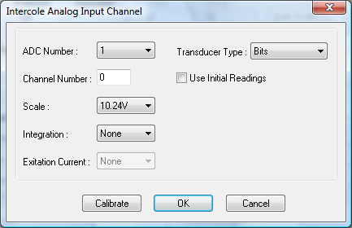

ADC Number
Selection for ADC to be configured

Channel Number
Enter channel number (0..255)

Transducer Type
Select transducer type

Scale
Select correct voltage range for input channel

Integration
The default value is 50Hz and in not normally changed

Exitation Current
It becomes available when transducer types linear, PRT 100 and strain gauge are selected

S/G Bridge Arms, S/G Resistance and S/G Factor
These values are available for strain gauge only

Digital channel specific configuration
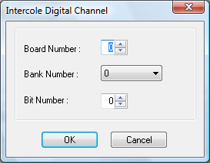

Board Number
Digital board number (1..20)

Bank Number
Available values are 0..3

Bit Number
Corresponding bit number (0..15)

Analog output channel configuration
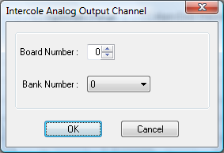

Board Number
Digital board number (1..20)

Bank Number
Available values are 0..3

Counter input channel configuration
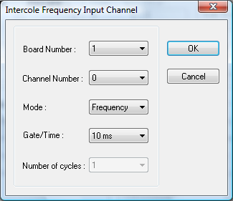

Board number
Frequency board number (1..4)

Channel number
Available channel numbers are 0..4

Mode
Scan type flag : frequency or period

Gate/Time
In frequency mode this parameter represents the gate code over which the measurementis made.
In period mode it represents the measurement time base code.

Number of cycles
In period mode it represents the number of cycles over which the measurement is made.

Advanced Device Configuration

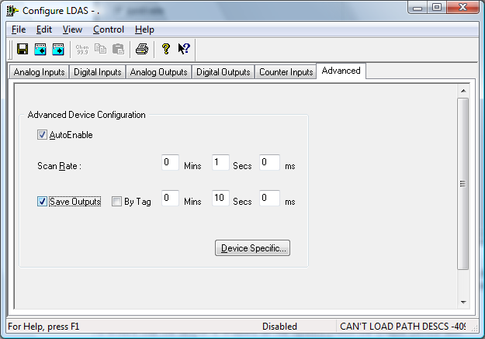

When the system is enabled and the device is enabled this window will display the Achieved Scan Rate . If the device is not scanning then any error associated with the device will be displayed instead.

AutoEnable Device
To ensure that the device is enabled on the system check the Enable Device box.

Scan Rate
To set the rate at which the device will scan, edit the text boxes associated with the Scan Rate field.

Save Outputs
To enable this utility check the Save Outputs flag. All values in output channels are saved to disk when the system is disabled. The next time the system is restarted the values which were previously in output channels will be restored to the appropriate channel number.

By Tag
Channel values can be saved and restored to channels using the channel tag instead of the channel number. In this way, channels can be rearranged within the modules and as long as the channel tags remain the same, the correct channel values will be restored to the appropriate channel number.

Device Specific Button
When the Device Specific Button is pressed, the following will apply :

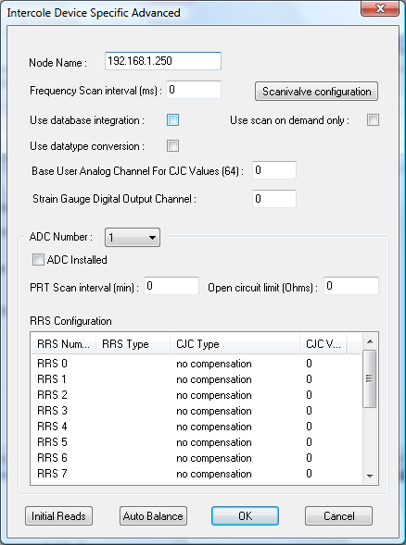

Node name
Spectra-node name

Frequency scan interval
Scan interval for reading data from the defined frequency boards and channels. A value of zero indicates no scanning is required

Use database integration

Use datatype conversion
If checked, all channels data are converted to engineering units. If not, all data are returned in volts

Use scan on demand only
Check this box, if scan at maximum rate isn’t required

Scanivalve configuration
To configure scanivalve channel click on button

ADC Number
Selection for ADC to be configured

PRT scan interval
Scan interval for all on-board PRT measurements

Open circuit limit
Value to check open circuit status of thermocouples

RRS configuration
List of RRS boards. To configure RRS, double click on it. Next dialog will appear

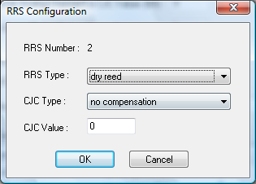

RRS Number
Number of RRS board to be configure

RRS Type
Select type of RRS board

CJC Type
Select type of CJC

CJC Value
Enter CJC value or channel (channel must be entered with prefix)

Scanivalve configuration
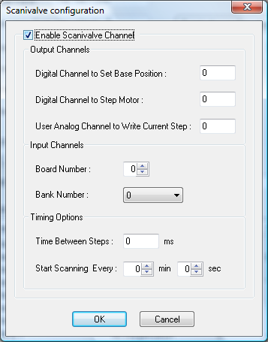

Enable Scanivalve Channel
Scanivalve channel is enabled if box checked

Digital Channel to Set Base Position
Enter digital output channel number, which corresponds to base positioning

Digital Channel to Step Motor
Enter digital output channel number, which corresponds to motor stepping

User Analog Channel to Write Current Step
Enter user analog channel number, which is used to store current motor position

Board Number and Bank Number
These fields allow configuring current motor position readings

Time Between Steps
This field allows to set time interval between motor stepping

Start Scanning Every
To configure periodic scanning enter required time

Intercole LDAS Driver Errors

Format Of Error Messages

Network Error Codes

Error Code
-1 | Host id error
-2 | Create socket error
-3 | Bind socket error
-4 | Connect error
-5 | Socket write error
-6 | Socket read error
-7 | Message type error
-8 | Create socket error

Configuration and Runtime Error Codes

Error Code
1 | Invalid ADC number
2 | Invalid RRS number or RRS range
3 | Invalid channel number or channel range
4 | Invalid ADC scan interval
5 | Invalid CJC scan interval
6 | Invalid calibration scan interval
7 | Invalid digital scan interval
8 | Invalid CJC type
9 | Invalid scanner type
10 | Invalid amplifier scale
11 | Invalid engineering unit
12 | Invalid integration count
13 | Invalid energising code
14 | Invalid digital board number
15 | Invalid digital bank number
16 | Invalid host type
17 | Invalid host supplied CJC value
18 | Invalid digital type
19 | Invalid scan state value
20 | Invalid frequency board number
21 | Invalid frequency low channel number
22 | Invalid frequency high channel number
23 | Invalid frequency mode
24 | Invalid frequency gate code
25 | Invalid frequency timebase code
26 | Invalid frequency cycle code
27 | Invalid group number
28 | Group format error
29 | Invalid scan list number
30 | Insufficient bytes in message
31 | Message not supported
32 | Illegal request
33 | Channel definition for undefined RRS
34 | Digital/DAC board type incompatible with define message
35 | Digital/DAC output to non-existent board
36 | Digital/DAC output failure
37 | Channel specified in TLM data request not same as last measured value
38 | Channel not defined
39 | ADC not resident
40 | Invalid date/time
41 | Incomplete DIP scan
42 | Scan request refused
43 | Scan List not defined
44 | Scan List/Scan Buffer correlation error
45 | Scan buffer offset error
46 | Cannot append channels to group
47 | Scan group not defined
48 | Scan not continuous
49 | No new data
50 | Channel not defined as strain gauge
51 | Gauge factor out of limits
52 | Gauge resistance out of limits
53 | Number of active arms out of limits
54 | Open circuit reference out of limits
55 | Too many channels in scan list
99 | Too many channels in scan list
99 | No free connections

Diagnostic Error Codes

Error Code
101 | Ram Fault if non zero
102 | Internal system error
103 | MS-664 current fault
104 | MS-664 latched fault
105 | MS-664 error
106 | Calibration failure in startup state
107 | ADCs current failure state
108 | ADCs current timeout state
109 | ADCs current calibration state
110 | ADCs current CJC failure state
111 | ADCs current RRS missing state
112 | ADCs missing TLM state
113 | ADCs latched failure state
114 | ADCs latched timeout state
115 | ADCs latched calibration state
116 | ADCs latched CJC failure state
117 | ADCs latched RRS missing state
118 | ADCs latched missing TLM state
119 | Current digital fault state
120 | Latched digital fault state
121 | Current frequency fault state
122 | Latched frequency fault state

Open Circuit Check Error Codes

Error Code
131 | Channel data bad
133 | RRS missing
134 | Channel failed limit check

