Partnership Courtyard, The Ramparts,
Dundalk, Ireland

Version 6.4.1.2
January 26, 2017
www.measuresoft.com
+353 42 933 2399

This document is the copyright of Measuresoft and may not be modified, copied or distributed in any form whatsoever without the prior permission of Measuresoft.

Instrunet User Manual

1. Installation and Setup 3
2. Configuration 3
3. Channel Configuration (Analogs) 3
3.1 Enable Channel 3
3.2 Tag 3
3.3 Description 3
3.4 Units 3
3.5 Device Specific Button 3
3.6 Scaling 3
3.6.1 Auto Scaling 3
3.7 Significant Change 3
3.8 Event Checking 3
3.8.1 High Limit 3
3.8.2 Low Limit 3
3.9 Alarm Checking 3
3.9.1 Enable Alarm Checking 3
3.9.2 Drive Common Alarm 3
3.9.3 Alarm Limit 3
3.9.4 Warning and Limit 3
3.9.5 Hysteresis 3
3.9.6 Priority 3
3.9.7 Alarm Delay 3
3.9.8 Alarm Message 3
3.10 Device Specific Button 3
4. Channel Configuration (Digitals) 3
4.1 Enable Channel 3
4.2 Tag 3
4.3 Description 3
4.4 Low State Description 3
4.5 High State Description 3
4.6 Event Checking 3
4.7 Alarm Checking 3
4.7.1 Alarm State 3
4.7.2 Alarm Priority 3
4.7.3 Common Alarm 3
4.7.4 Alarm Delay 3
4.7.5 Alarm Message 3
4.8 Device Specific Button 3
5. Advanced Device Configuration 3
5.1 AutoEnable Device 3
5.2 Scan Rate 3
5.3 Save Outputs 3
5.4 Device Specific Button 3
5.4.1 Configuring channels. 3
5.4.2 Digital I/O channels 3
5.4.3 Saving Configurations via InstruNet World 3
Restore This command is the complement of the Store command. 3
6. Using Instrunet Channels 3

Installation and Setup

1.1 128M of RAM is recommended to run the Instrunet driver on the server machine.

  - See the section Hardware Installation in the instruNet User’s Manual

  - Insert the diskette labelled instruNet For MS-Windows , which comes with your instruNet PCI Network Controller board , into your floppy drive.

Click

Select and click Run.
Type in the name of the application shown below in the Run dialog box.
A = the drive letter of your floppy drive.
Click OK.
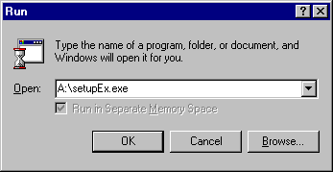

Note: If you are performing this installation under Windows NT , you must be logged on
as an administrator.

The Installation program will provide you with further information through the course of the installation.

Further information may be found in the Software Installation section of the
instruNet User’s Manual.

  - SHUT DOWN your computer.
REBOOT the computer.

  - To check that the InstruNet driver is installed correctly run InstruNet world and verify that channels on card 1 are listed.

Insert the diskette labelled Orchestrator InstruNet driver into your CD ROM drive

Press the Windows Button + R and

Type in the name of the application shown below in the Run dialog box.
A = the drive letter of your floppy drive.
Click OK.

Any further instructions and information will be provided by the Installation/setup program.

Note: If you are performing this installation under Windows NT, you must be logged
on as an administrator.

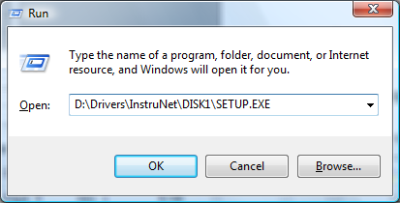

1.5 The appropriate drivers should now be installed on your system.

Orchestrator can now use the InstruNet hardware.

Configuration

The first time the system is configured it is necessary to enable and configure all devices you require. To configure a particular device select the Devices option from the main menu followed by the appropriate device.
This will launch an application to configure the device. You will be presented with a set of tabs as shown below.
To configure a channel select a group of channels by clicking on the appropriate channel tab. From the list provided select a channel and double-click.
Alternatively you can select a channel and then click on the Configure Channel button.
This will launch a channel configuration dialog which enables you to configure individual channels.

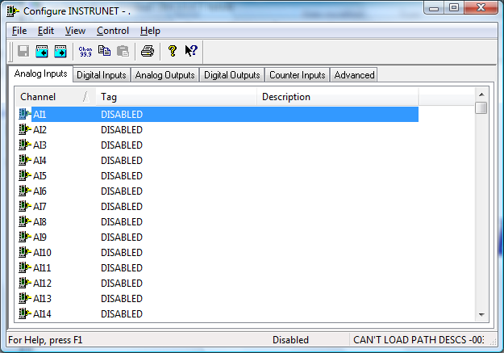

Channel Configuration (Analogs)

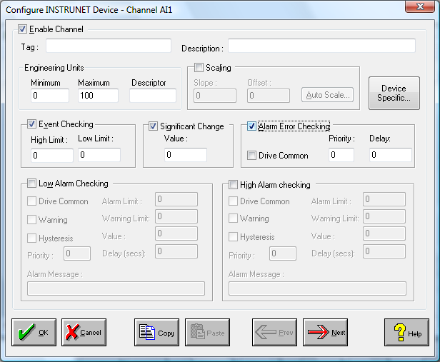

Enable Channel
The Enable Channel check box must be checked to enable, and allow this channel to be configured and ultimately included with all other configured channels in the overall system.

Tag
The Tag field is a 12 character alphanumeric field that can contain channel information or wiring schedule references.

Description
The Description field is a 32 character alphanumeric field in which a description of the channel can be detailed.

Units
A 4 character field available to describe the units of the output.

Device Specific Button
This application can be use as a generic device configuration program. If the Device Specific Button is visible, then click on it to configure channel features that are specific only to the type of device you are configuring.
In the case of InstruNet , a dialog box appears showing the location of the selected channel on the network.

Scaling
NB. Scaling is only available to Analogue channels that are not Output channels.

Some transducers give a number of pulses, or a frequency output proportional to their full scale range. To enable the Scaling utility check the Scaling Check box. The Slope and Offset values can be entered directly into the text boxes. The formula applied is:

y = mx + c where: m is SLOPE
x is the measured value.
c is the OFFSET

Auto Scaling
Click On the Auto Scale button if you want the scale and offset values calculated automatically. A dialog box will be displayed. Enter the values in the text boxes. The low measured value, and the high measured value, the output range of the transducer. When the fields have been completed, and assuming the System is enabled click on the Apply button. Under the heading Current Values the actual measured value will be shown, as well as the Engineering Value.

Click on OK to accept the scaling, or Cancel to abort the Auto Scaling feature.

NB. Scaling will not be applied to the channel, even if the system is enabled, until the system is next enabled or the InstruNet Device is reconfigured

Significant Change
Significant changes on InstruNet channels do not trigger logger events.

The significant change status of a channel can be monitored from one scan to the next.

Event Checking
Event checking is used, if required to trigger a logger to record information on a number of channels during an event. Check the Event Checking check box if this channel is to trigger an event. Events are detected on inputs using data acquired at 1Khz. Events are detected on outputs using the configured scan rate.

High Limit
A value, in engineering units, entered in this text box will define the level that, if exceeded, will cause an event trigger.

Low Limit
A value entered in this text box will define the level that if the channel result falls below will cause an event trigger.

Alarm Checking
Alarm checking is available on all channels throughout the system. Low Alarm and High Alarm levels can be configured independent of each other. If the channel output exceeds the High Alarm limit then an alarm will be triggered as it will if the output goes below the Low Alarm limit. Alarms and warnings are detected at the configured scan rate.

When monitoring channels, if the high or low alarm is triggered, then the fact will be annotated alongside the other channel information in the Channel Monitor. To configure the Alarm Checking section of the device complete the options as follows for either or both the High Alarm and Low Alarm checking.

Enable Alarm Checking
Check either the Low Alarm Checking or High Alarm Checking or both check boxes to enable the facility.

Drive Common Alarm
A common alarm is a single digital output which will switch on when any channel with the Drive Common Alarm enabled goes into an alarm state. Check this box if a link to the Common Alarm is required.

Alarm Limit
Specifies the value which will trigger this alarm. for Low Alarm Checking it will be any value <= the Alarm Limit and for High Alarm Checking it will be any value >= the Alarm Limit.

Warning and Limit
If required, a warning can be displayed when a channel reaches a limit close to the alarm limit. For low alarm checking, the limit must be less than the alarm limit. For high alarm checking, the warning limit must be less than the alarm limit

Hysteresis
Hysteresis can prevent 'noisy' channels from reporting multiple alarms when the average reading is close to the alarm threshold. Check the box if this feature if needed. Enter the value of the dead band in the corresponding value field.

Priority
Enter or edit the number in the text box to allocate the priority of this alarm. Alarm priority ranges are from 0 to 255.

Alarm Delay
Enter the time, in seconds, between the channel value entering the alarm state and the system flagging an alarm.

Alarm Message
An Alarm Message can be defined to be displayed on the Status line of the Main Window when a channel goes into an alarm state. Enter the message, up to 32 characters, that is to appear in the event of an alarm.

Device Specific Button
When the Device Specific Button is pressed, in the case of the InstruNet device the following “Device Configuration” dialog box is presented.
This dialog box indicates the location of the selected channel on the InstruNet network.

Channel Configuration (Digitals)

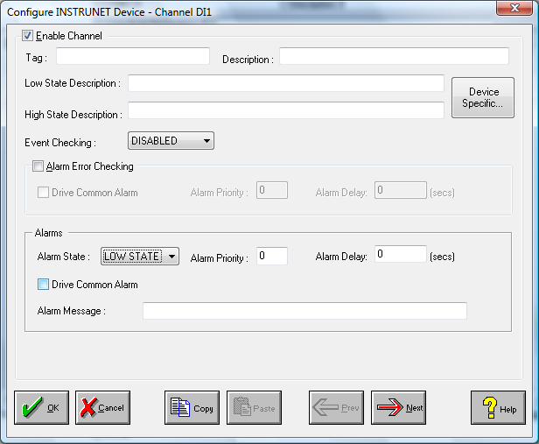

Enable Channel
The Enable Channel check box must be checked to enable, and allow this channel to be configured and ultimately included with all other configured channels in the overall system.

Tag
The Tag field is an 12 character alphanumeric field that can contain channel information or wiring schedule references.

Description
The Description field is a 32 character alphanumeric field in which a description of the channel can be detailed.

LowState Description
A 32 character field in which to enter a description of the low state of the channel.

HighState Description
A 32 character field in which to enter a description of the high state of the channel.

Event Checking
Event checking is used, if required to trigger a logger to record information on an event. If this facility is required click on the drop down list box and select OFF, HIGHSTATE, or LOWSTATE as appropriate. Events are detected on inputs using data acquired at 1Khz. Events are detected on outputs using the configured scan rate.

Alarm Checking

AlarmState
Alarm checking is available on all channels throughout the system. To configure alarm checking on this channel click on the drop down box and select OFF, HIGHSTATE, or LOWSTATE as appropriate. If the channel's output state changes to an AlarmState an alarm will be triggered on the channel. When monitoring channels, if the alarm is triggered, the fact will be annotated alongside the other channel information in the Channel Monitor . Alarms and warnings are detected at the configured scan rate.

Alarm Priority
Enter the priority of the alarm triggered by this channel. Alarm priority ranges are from 0 to 255.

Common Alarm
Channels can be configured to trigger a Common Alarm. A common alarm is a single digital output which will switch on when any channel with the Drive Common Alarm enabled goes into an alarm state.

Alarm Delay
Enter the time, in seconds, between the channel value entering the alarm state and the system flagging an alarm.

Alarm Message
An Alarm Message can be defined to be displayed on the Status line of the Main Window when a channel goes into an alarm state.

Device Specific Button
When the Device Specific Button is pressed, in the case of the InstruNet device the following “Device Configuration” dialog box is presented.
This dialog box indicates the location of the selected Orchestrator channel on the InstruNet network.

Advanced Device Configuration

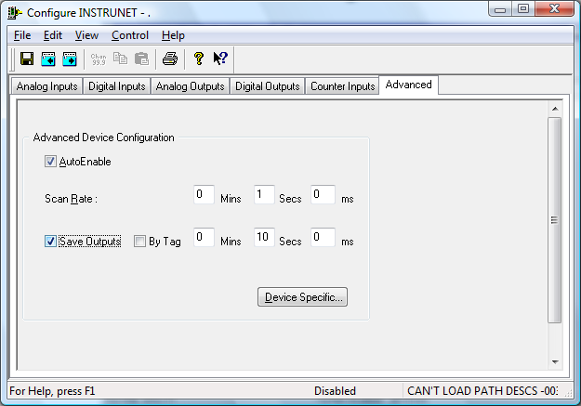

When the system is enabled and the device is enabled this window will display the Achieved Scan Rate . If the device is not scanning then any error associated with the device will be displayed instead.

AutoEnable Device
To ensure that the device is enabled on the system check the Enable Device box.

Scan Rate
To set the rate at which the device will scan, edit the text boxes associated with the Scan Rate field. The scan rate should be greater than 50ms and less than or equal 2 seconds. Data from the InstruNet is automatically buffered for logging purpose at the maximum logging rate of 1Khz. Logging rates for InstruNet data can therefore be 1ms or greater.

Save Outputs
To enable this utility check the Save Outputs flag. All values in output channels are saved to disk when the system is disabled. The next time the system is restarted the values which were previously in output channels will be restored to the appropriate channel number.

By Tag
Channel values can be saved and restored to channels using the channel tag instead of the channel number. In this way, channels can be rearranged within the modules and as long as the channel tags remain the same, the correct channel values will be restored to the appropriate channel number.

Device Specific Button
If the Device Specific Button is visible and the systems is disabled, then click on it to configure features that are specific only to this device. In the case of InstruNet an application called InstruNet World is launched.

NOTE: It is important to have the main Orchestrator system disabled from the main toolbar/menu before launching InstruNet World.

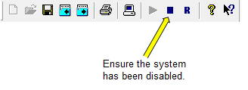
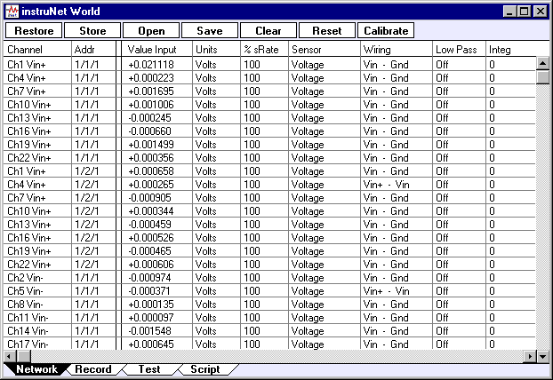

This application allows the user to configure the InstruNet network , the various input and output analogue channels , as well as configure the Digital IO channels connected on the InstruNet network.

After exiting the InstruNet World application, it is important to exit the Orchestrator InstruNet Configuration program before enabling the system. It is also important not to press the Device Specific button on the advanced tab of the InstruNet configuration menu. If you do not follow this, the following message will appear.
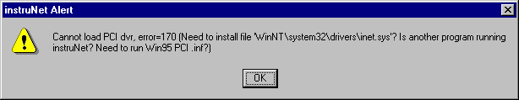

Configuring channels.

In order to configure a channel , from the Network window click on the row corresponding to the required channel.
The Probe dialog window appears as shown below. This displays device information and also allows configuration of the channel.
Channel settings can be altered by making the appropriate selection from the Settings drop down menu. (Further information can be found in the instruNet Users Manual).
The device’s address on the network is displayed on the top.
The correlation between the InstruNet address and the addressing system used by Orchestrator can be found in Appendix 1.

Channel Input / Output is displayed in Real Time on the graph at the bottom of the Window.

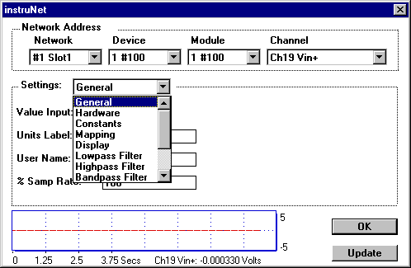

Digital I/O channels

Some hardware devices , namely models 100 and 100B , provide Digital I/O channels.
These have 8 independently configurable Digital I/O bits marked as DIO1..DIO8 on Channel 25 of the device.

Each bit can but configured as a digital input or as a digital output as per the following example.

EX: We want to configure channel 25 in the following manner.
DIO1 as a digital input.
DIO2 as a digital output.
DIO3 as a digital output.
DIO4 as a digital output.
DIO5 as a digital input.
DIO6 as a digital output.
DIO7 as a digital output.
DIO8 as a digital output.

DIO8 is the Most Significant Bit of Channel 25.
DIO1 is the Least Significant Bit of Channel 25.

Configuring the direction of each bit involves writing a value for the direction bits field using the InstruNet World application.

Start Orchestrator.

From the Devices Menu select INSTRUNET.

The following dialog appears.

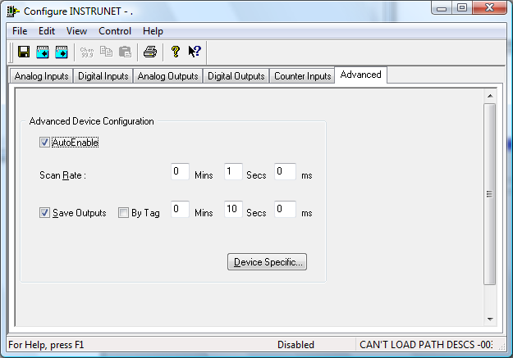

Click on the Advanced tab.
Click on the Device Specific button.
This will launch the InstruNet World application

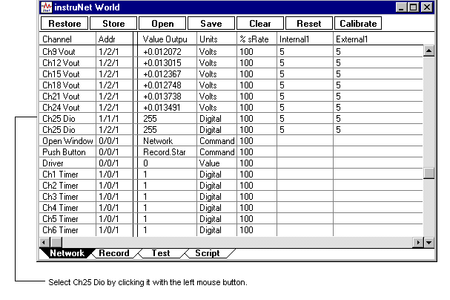Click on the Network Tab of the InstruNet World window.
Select a Ch25Dio channel by left clicking on it with the mouse.
The following dialog (called the Probe dialog) appears.

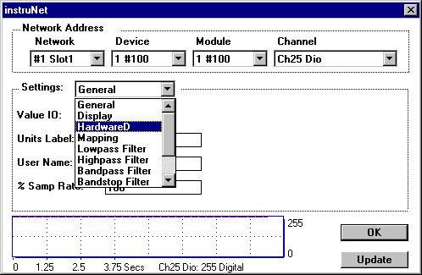

From the Settings: drop down list select HardwareD.

The dialog changes to the following.

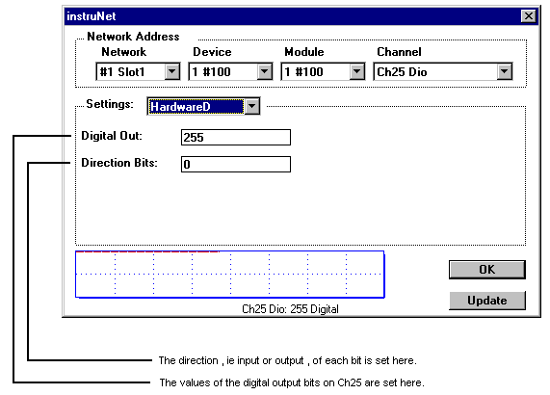
It is with this dialog window that we configure the 8 digital i/o bits on channel 25.

In order to configure a bit as an output we write 1 to the appropriate direction bit.
In order to configure a bit as an input we write 0 to the appropriate direction bit.

For our example quoted above we have DIO8 as output ⇒ direction bit = 1
DIO7 as output ⇒ direction bit = 1
DIO6 as output ⇒ direction bit = 1
DIO5 as input ⇒ direction bit = 0
DIO4 as output ⇒ direction bit = 1
DIO3 as output ⇒ direction bit = 1
DIO2 as output ⇒ direction bit = 1
DIO1 as input ⇒ direction bit = 0

This gives us a Direction Bits value of binary 11101110_{binary}.

Converting this to decimal yields 238_{decimal} ,
Type this value into the Direction Bits: field shown in the dialog window above.

Obviously when a bit is configured as an output you can write a value to it.
This is done with the Digital Out: edit box shown above.

To set an output bit high , write 1 to it. To set it low , write 0 to it.

EX Using the input/output configuration in the example above.
To set DIO8,DIO6,DIO3 high and DIO7,DIO4,DIO2 low we would do the following.

DIO8 = 1
DIO7 = 0
DIO6 = 1
DIO5 = X
DIO4 = 0
DIO3 = 1
DIO2 = 0
DIO1 = X

Where X = don’t care because these bits are set as inputs.

NB When a bit is configured as an input and if there is no external input source connected
to it , then if we read the value of that input bit it will float high to a logic 1

We’ll set X=1 for the sake of argument.

This will yield the following binary value for the Digital Out: field. 10110101_{binary}.

Converting this to decimal yields the following value 181_{decimal}.
Type this value into the Digital Out: edit box.

Note : Setting the direction of the digital inputs and outputs is the main and probably the only task for which you will use the InstruNet World application.

Saving Configurations via InstruNet World

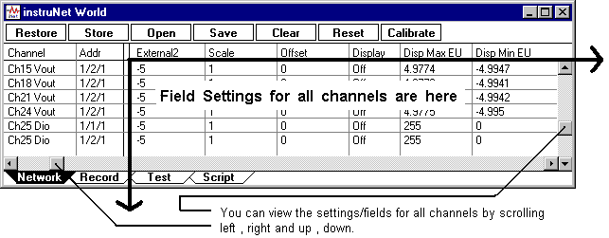
At the top of the Network page of InstruNet World there is a selection of buttons which can be used to save/set the configuration of the InstruNet network.

Save This allows you to save the current settings of all fields in the entire Network page
shown above.
A standard File Save Dialog box appears which allows you to specify a file name
and a directory in which to save the file.
The default location for these files in Orchestrator is
<drive>\ORCHESTRATOR\CURRENT_CONFIG\Iunet_<device_number>\
When the Save command is used and the settings are saved in a file called <drive>\ORCHESTRATOR\CURRENT_CONFIG\Iunet_<device_number>\instrNet.prf, then the Orchestrator InstruNet driver will load the settings file each time the system is enabled. This is important if you are saving InstruNet settings on disk or moving setting from one machine to another. If the file is saved in the <drive>\ORCHESTRATOR\CURRENT_CONFIG\Iunet_<device_number>directory, then the settings are saved when the Orchestrator configuration is saved.

Store This is like Save except that a File Save Dialog box does not appear ,
i.e. you do not specify a filename or a location. This is done automatically for you.
The file is saved in an operating system preferences directory. On my system this happens to be C:\WINNT40\System32.

NB: When you choose the Store command , any settings saved in the above
default file are overwritten and replaced with the current settings.

Open This command is the complement of the Save command.
It allows you to open a specified configuration file.
i.e. A standard File Open Dialog Box appears which allows you to choose a file to
open.
The InstruNet network is then configured to these settings.

Restore This command is the complement of the Store command.
It allows you to set the current configuration/settings of the network to those that that are saved in the configuration file used by the Store command.
Like the Store command the user is not asked to specify a filename.
The file used in the Store command is automatically selected.

Clear Clears all field settings to their default values.

Reset Clears all field settings to their default values and
Resets all InstruNet hardware.

Further information regarding the operation of all these commands may be found in the instruNet Users Manual on pages 2-13/14 of the instruNet Tutorial and on pages 5-4/5

Using Instrunet Channels

With the exception of loggers, Instrunet channels are only processed at the scan rate specified in the Advanced Device settings. Therefore alarms and calculations of Instrunet channels an only be performed at a maximum speed of 50Hz.

Loggers on the other hand will process Instrunet data at speed up to 1Khz. It is important to make sure that the buffer allocated to logging is adequate. If not enough logging buffers are allocated, you may experience poor performance such as erratic mouse movement.

When loggers are logging Instrunet input channels, they only start logging when the system is enabled and the Instrunet driver has started. If a logger remains active when the system is disabled and subsequently re-enabled, the logger will stop logging. Therefore when disabling the system, you must disable all loggers that log Instrunet input channels.

APPENDIX 1

The following table shows the correlation between the InstruNet channel addressing system and the Orchestrator channel reference system.

AI = Analogue Input channels Range 1 - 512
AO = Analogue Output channels Range 1 - 256
CI = Counter Input channels Range 1 - 256
DI = Digital Input channels Range 1 – 256
DO = Digital Output channels Range 1 - 256

InstruNet  Device | InstruNet  Channel | Orchestrator  Channel | InstruNet  Device | InstruNet  Channel | Orchestrator  Channel
1 | Ch 1 Vin (+) | AI1 | 2 | Ch 1 Vin (+) | AI17
 | Ch 2 Vin (-) | AI2 |  | Ch 2 Vin (-) | AI18
 | Ch 3 Vout | AO1 |  | Ch 3 Vout | AO9
 | Ch 4 Vin (+) | AI3 |  | Ch 4 Vin (+) | AI19
 | Ch 5 Vin (-) | AI4 |  | Ch 5 Vin (-) | AI20
 | Ch 6 Vout | AO2 |  | Ch 6 Vout | AO10
 | Ch 7 Vin (+) | AI5 |  | Ch 7 Vin (+) | AI21
 | Ch 8 Vin (-) | AI6 |  | Ch 8 Vin (-) | AI22
 | Ch 9 Vout | AO3 |  | Ch 9 Vout | AO11
 | Ch10 Vin (+) | AI7 |  | Ch10 Vin (+) | AI23
 | Ch11 Vin (-) | AI8 |  | Ch11 Vin (-) | AI24
 | Ch12 Vout | AO4 |  | Ch12 Vout | AO12
 | Ch13 Vin (+) | AI9 |  | Ch13 Vin (+) | AI25
 | Ch14 Vin (-) | AI10 |  | Ch14 Vin (-) | AI26
 | Ch15 Vout | AO5 |  | Ch15 Vout | AO13
 | Ch16 Vin (+) | AI11 |  | Ch16 Vin (+) | AI27
 | Ch17 Vin (-) | AI12 |  | Ch17 Vin (-) | AI28
 | Ch18 Vout | AO6 |  | Ch18 Vout | AO14
 | Ch19 Vin (+) | AI13 |  | Ch19 Vin (+) | AI29
 | Ch20 Vin (-) | AI14 |  | Ch20 Vin (-) | AI30
 | Ch21 Vout | AO7 |  | Ch21 Vout | AO15
 | Ch22 Vin (+) | AI15 |  | Ch22 Vin (+) | AI31
 | Ch23 Vin (-) | AI16 |  | Ch23 Vin (-) | AI32
 | Ch24 Vout | AO8 |  | Ch24 Vout | AO16
 | Ch25 DIO1 | DI1,DO1,CI1 |  | Ch25 DIO1 | DI9,DO9,CI9
 | Ch25 DIO2 | DI2,DO2,CI2 |  | Ch25 DIO2 | DI10,DO10,CI10
 | Ch25 DIO3 | DI3,DO3,CI3 |  | Ch25 DIO3 | DI11,DO11,CI11
 | Ch25 DIO4 | DI4,DO4,CI4 |  | Ch25 DIO4 | DI12,DO12,CI12
 | Ch25 DIO5 | DI5,DO5,CI5 |  | Ch25 DIO5 | DI13,DO13,CI13
 | Ch25 DIO6 | DI6,DO6,CI6 |  | Ch25 DIO6 | DI14,DO14,CI14
 | Ch25 DIO7 | DI7,DO7,CI7 |  | Ch25 DIO7 | DI15,DO15,CI15
 | Ch25 DIO8 | DI8,DO8,CI8 |  | Ch25 DIO8 | DI16,DO16,CI16

InstruNet  Device | InstruNet  Channel | Orchestrator  Channel | InstruNet  Device | InstruNet  Channel | Orchestrator  Channel
3 | Ch 1 Vin (+) | AI33 | 4 | Ch 1 Vin (+) | AI49
 | Ch 2 Vin (-) | AI34 |  | Ch 2 Vin (-) | AI50
 | Ch 3 Vout | AO17 |  | Ch 3 Vout | AO25
 | Ch 4 Vin (+) | AI35 |  | Ch 4 Vin (+) | AI51
 | Ch 5 Vin (-) | AI36 |  | Ch 5 Vin (-) | AI52
 | Ch 6 Vout | AO18 |  | Ch 6 Vout | AO26
 | Ch 7 Vin (+) | AI37 |  | Ch 7 Vin (+) | AI53
 | Ch 8 Vin (-) | AI38 |  | Ch 8 Vin (-) | AI54
 | Ch 9 Vout | AO19 |  | Ch 9 Vout | AO27
 | Ch10 Vin (+) | AI39 |  | Ch10 Vin (+) | AI55
 | Ch11 Vin (-) | AI40 |  | Ch11 Vin (-) | AI56
 | Ch12 Vout | AO20 |  | Ch12 Vout | AO28
 | Ch13 Vin (+) | AI41 |  | Ch13 Vin (+) | AI57
 | Ch14 Vin (-) | AI42 |  | Ch14 Vin (-) | AI58
 | Ch15 Vout | AO21 |  | Ch15 Vout | AO29
 | Ch16 Vin (+) | AI43 |  | Ch16 Vin (+) | AI59
 | Ch17 Vin (-) | AI44 |  | Ch17 Vin (-) | AI60
 | Ch18 Vout | AO22 |  | Ch18 Vout | AO30
 | Ch19 Vin (+) | AI45 |  | Ch19 Vin (+) | AI61
 | Ch20 Vin (-) | AI46 |  | Ch20 Vin (-) | AI62
 | Ch21 Vout | AO23 |  | Ch21 Vout | AO31
 | Ch22 Vin (+) | AI47 |  | Ch22 Vin (+) | AI63
 | Ch23 Vin (-) | AI48 |  | Ch23 Vin (-) | AI64
 | Ch24 Vout | AO24 |  | Ch24 Vout | AO32
 | Ch25 DIO1 | DI17,DO17,CI17 |  | Ch25 DIO1 | DI25,DO25,CI25
 | Ch25 DIO2 | DI18,DO18,CI18 |  | Ch25 DIO2 | DI26,DO26,CI26
 | Ch25 DIO3 | DI19,DO19,CI19 |  | Ch25 DIO3 | DI27,DO27,CI27
 | Ch25 DIO4 | DI20,DO20,CI20 |  | Ch25 DIO4 | DI28,DO28,CI28
 | Ch25 DIO5 | DI21,DO21,CI21 |  | Ch25 DIO5 | DI29,DO29,CI29
 | Ch25 DIO6 | DI22,DO22,CI22 |  | Ch25 DIO6 | DI30,DO30,CI30
 | Ch25 DIO7 | DI23,DO23,CI23 |  | Ch25 DIO7 | DI31,DO31,CI31
 | Ch25 DIO8 | DI24,DO24,CI24 |  | Ch25 DIO8 | DI32,DO32,CI32

InstruNet  Device | InstruNet  Channel | Orchestrator  Channel | InstruNet  Device | InstruNet  Channel | Orchestrator  Channel
5 | Ch 1 Vin (+) | AI65 | 6 | Ch 1 Vin (+) | AI81
 | Ch 2 Vin (-) | AI66 |  | Ch 2 Vin (-) | AI82
 | Ch 3 Vout | AO33 |  | Ch 3 Vout | AO41
 | Ch 4 Vin (+) | AI67 |  | Ch 4 Vin (+) | AI83
 | Ch 5 Vin (-) | AI68 |  | Ch 5 Vin (-) | AI84
 | Ch 6 Vout | AO34 |  | Ch 6 Vout | AO42
 | Ch 7 Vin (+) | AI69 |  | Ch 7 Vin (+) | AI85
 | Ch 8 Vin (-) | AI70 |  | Ch 8 Vin (-) | AI86
 | Ch 9 Vout | AO35 |  | Ch 9 Vout | AO43
 | Ch10 Vin (+) | AI71 |  | Ch10 Vin (+) | AI87
 | Ch11 Vin (-) | AI72 |  | Ch11 Vin (-) | AI88
 | Ch12 Vout | AO36 |  | Ch12 Vout | AO44
 | Ch13 Vin (+) | AI73 |  | Ch13 Vin (+) | AI89
 | Ch14 Vin (-) | AI74 |  | Ch14 Vin (-) | AI90
 | Ch15 Vout | AO37 |  | Ch15 Vout | AO45
 | Ch16 Vin (+) | AI75 |  | Ch16 Vin (+) | AI91
 | Ch17 Vin (-) | AI76 |  | Ch17 Vin (-) | AI92
 | Ch18 Vout | AO38 |  | Ch18 Vout | AO46
 | Ch19 Vin (+) | AI77 |  | Ch19 Vin (+) | AI93
 | Ch20 Vin (-) | AI78 |  | Ch20 Vin (-) | AI94
 | Ch21 Vout | AO39 |  | Ch21 Vout | AO47
 | Ch22 Vin (+) | AI79 |  | Ch22 Vin (+) | AI95
 | Ch23 Vin (-) | AI80 |  | Ch23 Vin (-) | AI96
 | Ch24 Vout | AO40 |  | Ch24 Vout | AO48
 | Ch25 DIO1 | DI33,DO33,CI33 |  | Ch25 DIO1 | DI41,DO41,CI41
 | Ch25 DIO2 | DI34,DO34,CI34 |  | Ch25 DIO2 | DI42,DO42,CI42
 | Ch25 DIO3 | DI35,DO35,CI35 |  | Ch25 DIO3 | DI43,DO43,CI43
 | Ch25 DIO4 | DI36,DO36,CI36 |  | Ch25 DIO4 | DI44,DO44,CI44
 | Ch25 DIO5 | DI37,DO37,CI37 |  | Ch25 DIO5 | DI45,DO45,CI45
 | Ch25 DIO6 | DI38,DO38,CI38 |  | Ch25 DIO6 | DI46,DO46,CI46
 | Ch25 DIO7 | DI39,DO39,CI39 |  | Ch25 DIO7 | DI47,DO47,CI47
 | Ch25 DIO8 | DI40,DO40,CI40 |  | Ch25 DIO8 | DI48,DO48,CI48

InstruNet  Device | InstruNet  Channel | Orchestrator  Channel | InstruNet  Device | InstruNet  Channel | Orchestrator  Channel
7 | Ch 1 Vin (+) | AI97 | 8 | Ch 1 Vin (+) | AI113
 | Ch 2 Vin (-) | AI98 |  | Ch 2 Vin (-) | AI114
 | Ch 3 Vout | AO49 |  | Ch 3 Vout | AO57
 | Ch 4 Vin (+) | AI99 |  | Ch 4 Vin (+) | AI115
 | Ch 5 Vin (-) | AI100 |  | Ch 5 Vin (-) | AI116
 | Ch 6 Vout | AO50 |  | Ch 6 Vout | AO58
 | Ch 7 Vin (+) | AI101 |  | Ch 7 Vin (+) | AI117
 | Ch 8 Vin (-) | AI102 |  | Ch 8 Vin (-) | AI118
 | Ch 9 Vout | AO51 |  | Ch 9 Vout | AO59
 | Ch10 Vin (+) | AI103 |  | Ch10 Vin (+) | AI119
 | Ch11 Vin (-) | AI104 |  | Ch11 Vin (-) | AI120
 | Ch12 Vout | AO52 |  | Ch12 Vout | AO60
 | Ch13 Vin (+) | AI105 |  | Ch13 Vin (+) | AI121
 | Ch14 Vin (-) | AI106 |  | Ch14 Vin (-) | AI122
 | Ch15 Vout | AO53 |  | Ch15 Vout | AO61
 | Ch16 Vin (+) | AI107 |  | Ch16 Vin (+) | AI123
 | Ch17 Vin (-) | AI108 |  | Ch17 Vin (-) | AI124
 | Ch18 Vout | AO54 |  | Ch18 Vout | AO62
 | Ch19 Vin (+) | AI109 |  | Ch19 Vin (+) | AI125
 | Ch20 Vin (-) | AI110 |  | Ch20 Vin (-) | AI126
 | Ch21 Vout | AO55 |  | Ch21 Vout | AO63
 | Ch22 Vin (+) | AI111 |  | Ch22 Vin (+) | AI127
 | Ch23 Vin (-) | AI112 |  | Ch23 Vin (-) | AI128
 | Ch24 Vout | AO56 |  | Ch24 Vout | AO64
 | Ch25 DIO1 | DI49,DO49,CI49 |  | Ch25 DIO1 | DI57,DO57,CI57
 | Ch25 DIO2 | DI50,DO50,CI50 |  | Ch25 DIO2 | DI58,DO58,CI58
 | Ch25 DIO3 | DI51,DO51,CI51 |  | Ch25 DIO3 | DI59,DO59,CI59
 | Ch25 DIO4 | DI52,DO52,CI52 |  | Ch25 DIO4 | DI60,DO60,CI60
 | Ch25 DIO5 | DI53,DO53,CI53 |  | Ch25 DIO5 | DI61,DO61,CI61
 | Ch25 DIO6 | DI54,DO54,CI54 |  | Ch25 DIO6 | DI62,DO62,CI62
 | Ch25 DIO7 | DI55,DO55,CI55 |  | Ch25 DIO7 | DI63,DO63,CI63
 | Ch25 DIO8 | DI56,DO56,CI56 |  | Ch25 DIO8 | DI64,DO64,CI64

InstruNet  Device | InstruNet  Channel | Orchestrator  Channel | InstruNet  Device | InstruNet  Channel | Orchestrator  Channel
9 | Ch 1 Vin (+) | AI129 | 10 | Ch 1 Vin (+) | AI145
 | Ch 2 Vin (-) | AI130 |  | Ch 2 Vin (-) | AI146
 | Ch 3 Vout | AO65 |  | Ch 3 Vout | AO73
 | Ch 4 Vin (+) | AI131 |  | Ch 4 Vin (+) | AI147
 | Ch 5 Vin (-) | AI132 |  | Ch 5 Vin (-) | AI148
 | Ch 6 Vout | AO66 |  | Ch 6 Vout | AO74
 | Ch 7 Vin (+) | AI133 |  | Ch 7 Vin (+) | AI149
 | Ch 8 Vin (-) | AI134 |  | Ch 8 Vin (-) | AI150
 | Ch 9 Vout | AO67 |  | Ch 9 Vout | AO75
 | Ch10 Vin (+) | AI135 |  | Ch10 Vin (+) | AI151
 | Ch11 Vin (-) | AI136 |  | Ch11 Vin (-) | AI152
 | Ch12 Vout | AO68 |  | Ch12 Vout | AO76
 | Ch13 Vin (+) | AI137 |  | Ch13 Vin (+) | AI153
 | Ch14 Vin (-) | AI138 |  | Ch14 Vin (-) | AI154
 | Ch15 Vout | AO69 |  | Ch15 Vout | AO77
 | Ch16 Vin (+) | AI139 |  | Ch16 Vin (+) | AI155
 | Ch17 Vin (-) | AI140 |  | Ch17 Vin (-) | AI156
 | Ch18 Vout | AO70 |  | Ch18 Vout | AO78
 | Ch19 Vin (+) | AI141 |  | Ch19 Vin (+) | AI157
 | Ch20 Vin (-) | AI142 |  | Ch20 Vin (-) | AI158
 | Ch21 Vout | AO71 |  | Ch21 Vout | AO79
 | Ch22 Vin (+) | AI143 |  | Ch22 Vin (+) | AI159
 | Ch23 Vin (-) | AI144 |  | Ch23 Vin (-) | AI160
 | Ch24 Vout | AO72 |  | Ch24 Vout | AO80
 | Ch25 DIO1 | DI65,DO65,CI65 |  | Ch25 DIO1 | DI73,DO73,CI73
 | Ch25 DIO2 | DI66,DO66,CI66 |  | Ch25 DIO2 | DI74,DO74,CI74
 | Ch25 DIO3 | DI67,DO67,CI67 |  | Ch25 DIO3 | DI75,DO75,CI75
 | Ch25 DIO4 | DI68,DO68,CI68 |  | Ch25 DIO4 | DI76,DO76,CI76
 | Ch25 DIO5 | DI69,DO69,CI69 |  | Ch25 DIO5 | DI77,DO77,CI77
 | Ch25 DIO6 | DI70,DO70,CI70 |  | Ch25 DIO6 | DI78,DO78,CI78
 | Ch25 DIO7 | DI71,DO71,CI71 |  | Ch25 DIO7 | DI79,DO79,CI79
 | Ch25 DIO8 | DI72,DO72,CI72 |  | Ch25 DIO8 | DI80,DO80,CI80

InstruNet  Device | InstruNet  Channel | Orchestrator  Channel | InstruNet  Device | InstruNet  Channel | Orchestrator  Channel
11 | Ch 1 Vin (+) | AI161 | 12 | Ch 1 Vin (+) | AI177
 | Ch 2 Vin (-) | AI162 |  | Ch 2 Vin (-) | AI178
 | Ch 3 Vout | AO81 |  | Ch 3 Vout | AO89
 | Ch 4 Vin (+) | AI163 |  | Ch 4 Vin (+) | AI179
 | Ch 5 Vin (-) | AI164 |  | Ch 5 Vin (-) | AI180
 | Ch 6 Vout | AO82 |  | Ch 6 Vout | AO90
 | Ch 7 Vin (+) | AI165 |  | Ch 7 Vin (+) | AI181
 | Ch 8 Vin (-) | AI166 |  | Ch 8 Vin (-) | AI182
 | Ch 9 Vout | AO83 |  | Ch 9 Vout | AO91
 | Ch10 Vin (+) | AI167 |  | Ch10 Vin (+) | AI183
 | Ch11 Vin (-) | AI168 |  | Ch11 Vin (-) | AI184
 | Ch12 Vout | AO84 |  | Ch12 Vout | AO92
 | Ch13 Vin (+) | AI169 |  | Ch13 Vin (+) | AI185
 | Ch14 Vin (-) | AI170 |  | Ch14 Vin (-) | AI186
 | Ch15 Vout | AO85 |  | Ch15 Vout | AO93
 | Ch16 Vin (+) | AI171 |  | Ch16 Vin (+) | AI187
 | Ch17 Vin (-) | AI172 |  | Ch17 Vin (-) | AI188
 | Ch18 Vout | AO86 |  | Ch18 Vout | AO94
 | Ch19 Vin (+) | AI173 |  | Ch19 Vin (+) | AI189
 | Ch20 Vin (-) | AI174 |  | Ch20 Vin (-) | AI190
 | Ch21 Vout | AO87 |  | Ch21 Vout | AO95
 | Ch22 Vin (+) | AI175 |  | Ch22 Vin (+) | AI191
 | Ch23 Vin (-) | AI176 |  | Ch23 Vin (-) | AI192
 | Ch24 Vout | AO88 |  | Ch24 Vout | AO96
 | Ch25 DIO1 | DI81,DO81,CI81 |  | Ch25 DIO1 | DI89,DO89,CI89
 | Ch25 DIO2 | DI82,DO82,CI82 |  | Ch25 DIO2 | DI90,DO90,CI90
 | Ch25 DIO3 | DI83,DO83,CI83 |  | Ch25 DIO3 | DI91,DO91,CI91
 | Ch25 DIO4 | DI84,DO84,CI84 |  | Ch25 DIO4 | DI92,DO92,CI92
 | Ch25 DIO5 | DI85,DO85,CI85 |  | Ch25 DIO5 | DI93,DO93,CI93
 | Ch25 DIO6 | DI86,DO86,CI86 |  | Ch25 DIO6 | DI94,DO94,CI94
 | Ch25 DIO7 | DI87,DO87,CI87 |  | Ch25 DIO7 | DI95,DO95,CI95
 | Ch25 DIO8 | DI88,DO88,CI88 |  | Ch25 DIO8 | DI96,DO96,CI96

InstruNet  Device | InstruNet  Channel | Orchestrator  Channel | InstruNet  Device | InstruNet  Channel | Orchestrator  Channel
13 | Ch 1 Vin (+) | AI193 | 14 | Ch 1 Vin (+) | AI209
 | Ch 2 Vin (-) | AI194 |  | Ch 2 Vin (-) | AI210
 | Ch 3 Vout | AO97 |  | Ch 3 Vout | AO105
 | Ch 4 Vin (+) | AI195 |  | Ch 4 Vin (+) | AI211
 | Ch 5 Vin (-) | AI196 |  | Ch 5 Vin (-) | AI212
 | Ch 6 Vout | AO98 |  | Ch 6 Vout | AO106
 | Ch 7 Vin (+) | AI197 |  | Ch 7 Vin (+) | AI213
 | Ch 8 Vin (-) | AI198 |  | Ch 8 Vin (-) | AI214
 | Ch 9 Vout | AO99 |  | Ch 9 Vout | AO107
 | Ch10 Vin (+) | AI199 |  | Ch10 Vin (+) | AI215
 | Ch11 Vin (-) | AI200 |  | Ch11 Vin (-) | AI216
 | Ch12 Vout | AO100 |  | Ch12 Vout | AO108
 | Ch13 Vin (+) | AI201 |  | Ch13 Vin (+) | AI217
 | Ch14 Vin (-) | AI202 |  | Ch14 Vin (-) | AI218
 | Ch15 Vout | AO101 |  | Ch15 Vout | AO109
 | Ch16 Vin (+) | AI203 |  | Ch16 Vin (+) | AI219
 | Ch17 Vin (-) | AI204 |  | Ch17 Vin (-) | AI220
 | Ch18 Vout | AO102 |  | Ch18 Vout | AO110
 | Ch19 Vin (+) | AI205 |  | Ch19 Vin (+) | AI221
 | Ch20 Vin (-) | AI206 |  | Ch20 Vin (-) | AI222
 | Ch21 Vout | AO103 |  | Ch21 Vout | AO111
 | Ch22 Vin (+) | AI207 |  | Ch22 Vin (+) | AI223
 | Ch23 Vin (-) | AI208 |  | Ch23 Vin (-) | AI224
 | Ch24 Vout | AO104 |  | Ch24 Vout | AO112
 | Ch25 DIO1 | DI97,DO97,CI97 |  | Ch25 DIO1 | DI105,DO105,CI105
 | Ch25 DIO2 | DI98,DO98,CI98 |  | Ch25 DIO2 | DI106,DO106,CI106
 | Ch25 DIO3 | DI99,DO99,CI99 |  | Ch25 DIO3 | DI107,DO107,CI107
 | Ch25 DIO4 | DI100,DO100,CI100 |  | Ch25 DIO4 | DI108,DO108,CI108
 | Ch25 DIO5 | DI101,DO101,CI101 |  | Ch25 DIO5 | DI109,DO109,CI109
 | Ch25 DIO6 | DI102,DO102,CI102 |  | Ch25 DIO6 | DI110,DO110,CI110
 | Ch25 DIO7 | DI103,DO103,CI103 |  | Ch25 DIO7 | DI111,DO111,CI111
 | Ch25 DIO8 | DI104,DO104,CI104 |  | Ch25 DIO8 | DI112,DO112,CI112

InstruNet  Device | InstruNet  Channel | Orchestrator  Channel | InstruNet  Device | InstruNet  Channel | Orchestrator  Channel
15 | Ch 1 Vin (+) | AI225 | 16 | Ch 1 Vin (+) | AI241
 | Ch 2 Vin (-) | AI226 |  | Ch 2 Vin (-) | AI242
 | Ch 3 Vout | AO113 |  | Ch 3 Vout | AO121
 | Ch 4 Vin (+) | AI227 |  | Ch 4 Vin (+) | AI243
 | Ch 5 Vin (-) | AI228 |  | Ch 5 Vin (-) | AI244
 | Ch 6 Vout | AO114 |  | Ch 6 Vout | AO122
 | Ch 7 Vin (+) | AI229 |  | Ch 7 Vin (+) | AI245
 | Ch 8 Vin (-) | AI230 |  | Ch 8 Vin (-) | AI246
 | Ch 9 Vout | AO115 |  | Ch 9 Vout | AO123
 | Ch10 Vin (+) | AI231 |  | Ch10 Vin (+) | AI247
 | Ch11 Vin (-) | AI232 |  | Ch11 Vin (-) | AI248
 | Ch12 Vout | AO116 |  | Ch12 Vout | AO124
 | Ch13 Vin (+) | AI233 |  | Ch13 Vin (+) | AI249
 | Ch14 Vin (-) | AI234 |  | Ch14 Vin (-) | AI250
 | Ch15 Vout | AO117 |  | Ch15 Vout | AO125
 | Ch16 Vin (+) | AI235 |  | Ch16 Vin (+) | AI251
 | Ch17 Vin (-) | AI236 |  | Ch17 Vin (-) | AI252
 | Ch18 Vout | AO118 |  | Ch18 Vout | AO126
 | Ch19 Vin (+) | AI237 |  | Ch19 Vin (+) | AI253
 | Ch20 Vin (-) | AI238 |  | Ch20 Vin (-) | AI254
 | Ch21 Vout | AO119 |  | Ch21 Vout | AO127
 | Ch22 Vin (+) | AI239 |  | Ch22 Vin (+) | AI255
 | Ch23 Vin (-) | AI240 |  | Ch23 Vin (-) | AI256
 | Ch24 Vout | AO120 |  | Ch24 Vout | AO128
 | Ch25 DIO1 | DI113,DO113,CI113 |  | Ch25 DIO1 | DI121,DO121,CI121
 | Ch25 DIO2 | DI114,DO114,CI114 |  | Ch25 DIO2 | DI122,DO122,CI122
 | Ch25 DIO3 | DI115,DO115,CI115 |  | Ch25 DIO3 | DI123,DO123,CI123
 | Ch25 DIO4 | DI116,DO116,CI116 |  | Ch25 DIO4 | DI124,DO124,CI124
 | Ch25 DIO5 | DI117,DO117,CI117 |  | Ch25 DIO5 | DI125,DO125,CI125
 | Ch25 DIO6 | DI118,DO118,CI118 |  | Ch25 DIO6 | DI126,DO126,CI126
 | Ch25 DIO7 | DI119,DO119,CI119 |  | Ch25 DIO7 | DI127,DO127,CI127
 | Ch25 DIO8 | DI120,DO120,CI120 |  | Ch25 DIO8 | DI128,DO128,CI128

InstruNet  Device | InstruNet  Channel | Orchestrator  Channel | InstruNet  Device | InstruNet  Channel | Orchestrator  Channel
17 | Ch 1 Vin (+) | AI257 | 18 | Ch 1 Vin (+) | AI273
 | Ch 2 Vin (-) | AI258 |  | Ch 2 Vin (-) | AI274
 | Ch 3 Vout | AO129 |  | Ch 3 Vout | AO137
 | Ch 4 Vin (+) | AI259 |  | Ch 4 Vin (+) | AI275
 | Ch 5 Vin (-) | AI260 |  | Ch 5 Vin (-) | AI276
 | Ch 6 Vout | AO130 |  | Ch 6 Vout | AO138
 | Ch 7 Vin (+) | AI261 |  | Ch 7 Vin (+) | AI277
 | Ch 8 Vin (-) | AI262 |  | Ch 8 Vin (-) | AI278
 | Ch 9 Vout | AO131 |  | Ch 9 Vout | AO139
 | Ch10 Vin (+) | AI263 |  | Ch10 Vin (+) | AI279
 | Ch11 Vin (-) | AI264 |  | Ch11 Vin (-) | AI280
 | Ch12 Vout | AO132 |  | Ch12 Vout | AO140
 | Ch13 Vin (+) | AI265 |  | Ch13 Vin (+) | AI281
 | Ch14 Vin (-) | AI266 |  | Ch14 Vin (-) | AI282
 | Ch15 Vout | AO133 |  | Ch15 Vout | AO141
 | Ch16 Vin (+) | AI267 |  | Ch16 Vin (+) | AI283
 | Ch17 Vin (-) | AI268 |  | Ch17 Vin (-) | AI284
 | Ch18 Vout | AO134 |  | Ch18 Vout | AO142
 | Ch19 Vin (+) | AI269 |  | Ch19 Vin (+) | AI285
 | Ch20 Vin (-) | AI270 |  | Ch20 Vin (-) | AI286
 | Ch21 Vout | AO135 |  | Ch21 Vout | AO143
 | Ch22 Vin (+) | AI271 |  | Ch22 Vin (+) | AI287
 | Ch23 Vin (-) | AI272 |  | Ch23 Vin (-) | AI288
 | Ch24 Vout | AO136 |  | Ch24 Vout | AO144
 | Ch25 DIO1 | DI129,DO129,CI129 |  | Ch25 DIO1 | DI137,DO137,CI137
 | Ch25 DIO2 | DI130,DO130,CI130 |  | Ch25 DIO2 | DI138,DO138,CI138
 | Ch25 DIO3 | DI131,DO131,CI131 |  | Ch25 DIO3 | DI139,DO139,CI139
 | Ch25 DIO4 | DI132,DO132,CI132 |  | Ch25 DIO4 | DI140,DO140,CI140
 | Ch25 DIO5 | DI133,DO133,CI133 |  | Ch25 DIO5 | DI141,DO141,CI141
 | Ch25 DIO6 | DI134,DO134,CI134 |  | Ch25 DIO6 | DI142,DO142,CI142
 | Ch25 DIO7 | DI135,DO135,CI135 |  | Ch25 DIO7 | DI143,DO143,CI143
 | Ch25 DIO8 | DI136,DO136,CI136 |  | Ch25 DIO8 | DI144,DO144,CI144

InstruNet  Device | InstruNet  Channel | Orchestrator  Channel | InstruNet  Device | InstruNet  Channel | Orchestrator  Channel
19 | Ch 1 Vin (+) | AI289 | 20 | Ch 1 Vin (+) | AI305
 | Ch 2 Vin (-) | AI290 |  | Ch 2 Vin (-) | AI306
 | Ch 3 Vout | AO145 |  | Ch 3 Vout | AO153
 | Ch 4 Vin (+) | AI291 |  | Ch 4 Vin (+) | AI307
 | Ch 5 Vin (-) | AI292 |  | Ch 5 Vin (-) | AI308
 | Ch 6 Vout | AO146 |  | Ch 6 Vout | AO154
 | Ch 7 Vin (+) | AI293 |  | Ch 7 Vin (+) | AI309
 | Ch 8 Vin (-) | AI294 |  | Ch 8 Vin (-) | AI310
 | Ch 9 Vout | AO147 |  | Ch 9 Vout | AO155
 | Ch10 Vin (+) | AI295 |  | Ch10 Vin (+) | AI311
 | Ch11 Vin (-) | AI296 |  | Ch11 Vin (-) | AI312
 | Ch12 Vout | AO148 |  | Ch12 Vout | AO156
 | Ch13 Vin (+) | AI297 |  | Ch13 Vin (+) | AI313
 | Ch14 Vin (-) | AI298 |  | Ch14 Vin (-) | AI314
 | Ch15 Vout | AO149 |  | Ch15 Vout | AO157
 | Ch16 Vin (+) | AI299 |  | Ch16 Vin (+) | AI315
 | Ch17 Vin (-) | AI300 |  | Ch17 Vin (-) | AI316
 | Ch18 Vout | AO150 |  | Ch18 Vout | AO158
 | Ch19 Vin (+) | AI301 |  | Ch19 Vin (+) | AI317
 | Ch20 Vin (-) | AI302 |  | Ch20 Vin (-) | AI318
 | Ch21 Vout | AO151 |  | Ch21 Vout | AO159
 | Ch22 Vin (+) | AI303 |  | Ch22 Vin (+) | AI319
 | Ch23 Vin (-) | AI304 |  | Ch23 Vin (-) | AI320
 | Ch24 Vout | AO152 |  | Ch24 Vout | AO160
 | Ch25 DIO1 | DI145,DO145,CI145 |  | Ch25 DIO1 | DI153,DO153,CI153
 | Ch25 DIO2 | DI146,DO146,CI146 |  | Ch25 DIO2 | DI154,DO154,CI154
 | Ch25 DIO3 | DI147,DO147,CI147 |  | Ch25 DIO3 | DI155,DO155,CI155
 | Ch25 DIO4 | DI148,DO148,CI148 |  | Ch25 DIO4 | DI156,DO156,CI156
 | Ch25 DIO5 | DI149,DO149,CI149 |  | Ch25 DIO5 | DI157,DO157,CI157
 | Ch25 DIO6 | DI150,DO150,CI150 |  | Ch25 DIO6 | DI158,DO158,CI158
 | Ch25 DIO7 | DI151,DO151,CI151 |  | Ch25 DIO7 | DI159,DO159,CI159
 | Ch25 DIO8 | DI152,DO152,CI152 |  | Ch25 DIO8 | DI160,DO160,CI160

InstruNet  Device | InstruNet  Channel | Orchestrator  Channel | InstruNet  Device | InstruNet  Channel | Orchestrator  Channel
21 | Ch 1 Vin (+) | AI321 | 22 | Ch 1 Vin (+) | AI337
 | Ch 2 Vin (-) | AI322 |  | Ch 2 Vin (-) | AI338
 | Ch 3 Vout | AO161 |  | Ch 3 Vout | AO169
 | Ch 4 Vin (+) | AI323 |  | Ch 4 Vin (+) | AI339
 | Ch 5 Vin (-) | AI324 |  | Ch 5 Vin (-) | AI340
 | Ch 6 Vout | AO162 |  | Ch 6 Vout | AO170
 | Ch 7 Vin (+) | AI325 |  | Ch 7 Vin (+) | AI341
 | Ch 8 Vin (-) | AI326 |  | Ch 8 Vin (-) | AI342
 | Ch 9 Vout | AO163 |  | Ch 9 Vout | AO171
 | Ch10 Vin (+) | AI327 |  | Ch10 Vin (+) | AI343
 | Ch11 Vin (-) | AI328 |  | Ch11 Vin (-) | AI344
 | Ch12 Vout | AO164 |  | Ch12 Vout | AO172
 | Ch13 Vin (+) | AI329 |  | Ch13 Vin (+) | AI345
 | Ch14 Vin (-) | AI330 |  | Ch14 Vin (-) | AI346
 | Ch15 Vout | AO165 |  | Ch15 Vout | AO173
 | Ch16 Vin (+) | AI331 |  | Ch16 Vin (+) | AI347
 | Ch17 Vin (-) | AI332 |  | Ch17 Vin (-) | AI348
 | Ch18 Vout | AO166 |  | Ch18 Vout | AO174
 | Ch19 Vin (+) | AI333 |  | Ch19 Vin (+) | AI349
 | Ch20 Vin (-) | AI334 |  | Ch20 Vin (-) | AI350
 | Ch21 Vout | AO167 |  | Ch21 Vout | AO175
 | Ch22 Vin (+) | AI335 |  | Ch22 Vin (+) | AI351
 | Ch23 Vin (-) | AI336 |  | Ch23 Vin (-) | AI352
 | Ch24 Vout | AO168 |  | Ch24 Vout | AO176
 | Ch25 DIO1 | DI161,DO161,CI161 |  | Ch25 DIO1 | DI169,DO169,CI169
 | Ch25 DIO2 | DI162,DO162,CI162 |  | Ch25 DIO2 | DI170,DO170,CI170
 | Ch25 DIO3 | DI163,DO163,CI163 |  | Ch25 DIO3 | DI171,DO171,CI171
 | Ch25 DIO4 | DI164,DO164,CI164 |  | Ch25 DIO4 | DI172,DO172,CI172
 | Ch25 DIO5 | DI165,DO165,CI165 |  | Ch25 DIO5 | DI173,DO173,CI173
 | Ch25 DIO6 | DI166,DO166,CI166 |  | Ch25 DIO6 | DI174,DO174,CI174
 | Ch25 DIO7 | DI167,DO167,CI167 |  | Ch25 DIO7 | DI175,DO175,CI175
 | Ch25 DIO8 | DI168,DO168,CI168 |  | Ch25 DIO8 | DI176,DO176,CI176

InstruNet  Device | InstruNet  Channel | Orchestrator  Channel | InstruNet  Device | InstruNet  Channel | Orchestrator  Channel
23 | Ch 1 Vin (+) | AI353 | 24 | Ch 1 Vin (+) | AI369
 | Ch 2 Vin (-) | AI354 |  | Ch 2 Vin (-) | AI370
 | Ch 3 Vout | AO177 |  | Ch 3 Vout | AO185
 | Ch 4 Vin (+) | AI355 |  | Ch 4 Vin (+) | AI371
 | Ch 5 Vin (-) | AI356 |  | Ch 5 Vin (-) | AI372
 | Ch 6 Vout | AO178 |  | Ch 6 Vout | AO186
 | Ch 7 Vin (+) | AI357 |  | Ch 7 Vin (+) | AI373
 | Ch 8 Vin (-) | AI358 |  | Ch 8 Vin (-) | AI374
 | Ch 9 Vout | AO179 |  | Ch 9 Vout | AO187
 | Ch10 Vin (+) | AI359 |  | Ch10 Vin (+) | AI375
 | Ch11 Vin (-) | AI360 |  | Ch11 Vin (-) | AI376
 | Ch12 Vout | AO180 |  | Ch12 Vout | AO188
 | Ch13 Vin (+) | AI361 |  | Ch13 Vin (+) | AI377
 | Ch14 Vin (-) | AI362 |  | Ch14 Vin (-) | AI378
 | Ch15 Vout | AO181 |  | Ch15 Vout | AO189
 | Ch16 Vin (+) | AI363 |  | Ch16 Vin (+) | AI379
 | Ch17 Vin (-) | AI364 |  | Ch17 Vin (-) | AI380
 | Ch18 Vout | AO182 |  | Ch18 Vout | AO190
 | Ch19 Vin (+) | AI365 |  | Ch19 Vin (+) | AI381
 | Ch20 Vin (-) | AI366 |  | Ch20 Vin (-) | AI382
 | Ch21 Vout | AO183 |  | Ch21 Vout | AO191
 | Ch22 Vin (+) | AI367 |  | Ch22 Vin (+) | AI383
 | Ch23 Vin (-) | AI368 |  | Ch23 Vin (-) | AI384
 | Ch24 Vout | AO184 |  | Ch24 Vout | AO192
 | Ch25 DIO1 | DI177,DO177,CI177 |  | Ch25 DIO1 | DI185,DO185,CI185
 | Ch25 DIO2 | DI178,DO178,CI178 |  | Ch25 DIO2 | DI186,DO186,CI186
 | Ch25 DIO3 | DI179,DO179,CI179 |  | Ch25 DIO3 | DI187,DO187,CI187
 | Ch25 DIO4 | DI180,DO180,CI180 |  | Ch25 DIO4 | DI188,DO188,CI188
 | Ch25 DIO5 | DI181,DO181,CI181 |  | Ch25 DIO5 | DI189,DO189,CI189
 | Ch25 DIO6 | DI182,DO182,CI182 |  | Ch25 DIO6 | DI190,DO190,CI190
 | Ch25 DIO7 | DI183,DO183,CI183 |  | Ch25 DIO7 | DI191,DO191,CI191
 | Ch25 DIO8 | DI184,DO184,CI184 |  | Ch25 DIO8 | DI192,DO192,CI192

InstruNet  Device | InstruNet  Channel | Orchestrator  Channel | InstruNet  Device | InstruNet  Channel | Orchestrator  Channel
25 | Ch 1 Vin (+) | AI385 | 26 | Ch 1 Vin (+) | AI401
 | Ch 2 Vin (-) | AI386 |  | Ch 2 Vin (-) | AI402
 | Ch 3 Vout | AO193 |  | Ch 3 Vout | AO201
 | Ch 4 Vin (+) | AI387 |  | Ch 4 Vin (+) | AI403
 | Ch 5 Vin (-) | AI388 |  | Ch 5 Vin (-) | AI404
 | Ch 6 Vout | AO194 |  | Ch 6 Vout | AO202
 | Ch 7 Vin (+) | AI389 |  | Ch 7 Vin (+) | AI405
 | Ch 8 Vin (-) | AI390 |  | Ch 8 Vin (-) | AI406
 | Ch 9 Vout | AO195 |  | Ch 9 Vout | AO203
 | Ch10 Vin (+) | AI391 |  | Ch10 Vin (+) | AI407
 | Ch11 Vin (-) | AI392 |  | Ch11 Vin (-) | AI408
 | Ch12 Vout | AO196 |  | Ch12 Vout | AO204
 | Ch13 Vin (+) | AI393 |  | Ch13 Vin (+) | AI409
 | Ch14 Vin (-) | AI394 |  | Ch14 Vin (-) | AI410
 | Ch15 Vout | AO197 |  | Ch15 Vout | AO205
 | Ch16 Vin (+) | AI395 |  | Ch16 Vin (+) | AI411
 | Ch17 Vin (-) | AI396 |  | Ch17 Vin (-) | AI412
 | Ch18 Vout | AO198 |  | Ch18 Vout | AO206
 | Ch19 Vin (+) | AI397 |  | Ch19 Vin (+) | AI413
 | Ch20 Vin (-) | AI398 |  | Ch20 Vin (-) | AI414
 | Ch21 Vout | AO199 |  | Ch21 Vout | AO207
 | Ch22 Vin (+) | AI399 |  | Ch22 Vin (+) | AI415
 | Ch23 Vin (-) | AI400 |  | Ch23 Vin (-) | AI416
 | Ch24 Vout | AO200 |  | Ch24 Vout | AO208
 | Ch25 DIO1 | DI193,DO193,CI193 |  | Ch25 DIO1 | DI201,DO201,CI201
 | Ch25 DIO2 | DI194,DO194,CI194 |  | Ch25 DIO2 | DI202,DO202,CI202
 | Ch25 DIO3 | DI195,DO195,CI195 |  | Ch25 DIO3 | DI203,DO203,CI203
 | Ch25 DIO4 | DI196,DO196,CI196 |  | Ch25 DIO4 | DI204,DO204,CI204
 | Ch25 DIO5 | DI197,DO197,CI197 |  | Ch25 DIO5 | DI205,DO205,CI205
 | Ch25 DIO6 | DI198,DO198,CI198 |  | Ch25 DIO6 | DI206,DO206,CI206
 | Ch25 DIO7 | DI199,DO199,CI199 |  | Ch25 DIO7 | DI207,DO207,CI207
 | Ch25 DIO8 | DI200,DO200,CI200 |  | Ch25 DIO8 | DI208,DO208,CI208

InstruNet  Device | InstruNet  Channel | Orchestrator  Channel | InstruNet  Device | InstruNet  Channel | Orchestrator  Channel
27 | Ch 1 Vin (+) | AI417 | 28 | Ch 1 Vin (+) | AI433
 | Ch 2 Vin (-) | AI418 |  | Ch 2 Vin (-) | AI434
 | Ch 3 Vout | AO209 |  | Ch 3 Vout | AO217
 | Ch 4 Vin (+) | AI419 |  | Ch 4 Vin (+) | AI435
 | Ch 5 Vin (-) | AI420 |  | Ch 5 Vin (-) | AI436
 | Ch 6 Vout | AO210 |  | Ch 6 Vout | AO218
 | Ch 7 Vin (+) | AI421 |  | Ch 7 Vin (+) | AI437
 | Ch 8 Vin (-) | AI422 |  | Ch 8 Vin (-) | AI438
 | Ch 9 Vout | AO211 |  | Ch 9 Vout | AO219
 | Ch10 Vin (+) | AI423 |  | Ch10 Vin (+) | AI439
 | Ch11 Vin (-) | AI424 |  | Ch11 Vin (-) | AI440
 | Ch12 Vout | AO212 |  | Ch12 Vout | AO220
 | Ch13 Vin (+) | AI425 |  | Ch13 Vin (+) | AI441
 | Ch14 Vin (-) | AI426 |  | Ch14 Vin (-) | AI442
 | Ch15 Vout | AO213 |  | Ch15 Vout | AO221
 | Ch16 Vin (+) | AI427 |  | Ch16 Vin (+) | AI443
 | Ch17 Vin (-) | AI428 |  | Ch17 Vin (-) | AI444
 | Ch18 Vout | AO214 |  | Ch18 Vout | AO222
 | Ch19 Vin (+) | AI429 |  | Ch19 Vin (+) | AI445
 | Ch20 Vin (-) | AI430 |  | Ch20 Vin (-) | AI446
 | Ch21 Vout | AO215 |  | Ch21 Vout | AO223
 | Ch22 Vin (+) | AI431 |  | Ch22 Vin (+) | AI447
 | Ch23 Vin (-) | AI432 |  | Ch23 Vin (-) | AI448
 | Ch24 Vout | AO216 |  | Ch24 Vout | AO224
 | Ch25 DIO1 | DI209,DO209,CI209 |  | Ch25 DIO1 | DI217,DO217,CI217
 | Ch25 DIO2 | DI210,DO210,CI210 |  | Ch25 DIO2 | DI218,DO218,CI218
 | Ch25 DIO3 | DI211,DO211,CI211 |  | Ch25 DIO3 | DI219,DO219,CI219
 | Ch25 DIO4 | DI212,DO212,CI212 |  | Ch25 DIO4 | DI220,DO220,CI220
 | Ch25 DIO5 | DI213,DO213,CI213 |  | Ch25 DIO5 | DI221,DO221,CI221
 | Ch25 DIO6 | DI214,DO214,CI214 |  | Ch25 DIO6 | DI222,DO222,CI222
 | Ch25 DIO7 | DI215,DO215,CI215 |  | Ch25 DIO7 | DI223,DO223,CI223
 | Ch25 DIO8 | DI216,DO216,CI216 |  | Ch25 DIO8 | DI224,DO224,CI224

InstruNet  Device | InstruNet  Channel | Orchestrator  Channel | InstruNet  Device | InstruNet  Channel | Orchestrator  Channel
29 | Ch 1 Vin (+) | AI449 | 30 | Ch 1 Vin (+) | AI465
 | Ch 2 Vin (-) | AI450 |  | Ch 2 Vin (-) | AI466
 | Ch 3 Vout | AO225 |  | Ch 3 Vout | AO233
 | Ch 4 Vin (+) | AI451 |  | Ch 4 Vin (+) | AI467
 | Ch 5 Vin (-) | AI452 |  | Ch 5 Vin (-) | AI468
 | Ch 6 Vout | AO226 |  | Ch 6 Vout | AO234
 | Ch 7 Vin (+) | AI453 |  | Ch 7 Vin (+) | AI469
 | Ch 8 Vin (-) | AI454 |  | Ch 8 Vin (-) | AI470
 | Ch 9 Vout | AO227 |  | Ch 9 Vout | AO235
 | Ch10 Vin (+) | AI455 |  | Ch10 Vin (+) | AI471
 | Ch11 Vin (-) | AI456 |  | Ch11 Vin (-) | AI472
 | Ch12 Vout | AO228 |  | Ch12 Vout | AO236
 | Ch13 Vin (+) | AI457 |  | Ch13 Vin (+) | AI473
 | Ch14 Vin (-) | AI458 |  | Ch14 Vin (-) | AI474
 | Ch15 Vout | AO229 |  | Ch15 Vout | AO237
 | Ch16 Vin (+) | AI459 |  | Ch16 Vin (+) | AI475
 | Ch17 Vin (-) | AI460 |  | Ch17 Vin (-) | AI476
 | Ch18 Vout | AO230 |  | Ch18 Vout | AO238
 | Ch19 Vin (+) | AI461 |  | Ch19 Vin (+) | AI477
 | Ch20 Vin (-) | AI462 |  | Ch20 Vin (-) | AI478
 | Ch21 Vout | AO231 |  | Ch21 Vout | AO239
 | Ch22 Vin (+) | AI463 |  | Ch22 Vin (+) | AI479
 | Ch23 Vin (-) | AI464 |  | Ch23 Vin (-) | AI480
 | Ch24 Vout | AO232 |  | Ch24 Vout | AO240
 | Ch25 DIO1 | DI225,DO225,CI225 |  | Ch25 DIO1 | DI233,DO233,CI233
 | Ch25 DIO2 | DI226,DO226,CI226 |  | Ch25 DIO2 | DI234,DO234,CI234
 | Ch25 DIO3 | DI227,DO227,CI227 |  | Ch25 DIO3 | DI235,DO235,CI235
 | Ch25 DIO4 | DI228,DO228,CI228 |  | Ch25 DIO4 | DI236,DO236,CI236
 | Ch25 DIO5 | DI229,DO229,CI229 |  | Ch25 DIO5 | DI237,DO237,CI237
 | Ch25 DIO6 | DI230,DO230,CI230 |  | Ch25 DIO6 | DI238,DO238,CI238
 | Ch25 DIO7 | DI231,DO231,CI231 |  | Ch25 DIO7 | DI239,DO239,CI239
 | Ch25 DIO8 | DI232,DO232,CI232 |  | Ch25 DIO8 | DI240,DO240,CI240

InstruNet  Device | InstruNet  Channel | Orchestrator  Channel | InstruNet  Device | InstruNet  Channel | Orchestrator  Channel
31 | Ch 1 Vin (+) | AI481 | 32 | Ch 1 Vin (+) | AI497
 | Ch 2 Vin (-) | AI482 |  | Ch 2 Vin (-) | AI498
 | Ch 3 Vout | AO241 |  | Ch 3 Vout | AO249
 | Ch 4 Vin (+) | AI483 |  | Ch 4 Vin (+) | AI499
 | Ch 5 Vin (-) | AI484 |  | Ch 5 Vin (-) | AI500
 | Ch 6 Vout | AO242 |  | Ch 6 Vout | AO250
 | Ch 7 Vin (+) | AI485 |  | Ch 7 Vin (+) | AI501
 | Ch 8 Vin (-) | AI486 |  | Ch 8 Vin (-) | AI502
 | Ch 9 Vout | AO243 |  | Ch 9 Vout | AO251
 | Ch10 Vin (+) | AI487 |  | Ch10 Vin (+) | AI50
 | Ch11 Vin (-) | AI488 |  | Ch11 Vin (-) | AI504
 | Ch12 Vout | AO244 |  | Ch12 Vout | AO252
 | Ch13 Vin (+) | AI489 |  | Ch13 Vin (+) | AI505
 | Ch14 Vin (-) | AI490 |  | Ch14 Vin (-) | AI506
 | Ch15 Vout | AO245 |  | Ch15 Vout | AO253
 | Ch16 Vin (+) | AI491 |  | Ch16 Vin (+) | AI507
 | Ch17 Vin (-) | AI492 |  | Ch17 Vin (-) | AI508
 | Ch18 Vout | AO246 |  | Ch18 Vout | AO254
 | Ch19 Vin (+) | AI493 |  | Ch19 Vin (+) | AI509
 | Ch20 Vin (-) | AI494 |  | Ch20 Vin (-) | AI510
 | Ch21 Vout | AO247 |  | Ch21 Vout | AO255
 | Ch22 Vin (+) | AI495 |  | Ch22 Vin (+) | AI511
 | Ch23 Vin (-) | AI496 |  | Ch23 Vin (-) | AI512
 | Ch24 Vout | AO248 |  | Ch24 Vout | AO256
 | Ch25 DIO1 | DI241,DO241,CI241 |  | Ch25 DIO1 | DI249,DO249,CI249
 | Ch25 DIO2 | DI242,DO242,CI242 |  | Ch25 DIO2 | DI250,DO250,CI250
 | Ch25 DIO3 | DI243,DO243,CI243 |  | Ch25 DIO3 | DI251,DO251,CI251
 | Ch25 DIO4 | DI244,DO244,CI244 |  | Ch25 DIO4 | DI252,DO252,CI252
 | Ch25 DIO5 | DI245,DO245,CI245 |  | Ch25 DIO5 | DI253,DO253,CI253
 | Ch25 DIO6 | DI246,DO246,CI246 |  | Ch25 DIO6 | DI254,DO254,CI254
 | Ch25 DIO7 | DI247,DO247,CI247 |  | Ch25 DIO7 | DI255,DO255,CI255
 | Ch25 DIO8 | DI248,DO248,CI248 |  | Ch25 DIO8 | DI256,DO256,CI256

