Partnership Courtyard, The Ramparts,
Dundalk, Ireland

Version 6.8.0.0
March 7, 2022
www.measuresoft.com
+353 42 933 2399

This document is the copyright of Measuresoft and may not be modified, copied or distributed in any form whatsoever without the prior permission of Measuresoft.

External

1. Installation and Setup 3
2. Configuration 4
3. Channel Configuration (Analogs) 5
3.1 Enable Channel 5
3.2 Tag 5
3.3 Description 5
3.4 Units 6
3.5 Device Specific Button 6
3.5.1 Analog outputs dialog. 6
3.5.2 Analog inputs dialog. 8
3.6 Scaling 9
3.6.1 Auto Scaling 9
3.7 Significant Change 9
3.8 Event Checking 9
3.8.1 High Limit 10
3.8.2 Low Limit 10
3.9 Alarm Checking 10
3.9.1 Enable Alarm Checking 10
3.9.2 Drive Common Alarm 10
3.9.3 Alarm Limit 10
3.9.4 Warning and Limit 10
3.9.5 Hysteresis 11
3.9.6 Priority 11
3.9.7 Alarm Delay 11
3.9.8 Alarm Message 11
4. Advanced Device Configuration 12
4.1 Advanced Configuration Dialog 12
4.2 AutoEnable Device 12
4.3 Scan Rate 12
4.4 Save Outputs 13
4.4.1 By Tag 13
4.5 Device Specific Button 13
4.5.1 Advanced configuration dialog. 14
APPENDIX 2 - Petron Mark8 Data Format 20
4.6 Channel configuration 20
5. APPENDIX 3 – Data Display Configuration 22
6. APPENDIX 4 – Lawicel CAN232 Configuration for J1938 25

Installation and Setup

Insert the diskette labelled External driver into your CD ROM drive.

Press the Windows Button + R

Note: If you are performing this installation under Windows NT, you must be logged on as an administrator.

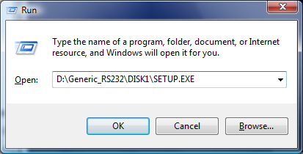

1.5 The appropriate drivers should now be installed on your system.

Configuration

The first time the system is configured it is necessary to enable and configure all devices you require. To configure a particular device select the Devices option from the main menu followed by the appropriate device.
This will launch an application to configure the device. You will be presented with a set of tabs as shown below.
To configure a channel select a group of channels by clicking on the appropriate channel tab. From the list provided select a channel and double-click.
Alternatively you can select a channel and then click on the Configure Channel button.
This will launch a channel configuration dialog which enables you to configure individual channels.

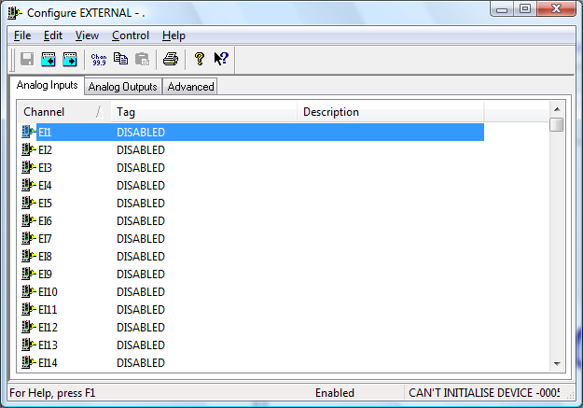

Channel Configuration (Analogs)

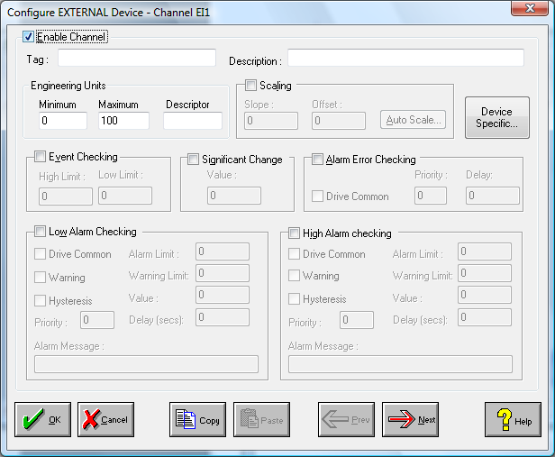

Enable Channel
The Enable Channel check box must be checked to enable, and allow this channel to be configured and ultimately included with all other configured channels in the overall system.

Tag
The Tag field is a 12 character alphanumeric field that can contain channel information or wiring schedule references.

Description
The Description field is a 32 character alphanumeric field in which a description of the channel can be detailed.

Units
A 4 character field available to describe the units of the output.

Device Specific Button
This application can be use as a generic device configuration program. If the Device Specific Button is visible, then click on it to configure channel features that are specific only to the type of device you are configuring.

For analog outputs, the following dialog box is displayed.

Analog outputs dialog.

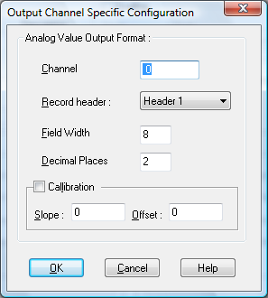

Channel
Channel value to be output e.g. any device or processor channel in the ScadaPro system.

Record Header
The data that will be inserted at the beginning of the output string as configured in Advanced, Device Specific settings e.g. date, time or any other string of ASCII characters that may be required.

Field width
Width and decimal places specify the number of ASCII characters used to output the value and precision i.e. 8 and 3 would send a value up to 9999.999.

Calibration
Used to apply a scale and offset to the channel value before transmission in the form y=mx+b where m is the slope and b the offset.

Analog inputs dialog.

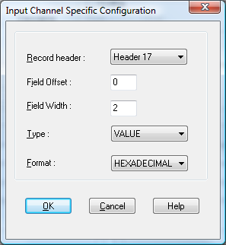

Record Header
Data, as specified in the advanced configuration screen, that will be removed from the beginning of the input string (up to 8 different header definitions are configurable).

Field offset
The number of characters from the beginning of the input string to the start of a particular channel. Note that if you have specified a header then those characters are now gone so must not be included in the character counting process.
NB Leave blank if "parsing" is specified in advanced | Device Specific | Channel delimiter.

Field width
Number of ASCII characters that the required value occupies.
NB Leave blank if "parsing" is specified in advanced | Device Specific | Channel delimiter.

Type
Specifies whether to parse for a value or to count the number of times the value is received. This is useful if you are using a device such as a weighscale and responding to a print button. If the 2 channels are configured for the same field, one as a count and the other as a value, then the system can receive the number of times a value was input and the last value input.
NB Ensure a count is configured before a value if "parsing" is specified in advanced | Device Specific | Channel delimiter.

Format
Specifies whether to parse for a decimal or hexadecimal value.

Scaling
NB. Scaling is only available to Analogue channels that are not Output channels.

Some transducers give a number of pulses, or a frequency output proportional to their full scale range. To enable the Scaling utility check the Scaling Check box. The Slope and Offset values can be entered directly into the text boxes. The formula applied is:

y = mx + c where: m is SLOPE
x is the measured value.
c is the OFFSET

Auto Scaling
Click on the Auto Scale button if you want the scale and offset values calculated automatically. A dialog box will be displayed. Enter the values in the text boxes. The low measured value, and the high measured value, the output range of the transducer. When the fields have been completed, and assuming the System is enabled click on the Apply button. Under the heading Current Values the actual measured value will be shown, as well as the Engineering Value.

Click on OK to accept the scaling, or Cancel to abort the Auto Scaling feature.

NB. Scaling will not be applied to the channel, even if the system is enabled, until the system is next enabled or the Device is reconfigured

Significant Change

The significant change status of a channel can be monitored from one scan to the next.

Event Checking
Event checking is used, if required to trigger a logger to record information on a number of channels during an event. Check the Event Checking check box if this channel is to trigger an event. Events are detected on inputs using data acquired at 1Khz. Events are detected on outputs using the configured scan rate.

High Limit
A value, in engineering units, entered in this text box will define the level that, if exceeded, will cause an event trigger.

Low Limit
A value entered in this text box will define the level that if the channel result falls below will cause an event trigger.

Alarm Checking
Alarm checking is available on all channels throughout the system. Low Alarm and High Alarm levels can be configured independent of each other. If the channel output exceeds the High Alarm limit then an alarm will be triggered as it will if the output goes below the Low Alarm limit. Alarms and warnings are detected at the configured scan rate.

When monitoring channels, if the high or low alarm is triggered, then the fact will be annotated alongside the other channel information in the Channel Monitor. To configure the Alarm Checking section of the device complete the options as follows for either or both the High Alarm and Low Alarm checking.

Enable Alarm Checking
Check either the Low Alarm Checking or High Alarm Checking or both check boxes to enable the facility.

Drive Common Alarm
A common alarm is a single digital output which will switch on when any channel with the Drive Common Alarm enabled goes into an alarm state. Check this box if a link to the Common Alarm is required.

Alarm Limit
Specifies the value that will trigger this alarm. For Low Alarm Checking it will be any value <= the Alarm Limit and for High Alarm Checking it will be any value >= the Alarm Limit.

Warning and Limit
If required, a warning can be displayed when a channel reaches a limit close to the alarm limit. For low alarm checking, the limit must be less than the alarm limit. For high alarm checking, the warning limit must be less than the alarm limit

Hysteresis
Hysteresis can prevent 'noisy' channels from reporting multiple alarms when the average reading is close to the alarm threshold. Check the box if this feature if needed. Enter the value of the dead band in the corresponding value field.

Priority
Enter or edit the number in the text box to allocate the priority of this alarm. Alarm priority ranges are from 0 to 255.

Alarm Delay
Enter the time, in seconds, between the channel value entering the alarm state and the system flagging an alarm.

Alarm Message
An Alarm Message can be defined to be displayed on the Status line of the Main Window when a channel goes into an alarm state. Enter the message, up to 32 characters, that is to appear in the event of an alarm.

Advanced Device Configuration

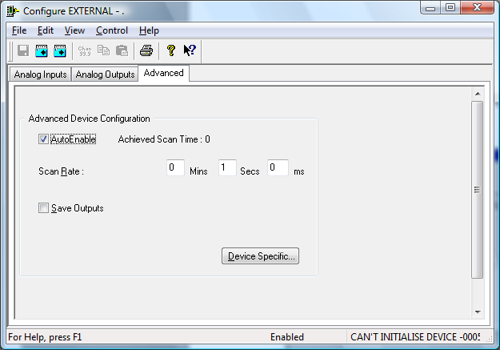

Advanced Configuration Dialog

When the system is enabled and the device is enabled this window will display the Achieved Scan Rate. If the device is not scanning then any error associated with the device will be displayed instead.

AutoEnable Device
To ensure that the device is enabled on the system check the Enable Device box.

Scan Rate
To set the rate, at which the device will scan, edit the text boxes associated with the Scan Rate field. In general, if a scan rate is set that is too fast for a particular device then the system will scan the data as fast as it can, reporting the actual achieved update rate as mentioned above. If the system gets errors three times in a row it will report those channels to be in error but will continue trying to process data in an attempt to get valid results.
While not necessary, it is often a good idea to estimate the fastest update rate possible for a particular device. This can be done by counting the number of characters, or bytes, to be received or transmitted and dividing it by the baud rate being used. For example, if we are receiving 360 characters at 1200 baud with serial framing parameters of 8 bits per byte, no parity, 1 start bit (there's always 1 start bit) and 1 stop bit. This means we have a total of 10 bits per byte * 360 characters which gives 3,600 bits/1200 or 3 seconds per scan. So, in this example, the fastest achievable scan would be 3 seconds.

Save Outputs
To enable this utility check the Save Outputs flag. All values in output channels are saved to disk when the system is disabled. The next time the system is restarted the values which were previously in output channels will be restored to the appropriate channel number.

By Tag
Channel values can be saved and restored to channels using the channel tag instead of the channel number. In this way, channels can be rearranged within the modules and as long as the channel tags remain the same, the correct channel values will be restored to the appropriate channel number.

Device Specific Button
If the Device Specific Button is visible and the system is disabled, then click on it to configure features that are specific only to this device.

Advanced configuration dialog.

You can change the Type in a dropdown menu which include Com Port, File, Directory.
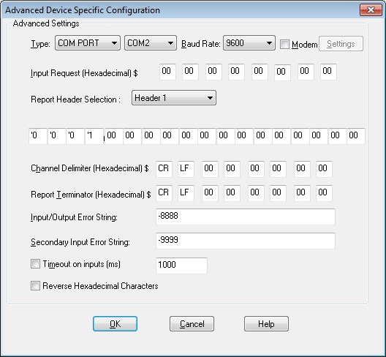

Comm.Port and Baud rate
Port # and speed used for receiving analog inputs and transmitting analog outputs. Other settings for the port can be specified using the Ports applet in Control panel.

Modem
This allows the external device to be connect via a modem or a device which required initialization and termination strings. The number to dial and optional initialization and termination strings can be specified in the modem settings. The port should also be configured to have Hardware flow control. Hex codes in the initialization and termination strings are prefixed by \x.

Input Request
The Input Request string is one or more hexadecimal values transmitted to the device and are used to request a set of results from the transmitting instrument. If the device doesn't support or require this feature then all fields should be set to 00.
NB A listing of ASCII characters to hex and decimal equivalents is contained in Appendix 1

Header Selection
Header selection allows for up to eight different report headers to be defined - see the next paragraph for the report header definition.

Report Header
The Report Header is a set of hexadecimal codes, relating to ASCII characters, which can be added to the beginning of an output string (e.g. date, time etc.) or a set of codes for matching input strings that can be received.
For output, YY,MH,DD,HH,MM,SS and MS can be used as special codes to specify current year, month, day, hour, minutes, seconds and milliseconds respectively.
For input ** matches any character.
The report header codes can be specified in hexadecimal or by prefixing an ascii character with ‘.

Channel Delimiter
A character(s) used to separate different values in an input or output string. It's positioned between consecutive analog values - typically a <space> or a <,> is used. You can enter the hex code for the character or, by first typing an apostrophe ('), you may enter the keyboard character directly instead of looking up the hex code.
NB If this facility is used then the field assignment functions described in the Channel Configuration section should be left blank.

Report Terminator
This character(s) used to indicate the end of a transmitted or received string - typically it's a CR and or a LF.

Error string
An ASCII string transmitted if the source channel of an analog output is in error. Simply type in the preferred message. It is recommended to use alpha characters since the receiving device may interpret numbers, spaces or other such entries as valid data or other meaningful codes.

Timeout
If a report header is not received within the timeout in milliseconds, the channels associated with the header are set in error.
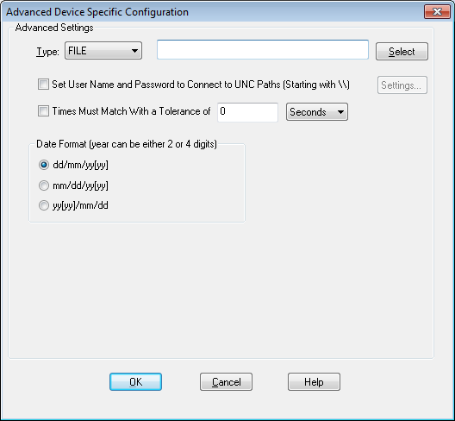

File
Select an XML file to use as a configuration.

Set User Name and Password
Set the username and password to connect to any Microsoft UNC paths.

Times match with Tolerance
Set the matching tolerance time in seconds or minutes.

Date Format
The date formats which can either be 2 or 4 digits for the year.

No Input File
When there is no input file you will receive “Input file is blank” error message. To overcome this, make sure there is an input file selected.
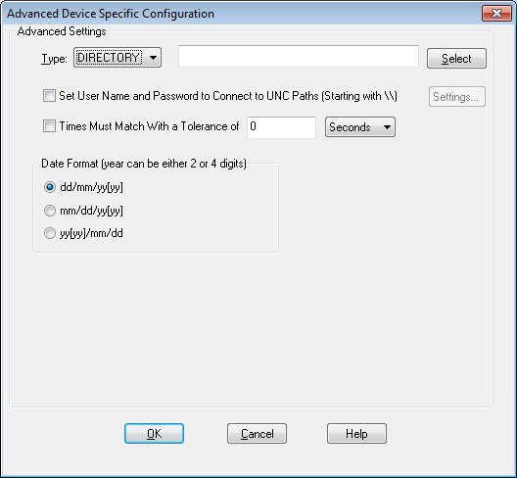

File
Select a directory to use as a configuration.

Set User Name and Password
Set the username and password to connect to any Microsoft UNC paths.

Times match with Tolerance
Set the matching tolerance time in seconds or minutes.

Date Format
The date formats which can either be 2 or 4 digits for the year.

No Input File
When there is no input file you will receive “Input directory is blank” error message. To overcome this, make sure there is an input file in the directory.

Creating a Remote Directory
To create a remote directory, simply right click on the directory and open the directory properties. Select the “Sharing” tab and click “Advanced Sharing”. Within the advanced sharing options check “Share this folder” and click on permissions, then assign permissions to whoever is to get access.

Setting up User Remote Access
Open up device specific settings and check “Set User Name and Password to Connect to UNC Paths [Starting with \\]” and then select settings to open up a windows dialog to input the username and password you have assigned to the remote directory.
NOTE: after assigning a username and password windows will store that username and password unlike the machine is restarted.
APPENDIX 1 - ASCII CODE

Decimal | Hexadecimal | ASCII | Decimal | Hexadecimal | ASCII
0  1  2  3  4  5  6  7  8  9  10  11  12  13  14  15 | 0  1  2  3  4  5  6  7  8  9  A  B  C  D  E  F | NUL  SOH  STX  ETX  EOT  ENQ  ACK  BEL  BS  TAB  LF  VT  FF  CR  SO  SI | 64  65  66  67  68  69  70  71  72  73  74  75  76  77  78  79 | 40  41  42  43  44  45  46  47  48  49  4A  4B  4C  4D  4E  4F | @  A  B  C  D  E  F  G  H  I  J  K  L  M  N  O
16  17  18  19  20  21  22  23  24  25  26  27  28  29  30  31 | 10  11  12  13  14  15  16  17  18  19  1A  1B  1C  1D  1E  1F | DLE  DC1  DC2  DC3  DC4  NAK  SYN  ETB  CAN  EM  SUB  ESC  FS  GS  RS  US | 80  81  82  83  84  85  86  87  88  89  90  91  92  93  94  95 | 50  51  52  53  54  55  56  57  58  59  5A  5B  5C  5D  5E  5F | P  Q  R  S  T  U  V  W  X  Y  Z  [  \  ]  ^  _
32  33  34  35  36  37  38  39  40  41  42  43  44  45  46  47 | 20  21  22  23  24  25  26  27  28  29  2A  2B  2C  2D  2E  2F | (space)  !  "  #  $  %  &  '  (  )  *  +  ,  -  .  / | 96  97  98  99  100  101  102  103  104  105  106  107  108  109  110  111 | 60  61  62  63  64  65  66  67  68  69  6A  6B  6C  6D  6E  6F | `  a  b  c  d  e  f  g  h  i  j  k  l  m  n  o
48  49  50  51  52  53  54  55  56  57  58  59  60  61  62  63 | 30  31  32  33  34  35  36  37  38  39  3A  3B  3C  3D  3E  3F | 0  1  2  3  4  5  6  7  8  9  :  ;  <  =  >  ? | 112  113  114  115  116  117  118  119  120  121  122  123  124  125  126  127 | 70  71  72  73  74  75  76  77  78  79  7A  7B  7C  7D  7E  7F | p  q  r  s  t  u  v  w  x  y  z  {  |  }  ~  

APPENDIX 2 - Petron Mark8 Data Format

Typical data transmission format: -
A011221115740 4391 4391 18015201540 220 3193738 0 810 0 159 108 111
B 9 9 504 1231520 319 49 0 63 63125 0 0 64 69 8 8 0 0 010000
E1000 490 0 0 0 0 010011110 100 0
F250250250 0 0 0 0 0 0 0
H 1 2 3

Header identification.
1) 20 41 {space A}
2) 20 42 {space B}
3) 20 45 {space E}
4) 20 46 {space F}
5) 20 48 {space H}

Line terminator is {CR LF}
Channel delimiter and Input Request should be empty for this device since we are using the character counting method of data point determination. This is done because not all points are separated with a common parsing character. Communication could also be defined using the parsing method but the date and time information contained in the first line would have to be omitted.

Channel configuration
Tag | Header | Offset | Width | Slope
Year | Header 1 | 0 | 2
Month | Header 1 | 2 | 2
Day | Header 1 | 4 | 2
Hour | Header 1 | 6 | 2
Minute | Header 1 | 8 | 2
Second | Header 1 | 10 | 2
depth | Header 1 | 12 | 5 | 0.1
btlc | Header 1 | 17 | 5 | 0.1
rop | Header 1 | 22 | 5 | 0.1
hkld | Header 1 | 27 | 4 | 0.1
pic-hkld | Header 1 | 31 | 4 | 0.1
wob | Header 1 | 35 | 4 | 0.1
torque | Header 1 | 39 | 4
pmpp | Header 1 | 43 | 4
casp | Header 1 | 47 | 4
pvt | Header 1 | 51 | 4 | 0.1
galo | Header 1 | 55 | 4
gas petron | Header 1 | 59 | 4
mw-in | Header 1 | 63 | 4 | 0.1
mw-out | Header 1 | 67 | 4 | 0.1
cond_in | Header 2 | 0 | 4
cond_out | Header 2 | 4 | 4
pump_out | Header 2 | 8 | 4
torque | Header 2 | 20 | 4
flow-out | Header 2 | 24 | 3
spm1 | Header 2 | 30 | 3
spm2 | Header 2 | 33 | 3
rot | Header 2 | 36 | 3
veloc | Header 2 | 39 | 3
Temp-in | Header 2 | 45 | 3
Temp-out | Header 2 | 48 | 3
tot-spm1 | Header 2 | 51 | 2
tot-spm2 | Header 2 | 53 | 2
PIT-INACT | Header 3 | 1 | 3 | 0.1
Trip Tank | Header 3 | 5 | 3 | 0.1
analog-gas | Header 3 | 18 | 4
CO2 | Header 3 | 34 | 3 | 0.1
pit1 | Header 4 | 0 | 3 | 0.1
pit2 | Header 4 | 3 | 3 | 0.1
pit3 | Header 4 | 6 | 3 | 0.1
pit4 | Header 4 | 9 | 3 | 0.1
pit5 | Header 4 | 12 | 3 | 0.1
pit6 | Header 4 | 15 | 3 | 0.1
pit7 | Header 4 | 18 | 3 | 0.1
pit8 | Header 4 | 21 | 3 | 0.1
pit9 | Header 4 | 24 | 3 | 0.1
pit10 | Header 4 | 27 | 3 | 0.1
pit11 | Header 4 | 30 | 3 | 0.1
pit12 | Header 4 | 33 | 3 | 0.1
pit13 | Header 4 | 36 | 3 | 0.1
pit14 | Header 4 | 39 | 3 | 0.1
pit15 | Header 4 | 42 | 3 | 0.1
pit16 | Header 4 | 45 | 3 | 0.1
h2s1 | Header 5 | 0 | 3
h2s2 | Header 5 | 3 | 3

APPENDIX 3 – Data Display Configuration

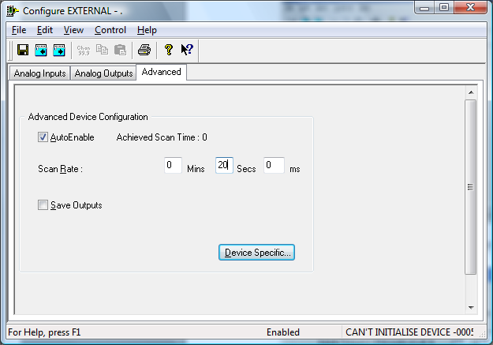

Set scan rate to 20 seconds so that display will update every 20 seconds.

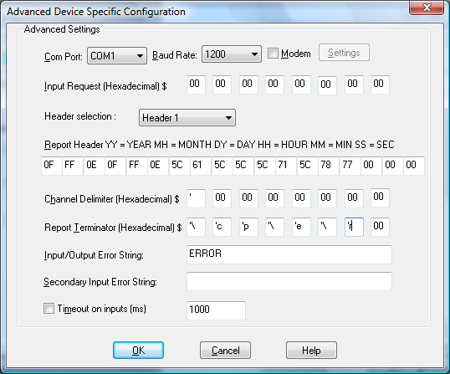

Header

Sends control characters
Addressed all displays \a\\
Clears text \q
ON command with wipe \xw

Terminator

ON command with pause \cf
End edit session \e
Left to right scrolling \r

Outputs can be digitals. For example

Q1 – Global Machine fault prefix
OFF = ALL MACHINES<space>
ON = MACHINE(S)<space>
Q2 – Q99 – Individual Machine
OFF = “”
ON = <machine identifier><space>
Q100 – Global Machine fault suffix
OFF = OK
ON = STOPPED

APPENDIX 4 – Lawicel CAN232 Configuration for J1938

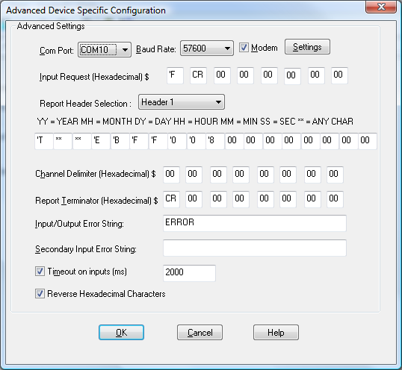

Baud rate is set to default baud rate of 57600.

The timeout is 2 seconds as most parameters are transmitted at least once a second.

The reverse hex characters options is set on. Note each hex byte is received as 2 characters in reverse byte format.

Initialisation and termination strings are defined in the modem section as shown below.

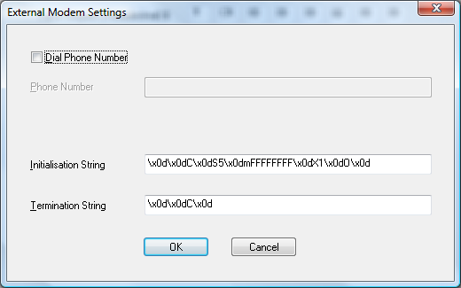

Initialisation string is defined to:
Close the CAN channel
Set the CAN baud rate to 250KB
Set the acceptance mask
Set Auto Poll ON
Open the CAN channel

Termination string is defined to close the CAN channel.
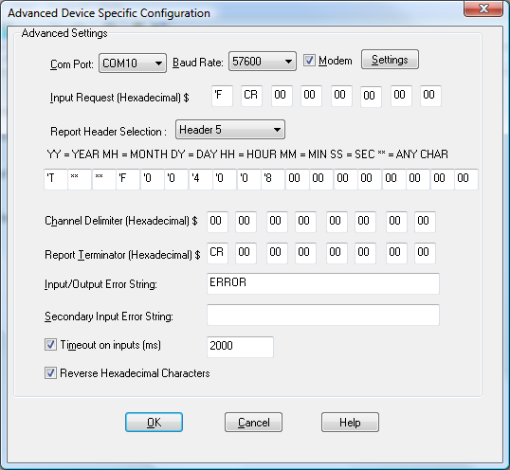

Headers are defined for each message type.
All J1939 messages received start with ‘T for extended message types whereasstartnd message types are prefixed by ‘t.
** in the above example indicates any source address.
The above example parses for F004- Electronic Engine Controller 1 Parameter Group number.
Prioirity is 0 and message length is 8.

Engine speed which starts at byte 4 (base 1) i.e. Field offset (base 0) is calculated as (4-1)*2 chars per bytes = 6.

Engine speed is specified in the J1939 spec to be 2 bytes but the Lawicell receives this as 4 ascii characters.
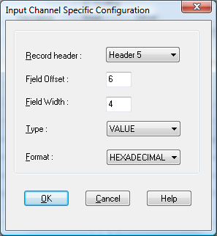

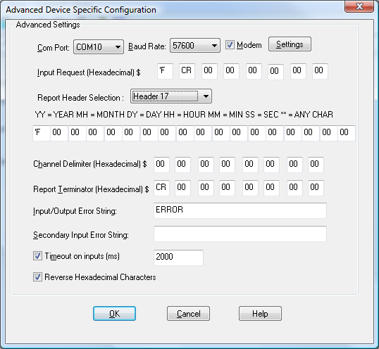

Input string is set to F <carriage return> in order to get the status of the Lawicell unit in an analog input as shown below.

