Partnership Courtyard, The Ramparts,
Dundalk, Ireland

Version 6.8.0.0
March 7, 2022
www.measuresoft.com
+353 42 933 2399

This document is the copyright of Measuresoft and may not be modified, copied or distributed in any form whatsoever without the prior permission of Measuresoft.

GE DPI User Manual

Table of Contents

1 Configuration 3
2 Channel Configuration 4
2.1 Enable Channel 4
2.2 Tag 4
2.3 Description 4
2.4 Engineering Units 4
2.4.1 Minimum 5
2.4.2 Maximum 5
2.4.3 Descriptor 5
2.5 Device Specific Button 5
2.5.1 Device 5
2.5.2 Pressure Units 5
3 Advanced Device Configuration 6
3.1 AutoEnable Device 6
3.2 Scan Rate 6
3.3 Save Outputs 6
3.3.1 By Tag 6
3.4 Device Specific Button 6
3.4.1 Communication Settings 7

Configuration

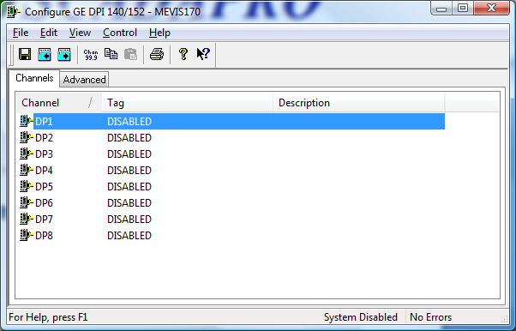

The first time the system is configured it is necessary to enable and configure all devices you require. To configure a particular device select the Devices option from the main menu followed by the GE DPI 140/152 device. This will launch an application to configure the device.

From the list provided select a channel and double-click. Alternatively you can select a channel and then click on the Configure Channel button.

This will launch a channel configuration dialog which enables you to configure individual channels.

Channel Configuration

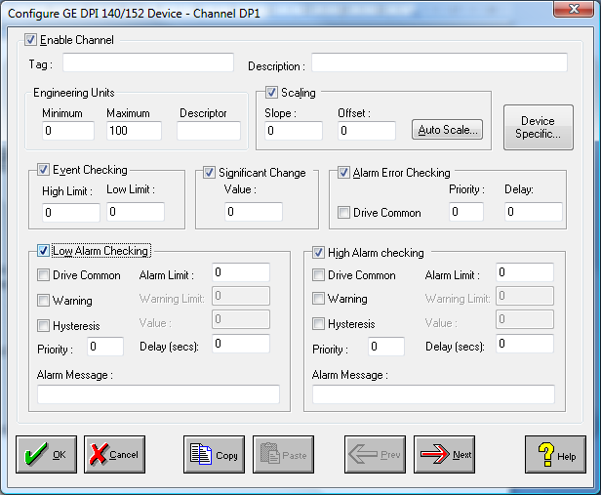

Enable Channel
The Enable Channel check box must be checked to enable and allow a channel to be configured and ultimately included with all other configured channels in the overall system.

Tag
The Tag field is a 12 character alphanumeric field that can contain channel information or wiring schedule references.

Description
The Description field is a 32 character alphanumeric field in which a description of the channel can be detailed.

Engineering Units
Specifies engineering details for this channel.

Minimum
Minimum engineering value for all Analog channels in addition to the unit field. The default is 0.

Maximum
Maximum engineering value for all Analog channels in addition to the unit field. The default is 100.

Descriptor
A four character field available to describe the units of the measurement.

Device Specific Button
When the Device Specific Button is pressed a dialog appears detailing the Analog Value Mapping between the channel being configured and the data associated with that channel. These settings are in relation to display configurations.

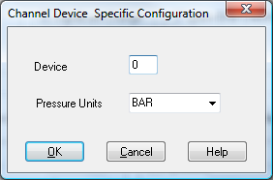

Device
Enter the address of the attached GE Druck Pressure Indicator device.

Pressure Units
Sets pressure units to be measured.

Advanced Device Configuration

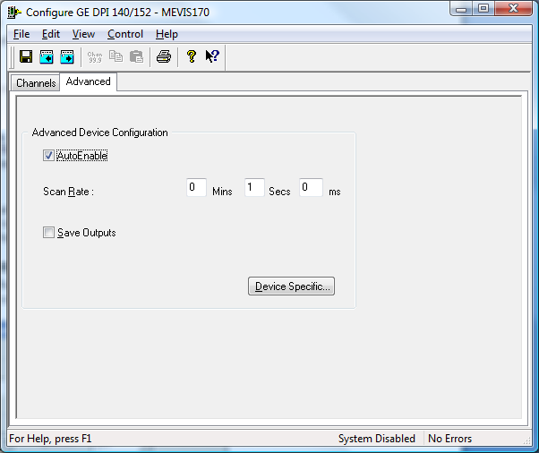

AutoEnable Device
To ensure that the device is enabled on the system check the Enable Device box.

Scan Rate
To set the rate at which the device will scan, edit the text boxes associated with the Scan Rate field.

Save Outputs
To enable this utility check the Save Outputs flag. All values in output channels are saved to disk when the system is disabled. The next time the system is restarted the values which were previously in output channels will be restored to the appropriate channel number.

By Tag
Channel values can be saved and restored to channels using the channel tag instead of the channel number. In this way, channels can be rearranged within the modules and as long as the channel tags remain the same, the correct channel values will be restored to the appropriate channel number.

Device Specific Button
When the Device Specific Button is pressed the following dialog appears to allow specific communication settings to be configured for the device.

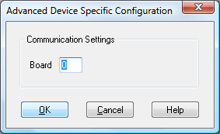

Communication Settings
The GPIB Gateway Communication Settings

Board
Enter the board number of the controller to which the instrument is attached.

