Partnership Courtyard, The Ramparts,
Dundalk, Ireland

Version 6.8.0.0
March 7, 2022
www.measuresoft.com
+353 42 933 2399

This document is the copyright of Measuresoft and may not be modified, copied or distributed in any form whatsoever without the prior permission of Measuresoft.

GASM Controller

Table of Contents

1 MONITORING AND CONTROLLING AN EXPERIMENT 3
1.1 Begin Experiment 3
1.2 End Experiment 3
1.3 Pause Experiment 3
1.4 Resume Experiment 4
1.5 Setup Experiment 4
1.6 Do Calibration Run 4
1.7 Exit 4
1.8 Experiment status 4
1.9 Experiment phase 4
1.10 Experiment Action 4
2 SETTING UP AN EXPERIMENT 5

MONITORING AND CONTROLLING AN EXPERIMENT

When the software to monitor, control and experiment is run, the following menu is displayed:

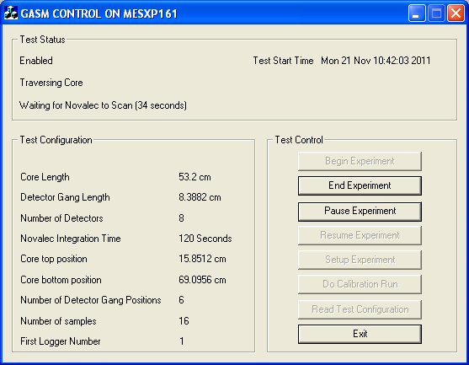

This displays the current status of the experiment, and the current configuration. The experiment can be controlled using the buttons on the right hand side of the display. These are:

Begin Experiment

Start the experiment using the current configuration.

End Experiment

End the currently running experiment. This button can also terminate a calibration run, before it has completed.

Pause Experiment

Pause the current experiment. The configuration can be changed while an experiment is paused, but not while it is running. This button can also pause a calibration run.

Resume Experiment

Resume the current experiment, using the current configuration.

Setup Experiment

Call up a menu to allow the configuration to be changed. See section 2 for full details.

Do Calibration Run

Start a calibration run.

Exit

Terminate the monitor program. Any experiment or calibration run that is active is unaffected by this action.

The status information at the top of the screen contains the three lines of information:

Experiment status

This can be Enabled, Paused, Disabled or Finished. Unless the status is Disabled, the start time of the current experiment, or the last experiment that was run if the status is Finished, is also displayed. Disabled is only displayed if no experiments have been run since the system was last reset.

Experiment phase

This is displayed if an experiment is Enabled or Paused, and can be one of the following:

- Traversing Core. The system is in normal operation mode, and is moving the detector gang along the length of the core, collecting counts from the Novalec.
- Tracking Front. The system has been configured to start with front tracking enabled, and is currently tracking the front along the length of the core. When the end of the core has been reached, the phase will change to Traversing Core.
- Tracking Front Setup. The system has been configured to start with front tracking enabled, and is doing the initial traverse along the length of the core to determine the means and standard deviations before flooding starts. When these parameters have been calculated, the phase will change to Tracking Front and flooding can be started.
- Calibration Run. The system is performing a calibration run.

Experiment Action

this displays the detail of what the software is actually doing, and is one of the following:

- Waiting for Novalec to Scan (nn seconds). The system is waiting for the Novalec to read the counts, and has been waiting for nn seconds. The system waits for the length of time specified in the configuration for the Novalec Integration Time plus five seconds, to ensure that the Novalec readings have been received and processed by the system.
- Moving Digiplan (nn Seconds). The Digiplan is being moved to a new position, and has been moving for nn seconds.

SETTING UP AN EXPERIMENT

Before an experiment can be started, it must be set up. The following information is required to run an experiment:

- Whether the flood is being carried upwards or downwards
- The length of the detector gang being used (lb); to be exact, this should be the distance between the top detector and the bottom detector of the gang
- The number of detectors (D)
- The core length (lc)
- The Novalec integration time, in seconds
- The top position of the core (Lt) (if the flood is being carried out downwards)
- The bottom position of the core (Lb) (if the flood is being carried out upwards)
- The number of steps the detector gang can make (S)

In addition, if the experiment will track the front at the start of the experiment, the following information is required:

- The number of samples used to calculate the mean and standard deviation of counts before flooding the core

The number of samples to be taken is also required for a calibration run.

All of these parameters can be entered manually. Software is available to determine the exact positions of the top and bottom of the core in the rig. From the screen that monitors and controls an experiment (see section), clicking on the button Setup Experiment first initialises the Novolec and the Digiplan devices and then calls up the menu displayed on the top of the next page.

The Novolec and Digiplan devices are initialised whenever the Setup Experiment button is clicked. For the Novolec, this involves downloading a series of commands to it, as defined by a text file. For the Digiplan, a separate text file contains commands to send; once these have been downloaded, the Digiplan is moved to its reference position, and this is assigned to be position 0. At the reference position, the top detector of the detector gang is assumed to be at position 0. Therefore, when moving the Digiplan to get the bottom detector into a particular position (e.g. Lb), the Digiplan must be instructed to move to where the top detector should be (i.e. Lb - lb).

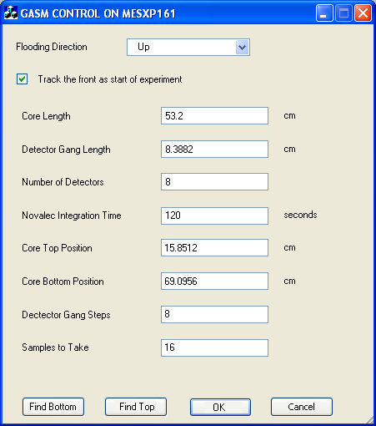

This screen allows all the configuration parameters to be edited manually. Note, however, that if either the core length (lc) or the detector gang length (lb) is changed, the number of detector gang steps (S) is automatically re-calculated.

The top and bottom core positions, Lt and Lb, are expressed in the terms of the distance from the Digiplan reference position, which is marked by a proximity switch at the top of the rig. This reference position is designated as position 0, and positions below this are positive. Lb is a fixed point, and will not normally change, but Lt will change with the length of the core. In addition to the proximity switch which marks the Digiplan reference position, there are two additional proximity switches on the rig which act as fail-safes. One is above the Digiplan reference position, the other is below the bottom of the core.

The software can determine the exact positions of both Lb and Lt if required. During an experiment or calibration run, the software will move the detector gang so that all the detectors are scanning the core at all times. This is done so that if the front is tracked at the start of an experiment, all the detectors can track the progress of the flood, and the decision on the percentage of detectors that have detected the flood does not need to account for any detectors that are not opposite the core. The algorithm for moving the detector gang is as follows:

- The initial position of the detector gang is set such that the bottom detector is opposite Lb (if flooding upwards), or the top detector is opposite Lt (if flooding downwards)

- The next position of the detector gang is lb + lb/D above (if flooding upwards) or below (if flooding downwards) the previous position. lb/D is added to the position, so that (if flooding upwards), the new position of the bottom detector is one detector position above the previous position of the top detector

- If flooding upwards, the detector gang position is checked to ensure that the top detector position is not above Lt. If it is, the position is adjusted downwards so that the top detector is opposite Lt

- If flooding downwards, the detector gang position is checked to ensure that the bottom detector position is not below Lb. If it is, the position is adjusted upwards so that the bottom detector is opposite Lb

Separate buttons are used to find Lb and Lt.

When the button Find Bottom is clicked, the Digiplan is moved to position Lb - lb - lb/2. This is the position that the top detector should be moved to so that the bottom detector is about half a detector gang width above the bottom position. The Novalec is used to measure the count from the bottom detector. The detector gang is then moved down by one detectors width (lb/D) and the counts from the bottom detector are measured again. This procedure is repeated until the base 10 logarithm of the counts from the last detector increases by 0.5 from the initially measured value. The previous position of the bottom detector is set to be Lb.

The software will move the detector gang by at most an amount 2 * lb. If Lb is not found before this amount has been moved, the software will display a message saying that the bottom of the core cannot be found, and give the user the opportunity to find Lb manually. The dialog box that is displayed is as follows:

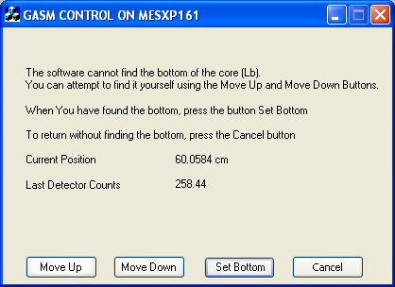
The user can attempt to find the bottom manually by clicking on the Move Up and the Move Down buttons. Each time one of these buttons is clicked, the Digiplan is moved by distance lb/D up or down, and the counts from the Novalec are measured. All the buttons except Cancel are disabled until the movement is complete and counts from the Novalec have been retrieved for the last detector.

The top of the core, Lt is found in a similar way. The main difference is that the core is initially moved to position Lb - lc - lb/2. This positions the detector gang such that the top detector of the gang is about half a detector gang width below the top of the core. The software then moves the detector gang upwards until the counts from the top detector increase as described above. If the software cannot find Lt, the user may manually attempt to find it, using a similar procedure to finding Lb manually.

