

Partnership Courtyard, The Ramparts,

Dundalk, Ireland

Version 6.8.0.0

March 7, 2022

www.measuresoft.com

+353 42 933 2399

This document is the copyright of Measuresoft and may not be modified, copied or distributed in any form whatsoever without the prior permission of Measuresoft.

Fardux Idea Logger User Manual

Table of Contents

1 Configuration 3

2 Advanced Device Configuration 4

2.1 AutoEnable Device 4

2.2 Scan Rate 4

2.3 Save Outputs 4

2.3.1 By Tag 5

2.4 Device Specific Button 5

2.4.1 Comm Port 5

2.4.2 Get Version 5

3 Analog Input Channel Configuration 7

3.1 Enable Channel 7

3.2 Tag 7

3.3 Description 7

3.4 Engineering Units 7

3.4.1 Minimum 8

3.4.2 Maximum 8

3.4.3 Descriptor 8

3.4.4 Scaling 8

3.4.4.1 Auto Scaling 8

# Configuration

The first time the system is configured it is necessary to enable and configure all devices you require. To configure a particular device select the ***Devices*** option from the main menu followed by the Fardux Idea Logger device. This will launch an application to configure the device.

DeviceSelect

From the list provided select a channel and double-click. Alternatively you can select a channel and then click on the Configure Channel button. 

This will launch a channel configuration dialog which enables you to configure individual channels.

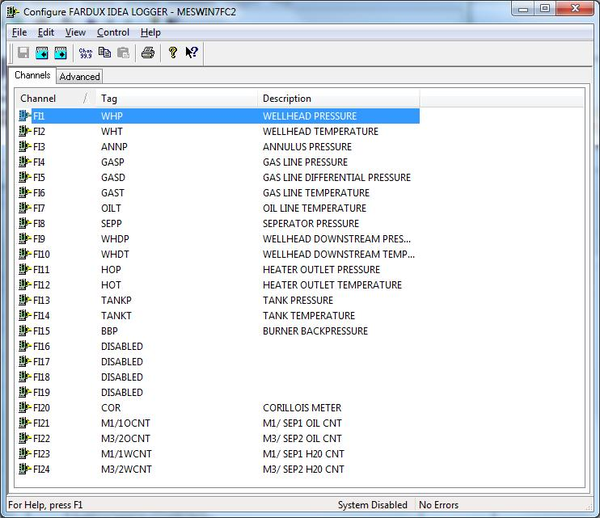

# Advanced Device Configuration

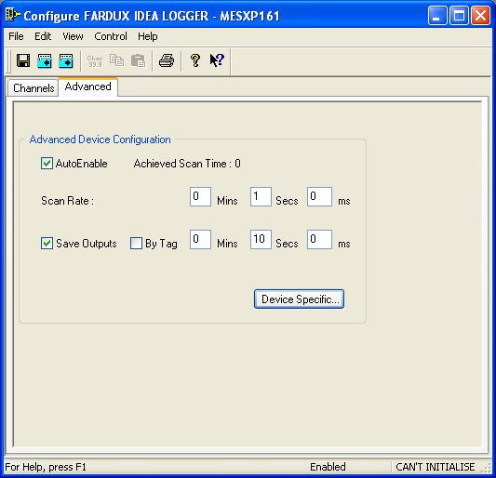

## AutoEnable Device

To ensure that the device is enabled on the system check the Enable Device box.

## Scan Rate

To set the rate at which the device will scan, edit the text boxes associated with the Scan Rate field.

## Save Outputs

To enable this utility check the Save Outputs flag. All values in output channels are saved to disk when the system is disabled. The next time the system is restarted the values which were previously in output channels will be restored to the appropriate channel number.

### By Tag

Channel values can be saved and restored to channels using the channel tag instead of the channel number. In this way, channels can be rearranged within the modules and as long as the channel tags remain the same, the correct channel values will be restored to the appropriate channel number.

## Device Specific Button

When the Device Specific Button is pressed the following dialog appears to allow specific communication settings to be configured for the device.

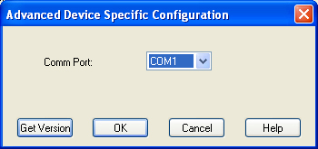

### Comm Port

Allows data transfer through comm ports connecting the computer to the Fardux Idea Logger device.

### Get Version

Gets the current version of the device.

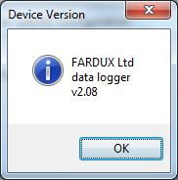

When the comm ports are disabled Scadapro is unable to communicate with the device. When the Get Version Button is pressed the following dialog appears.

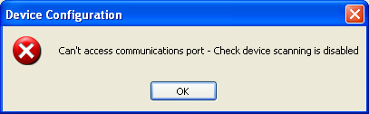

# Analog Input Channel Configuration

Autoscanning is used to scan analog inputs.

When the user selects an analog input to be configured the following is displayed.

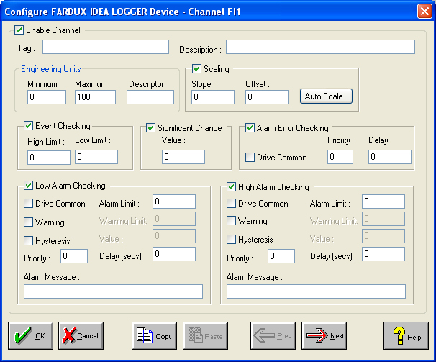

## Enable Channel

The Enable Channel check box must be checked to enable and allow a channel to be configured and ultimately included with all other configured channels in the overall system.

## Tag

The Tag field is a 12 character alphanumeric field that can contain channel information or wiring schedule references.

## Description

The Description field is a 32 character alphanumeric field in which a description of the channel can be detailed.

## Engineering Units

Specifies engineering details for this channel.

Minimum

Minimum engineering value for all Analog channels in addition to the unit field. The default is 0.

Maximum

Maximum engineering value for all Analog channels in addition to the unit field. The default is 100.

Descriptor

Describe the units of the measurement.

### Scaling

#### Auto Scaling

Click On the Auto Scale button if you want the scale and offset values calculated automatically. A dialog box will be displayed. Enter the values in the text boxes. The low measured value, and the high measured value, the output range of the transducer. When the fields have been completed, and assuming the System is enabled click on the Apply button. Under the heading Current Values the actual measured value will be shown, as well as the Engineering Value.The measured value is the raw from the device which is in the range 0 to 65355. The engineering value is converted EU value which is normally 0 @ 13107 and full scale at 65355.

