Measuresoft Development Ltd.

Ametek Programmable Power
EX10XX User Manual

Version: 6.4.8.2
1. Installation 3
2. Configuration 4
3. Advanced Device Configuration 5
3.1 AutoEnable Device 5
3.2 Scan Rate 5
3.3 Save Outputs 5
3.4 Device Specific Button 5
3.4.1 Address 6
3.4.2 Search 6
3.4.3 Sample Rate 6
3.4.4 Temperature in Farenheit 6
3.4.5 Forward Polynomial User0 and User1 6
3.4.6 Inverse Polynmial User0 and User1 6
3.4.7 Alarm Reset 7
3.4.8 Browse 7
3.4.9 Reset 7
3.4.10 Calibrate 7
4. Channel Configuration (Analogs) 8
4.1 Enable Channel 8
4.2 Tag 8
4.3 Description 8
4.4 Units 8
4.5 Scaling 9
4.5.1 Auto Scaling 9
4.6 Significant Change 9
4.7 Event Checking 9
4.7.1 High Limit 9
4.7.2 Low Limit 9
4.8 Alarm Checking 9
4.8.1 Enable Alarm Checking 10
4.8.2 Drive Common Alarm 10
4.8.3 Alarm Limit 10
4.8.4 Warning and Limit (Analogue channel only) 10
4.8.5 Hysteresis 10
4.8.6 Priority 10
4.8.7 Alarm Delay 10
4.8.8 Alarm Message 10
4.8.9 Alarm on Error Checking 10
4.9 Device Specific Button 11
4.9.1 Analog Inputs 11
5. Channel Configuration (Digitals) 12
5.1 Enable Channel 12
5.2 Tag 12
5.3 Description 12
5.4 Low State Description 12
5.5 High State Description 12
5.6 Event Checking 13
5.7 Alarm Checking 13
5.7.1 Alarm State 13
5.7.2 Alarm Priority 13
5.7.3 Common Alarm 13
5.7.4 Alarm Delay 13
5.7.5 Alarm Message 13
5.7.6 Alarm on Error Checking 13
5.8 Device Specific Button 14
5.8.1 Output Enable 14
5.8.2 Latch Limit Events 14
5.8.3 Invert Limit Events 14
5.8.4 Set Limit Event 14

Installation
The Ametek Programmable Power EX10XX Series Driver installation has the following three stages:
- Installation of the Keysight IO Library Suite
- Installation of the Vtex 10XXA Plug and Play driver
- Installation of the ScadaPro Ametek Programmable Power EX10XX Series Driver Driver

NB: Please complete the stages above in the order indicated.

The Agilent IO Library can be downloaded from https://www.keysight.com/en/pd-1985909/io-libraries-suite. When the library has been downloaded run the setup and accept the default settings.

The Vtex 10XXA Plug and Play driver can be downloaded from https://www.powerandtest.com/ate-data-acq/data-acquisition/static-daq/ex1000a. Click on the Download links. From the Download list select 72-0406-000--EX10xxA, RX10xx Driver Plug and Play. Download and extract the file zip file and run setup.exe. A reboot is required at this stage.

Install the ScadaPro Ametek Programmable Power EX10XX Series Driver Driver driver from the installation CD provided by running the driver setup.msi. Accept the default installation settings.

Configuration

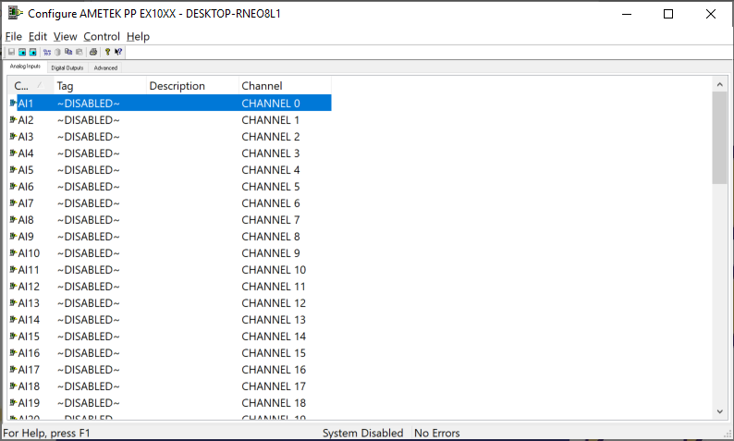

The first time the system is configured it is necessary to enable and configure all devices you require. To configure a particular device select the Devices option from the main menu followed by the appropriate device.
This will launch an application to configure the device. You will be presented with a set of tab dialogs as shown above.

The Advanced device configuration is used to configure the device IP addeess.

To configure channels, click on the appropriate channel tab. From the list provided select a channel and double-click. Alternatively you can select a channel and then click on the Configure Channel button. This will launch a channel configuration dialog which enables you to configure individual channels.

Advanced Device Configuration

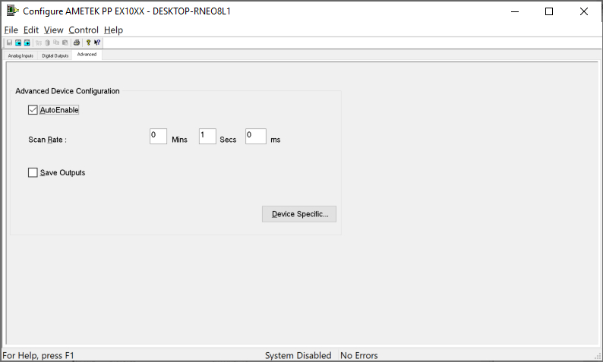

AutoEnable Device
To ensure that the device is enabled on the system check the Enable Device box.

Scan Rate
To set the rate at which the device will scan, edit the text boxes associated with the Scan Rate field.

Save Outputs
To enable this utility check the Save Outputs flag. All values in output channels are saved to disk when the system is disabled. The next time the system is restarted the values which were previously in output channels will be restored to the appropriate channel number.

Device Specific Button
If the Device Specific Button is visible, then click on it to configure features that are specific only to this device. In the case of the LXI EX1048 the following dialog will appear.

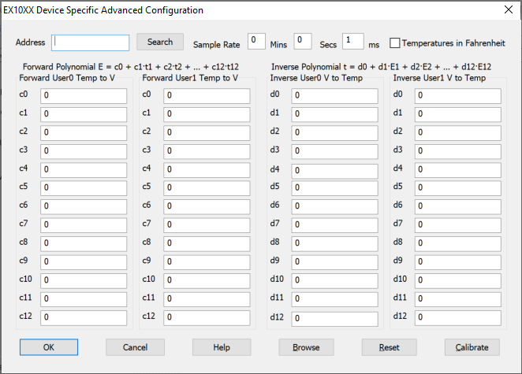

Address
The IP address of the EX1048 device

Search
Searches for the first EX1048 on the local area network and updates the Address.

Sample Rate
The trigger timer rate.

Temperature in Farenheit
Temperature in Fahrenheit. Report temperatures in degrees Celsius or degrees Fahrenheit.

Forward Polynomial User0 and User1
User 0 and User 1 EU Conversions on analog inputs use forward conversion polynomials to convert a CJC temperature into a compensating cold junction voltage and has the form of:

E = c0 + c1 *t + c *t +K+ c *t

where E is in volts, t is in ºC, and co – c12 are the coefficients.

Inverse Polynmial User0 and User1
User 0 and User 1 EU Conversions on analog inputs use inverse conversion polynomial to convert a compensated input voltage into temperature and has the form of:

t = d0 + d1 *E + d *E +K+ d *E

where E is in volts, t is in ºC, and do – d12 are the coefficients.

Alarm Reset
This field specifies the Digital Channel that will be used to reset the alarms on the Envirocon Device. When this channel is set HIGH all alarms will be reset.

Browse
Browse is used to open the Internet Bowser to access the EX1048 device directly.

Reset
Reset is used to abort data acquisition and to reset the EX1048 device.

Calibrate
Calibrate is used to perform calibration functions on the EX1048 device.

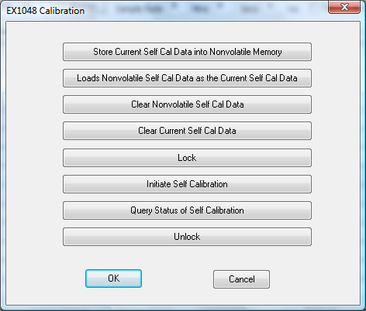

Channel Configuration (Analogs)

Physical Analog Input Channel 0 to 47 are mapped to analog inputs 1 to 48.

Channels 49 to 60 are reserved for future support of CJC values.

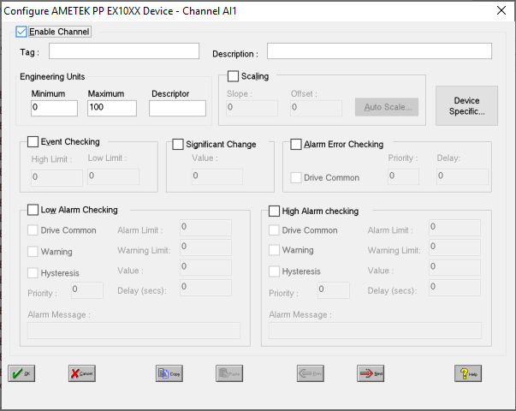

Enable Channel
The Enable Channel check box must be checked to enable, and allow this channel to be configured and ultimately included with all other configured channels in the overall system.

Tag
The Tag field is a 12 character alphanumeric field that can contain channel information or wiring schedule references.

Description
The Description field is a 32 character alphanumeric field in which a description of the channel can be detailed.

Units
A 4 character field available to describe the units of the output.

Scaling
NB. Scaling is only available to Analog channels that are not Output channels.

Some transducers give a number of pulses, or a frequency output proportional to their full scale range. To enable the Scaling utility check the Scaling Check box. The Slope and Offset values can be entered directly into the text boxes. The formula applied is:

y = mx + c where: m is SLOPE
x is the measured value.
c is the OFFSET

Auto Scaling
Click On the Auto Scale button if you want the scale and offset values calculated automatically. A dialog box will be displayed. Enter the values in the text boxes. The low measured value, and the high measured value, the output range of the transducer. When the fields have been completed, and assuming the System is enabled click on the Apply button. Under the heading Current Values the actual measured value will be shown, as well as the Engineering Value.

Click on OK to accept the scaling, or Cancel to abort the Auto Scaling feature.

NB. Scaling will not be applied to the channel, even if the system is enabled, until the system is next enabled or the Device is reconfigured

Significant Change
To enable the Significant Change feature check the Sig Change check box. This facility allows filtering of data on channels on which significant change is of interest. Such changes can cause an event, which can be logged.
The figure entered in the Value text box, is the rate of change that if the output level exceeds per scan, either increasing or decreasing will cause the significant change event trigger. The scan rate is determined in the Advanced Device configuration
If a logger is configured each time the significant change trigger operates information on the channels defined in the logger will be recorded . A significant change event only lasts one scan, unless the next reading also changes greater than the Significant change value

When monitoring channels, if the Significant Change is triggered, then the fact will be annotated alongside the other channel information in the Channel Monitor. The significant change events are in addition to those caused by an Event.

Event Checking
Event checking is used, if required to trigger a logger to record information on a number of channels during an event. Check the Event Checking check box if this channel is to trigger an event.

High Limit
A value, in engineering units, entered in this text box will define the level that, if exceeded, will cause an event trigger.

Low Limit
A value entered in this text box will define the level that if the channel result falls below will cause an event trigger.

Alarm Checking
Alarm checking is available on all channels throughout the system. Low Alarm and High Alarm levels can be configured independent of each other. If the channel output exceeds the High Alarm limit then an alarm will be triggered as it will if the output goes below the Low Alarm limit.

When monitoring channels, if the high or low alarm is triggered, then the fact will be annotated alongside the other channel information in the Channel Monitor. To configure the Alarm Checking section of the device complete the options as follows for either or both the High Alarm and Low Alarm checking.

Enable Alarm Checking
Check either the Low Alarm Checking or High Alarm Checking or both check boxes to enable the facility.

Drive Common Alarm
A common alarm is a single digital output which will switch on when any channel with the Drive Common Alarm enabled goes into an alarm state. Check this box if a link to the Common Alarm is required.

Alarm Limit
Specifies the value which will trigger this alarm. for Low Alarm Checking it will be any value <= the Alarm Limit and for High Alarm Checking it will be any value >= the Alarm Limit.

Warning and Limit (Analogue channel only)
If required, a warning can be displayed when a channel reaches a limit close to the alarm limit. For low alarm checking, the limit must be less than the alarm limit. For high alarm checking, the warning limit must be less than the alarm limit

Hysteresis
Hysteresis can prevent 'noisy' channels from reporting multiple alarms when the average reading is close to the alarm threshold. Check the box if this feature if needed. Enter the value of the dead band in the corresponding value field.

Priority
Enter or edit the number in the text box to allocate the priority of this alarm. Alarm priority ranges are from 0 to 255.

Alarm Delay
Enter the time, in seconds, between the channel value entering the alarm state and the system flagging an alarm.

Alarm Message
An Alarm Message can be defined to be displayed on the Status line of the Main Window when a channel goes into an alarm state. Enter the message, up to 32 characters, that is to appear in the event of an alarm.

Alarm on Error Checking
Checking this section will enable the device to generate alarms when a channel goes into error.

Device Specific Button

When the Device Specific Button is pressed the following dialog is presented.

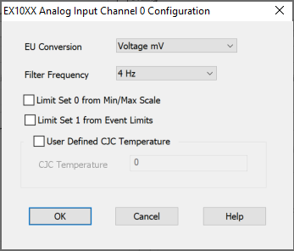

Analog Inputs

EU Conversion
Sets the engineering units (EU) conversion for the channel.

Filter Frequency
Sets the hardware filter frequency for the specified channels to 4Hz or 1kHz

Limit Set 0 from Min/Max Scale
By default, the limit values for limit set 0 are set automatically, based on the EU conversion and units selection for each channel. If manual limit control has been enabled the user defined limit values come from the min/max scale value of the channel.

Limit Set 1 from Event Limits
If manual limit control has been enabled the user defined limit values come from the event limits of the channel.

User Defined CJC Temperature
Enables the use of a user-defined CJC temperature instead of the internally measured one.

CJC Temperature
Sets the user-defined CJC temperature for the channel. The value is entered in Degrees Celsius regardless of whether results are reported in Fahrenheit or Celsius.

Channel Configuration (Digitals)

DIO Channels 0 to 7 are mapped to digital outputs 1 to 8.

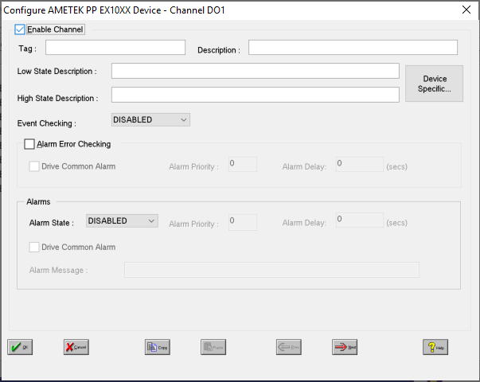

Enable Channel
The Enable Channel check box must be checked to enable, and allow this channel to be configured and ultimately included with all other configured channels in the overall system.

Tag
The Tag field is a 12 character alphanumeric field that can contain channel information or wiring schedule references.

Description
The Description field is a 32 character alphanumeric field in which a description of the channel can be detailed.

Low State Description
A 32 character field in which to enter a description of the low state of the channel.

High State Description
A 32 character field in which to enter a description of the high state of the channel.

Event Checking
Event checking is used, if required to trigger a logger to record information on an event. If this facility is required click on the drop down list box and select OFF, HIGH STATE, or LOW STATE as appropriate

Alarm Checking

Alarm State
Alarm checking is available on all channels throughout the system. To configure alarm checking on this channel click on the drop down box and select OFF, HIGH STATE, or LOW STATE as appropriate. If the channel's output state changes to an Alarm State an alarm will be triggered on the channel. When monitoring channels, if the alarm is triggered, the fact will be annotated alongside the other channel information in the Channel Monitor .

Alarm Priority
Enter the priority of the alarm triggered by this channel. Alarm priority ranges are from 0 to 255.

Common Alarm
Channels can be configured to trigger a Common Alarm. A common alarm is a single digital output which will switch on when any channel with the Drive Common Alarm enabled goes into an alarm state.

Alarm Delay
Enter the time, in seconds, between the channel value entering the alarm state and the system flagging an alarm.

Alarm Message
An Alarm Message can be defined to be displayed on the Status line of the Main Window when a channel goes into an alarm state.

Alarm on Error Checking
Checking this section will enable the device to generate alarms when a channel goes into error.

Device Specific Button

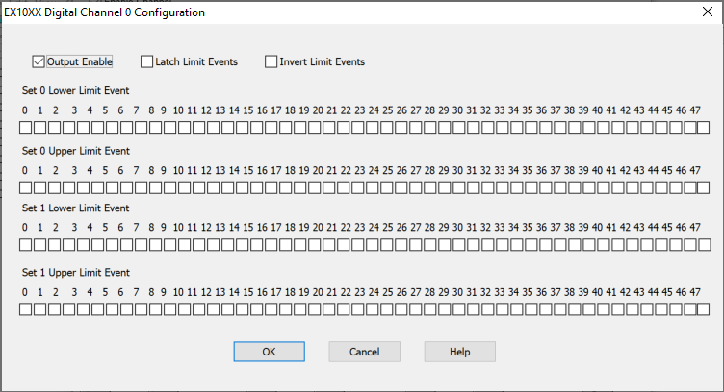

Output Enable
Output Enable Enables the output functionality of the channel on the I/O port. If not enabled the channel functions as a digital input.

Latch Limit Events
Enables or disables latch operation of a DIO channel linked as a limit event. The nominal operation of a linked DIO channel is to reflect the latest limit evaluation. That is, it will be updated with every scan. In latch mode, a transition out of the cleared state would remain, regardless of future limit evaluations, until it is cleared at the beginning of a new acquisition.

Invert Limit Events
Enables or disables inverted operation of a DIO channel linked as a limit event. The nominal transition of a DIO channel is from low to high whenever the linked limit is exceeded. In invert mode, it is from high to low.

Set Limit Event
Links limit evaluations to the operation of the digital I/O port. In nominal operation, a DIO channel that is linked to an input channel’s limit evaluation will transition from low to high whenever the limit is exceeded. Multiple linkages per DIO channel are allowed and are logically OR’ed together. That is, a DIO channel that is linked to four input channel limit evaluations will transition whenever any of the four limits are exceeded. Multiple linkages can be created on the same input channel and/or spanning multiple input channels.

