Partnership Courtyard, The Ramparts,
Dundalk, Ireland

Version 6.8.0.0
March 7, 2022
www.measuresoft.com
+353 42 933 2399

This document is the copyright of Measuresoft and may not be modified, copied or distributed in any form whatsoever without the prior permission of Measuresoft.

Eurotherm Driver User Manual

CONTENTS

1. Configuration 3
2. Channel Configuration (Analogs) 3
2.1. Enable Channel 3
2.2. Tag 3
2.3. Description 3
2.4. Units 3
2.5. Scaling 3
2.5.1. Auto Scaling 3
2.6. Significant Change 3
2.7. Event Checking 3
2.7.1. High Limit 3
2.7.2. Low Limit 3
2.8. Alarm Checking 3
2.8.1. Enable Alarm Checking 3
2.8.2. Drive Common Alarm 3
2.8.3. Alarm Limit 3
2.8.4. Warning and Limit (Analogue channel only) 3
2.8.5. Hysteresis 3
2.8.6. Priority 3
2.8.7. Alarm Delay 3
2.8.8. Alarm Message 3
2.8.9. Alarm on Error Checking 3
2.9. Device Specific Button 3
2.9.1. Channel Type 3
2.9.2. GID 3
2.9.3. UID 3
2.9.4. Loop Required 3
2.9.5. Loop Number 3
2.9.6. Mnemonic 3
3. Channel Configuration (Digitals) 3
3.1. Enable Channel 3
3.2. Tag 3
3.3. Description 3
3.4. Low State Description 3
3.5. High State Description 3
3.6. Event Checking 3
3.7. Alarm Checking 3
3.7.1. Alarm State 3
3.7.2. Alarm Priority 3
3.7.3. Common Alarm 3
3.7.4. Alarm Delay 3
3.7.5. Alarm Message 3
3.7.6. Alarm on Error Checking 3
3.8. Device Specific Button 3
3.8.1. Channel Type 3
3.8.2. GID 3
3.8.3. UID 3
3.8.4. Loop Required 3
3.8.5. Loop Number 3
3.8.6. Mnemonic 3
4. Advanced Device Configuration 3
4.1. AutoEnable Device 3
4.2. Scan Rate 3
4.3. Save Outputs 3
4.4. Device Specific Button 3
4.4.1. Port 3
4.4.2. Baud-rate 3
4.4.3. Parity 3
4.4.4. Data Bits 3
5. MONITORING THE SCANNER SOFTWARE 3
5.1. MULTIDROPPED RS485 CONNECTIONS 3
5.2. POINT-TO-POINT RS232 CONNECTIONS 3

Configuration

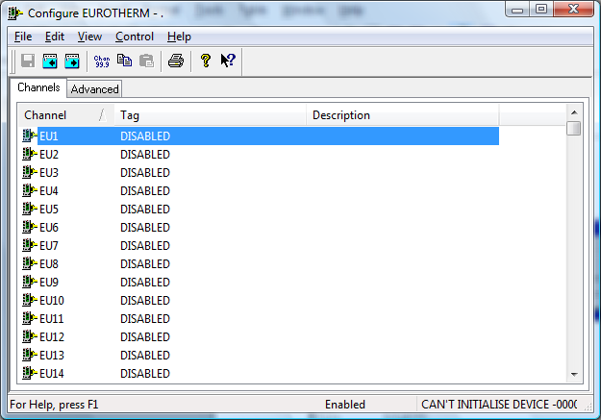

The first time the system is configured it is necessary to enable and configure all devices you
require. To configure a particular device select the Devices option from the main menu
followed by the appropriate device.
This will launch an application to configure the device. You will be presented with a set of tab
dialogs as shown above.
To configure channels, select the type required by clicking on the appropriate channel tab.
From the list provided select a channel and double-click. Alternatively you can select a channel
and then click on the Configure Channel button. This will launch a channel configuration
dialog which enables you to configure individual channels.

Channel Configuration (Analogs)

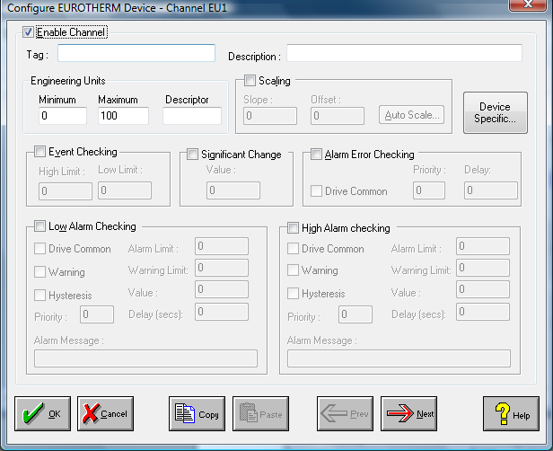

Enable Channel
The Enable Channel check box must be checked to enable, and allow this channel to be
configured and ultimately included with all other configured channels in the overall system.

Tag
The Tag field is a 12 character alphanumeric field that can contain channel information or
wiring schedule references.

Description
The Description field is a 32 character alphanumeric field in which a description of the channel
can be detailed.

Units
A 4 character field available to describe the units of the output.

Scaling
NB. Scaling is only available to Analog channels that are not Output channels.

Some transducers give a number of pulses, or a frequency output proportional to their full
scale range. To enable the Scaling utility check the Scaling Check box. The Slope and Offset
values can be entered directly into the text boxes. The formula applied is:

y = mx + c where: m is SLOPE
x is the measured value.
c is the OFFSET

Auto Scaling
Click On the Auto Scale button if you want the scale and offset values calculated
automatically. A dialog box will be displayed. Enter the values in the text boxes. The low
measured value, and the high measured value, the output range of the transducer. When the
fields have been completed, and assuming the System is enabled click on the Apply button.
Under the heading Current Values the actual measured value will be shown, as well as the
Engineering Value.

Click on OK to accept the scaling, or Cancel to abort the Auto Scaling feature.

NB. Scaling will not be applied to the channel, even if the system is enabled, until the system is
next enabled or the Device is reconfigured

Significant Change
To enable the Significant Change feature check the Sig Change check box. This facility
allows filtering of data on channels on which significant change is of interest. Such changes
can cause an event, which can be logged.
The figure entered in the Value text box, is the rate of change that if the output level exceeds
per scan, either increasing or decreasing will cause the significant change event trigger. The
scan rate is determined in the Advanced Device configuration
If a logger is configured each time the significant change trigger operates information on the
channels defined in the logger will be recorded . A significant change event only lasts one
scan, unless the next reading also changes greater than the Significant change value

When monitoring channels, if the Significant Change is triggered, then the fact will be
annotated alongside the other channel information in the Channel Monitor. The significant
change events are in addition to those caused by an Event.

Event Checking
Event checking is used, if required to trigger a logger to record information on a number of
channels during an event. Check the Event Checking check box if this channel is to trigger an
event.

High Limit
A value, in engineering units, entered in this text box will define the level that, if exceeded, will
cause an event trigger.

Low Limit
A value entered in this text box will define the level that if the channel result falls below will
cause an event trigger.

Alarm Checking
Alarm checking is available on all channels throughout the system. Low Alarm and High
Alarm levels can be configured independent of each other. If the channel output exceeds the
High Alarm limit then an alarm will be triggered as it will if the output goes below the Low
Alarm limit.

When monitoring channels, if the high or low alarm is triggered, then the fact will be annotated
alongside the other channel information in the Channel Monitor. To configure the Alarm
Checking section of the device complete the options as follows for either or both the High
Alarm and Low Alarm checking.

Enable Alarm Checking
Check either the Low Alarm Checking or High Alarm Checking or both check boxes to
enable the facility.

Drive Common Alarm
A common alarm is a single digital output which will switch on when any channel with the
Drive Common Alarm enabled goes into an alarm state. Check this box if a link to the
Common Alarm is required.

Alarm Limit
Specifies the value which will trigger this alarm. for Low Alarm Checking it will be any value
<= the Alarm Limit and for High Alarm Checking it will be any value >= the Alarm Limit.

Warning and Limit (Analogue channel only)
If required, a warning can be displayed when a channel reaches a limit close to the alarm limit.
For low alarm checking, the limit must be less than the alarm limit. For high alarm checking,
the warning limit must be less than the alarm limit

Hysteresis
Hysteresis can prevent 'noisy' channels from reporting multiple alarms when the average
reading is close to the alarm threshold. Check the box if this feature if needed. Enter the
value of the dead band in the corresponding value field.

Priority
Enter or edit the number in the text box to allocate the priority of this alarm. Alarm priority
ranges are from 0 to 255.

Alarm Delay
Enter the time, in seconds, between the channel value entering the alarm state and the system
flagging an alarm.

Alarm Message
An Alarm Message can be defined to be displayed on the Status line of the Main Window
when a channel goes into an alarm state. Enter the message, up to 32 characters, that is to
appear in the event of an alarm.

Alarm on Error Checking
Checking this section will enable the device to generate alarms when a channel goes into error.

Device Specific Button
When the Device Specific Button is pressed the following dialog is presented.

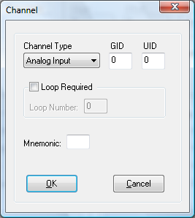

Channel Type
Identifies the type of channel, which can be one of the following:

Analog Input
Digital Input
Analog Output
Digital Output.

GID
Identifies the group identifier(GID). Valid Range 0-9.

UID
Identifies the unit identifier(UID). Valid Range 0-63.

Loop Required
Specifies that a loop is required.

Loop Number
Specifies the number of loops required. This is only available if the Loop Required Check Box
has been checked.

Mnemonic
Identifies the mnemonic in the Eurotherm instrument that contains the value of interest.

Channel Configuration (Digitals)

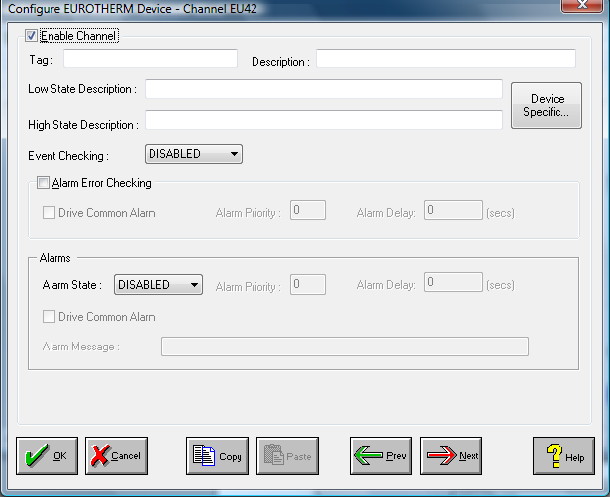

Enable Channel
The Enable Channel check box must be checked to enable, and allow this channel to be
configured and ultimately included with all other configured channels in the overall system.

Tag
The Tag field is a 12 character alphanumeric field that can contain channel information or
wiring schedule references.

Description
The Description field is a 32 character alphanumeric field in which a description of the channel
can be detailed.

LowState Description
A 32 character field in which to enter a description of the low state of the channel.

HighState Description
A 32 character field in which to enter a description of the high state of the channel.

Event Checking
Event checking is used, if required to trigger a logger to record information on an event. If
this facility is required click on the drop down list box and select OFF, HIGHSTATE, or
LOWSTATE as appropriate

Alarm Checking

AlarmState
Alarm checking is available on all channels throughout the system. To configure alarm
checking on this channel click on the drop down box and select OFF, HIGHSTATE, or
LOWSTATE as appropriate. If the channel's output state changes to an AlarmState an alarm
will be triggered on the channel. When monitoring channels, if the alarm is triggered, the fact
will be annotated alongside the other channel information in the Channel Monitor .

Alarm Priority
Enter the priority of the alarm triggered by this channel. Alarm priority ranges are from 0 to
255.

Common Alarm
Channels can be configured to trigger a Common Alarm. A common alarm is a single digital
output which will switch on when any channel with the Drive Common Alarm enabled goes
into an alarm state.

Alarm Delay
Enter the time, in seconds, between the channel value entering the alarm state and the system
flagging an alarm.

Alarm Message
An Alarm Message can be defined to be displayed on the Status line of the Main Window
when a channel goes into an alarm state.

Alarm on Error Checking
Checking this section will enable the device to generate alarms when a channel goes into error.

Device Specific Button
When the Device Specific Button is pressed in the case of the Eurotherm device the
following dialog is presented.

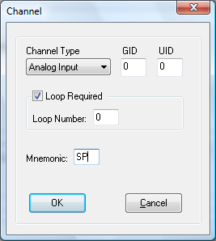

Channel Type
Identifies the type of channel, which can be one of the following:

Analog Input
Digital Input
Analog Output
Digital Output.

GID
Identifies the group identifier(GID). Valid Range 0-9.

UID
Identifies the unit identifier(UID). Valid Range 0-63.

Loop Required
Specifies that a loop is required.

Loop Number
Specifies the number of loops required. This is only available if the Loop Required Check Box
has been checked.

Mnemonic
Identifies the mnemonic in the Eurotherm instrument that contains the value of interest.

Advanced Device Configuration

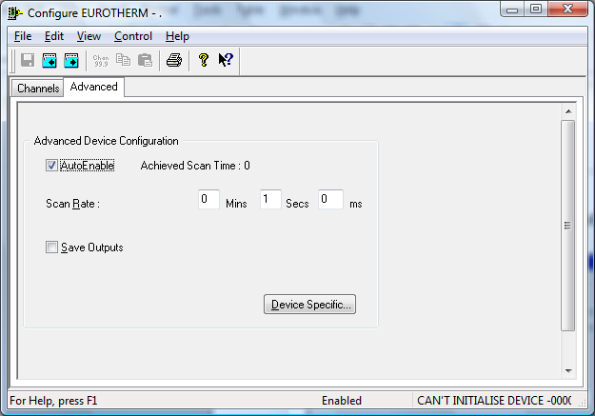

AutoEnable Device
To ensure that the device is enabled on the system check the Enable Device box.

Scan Rate
To set the rate at which the device will scan, edit the text boxes associated with the Scan Rate field.

Save Outputs
To enable this utility check the Save Outputs flag. All values in output channels are saved to
disk when the system is disabled. The next time the system is restarted the values which were
previously in output channels will be restored to the appropriate channel number.

By Tag
Channel values can be saved and restored to channels using the channel tag instead of the channel number. In this way, channels can be rearranged within the modules and as long as the channel tags remain the same, the correct channel values will be restored to the appropriate channel number.

Device Specific Button
If the Device Specific Button is visible, then click on it to configure features that are specific only to this device. In the case of the Eurotherm the following dialog will appear.

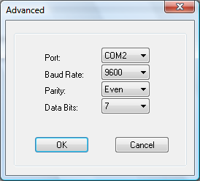

Port
Select the appropriate COMPort from the list provided.

Baud-rate
Select the appropriate Baud Rate from the list provided for the Eurotherm device attached to
the COMPort specified above. This is normally 9600 baud.

Parity
Select the appropriate Parity from the list provided for the Eurotherm device attached to the COMPort specified above. This is normally Even.

Data Bits
Select the appropriate Data Bits from the list provided for the Eurotherm device attached to the COMPort specified above. This is normally 7.

MONITORING THE SCANNER SOFTWARE

Once the channels have been configured and the device enabled, the next time the system is
enabled the system will communicate with the Eurotherm instruments. The channels used to
hold values read back from the Eurotherms can be monitored using the channel monitor or the
visual environment; see the system User Guide for details. Values from the Eurotherms can
also be logged and replayed via one of the standard replay options.

In normal operation, the scanner can retrieve about 8-10 values from a Eurotherm 800
network per second, and about 40 values per second from a Eurotherm 900 network
(communicating at 9600 baud). If several channels are configured to access the same
mnemonic from the same Eurotherm, for instance if several digital channels access different
bits from the same mnemonic, the system asks for the mnemonic only once, so the retrieval
rate per channel may be higher. Output channels are written to the Eurotherm only if they have
been changed, but when they are written, the retrieval rate will decrease.

If an error occurs retrieving a value from a Eurotherm, all channels dependent on that value
are set into error. If the current screen has an ERRORS field, a message is displayed in this
field. This message includes the number of the channel that caused the error.

If multiple errors occur during a scan, all the affected channels are put into error, however, the
displayed error message refers only to the first error that occurred.

If an error occurs while writing a value to a Eurotherm, attempts to write will be made on
subsequent scans, until the three successive failures have occurred. An error message is
displayed, this message taking precedence over messages reporting errors retrieving values
from Eurotherms. Until the write is successful or before three successive errors have occurred,
the value in the output channel is the value that is being written to the Eurotherm, not the
value currently in the Eurotherm. After this, the value is read back from the Eurotherm and
stored in the output channel. If, therefore, the attempt to write did not succeed, the value in
the channel will revert to what is was.

The following errors can be reported by the system:

Error Message | Explanation
No response | No response was received from the Eurotherm. A system error code is included in the message. Check that the Eurotherm is turned on, connected to the system and has the correct address, baud rate and parity etc
Bad response | A response was received, but it was not what was expected. A system error code, and a code indicating where in the response the error occurred are included in the message. If this error occurs frequently in a multidropped RS485 network, it may be necessary to fit terminating resistors to the communication network
Bad Parameter | A Eurotherm was asked about a parameter mnemonic that it did not recognise. Check that the configured mnemonic is correct
Etherm C/sum failure | The parameter failed the Eurotherm internal checksum (Eurotherm 820 only)
Response too long | The reply received from the Eurotherm was longer than expected by the system. This may be indicative of a noisy communication line
Analog reading digital | An analog channel has been configured to read a digital status word. This cannot be done
Digital reading analog | A digital channel has been configured to read an analog parameter. This cannot be done
Bad Digital Value | An unrecognised character appeared in a response containing a digital status word
Value out of range | An attempt was made to write to a Eurotherm a value greater than 99999 or less than -9999
NAK Setting Output | The Eurotherm rejected an attempt to write to it. This can occur for several reasons:  - the value of the parameter is out of range  - the parameter is not recognised by the Eurotherm  - the parameter cannot be written (for instance OP if in automatic control)
Bad Write | A system error occurred writing to the Eurotherms.

APPENDIX A

Refer to Eurotherm documentation for instructions on how to configure an instrument for
either RS485 or RS232 communications.

MULTIDROPPED RS485 CONNECTIONS

1. Connect the Eurotherm instruments by connecting all the RX+ terminals together;
similarly, connect together all the TX+ terminals, the RX+ terminals, the RX- terminals and
the COM (common) terminals. In noisy environments, it may be necessary to connect
terminating resistors across the receive circuits, see Eurotherm manuals for details. Note that
the converter comes supplied with a terminating resistor across its receive circuits.

2. Connect the Eurotherms to the RS232 - RS485 converter as follows:

Eurotherm Converter (RS485 side)

₋₋₋₋₋₋₋
RX+ --------------------------------------------- TX (pin 4)

RX- --------------------------------------------- TX (pin 3)
₋₋₋₋₋₋₋
TX+ --------------------------------------------- RX (pin 5)

TX- --------------------------------------------- RX (pin 6)

COM --------------------------------------------- GND (pin 2)

- Connect the RS232 - RS485 converter to a host computer with a 9 pin serial comms
port as follows:

Converter (RS232 side) Host Computer
25 Way D-Type 9 Way D-Type
Male Female

2 --------------------------------------------- 3
3 --------------------------------------------- 2
7 --------------------------------------------- 5

OR

- Connect the RS232 - RS485 converter to a host computer with a 25 pin serial comms
port as follows:

Converter (RS232 side) Host Computer
25 Way D-Type 25 Way D-Type
Male Male

2 --------------------------------------------- 2
3 --------------------------------------------- 3
7 --------------------------------------------- 7

POINT-TO-POINT RS232 CONNECTIONS

1. Connect the Eurotherm to a host computer with a 9 pin serial comms port as follows:

Eurotherm Host Computer
9 Way D-Type
Female
RX+ --------------------------------------------- 3
TX+ --------------------------------------------- 2
COM --------------------------------------------- 5
OR

- Connect the Eurotherm to the host computer with a 25 pin serial comms port as
follows:

Eurotherm Host Computer
25 Way D-Type
Male
RX+ --------------------------------------------- 2
TX+ --------------------------------------------- 3
COM --------------------------------------------- 7

