Partnership Courtyard, The Ramparts,
Dundalk, Ireland

Version 6.4.1.2
January 25, 2017
www.measuresoft.com
+353 42 933 2399

This document is the copyright of Measuresoft and may not be modified, copied or distributed in any form whatsoever without the prior permission of Measuresoft.

Envirocon User Manual

1. Configuration Error! Bookmark not defined.
2. Channel Configuration (Analogs) 2
2.1 Enable Channel 2
2.2 Tag 2
2.3 Description 2
2.4 Units 2
2.5 Scaling 2
2.5.1 Auto Scaling 2
2.6 Significant Change 2
2.7 Event Checking 2
2.7.1 High Limit 2
2.7.2 Low Limit 2
2.8 Alarm Checking 2
2.8.1 Enable Alarm Checking 2
2.8.2 Drive Common Alarm 2
2.8.3 Alarm Limit 2
2.8.4 Warning and Limit (Analogue channel only) 2
2.8.5 Hysteresis 2
2.8.6 Priority 2
2.8.7 Alarm Delay 2
2.8.8 Alarm Message 2
2.9 Device Specific Button 2
2.9.1 Analog Inputs 2
2.9.2 Analog Outputs 2
3. Channel Configuration (Digitals) 2
3.1 Enable Channel 2
3.2 Tag 2
3.3 Description 2
3.4 Low State Description 2
3.5 High State Description 2
3.6 Event Checking 2
3.7 Alarm Checking 2
3.7.1 Alarm State 2
3.7.2 Alarm Priority 2
3.7.3 Common Alarm 2
3.7.4 Alarm Delay 2
3.7.5 Alarm Message 2
3.8 Device Specific Button 2
4. Advanced Device Configuration 2
4.1 AutoEnable Device 2
4.2 Scan Rate 2
4.3 Save Outputs 2
4.4 Device Specific Button 2
4.4.1 Communication Port 2
4.4.2 Baud Rate 2
4.4.3 Data Bits 2
4.4.4 Stop Bits 2
4.4.5 Parity 2
4.4.6 Alarm Reset 2

Configuration

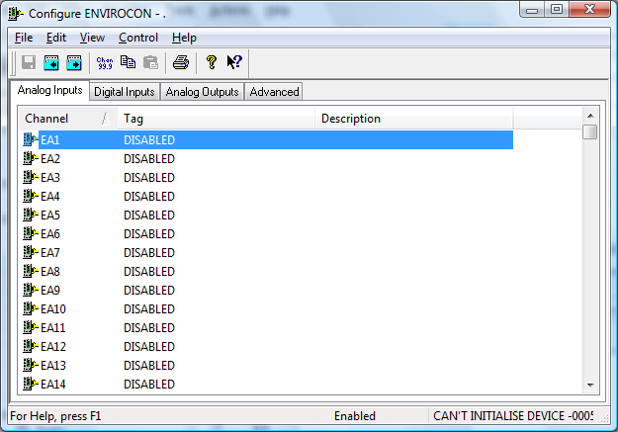

The first time the system is configured it is necessary to enable and configure all devices you require. To configure a particular device select the Devices option from the main menu followed by the appropriate device.
This will launch an application to configure the device. You will be presented with a set of tab dialogs as shown above.
To configure channels, select the type required by clicking on the appropriate channel tab. From the list provided select a channel and double-click. Alternatively you can select a channel and then click on the Configure Channel button. This will launch a channel configuration dialog which enables you to configure individual channels.

Channel Configuration (Analogs)

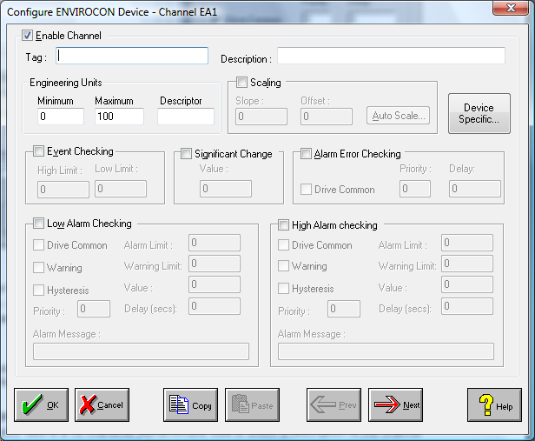

Enable Channel
The Enable Channel check box must be checked to enable, and allow this channel to be configured and ultimately included with all other configured channels in the overall system.

Tag
The Tag field is a 12 character alphanumeric field that can contain channel information or wiring schedule references.

Description
The Description field is a 32 character alphanumeric field in which a description of the channel can be detailed.

Units
A 4 character field available to describe the units of the output.

Scaling
NB. Scaling is only available to Analog channels that are not Output channels.

Some transducers give a number of pulses, or a frequency output proportional to their full scale range. To enable the Scaling utility check the Scaling Check box. The Slope and Offset values can be entered directly into the text boxes. The formula applied is:

y = mx + c where: m is SLOPE
x is the measured value.
c is the OFFSET

Auto Scaling
Click On the Auto Scale button if you want the scale and offset values calculated automatically. A dialog box will be displayed. Enter the values in the text boxes. The low measured value, and the high measured value, the output range of the transducer. When the fields have been completed, and assuming the System is enabled click on the Apply button. Under the heading Current Values the actual measured value will be shown, as well as the Engineering Value.

Click on OK to accept the scaling, or Cancel to abort the Auto Scaling feature.

NB. Scaling will not be applied to the channel, even if the system is enabled, until the system is next enabled or the Device is reconfigured

Significant Change
To enable the Significant Change feature check the Sig Change check box. This facility allows filtering of data on channels on which significant change is of interest. Such changes can cause an event, which can be logged.
The figure entered in the Value text box, is the rate of change that if the output level exceeds per scan, either increasing or decreasing will cause the significant change event trigger. The scan rate is determined in the Advanced Device configuration
If a logger is configured each time the significant change trigger operates information on the channels defined in the logger will be recorded . A significant change event only lasts one scan, unless the next reading also changes greater than the Significant change value

When monitoring channels, if the Significant Change is triggered, then the fact will be annotated alongside the other channel information in the Channel Monitor. The significant change events are in addition to those caused by an Event.

Event Checking
Event checking is used, if required to trigger a logger to record information on a number of channels during an event. Check the Event Checking check box if this channel is to trigger an event.

High Limit
A value, in engineering units, entered in this text box will define the level that, if exceeded, will cause an event trigger.

Low Limit
A value entered in this text box will define the level that if the channel result falls below will cause an event trigger.

Alarm Checking
Alarm checking is available on all channels throughout the system. Low Alarm and High Alarm levels can be configured independent of each other. If the channel output exceeds the High Alarm limit then an alarm will be triggered as it will if the output goes below the Low Alarm limit.

When monitoring channels, if the high or low alarm is triggered, then the fact will be annotated alongside the other channel information in the Channel Monitor. To configure the Alarm Checking section of the device complete the options as follows for either or both the High Alarm and Low Alarm checking.

Enable Alarm Checking
Check either the Low Alarm Checking or High Alarm Checking or both check boxes to enable the facility.

Drive Common Alarm
A common alarm is a single digital output which will switch on when any channel with the Drive Common Alarm enabled goes into an alarm state. Check this box if a link to the Common Alarm is required.

Alarm Limit
Specifies the value which will trigger this alarm. for Low Alarm Checking it will be any value <= the Alarm Limit and for High Alarm Checking it will be any value >= the Alarm Limit.

Warning and Limit (Analogue channel only)
If required, a warning can be displayed when a channel reaches a limit close to the alarm limit. For low alarm checking, the limit must be less than the alarm limit. For high alarm checking, the warning limit must be less than the alarm limit

Hysteresis
Hysteresis can prevent 'noisy' channels from reporting multiple alarms when the average reading is close to the alarm threshold. Check the box if this feature if needed. Enter the value of the dead band in the corresponding value field.

Priority
Enter or edit the number in the text box to allocate the priority of this alarm. Alarm priority ranges are from 0 to 255.

Alarm Delay
Enter the time, in seconds, between the channel value entering the alarm state and the system flagging an alarm.

Alarm Message
An Alarm Message can be defined to be displayed on the Status line of the Main Window when a channel goes into an alarm state. Enter the message, up to 32 characters, that is to appear in the event of an alarm.

Alarm on Error Checking
Checking this section will enable the device to generate alarms when a channel goes into error.

Device Specific Button

When the Device Specific Button is pressed the following dialog is presented.

Analog Inputs
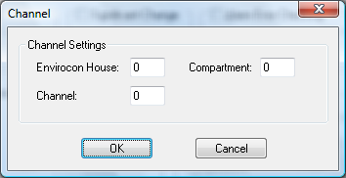

Envirocon House
This field specifies the envirocon house number. This option is only editable on the first of every 8 blocks of channels.

Compartment
This field specifies the envirocon compartment. This option is only editable on the first of every 8 blocks of channels.

Channel
This field specifies the number of the required channel on the envirocon device.

Analog Outputs

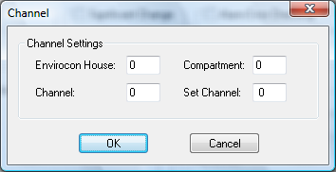

Envirocon House
This field specifies the envirocon house number. This option is only editable on the first of every 8 blocks of channels.

Compartment
This field specifies the envirocon compartment. This option is only editable on the first of every 8 blocks of channels.

Channel
This field specifies the number of the required channel on the envirocon device.

Set Cahnnel
This field specifies the channels that will be used to control the outputs. This option is only editable on the first of every 8 blocks of channels. If the channel specified is in a HIGH state then the corresponding 8 Channels a written out to the envirocon device.

Channel Configuration (Digitals)

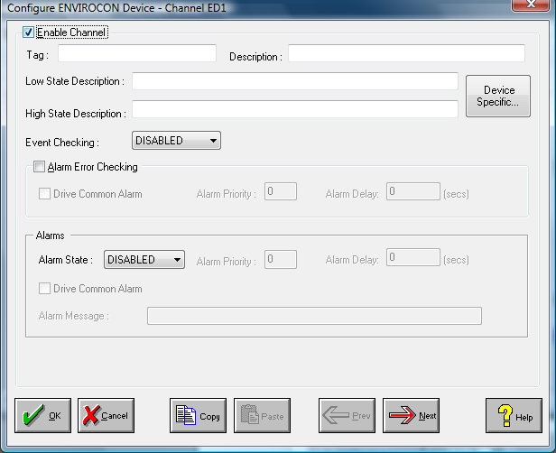

Enable Channel
The Enable Channel check box must be checked to enable, and allow this channel to be configured and ultimately included with all other configured channels in the overall system.

Tag
The Tag field is a 12 character alphanumeric field that can contain channel information or wiring schedule references.

Description
The Description field is a 32 character alphanumeric field in which a description of the channel can be detailed.

LowState Description
A 32 character field in which to enter a description of the low state of the channel.

HighState Description
A 32 character field in which to enter a description of the high state of the channel.

Event Checking
Event checking is used, if required to trigger a logger to record information on an event. If this facility is required click on the drop down list box and select OFF, HIGHSTATE, or LOWSTATE as appropriate

Alarm Checking

AlarmState
Alarm checking is available on all channels throughout the system. To configure alarm checking on this channel click on the drop down box and select OFF, HIGHSTATE, or LOWSTATE as appropriate. If the channel's output state changes to an AlarmState an alarm will be triggered on the channel. When monitoring channels, if the alarm is triggered, the fact will be annotated alongside the other channel information in the Channel Monitor .

Alarm Priority
Enter the priority of the alarm triggered by this channel. Alarm priority ranges are from 0 to 255.

Common Alarm
Channels can be configured to trigger a Common Alarm. A common alarm is a single digital output which will switch on when any channel with the Drive Common Alarm enabled goes into an alarm state.

Alarm Delay
Enter the time, in seconds, between the channel value entering the alarm state and the system flagging an alarm.

Alarm Message
An Alarm Message can be defined to be displayed on the Status line of the Main Window when a channel goes into an alarm state.

Alarm on Error Checking
Checking this section will enable the device to generate alarms when a channel goes into error.

Device Specific Button
When the Device Specific Button is pressed then in the case of the Envirocon device the following dialog is presented.

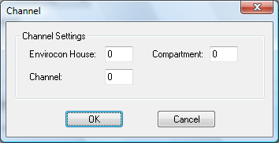

Envirocon House
This field specifies the envirocon house number. This option is only editable on the first of every 8 blocks of channels.

Compartment
This field specifies the envirocon compartment. This option is only editable on the first of every 8 blocks of channels.

Channel
This field specifies the number of the required channel on the envirocon device.

Advanced Device Configuration

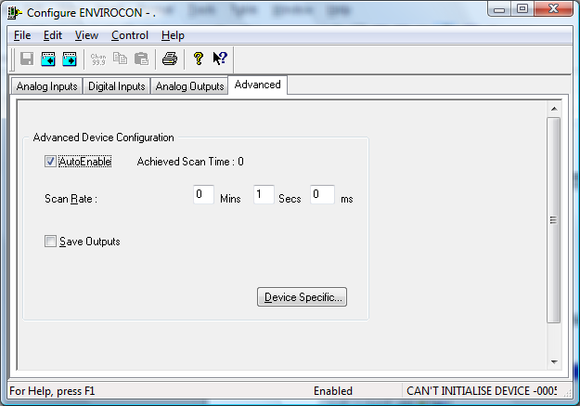

AutoEnable Device
To ensure that the device is enabled on the system check the Enable Device box.

Scan Rate
To set the rate at which the device will scan, edit the text boxes associated with the Scan Rate field.

Save Outputs
To enable this utility check the Save Outputs flag. All values in output channels are saved to disk when the system is disabled. The next time the system is restarted the values which were previously in output channels will be restored to the appropriate channel number.

By Tag
Channel values can be saved and restored to channels using the channel tag instead of the channel number. In this way, channels can be rearranged within the modules and as long as the channel tags remain the same, the correct channel values will be restored to the appropriate channel number.

Device Specific Button
If the Device Specific Button is visible, then click on it to configure features that are specific only to this device. In the case of the Envirocon the following dialog will appear.

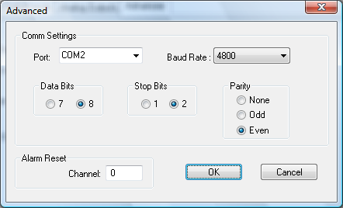

CommunicationPort
Select the required communication port from the list provided. The list will display all the communication ports available on the system.

Baud Rate
Select the baud rate for communications with the Envirocon Device.

Data Bits
Select the number of data bits being used with the Envirocon Device: 7 or 8

Stop Bits
Select the number of stop bits being used with the Envirocon Device : 1 or 2

Parity
Select the type of parity being used with the Envirocon Device : None
Odd
Even

Alarm Reset
This field specifies the Digital Channel that will be used to reset the alarms on the Envirocon Device. When this channel is set HIGH all alarms will be reset.

