

Partnership Courtyard, The Ramparts,

Dundalk, Ireland

Version 6.8.0.0

March 7, 2022

www.measuresoft.com

+353 42 933 2399

This document is the copyright of Measuresoft and may not be modified, copied or distributed in any form whatsoever without the prior permission of Measuresoft.

Eden Protocol User Manual

3.2.0.3

Table of Contents

1 Configuration 3

2 Advanced Device Configuration 4

2.1 AutoEnable Device 4

2.2 Scan Rate 4

2.3 Save Outputs 4

2.4 Device Specific Button 4

3 Configure Packets 5

3.1 Ports 5

3.2 Values 5

3.3 Type 5

3.4 Add Packet 5

3.5 Modify Packet 6

3.6 Delete Packet 6

4 Configure Packet 7

4.1 PDU Header 7

4.2 Add Parameter 8

4.3 Modify Parameter 8

4.4 Delete Packet 8

5 Enter Channel Range 9

5.1 Prefix 9

5.2 From 9

5.3 To 9

# Configuration

The first time the system is configured it is necessary to enable and configure all devices you require. To configure a particular device select the ***Devices*** option from the main menu followed by the Eden Protocol Server device. This will launch an application to configure the device.

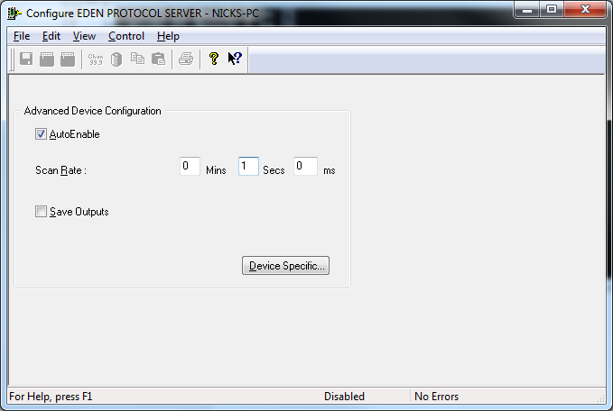

# Advanced Device Configuration



## AutoEnable Device

To ensure that the device is enabled on the system check the Enable Device box.

## Scan Rate

To set the rate at which the device will transmit packets to client connections, edit the text boxes associated with the Scan Rate field.

## Save Outputs

To enable this utility check the Save Outputs flag. The Eden Protocol server does not use this option.

## Device Specific Button

When the Device Specific Button is pressed the following dialog appears to allow packets to be configured.

# Configure Packets

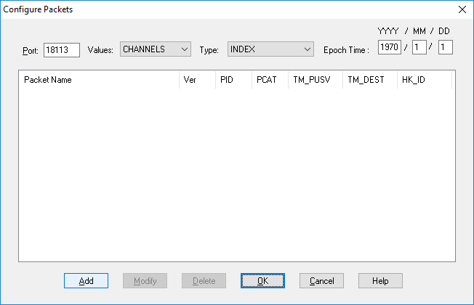

## Port

Sets the TCP/IP port for incoming connections. Defaults to 18113.

## Values

Sets the types of values output in packets to be SIMULATED values or CHANNEL value. If running on a demo free license system, only SIMULATED values are output.

## Type

Sets the types of simulated values output in packets to be

INDEX - The parameter index base 0 of the value being output.

RAMP - A value which ramps from min to max and then down again

RANDOM - Random value

SINE - Producers a sine from min to max

SQUARE - Alternates between min and max value

MID VALUE - Outputs a constant mid value between min and max

On a demo free license system where no source device channels are present min and max are 0 and 100 respectively.

## EPOCH Time

Sets the base time for transmitting TM_TIME field in packets.

## Add Packet

This option prompts for a packet name and display the Configure Packet dialog

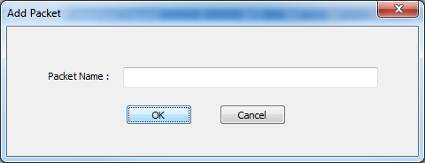

## Modify Packet

Double clicking on a packet listed or selecting the Modify Packet option displays the Configure Packet dialog.

## Delete Packet

This option deletes the currently selected packet.

# Configure Packet

When the user selects a packet be configured the following is displayed.

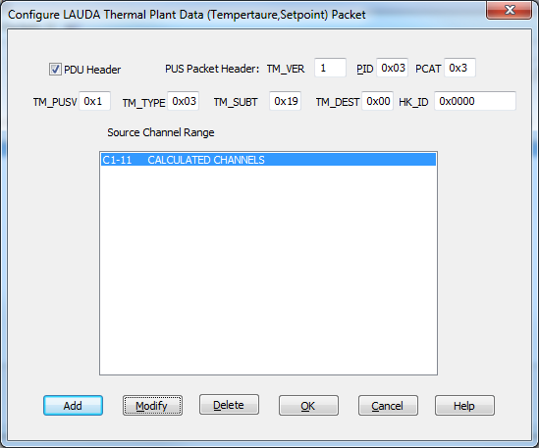

## PDU Header

The check box must be checked to include a PDU Header and PDU Secondary Header in the packets to be transmitted.



A PUS packet will always be transmitted.The PUS packet structure is as follows and some of the fields in the packets can be configured.

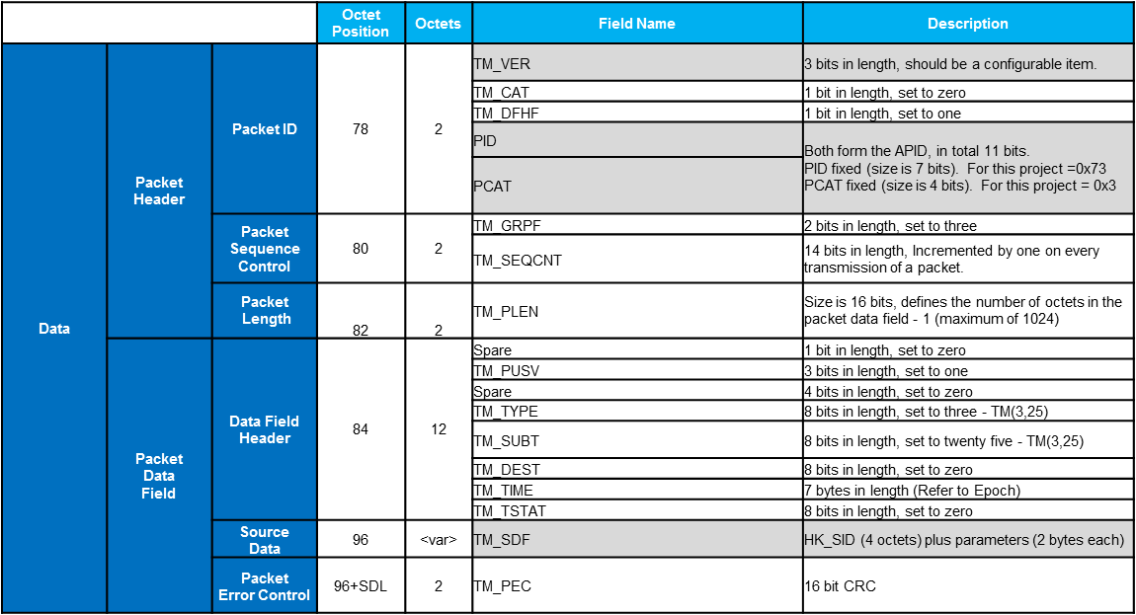

**NOTE: If HK_SID is specified to be in the range 0x00 to 0xFF, then the TM_SDF/HK_SID field is transmitted as a single byte/octet and not as 4 octets specified above.**

## Add Parameter

This displays the Enter Channel Range dialog

## Modify Parameter

Double clicking on a parameter source channel listed or selecting the Modify Parameter option displays the Enter Channel Range dialog.

## Delete Packet

This option deletes the currently selected parameter source channel listed.

# Enter Channel Range

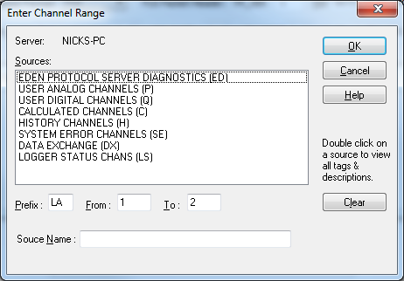

## Prefix

The 2 character prefix that identifies the channel range.

## From

The starting channel.

## To

The end channel

Double clicking any of the sources displays the following dialog which allows a channel range to be selected.

