Partnership Courtyard, The Ramparts,
Dundalk, Ireland

Version 6.8.0.0
March 7, 2022
www.measuresoft.com
+353 42 933 2399

This document is the copyright of Measuresoft and may not be modified, copied or distributed in any form whatsoever without the prior permission of Measuresoft.

Digiplan User Manual

Table of Contents

1 Configuration 3
2 Advanced Device Configuration 4
2.1 AutoEnable Device 4
2.2 Scan Rate 4
2.3 Save Outputs 4
2.3.1 By Tag 5
2.4 Device Specific Button 5
2.4.1.1 Port 5
2.4.1.2 Baud Rate 5
2.4.1.3 Parity 5
2.4.1.4 Data Bits 5
2.4.1.5 Num Axes 5
2.4.1.6 Talk 6
3 Analog Input Channel Configuration 7
3.1 Enable Channel 7
3.2 Tag 7
3.3 Description 7
3.4 Engineering Units 7
3.4.1 Minimum 8
3.4.2 Maximum 8
3.4.3 Descriptor 8

Configuration

The first time the system is configured it is necessary to enable and configure all devices you require. To configure a particular device select the Devices option from the main menu followed by the Digiplan device. This will launch an application to configure the device.

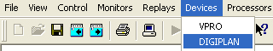

From the list provided select a channel and double-click. Alternatively you can select a channel and then click on the Configure Channel button.

This will launch a channel configuration dialog which enables you to configure individual channels.

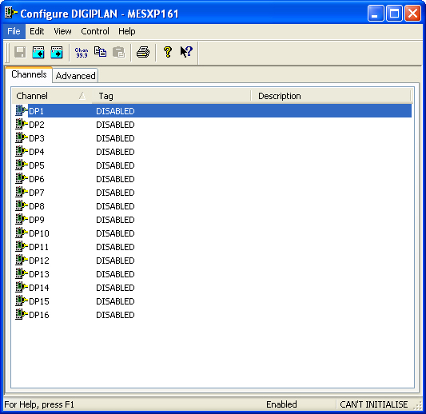

Advanced Device Configuration

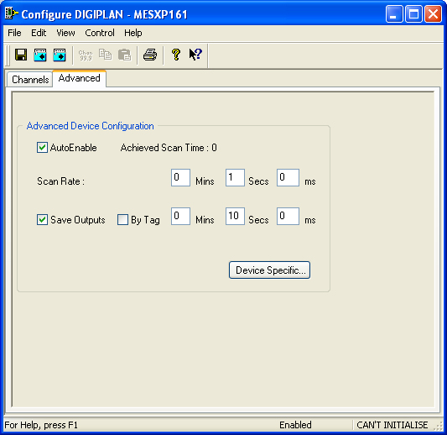

AutoEnable Device
To ensure that the device is enabled on the system check the Enable Device box.

Scan Rate
To set the rate at which the device will scan, edit the text boxes associated with the Scan Rate field.

Save Outputs
To enable this utility check the Save Outputs flag. All values in output channels are saved to disk when the system is disabled. The next time the system is restarted the values which were previously in output channels will be restored to the appropriate channel number.

By Tag
Channel values can be saved and restored to channels using the channel tag instead of the channel number. In this way, channels can be rearranged within the modules and as long as the channel tags remain the same, the correct channel values will be restored to the appropriate channel number.

Device Specific Button
When the Device Specific Button is pressed the following dialog appears to allow specific communication settings to be configured for the device.

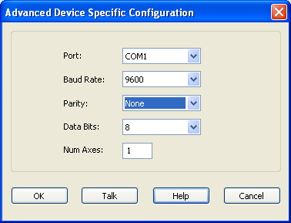

Port
Displays communications ports available on your computer

Baud Rate
Lists the baud rates that are supported by the hardware on your PC. Choose the highest speed that is supported by the hardware. If you encounter problems, you may have to adjust this to a slower speed at a later time.

Parity
Displays the various choices that can be implemented for parity checking.

Data Bits
Displays the various sizes of data bits to send.

Num Axes
Defines the number of axes on the Digiplan controller. The software assumes that there is only one axis, but the ScadaPro interface has been written to support up to four axes.

Talk
When the Talk button is clicked the following dialog is displayed.
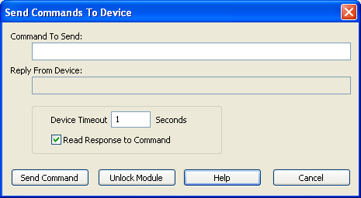

Enter the command to send to the device in the upper box, and click the Send Command button. If the Read Response to Command is checked, the dialog waits for a response from the device, up to the specified timeout. If the Read Response to Command is not checked, the dialog waits until the command has been sent to the device.

While a command is being sent to the device, a lock is set to that other commands from other client workstations cannot be sent to the device until the first command has been processed. The Unlock Module button is provided in the event that network problems mean that a workstation is unable to release the lock - it forces the current lock to be released.

Analog Input Channel Configuration

Autoscanning is used to scan analog inputs.

When the user selects an analog input to be configured the following is displayed.

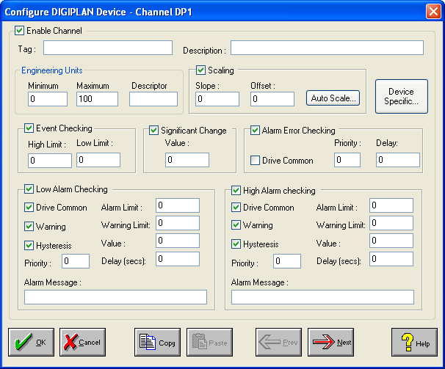

Enable Channel
The Enable Channel check box must be checked to enable and allow a channel to be configured and ultimately included with all other configured channels in the overall system.

Tag
The Tag field is a 12 character alphanumeric field that can contain channel information or wiring schedule references.

Description
The Description field is a 32 character alphanumeric field in which a description of the channel can be detailed.

Engineering Units
Specifies engineering details for this channel.

Minimum
Minimum engineering value for all Analog channels in addition to the unit field. The default is 0.

Maximum
Maximum engineering value for all Analog channels in addition to the unit field. The default is 100.

Descriptor
Describe the units of the measurement.

Channel Device Specific Configuration

When the Channel Device Specific Button is pressed the following dialog appears to allow specific communication settings to be configured for the device.

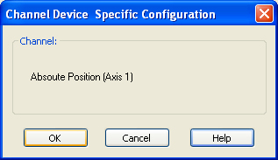

This dialog displays what axes is on the Digiplan controller.

