

Partnership Courtyard, The Ramparts,

Dundalk, Ireland

Version 6.8.0.0

March 7, 2022

www.measuresoft.com

+353 42 933 2399

This document is the copyright of Measuresoft and may not be modified, copied or distributed in any form whatsoever without the prior permission of Measuresoft.

Solo Driver User Manual

Table of Contents

Configuring a Solo/ICP DCON Device 4

Advance Configuration 5

Scan Rate 5

Save Outputs 5

Listener Mode 6

Comm Port Settings 7

Configuring a Module 8

Module Type 8

Address 8

Acquisition Rate 8

Configure Channel 9

OK 9

Cancel 9

Help 9

Set Module Address 10

Configure Analog Input Modules 11

Enable Channel 11

Listener Mode 11

Tag 11

Description 12

Reference 12

Engineering Units 12

Scaling 12

Auto Scale 12

Significant Change 12

Event Checking 13

Low and High Alarm Checking 13

Alarm Error Checking 14

Use Module Alarm Scheme 14

Configure Analog Output Modules 15

Enable Channel 15

Listener Mode 15

Tag 15

Description 15

Reference 16

Engineering Units 16

Significant Change 16

Event Checking 16

Low and High Alarm Checking 16

Alarm Error Checking 17

Use Module Scheme 17

Configure Counter Input Modules 18

Enable Channel 18

Listener Mode 18

Tag 18

Description 18

Engineering Units 19

Scaling 19

Auto Scale 19

Significant Change 19

Event Checking 19

Low and High Alarm Checking 19

Alarm Error Checking 20

Configure Digital Input Channels. 21

Enable Channel 21

Listener Mode 21

Tag 21

Description 21

Low State Description 22

High State Description 22

Event Checking 22

Alarm Error Checking 22

Alarms 22

Configure Digital Output Channels. 23

Enable Channel 23

Listener Mode 23

Tag 23

Description 23

Low State Description 24

High State Description 24

Event Checking 24

Alarm Error Checking 24

Alarms 24

Interrogate Modules 25

Error Codes 27

Error Codes 27

Comms Error Codes 27

System Error Codes 28

Debug Facility 29

Switching Debugging On 29

Selecting the Debug Type 29

# Configuring a Solo/ICP DCON Device

The first time the system is configured it is necessary to enable and configure the way you wish the overall Solo Device to operate. To configure the Solo System either select Devices from the menu bar on the Main Window and then **Solo/ICP DCON** or double click the Solo/ICP DCON Icon in the Application Program Group.

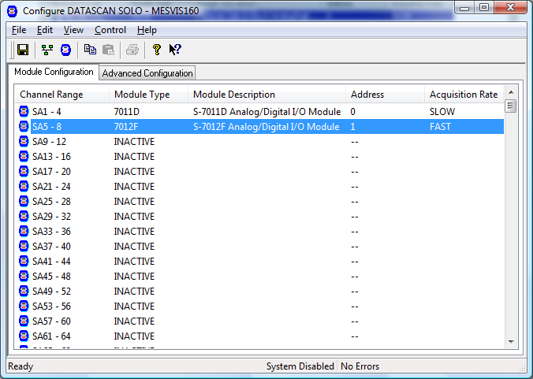

To configure the operation of the whole Device choose the ***Advanced Configuration******Tab***.

To configure a Solo Module point to the appropriate module in the ***Module Configuration Tab*** and double click.

# Advance Configuration

The Advanced Configuration window appears as follows.

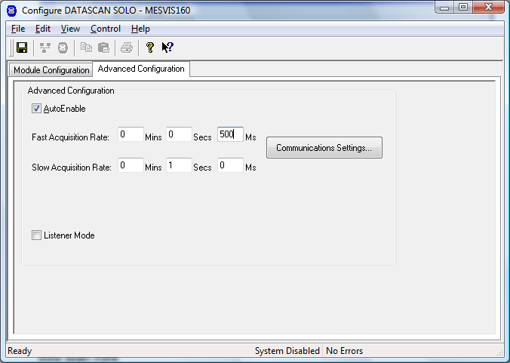

To ensure that the Solo Service is included in the system check the **Auto-Enable Device** box.

## Scan Rate

The device can work in a dual ring mode. This allows a small number of channels to be sampled on the *FAST RING* more frequently than those on the *SLOW RING*. All channels on one Module are sampled at the same rate.

To set the rates, edit the text boxes associated with the Slow Ring A and the Fast Ring B. The values entered should take into account the number of channels on the Network. The times selected should be greater than the time taken for the device to sample all the configured channels. If a faster time or 0 (Zero) is entered then the device will scan as fast as possible. The Fast Ring must be a rate which is a multiple faster than that of Slow Ring.

## Save Outputs

To enable this utility check the Save Outputs flag. All values in output channels are saved to disk when the system is disabled. The next time the system is restarted the values which were previously in output channels will be restored to the appropriate channel number.

**By Tag**

Channel values can be saved and restored to channels using the channel tag instead of the channel number. In this way, channels can be rearranged within the modules and as long as the channel tags remain the same, the correct channel values will be restored to the appropriate channel number.

## Listener Mode

The Device can be configured so that all Channels are in Listener Mode. To enable this check the Listener Mode Checkbox

### Comm Port Settings

This dialog is used to configure the communications link between the Solo/ICP DCON Network and the computer. From the resulting Com Port dialog box complete as follows:

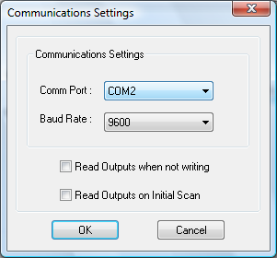

**Comm Port**

From the drop down list select the serial port to be used.

**Baud Rate**

Select appropriate baud rate for the link.

**Read Outputs when not writing**

Allows analog outputs to be read if they have not changed in the last scan

**Read Outputs on initial scan**

Reads outputs on the first scan

**OK**

Click on the OK button to accept the changes

**Cancel**

Selecting Cancel will abort any changes, reverting back to previous configuration of the port

# Configuring a Module

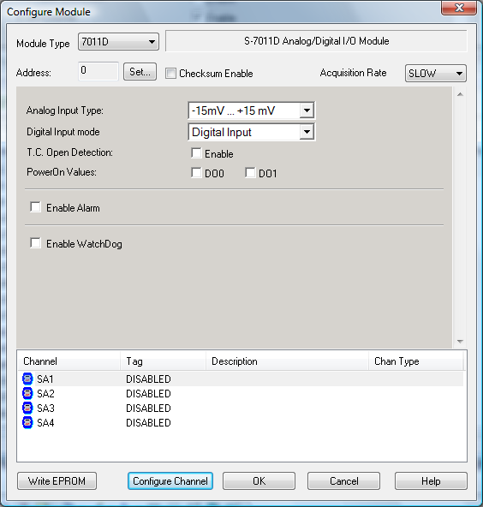

## Module Type

From the Module Type drop down list select the Module type to be configured. The module type number is prominent on the front of each Unit.

## Address

This specifies the address for this module. This can be set at configuration time using the ***Set*** button.

## Acquisition Rate

From the drop down list select the Acquisition Rate that this unit is to operate on.

**Module Specific configuration template**

Some module specific information can be set in HTML template within dialog Box. The shown S-7011D template allow to set up Analog Input Type, Thermocouple Open detection, Event and LED channel settings, Watch Dog and alarm settings. Refer to the module documentation for details about module specific settings. Changes in module specific configuration may change the sate of the module channels in list below. For example, enabling LED Output channel for 7017D will make accessible an additional LED Output channel in the module channel list.

## Configure Channel

This button takes you to the Channel Configuration Dialog for the selected channel.

## OK

When advanced device configuration is complete click on this button to accept and move back to previous Window.

## Cancel

Nullify any changes made to both the module and channels configurations during this configuration session. The system will retain the previous configuration.

## Help

Online Help for Configuring Module.

### Set Module Address

This dialog allows the user to set the module address given its Product Code and Serial Number.

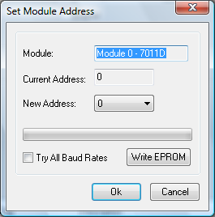

**Module**

The field will display the module ID and module name. The user cannot edit this field.

**Current Address**

The current address of the module.

**New Address**

The user must enter the New Address that the module will be set to. Any other module in the network should not use the New Module address.

**Write EPROM**

The **Write EPROM** button gives the user the ability to change the module address in the module EPROM. The module selected by **Current Address** and changed to the **New Address**.

If module new module address already set in module EPROM you may skip this step – just click **Ok** button to update module address in Ne Configuration file.

**Try All Baud Rates**

Try all possible baud rates while searching for the module for **Writing EPROM**. The new baud rate will be set according to the **Advanced Tab** settings.

**Ok**

Exits this dialog and saves options.

**Cancel**

Exits this dialog without saving options.

# Configure Analog Input Modules

## 

## Enable Channel

The Enable Channel check box must be checked to enable, and allow this channel to be configured and ultimately included with all other configured channels in the overall System

## Listener Mode

To make this channel operate in listener mode select this option.

## Tag

The tag is an 15 character solo numeric field that can contain channel information or wiring schedule references.

## Description

The Description field is a 32 character solo numeric field in which a description of the channel can be detailed.

## Reference

When the **Reference** check box is checked then this channel has been defined as a *Reference Channel*. Values of a Reference channel are displayed as the measured value - zero (reference) value. When the System is enabled the zero value can be initialized using one of the following methods:

i) From the Solo Device Main Window choose **Initialize** from the **Control** Menu.

ii) From the Main Window choose **Initialise** from the **Control** menu.

iii) Press the keys **CTRL** + **I** together.

## Engineering Units

**Minimum**

Minimum engineering value for all analog channels in addition to the unit field. The default is 0

**Maximum**

Maximum engineering value for all analog channels in addition to the unit field. The default is 100

**Descriptor**

An 8 character field available to describe the units of the measurement

## Scaling

To enable the utility check the Scaling Check box. The **Slope**  and **Offset**  values can be entered directly into the text boxes. The formula applied is:

y = mx + c where: m is SLOPE

x is the measured value.

c is the OFFSET

## Auto Scale

Click On the Auto Scale button if you want the scale and offset values calculated automatically. In the dialog box enter the values in the text boxes. The low measured value, and the high measured value, the output range of the transducer.

|  |
| --- |
| **NB.**  **Scaling will not be applied to the channel, even if the system is enabled, until the system is next enabled or the Solo Device is reconfigured.** |

## Significant Change

To enable the Significant Change feature check the **Sig Change** check box. This facility allows filtering of data on channels on which significant change is of interest. Such changes can cause an event, which can be logged.

The figure entered in the **Value** text box, in engineering units is the rate of change that if the measured channel exceeds per scan, either increasing or decreasing will cause the significant change event trigger. The scan rate is determined in the Advanced Configuration Tab.

If a logger is configured in Event mode, or Period-Event, each time the significant change trigger operates information on the channels defined in the logger will be recorded . A significant change event only lasts one scan, unless the next reading also changes greater than the Significant change value

When monitoring channels, if the Significant Change is triggered, then the fact will be annotated alongside the other channel information in the Monitor Window.

The significant change events are in addition to those caused by an *Event*.

## Event Checking

Event checking is used, if required to trigger a logger to record information on a number of channels during an event. Check the **Event Checking** check box if this facility is needed.

**High Limit**

A value, in engineering units, entered in this text box will define the level that, if

exceeded, will cause an event trigger.

**Low Limit**

A value entered in this text box will define the level that if the channel result falls below

will cause an event trigger.

## Low and High Alarm Checking

Alarm checking is available on all channels throughout the system. **Low Alarm** and **High Alarm** levels can be configured independent of each other. All the values entered are in engineering units. If a channel reading exceeds the High Alarm limit then an alarm will be triggered as it will if the channel goes below the Low Alarm limit.

When monitoring channels, if the high or low alarm is triggered, then the fact will be annotated alongside the other channel information in the Monitor Window.

**Enable Alarm Checking**

Check either the **Low Alarm Checking** or **High Alarm Checking** or both check boxes to enable the facility.

**Drive Common Alarm**

A common alarm is a single digital output which will switch on when any channel with the Drive Common Alarm enabled goes into an alarm state.

Check this box if a link to the Common Alarm is required.

**Alarm Limit**

The value at which the channel will flag an alarm

**Warning and Limit (Analog channel only)**

If required, a warning can be displayed when a channel reaches a limit close to the alarm limit. For low alarm checking, the limit must be less than the alarm limit. For high alarm checking, the warning limit must be less than the alarm limit

**Hysteresis**

Check the box if this feature if needed. Enter the value of the dead band in the text box.

Hysteresis can prevent 'noisy' channels from reporting multiple alarms when the average reading is close to the alarm or warning threshold. **The Hysteresis value is relative to the warning or alarm limit.**

**Priority**

Enter or edit the number in the text box to allocate the priority of this alarm.

**Alarm Delay**

Enter the time, in seconds, between the channel value entering the alarm state and the system flagging an alarm.

**Alarm Message**

An Alarm Message can be defined to be displayed on the Status line of the application Main Window when a channel goes into an alarm state.

Enter the message, up to 32 characters.

## Alarm Error Checking

**Drive Common**

A common alarm is a single digital output which will switch on when any channel with the **Drive Common Alarm** enabled goes into an alarm state.

Check this box if a link to the Common Alarm is required.

**Priority**

Enter or edit the number in the text box to allocate the priority of this channels alarm.

**Delay**

Enter the time, in seconds, between the channel value entering the alarm state and the system

flagging an alarm.

## Use Module Alarm Scheme

If this option is present it allows the Alarm Limits to be downloaded to the Module. These limits will be used to drive the Alarm Channel.

# Configure Analog Output Modules

## 

## Enable Channel

The Enable Channel check box must be checked to enable, and allow this channel to be configured and ultimately included with all other configured channels in the overall System

## Listener Mode

To make this channel operate in listener mode select this option.

## Tag

The tag is an 15 character solo numeric field that can contain channel information or wiring schedule references.

## Description

The Description field is a 32 character solo numeric field in which a description of the channel can be detailed.

## Reference

When the **Reference** check box is checked then this channel has been defined as a *Reference Channel*. Values of a Reference channel are displayed as the measured value - zero (reference) value. When the System is enabled the zero value can be initialized using one of the following methods:

i) From the Solo Device Main Window choose **Initialize** from the **Control** menu.

ii) From the Main Window choose **Initialise** from the **Control** menu.

iii) Press the keys **CTRL** + **I** together.

## Engineering Units

**Minimum**

Minimum engineering value for all analog channels in addition to the unit field. The default is 0

**Maximum**

Maximum engineering value for all analog channels in addition to the unit field. The default is

100

**Descriptor**

An 8 character field available to describe the units of the measurement

## Significant Change

To enable the Significant Change feature check the **Sig Change**  check box. This facility allows filtering of data on channels on which significant change is of interest. Such changes can cause an event, which can be logged.

The figure entered in the **Value** text box, in engineering units is the rate of change that if the measured channel exceeds per scan, either increasing or decreasing will cause the significant change event trigger. The scan rate is determined in the Advanced Configuration Tab.

If a logger is configured in Event mode, or Period-Event, each time the significant change trigger operates information on the channels defined in the logger will be recorded. A significant change event only lasts one scan, unless the next reading also changes greater than the Significant change value

When monitoring channels, if the Significant Change is triggered, then the fact will be annotated alongside the other channel information in the Monitor Window.

The significant change events are in addition to those caused by an *Event*.

## Event Checking

Event checking is used, if required to trigger a logger to record information on a number of channels during an event. Check the **Event Checking**  check box if this facility is needed.

**High Limit**

A value, in engineering units, entered in this text box will define the level that, if exceeded, will cause an event trigger.

**Low Limit**

A value entered in this text box will define the level that if the channel result falls below will cause an event trigger.

## Low and High Alarm Checking

Alarm checking is available on all channels throughout the system. **Low Alarm** and  **High Alarm** levels can be configured independent of each other. All the values entered are in engineering units. If a channel reading exceeds the High Alarm limit then an alarm will be triggered as it will if the channel goes below the Low Alarm limit.

When monitoring channels, if the high or low alarm is triggered, then the fact will be annotated alongside the other channel information in the Monitor Window.

**Enable Alarm Checking**

Check either the **Low Alarm Checking** or **High Alarm Checking** or both check boxes to enable the facility.

**Drive Common Alarm**

A common alarm is a single digital output which will switch on when any channel with the Drive Common Alarm enabled goes into an alarm state.

Check this box if a link to the Common Alarm is required.

**Alarm Limit**

The value at which the channel will flag an alarm

**Warning and Limit (Analog channel only)**

If required, a warning can be displayed when a channel reaches a limit close to the alarm limit. For low alarm checking, the limit must be less than the alarm limit. For high alarm checking, the warning limit must be less than the alarm limit

**Hysteresis**

Check the box if this feature is needed. Enter the value of the dead band in the text box.

Hysteresis can prevent 'noisy' channels from reporting multiple alarms when the average reading is close to the alarm or warning threshold. **The Hysteresis value is relative to the warning or alarm limit.**

**Priority**

Enter or edit the number in the text box to allocate the priority of this alarm.

**Alarm Delay**

Enter the time, in seconds, between the channel value entering the alarm state and the system flagging an alarm.

**Alarm Message**

An Alarm Message can be defined to be displayed on the Status line of the application Main Window when a channel goes into an alarm state.

Enter the message, up to 32 characters.

## Alarm Error Checking

**Drive Common**

A common alarm is a single digital output which will switch on when any channel with the **Drive Common Alarm** enabled goes into an alarm state.

Check this box if a link to the Common Alarm is required.

**Priority**

Enter or edit the number in the text box to allocate the priority of this channels alarm.

**Delay**

Enter the time, in seconds, between the channel value entering the alarm state and the system flagging an alarm.

## Use Module Scheme

If this option is present it allows the Alarm Limits to be downloaded to the Module. These limits will be used to drive the Alarm Channel.

# Configure Counter Input Modules

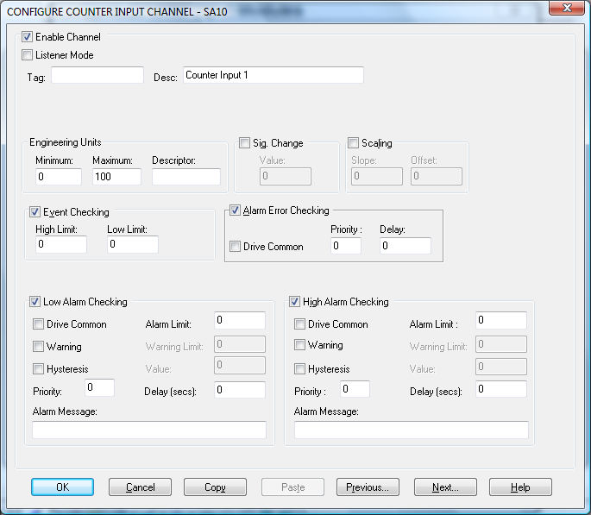

## Enable Channel

The Enable Channel check box must be checked to enable, and allow this channel to be configured and ultimately included with all other configured channels in the overall System

## Listener Mode

To make this channel operate in listener mode select this option.

## Tag

The tag is a 15 character solo numeric field that can contain channel information or wiring schedule references.

## Description

The Description field is a 32 character solo numeric field in which a description of the channel can be detailed.

## Engineering Units

**Minimum**

Minimum engineering value for all analog channels in addition to the unit field. The default is 0

**Maximum**

Maximum engineering value for all analog channels in addition to the unit field. The default is

100

**Descriptor**

An 8 character field available to describe the units of the measurement

## Scaling

To enable the utility check the Scaling Check box. The **Slope**  and **Offset**  values can be entered directly into the text boxes. The formula applied is:

y = mx + c where: m is SLOPE

x is the measured value.

c is the OFFSET

## Auto Scale

Click On the Auto Scale button if you want the scale and offset values calculated automatically. In the dialog box enter the values in the text boxes. The low measured value, and the high measured value, the output range of the transducer.

|  |
| --- |
| **NB.**  **Scaling will not be applied to the channel, even if the system is enabled, until the system is next enabled or the Solo Device is reconfigured.** |

## Significant Change

To enable the Significant Change feature check the **Sig Change**  check box. This facility allows filtering of data on channels on which significant change is of interest. Such changes can cause an event, which can be logged.

The figure entered in the **Value** text box, in engineering units is the rate of change that if the measured channel exceeds per scan, either increasing or decreasing will cause the significant change event trigger. The scan rate is determined in the Advanced Configuration Tab.

If a logger is configured in Event mode, or Period-Event, each time the significant change trigger operates information on the channels defined in the logger will be recorded . A significant change event only lasts one scan, unless the next reading also changes greater than the Significant change value

When monitoring channels, if the Significant Change is triggered, then the fact will be annotated alongside the other channel information in the Monitor Window.

The significant change events are in addition to those caused by an *Event*.

## Event Checking

Event checking is used, if required to trigger a logger to record information on a number of channels during an event. Check the **Event Checking** check box if this facility is needed.

**High Limit**

A value, in engineering units, entered in this text box will define the level that, if exceeded, will cause an event trigger.

**Low Limit**

A value entered in this text box will define the level that if the channel result falls below will cause an event trigger.

## Low and High Alarm Checking

Alarm checking is available on all channels throughout the system. **Low Alarm** and  **High Alarm** levels can be configured independent of each other. All the values entered are in engineering units. If a channel reading exceeds the High Alarm limit then an alarm will be triggered as it will if the channel goes below the Low Alarm limit.

When monitoring channels, if the high or low alarm is triggered, then the fact will be annotated alongside the other channel information in the Monitor Window.

**Enable Alarm Checking**

Check either the **Low Alarm Checking** or **High Alarm Checking** or both check boxes to enable the facility.

**Drive Common Alarm**

A common alarm is a single digital output which will switch on when any channel with the Drive Common Alarm enabled goes into an alarm state.

Check this box if a link to the Common Alarm is required.

**Alarm Limit**

The value at which the channel will flag an alarm

**Warning and Limit (Analog channel only)**

If required, a warning can be displayed when a channel reaches a limit close to the alarm limit. For low alarm checking, the limit must be less than the alarm limit. For high alarm checking, the warning limit must be less than the alarm limit

**Hysteresis**

Check the box if this feature if needed. Enter the value of the dead band in the text box.

Hysteresis can prevent 'noisy' channels from reporting multiple alarms when the average reading is close to the alarm or warning threshold. **The Hysteresis value is relative to the warning or alarm limit.**

**Priority**

Enter or edit the number in the text box to allocate the priority of this alarm.

**Alarm Delay**

Enter the time, in seconds, between the channel value entering the alarm state and the system flagging an alarm.

**Alarm Message**

An Alarm Message can be defined to be displayed on the Status line of the application Main Window when a channel goes into an alarm state.

Enter the message, up to 32 characters.

## Alarm Error Checking

**Drive Common**

A common alarm is a single digital output which will switch on when any channel with the **Drive**

**Common Alarm** enabled goes into an alarm state.

Check this box if a link to the Common Alarm is required.

**Priority**

Enter or edit the number in the text box to allocate the priority of this channels alarm.

**Delay**

Enter the time, in seconds, between the channel value entering the alarm state and the

system flagging an alarm.

# Configure Digital Input Channels.

## 

## Enable Channel

The Enable Channel check box must be checked to enable, and allow this channel to be configured and ultimately included with all other configured channels in the System.

## Listener Mode

To make this channel operate in listener mode select this option.

## Tag

The Tag field is an 12 character solo numeric field that can contain channel information or wiring schedule references.

## Description

The Description field is a 16 character solo numeric field in which a description of the channel can be detailed.

## Low State Description

A 32 character field in which to enter a description of the low state of the channel.

## High State Description

A 32 character field in which to enter a description of the high state of the channel.

## Event Checking

Event checking is used, if required to trigger a logger to record information on an event. If this facility is required click on the drop down list box and select OFF, HIGH STATE, or LOW STATE as appropriate

## Alarm Error Checking

**Drive Common**

A common alarm is a single digital output which will switch on when any channel with the **Drive**

**Common Alarm** enabled goes into an alarm state.

Check this box if a link to the Common Alarm is required.

**Priority**

Enter or edit the number in the text box to allocate the priority of this channels alarm.

**Delay**

Enter the time, in seconds, between the channel value entering the alarm state and the

system flagging an alarm.

## Alarms

**Alarm State**

Alarm checking is available on all channels throughout the System. To configure alarm checking on this channel click on the drop down box and select OFF, HIGH STATE, or LOW STATE as appropriate. If the channel's output state changes to an Alarm State an alarm will be triggered on the channel. When monitoring channels, if the alarm is triggered, the fact will be annotated alongside the other channel information in the Monitor Window.

**Alarm Priority**

Enter the priority of the alarm triggered by this channel.

**Common Alarm**

Channels can be configured to trigger a Common Alarm. A common alarm is a single digital output which will switch on when any channel with the Drive Common Alarm enabled goes into an alarm state.

**Alarm Message**

An Alarm Message can be defined to be displayed on the Status line of the Main Window when a channel goes into an alarm state.

# Configure Digital Output Channels.

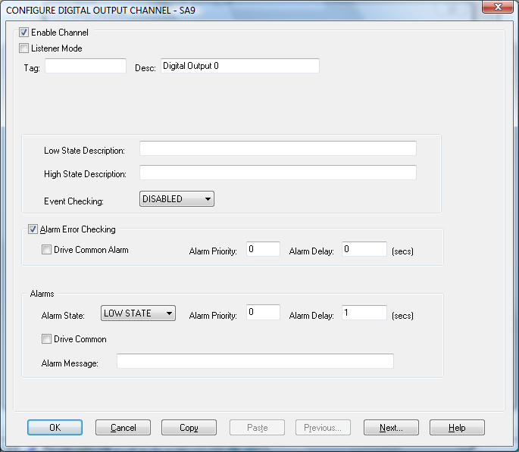

## Enable Channel

The Enable Channel check box must be checked to enable, and allow this channel to be configured and ultimately included with all other configured channels in the System.

## Listener Mode

To make this channel operate in listener mode select this option.

## Tag

The Tag field is an 12 character solo numeric field that can contain channel information or wiring schedule references.

## Description

The Description field is a 16 character solo numeric field in which a description of the channel can be detailed.

## Low State Description

A 32 character field in which to enter a description of the low state of the channel.

## High State Description

A 32 character field in which to enter a description of the high state of the channel.

## Event Checking

Event checking is used, if required to trigger a logger to record information on an event. If this facility is required click on the drop down list box and select OFF, HIGH STATE, or LOW STATE as appropriate.

## Alarm Error Checking

**Drive Common**

A common alarm is a single digital output which will switch on when any channel with the **Drive**

**Common Alarm** enabled goes into an alarm state.

Check this box if a link to the Common Alarm is required.

**Priority**

Enter or edit the number in the text box to allocate the priority of this channels alarm.

**Delay**

Enter the time, in seconds, between the channel value entering the alarm state and the

system flagging an alarm.

## Alarms

**Alarm State**

Alarm checking is available on all channels throughout the System. To configure alarm checking on this channel click on the drop down box and select OFF, HIGH STATE, or LOW STATE as appropriate. If the channel's output state changes to an Alarm State an alarm will be triggered on the channel. When monitoring channels, if the alarm is triggered, the fact will be annotated alongside the other channel information in the Monitor Window.

**Alarm Priority**

Enter the priority of the alarm triggered by this channel.

**Common Alarm**

Channels can be configured to trigger a Common Alarm. A common alarm is a single digital output which will switch on when any channel with the Drive Common Alarm enabled goes into an alarm state.

**Alarm Message**

An Alarm Message can be defined to be displayed on the Status line of the Main Window when a channel goes into an alarm state.

# Interrogate Modules

The user can interrogate what modules are present on the Network and read the configuration into the next available slot.

This can be achieved by clicking on the ***Network Modules*** option in the Edit menu. The user will be presented with the following dialog:

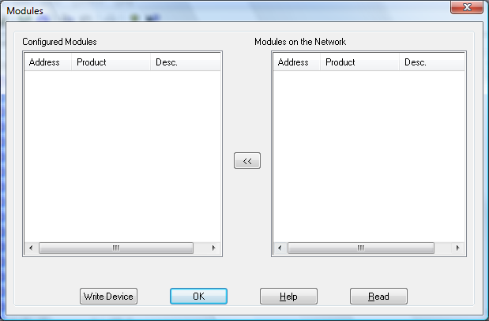

The user must then click Read to begin interrogation of the device. The user is then presented with the following dialog:

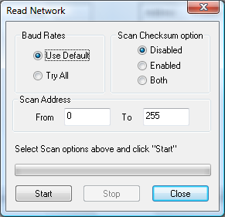

The range limits for the address of the modules to search for must first be entered, as well as baud rate and checksum search settings.

**Note: The more modules in the search the longer this will take.**

As soon as modules found they will appear in the Modules on the Network List.

When Searching is complete the user is presented with the following list view:

The left hand pane describes the modules that are currently configured in the system whilst the right hand pane displays the details for the modules that where within the search range.

By clicking the ***<<*** button you may add modules selected in right list view to the current Configured Modules. If module with such address already exists in the system you’ll be asked about overwriting existing module configuration information. At this stage the module configuration information downloaded from the module EPROM.

# Error Codes

Error messages will be reported to users in the Error Banner of both the Main Application and the Configurations Main View. They will take the following format:

M:nnn XX A:nnn C:nnn S:nnnnn

M: - Details the Module reporting the error.

XX - Details the Command causing the error.

A: - Details the associated Solo error code.

C: - Details the associated Comms error code.if appropriate.

S: - Details the associated System error code if appropriate.

## Error Codes

|  |  |
| --- | --- |
| 001 | If this code appears you should look to the C: to get a description of the problem |
| 002 | The selected baud rate is unsupported on this system |
| 003 | Not all of the packet was received within the timeout period for the command |
| 004 | The packing framing characters received were incorrect |
| 005 | A invalid checksum was received |
| 006 | An address was expected in the packet but was not found |
| 007 | An unknown command was sent to the module |
| 008 | The parameters sent with this request were unexpected |
| 009 | The parameter sent with this command was out of range |
| 010 | The channel range specified for this command was invalid |
| 011 | No data was returned for the query |
| 012 | Unknown error returned from the module |
| 013 | The return address on the packet was not what was expected |
| 014 | Unexpected address for this command |
| 015 | The contents of the returned packet was unexpected |
| 016 | An unexpected token was encountered int he return packet |
| 017 | The start channel number for the data packet was not what was expected |
| 018 | The data packet was incomplete |
| 019 | The returned data format was not what was expected |
| 020 | An invalid range of channels was requested |
| 021 | The channel range in the return packet was unexpected |
| 022 | The report format of the return packet was unexpected |

## Comms Error Codes

|  |  |
| --- | --- |
| 001 | If this code appears you should look to the S: to get a description of the problem |
| 002 | The selected communication port is already in use |
| 003 | Could not write all the data to the communication port |
| 004 | Could not read all the requested data on the communication port |
| 005 | The operation being performed on the communication port timed out |
| 006 | The communications handle is invalid |

## System Error Codes

Refer to the operating system documentation.

# Debug Facility

The Solo driver contains a debug facility which allows it to be debugged at run-time should an error occur. To enable this facility a number of **Registry Entries** must be set:

## Switching Debugging On

To switch debugging on simply add the following registry key

***HKEY_LOCAL_MACHINE\SOFTWARE\Measuresoft\<ProductName>\SOLO_<dev_number>_Debug*** and set its value to “**ON”.**

## Selecting the Debug Type

The Solo Driver allows you to output the debug information to a Console Window, Text File or as a Trace Statement which can be displayed by applications such as DBWIN32.EXE. To enable these facilities add the following registry key

***HKEY_LOCAL_MACHINE\SOFTWARE\Measuresoft\<ProductName>\SOLO_<dev_number>_DebugType***

The values of this key can be as follows:

**“CON”** to send output to a console window

**“FILE”** to send the output to a text file or

**“TRACE”** to send the output as a trace statement.

These can be concatenated to send the output to multiple types by using the **|** symbol.

e.g. “**FILE|CON”** would send the output to both File and Console Window.

When sending output to the **FILE** type you must specify the file. To do this add the following registry entry

HKEY_LOCAL_MACHINE\SOFTWARE\Measuresoft\<ProductName>\SOLO_<dev_number>_DebugFile

Its value should contain the name of the file you wish to output debug information too.

**Note:** Console (CON) is not supported on Windows Vista. Instead set the output mode to TRACE, and to view the debug data you must use SysInternals Debug Viewer. This can be downloaded from <http://www.microsoft.com/technet/sysinternals/Utilities/DebugView.mspx>

In order for Console mode to work on Windows XP the service must be configured to logon as the System Account with Interact with Desktop enabled