Partnership Courtyard, The Ramparts,
Dundalk, Ireland

Version 6.8.0.0
March 7, 2022
www.measuresoft.com
+353 42 933 2399

This document is the copyright of Measuresoft and may not be modified, copied or distributed in any form whatsoever without the prior permission of Measuresoft.

CrystalTek Model 66TR Controller Driver User Manual

Table of Contents

1 Configuration 4
2 Advanced Device Configuration 5
2.1 AutoEnable Device 5
2.2 Scan Rate 5
2.3 Save Outputs 5
2.3.1 By Tag 5
2.4 Device Specific Button 6
2.4.1 Model 6
2.4.2 Excitation Frequency 6
2.4.3 GPIB 6
2.4.3.1 Board 6
2.4.3.2 Address 6
2.4.4 RS-232 6
2.4.4.1 Port 7
2.4.4.2 Speed 7
2.4.4.3 Parity 7
2.4.5 Command 7
2.4.6 Curves 7
2.4.7 Curve No 8
3 Analog Input Channel Configuration 9
3.1 Enable Channel 9
3.2 Tag 9
3.3 Description 9
3.4 Engineering Units 9
3.4.1 Minimum 10
3.4.2 Maximum 10
3.4.3 Descriptor 10
3.5 Device Specific Button 10
3.5.1 Input number 10
3.5.2 Reading 10
3.5.3 Configure 11
3.5.4 Sensor Type 11
3.5.5 Coefficient 11
3.5.6 Sensor Units/Excitation Mode 11
3.5.7 Input Excitation 11
3.5.8 Range 11
3.5.9 Dwell Time 11
3.5.10 Pause Time 12
3.5.11 Compensation 12
3.5.12 Curve No 12
3.5.13 Filter 12
3.5.13.1 Points 12
3.5.13.1 Settle Time 12
3.5.13.2 Window 12
4 Digital Input Channel Configuration 13
4.1 Enable Channel 13
4.2 Tag 13
4.3 Description 13
4.4 Low State Description 13
4.5 High State Description 14
4.6 Event Checking 14
4.7 Alarm Checking 14
4.7.1 Alarm State 14
4.7.2 Alarm Priority 14
4.7.3 Common Alarm 14
4.7.4 Alarm Delay 14
4.7.5 Alarm Message 14
4.8 Device Specific Button 14
4.8.1 Input number 15
5 Analog Output Channel Configuration 16
5.1 Direct Analog Outputs 16
5.1.1 Output number 16
5.1.2 Bipolar 16
5.1.3 PID Controlled 16
5.1.4 -100% and 100% Output Values 16
5.2 Control Loop Parameters 17
5.2.1 Loop number 17
5.2.2 Loop parameters 18
6 Digital Output Channel Configuration 20
6.1 Device Specific Button 20
6.1.1 Type 20
6.1.2 Output 20
6.1.3 Alarm 20
6.1.4 Alarm Channel 21

Configuration

The first time the system is configured it is necessary to enable and configure all devices you require. To configure a particular device select the Devices option from the main menu followed by the Lakeshore device. This will launch an application to configure the device.

From the list provided select a channel and double-click. Alternatively you can select a channel and then click on the Configure Channel button.

This will launch a channel configuration dialog which enables you to configure individual channels.

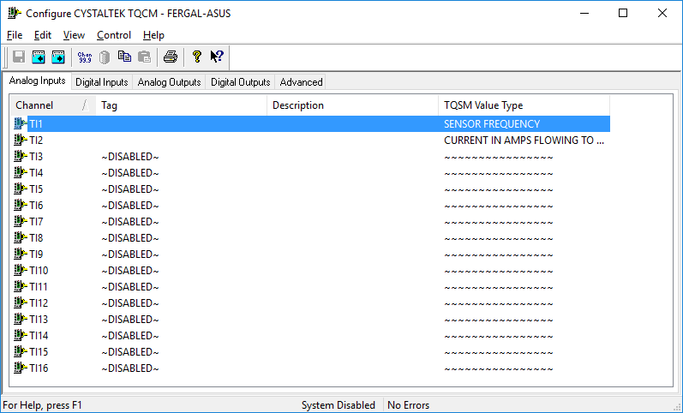

Advanced Device Configuration

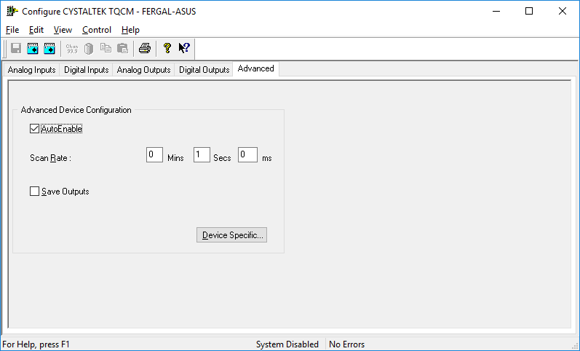

AutoEnable Device
To ensure that the device is enabled on the system check the Enable Device box.

Scan Rate
To set the rate at which the device will scan, edit the text boxes associated with the Scan Rate field.

Save Outputs
To enable this utility check the Save Outputs flag. All values in output channels are saved to disk when the system is disabled. The next time the system is restarted the values which were previously in output channels will be restored to the appropriate channel number.

By Tag
Channel values can be saved and restored to channels using the channel tag instead of the channel number. In this way, channels can be rearranged within the modules and as long as the channel tags remain the same, the correct channel values will be restored to the appropriate channel number.

Device Specific Button
When the Device Specific Button is pressed the following dialog appears to allow specific communication settings to be configured for the device.

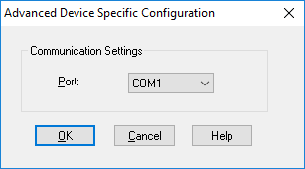

Port
Displays communications ports available on your computer

Analog Input Channel Configuration

When the user selects an analog input to be configured the following is displayed.

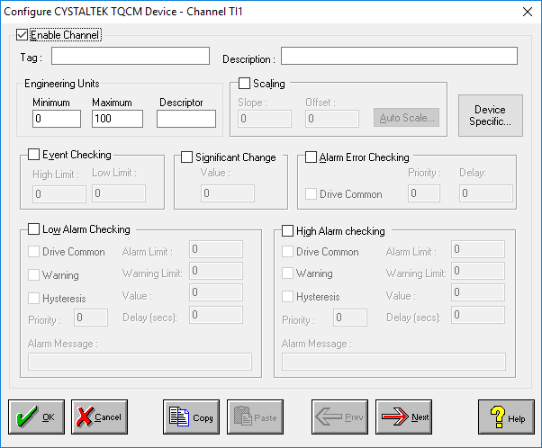

Enable Channel
The Enable Channel check box must be checked to enable and allow a channel to be configured and ultimately included with all other configured channels in the overall system.

Tag
The Tag field is a 12 character alphanumeric field that can contain channel information or wiring schedule references.

Description
The Description field is a 32 character alphanumeric field in which a description of the channel can be detailed.

Engineering Units
Specifies engineering details for this channel.

Minimum
Minimum engineering value for all Analog channels in addition to the unit field. The default is 0.

Maximum
Maximum engineering value for all Analog channels in addition to the unit field. The default is 100.

Descriptor
Describe the units of the measurement.

Device Specific Button
When the Device Specific Button is pressed the following dialog appears to allow specific device configuration of the particular channel.

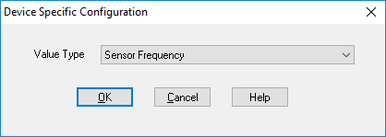

Value Type
The type of value to be read from the device.

Digital Input Channel Configuration

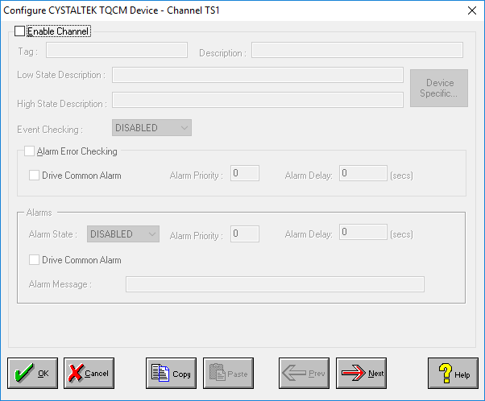

Enable Channel
The Enable Channel check box must be checked to enable, and allow this channel to be configured and ultimately included with all other configured channels in the overall system.

Tag
The Tag field is an 12 character alphanumeric field that can contain channel information or wiring schedule references.

Description
The Description field is a 32 character alphanumeric field in which a description of the channel can be detailed.

Low State Description
A 32 character field in which to enter a description of the low state of the channel.

High State Description
A 32 character field in which to enter a description of the high state of the channel.

Event Checking
Event checking is used, if required to trigger a logger to record information on an event. If this facility is required click on the drop down list box and select OFF, HIGH STATE, or LOW STATE as appropriate. Events are detected on inputs using data acquired at 1Khz. Events are detected on outputs using the configured scan rate.

Alarm Checking

Alarm State
Alarm checking is available on all channels throughout the system. To configure alarm checking on this channel click on the drop down box and select OFF, HIGH STATE, or LOW STATE as appropriate. If the channel's output state changes to an Alarm State an alarm will be triggered on the channel. When monitoring channels, if the alarm is triggered, the fact will be annotated alongside the other channel information in the Channel Monitor . Alarms and warnings are detected at the configured scan rate.

Alarm Priority
Enter the priority of the alarm triggered by this channel. Alarm priority ranges are from 0 to 255.

Common Alarm
Channels can be configured to trigger a Common Alarm. A common alarm is a single digital output which will switch on when any channel with the Drive Common Alarm enabled goes into an alarm state.

Alarm Delay
Enter the time, in seconds, between the channel value entering the alarm state and the system flagging an alarm.

Alarm Message
An Alarm Message can be defined to be displayed on the Status line of the Main Window when a channel goes into an alarm state.

Device Specific Button
When the Device Specific Button is pressed the following dialog appears to allow specific device configuration of the particular channel.

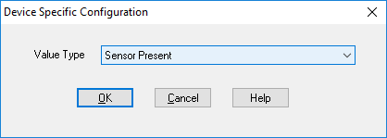

Value Type
The type of value to be read from the device.

Analog Output Channel Configuration

Current Analog Outputs values are read from the device when the scanning starts. If the output changes via system channels e.g. from the calculator or a monitor the output is written to the device.

See Analog Input for an explanation of the standard channel configuration.

Analog Outputs
When the Device Specific Button is pressed the following dialog appears to allow specific device configuration of analog outputs.

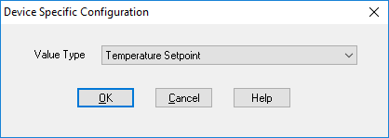

Value Type

The type of value to be read from and written to the device.

Digital Output Channel Configuration

Current Digital Outputs values are read from the device when the scanning starts. If the output changes via system channels e.g. from the calculator or a monitor the output is written to the device.

See Digital Input for an explanation of the standard channel configuration.

Device Specific Button
When the Device Specific Button is pressed the following dialog appears to allow specific device configuration of the particular channel.

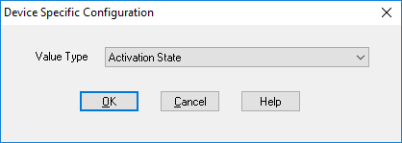

Value Type

The type of value to be read from and written to the device.

